1. Instanciação, lookup

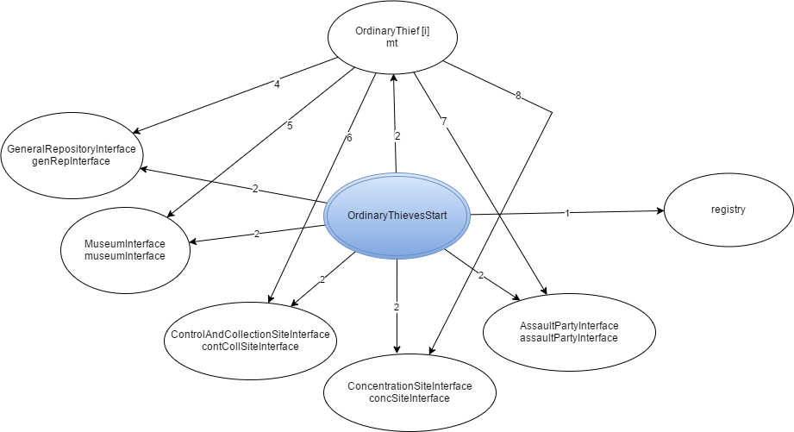

1. Instanciação
2. Instanciação, join, start
3. addThief, updateThiefState, updateThiefCylinder, updateThiefSituation
4. rollACanvas
5. handACanvas
6. crawlIn, crawlOut, joinParty, reverseDirection, getTargetRoom
7. amINeeded, getPartyId, prepareExcursion