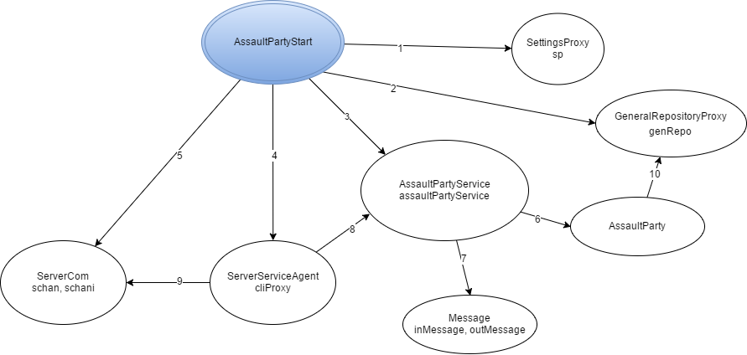

Legenda:

1. instantiate, getASSAULT_PARTY_SIZE
2. Instantiate
3. Instantiate
4. Instantiate, start
5. Instantiate, start, accept,
6. crawlIn, crawlOut, getTargetRoom, joinParty, reverseDirection, sendAssaultParty, setRoom
7. Instantiate, getType, getArgs
8. processRequest
9. readObject, writeObject, close
10. updateThiefPosition, updateThiefSituation, setRoomIdAP