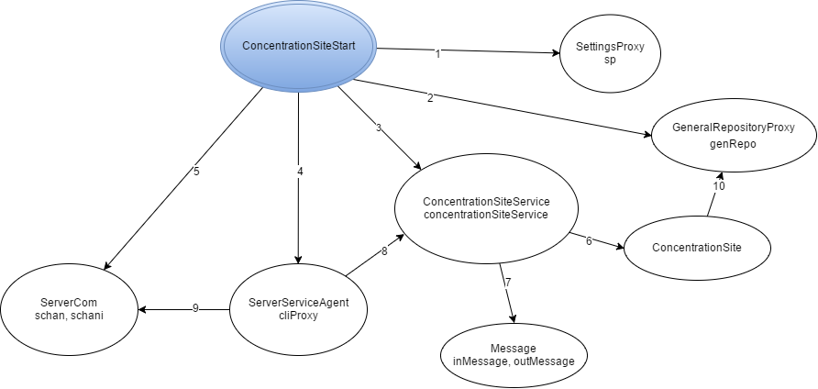

Legenda:

1. instantiate, getN_ORD_THIEVES, getASSAULT_PARTY_SIZE
2. Instantiate
3. Instantiate
4. Instantiate, start
5. Instantiate, start, accept,
6. amINeeded, prepareExcursion, prepareAssaultParty, sumUpResults, startOperations, getPartyId, appraiseSit
7. Instantiate, getType, getArgs
8. processRequest
9. readObject, writeObject, close
10. setPartyElement