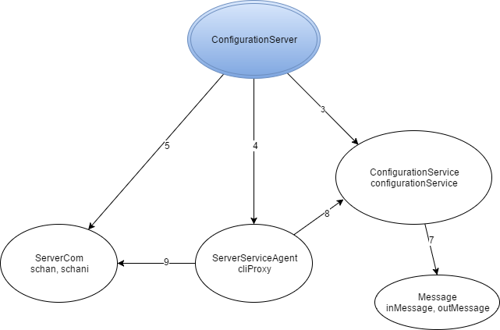

Legenda:

1. Instantiate
2. Instantiate, start
3. Instantiate, start, accept,
4. Instantiate, getType, getArgs
5. processRequest
6. readObject, writeObject, close