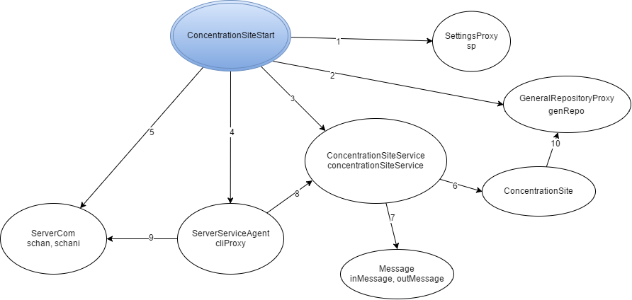

Legenda:

1. instantiate, getN_ROOMS, getN_ORD_THIEVES, getASSAULT_PARTY_SIZE
2. Instantiate
3. Instantiate
4. Instantiate, start
5. Instantiate, start, accept,
6. collectCanvas, handACanvas, getTargetRoom, getPartyToDeploy, isHeistCompleted, takeARest, waitingNedded
7. Instantiate, getType, getArgs
8. processRequest
9. readObject, writeObject, close
10. clearParty, setCollectedCanvas