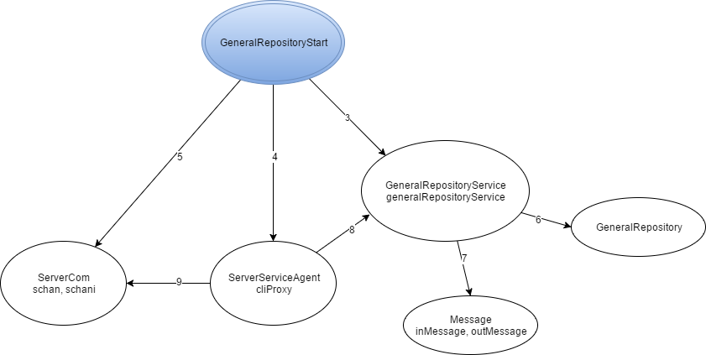

Legenda:

1. Instantiate
2. Instantiate, start
3. Instantiate, start, accept,
4. FinalizeLog, addThief, clearParty, setCollectedCanvas, setPartyElement, setRoomAtributes, setRoomCanvas, setRoomIdAP, updateMThiefState, updateThiefCylinder, updateThiefPosition, updateThiefSituation, updateThiefState
5. Instantiate, getType, getArgs
6. processRequest
7. readObject, writeObject, close