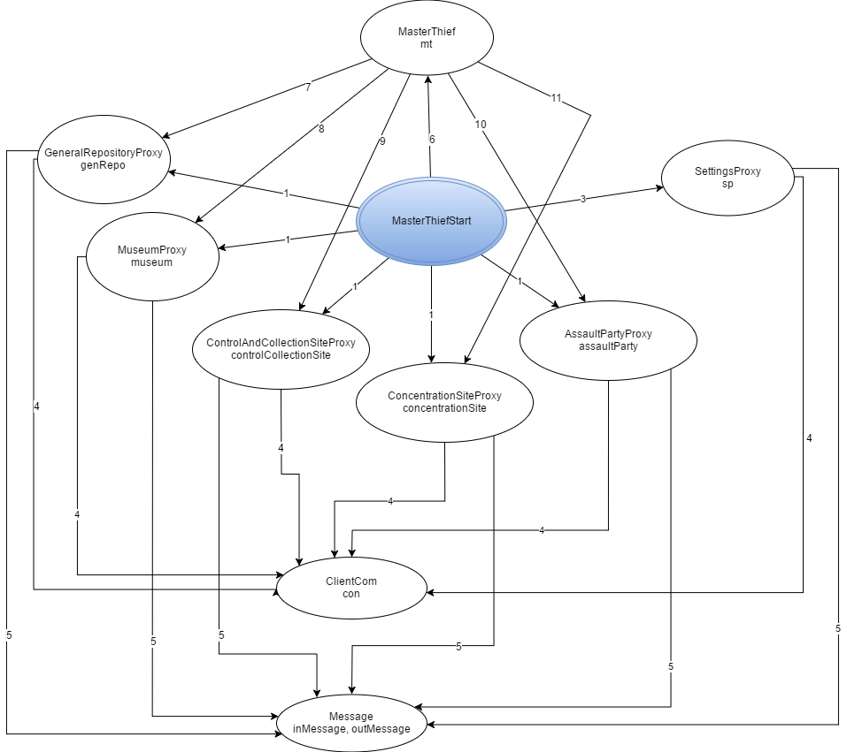

Legenda:

1. Instantiate
2. Instantiate, getN_ORD_THIEVES, getASSAULT_PARTY_SIZE
3. Instantiate, start, accept,
4. readObject, writeObject, close
5. Instantiate, start
6. updateMThiefState, FinalizeLog
7. getRoomDistance
8. getTargetRoom, getPartyToDeploy, takeARest, collectCanvas, isHeistCompleted, waitingNedded
9. setRoom, sendAssaultParty
10. startOperations, prepareAssaultParty, sumUpResults, appraiseSit