Legenda: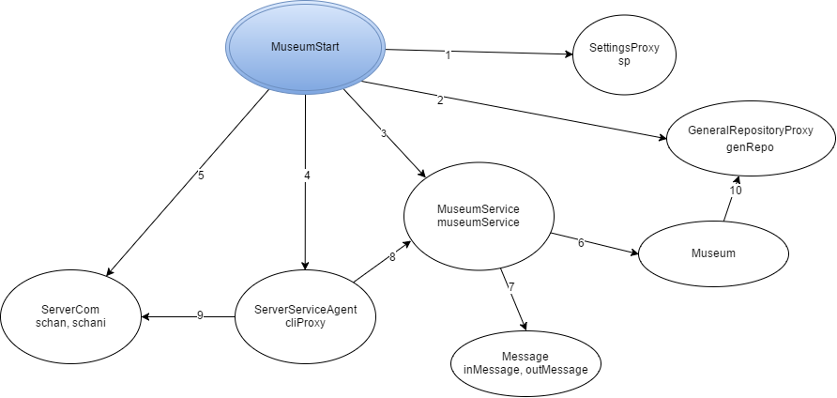

1. instantiate, getN_ROOMS, getMAX_ROOM_DISTANCE, getMIN_ROOM_DISTANCE, getMAX_PAITING_PER_ROOM, getMIN_PAITING_PER_ROOM
2. Instantiate
3. Instantiate
4. Instantiate, start
5. Instantiate, start, accept,
6. rollACanvas, getRoomDistance
7. Instantiate, getType, getArgs
8. processRequest
9. readObject, writeObject, close
10. setRoomAtributes, setRoomCanvas