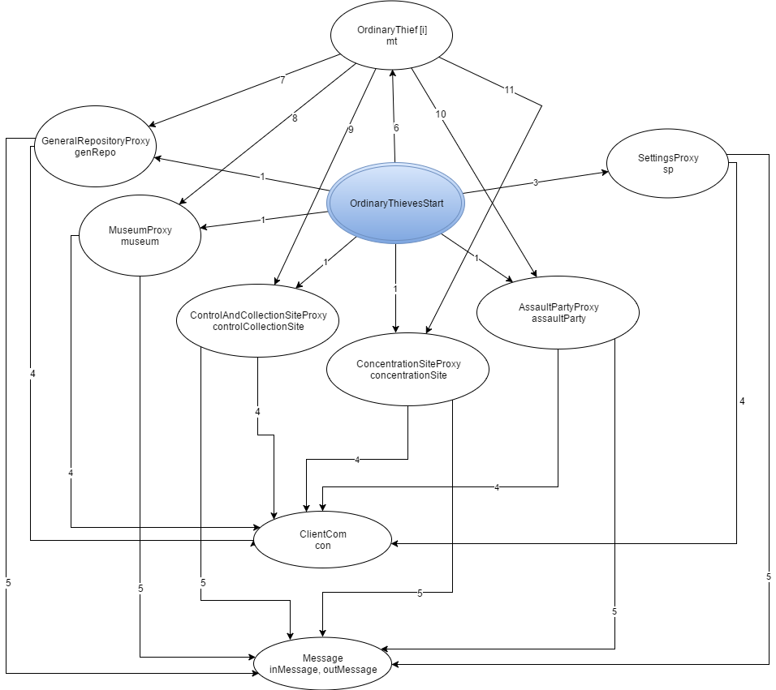

Legenda:

1. Instantiate
2. Instantiate, getN_ORD_THIEVES, getASSAULT_PARTY_SIZE, getMAX_THIEF_SPEED, getMIN_THIEF_SPEED
3. Instantiate, start, accept,
4. readObject, writeObject, close
5. Instantiate, start
6. addThief, updateThiefState, updateThiefCylinder, updateThiefSituation
7. rollACanvas
8. handACanvas
9. crawlIn, crawlOut, joinParty, reverseDirection, getTargetRoom
10. amINeeded, getPartyId, prepareExcursion