Open the GIT bash shell

====================

Change the directory to the local workspace location : eg: mkdir c:/ravi; cd c:/ravi

Clone the repo

=============

* git clone <repo_location> [eg: git clone <https://github.com/rpadma2/git_tutorial> ]

The above command creates git_tutorial directory under c:/ravi

Create a local branch

=================

* git checkout -b <userid>/<branch_name> [eg: git checkout -b rpadma2/test_drivetrain]

Add a new file or modify the existing file

=================================

* git add <newfile> [eg: vi test.txt … Add few lines… You can use any editor to create a new file under initial workspace location where the repo is checked out. Eg: c:/ravi/git_tutorial/test.txt

Commit the new file (or) update file changes to the branch

=================================================

* git commit [This will open an editor… Type the file changes information on the first line and save it and do “ ESC :wq!”
* git commit -m “Added new file” : This automatically adds the comment information.

Push the changes to your local branch

===============================

* git push origin <branch_name> [eg: git push origin rpadma2/test_version]

Go to github to create a new pull request

==================================

Click on the branches

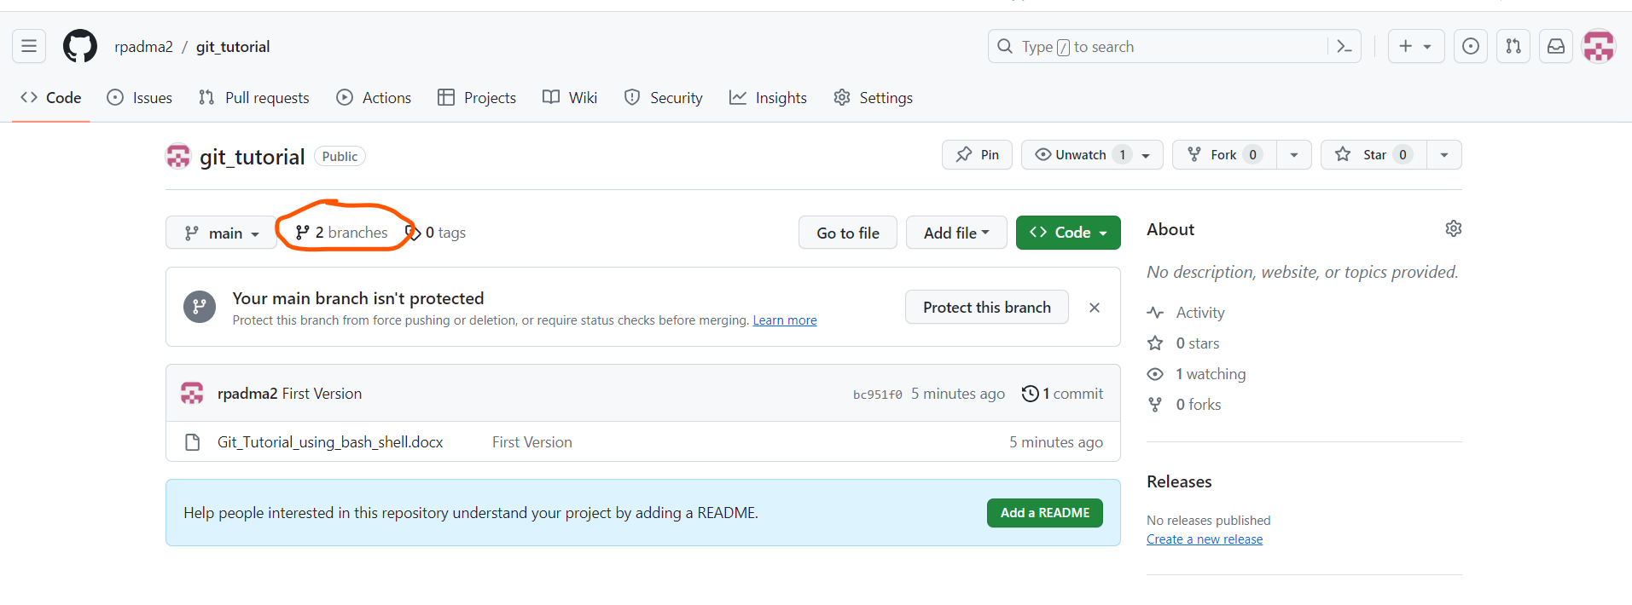

Select your branch and create a new pull request

