How to manually wire a circuit using the Software Configurable Breadboard
Summary: This Proof of Skills assignment walks the reader through the best practices for using the manual configuration controls in the SCB User Interface. As the name implies the SCB is configured or programed as it were from a list of component locations and connections, often from a text file which can be thought of as the “program” to set up the board.
Step1:
Looking at the schematic of the circuit to be wired:
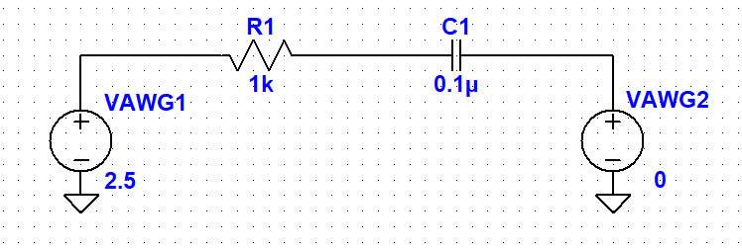
First Node

Second Node

Third Node

This simple example consists of a resistor and a capacitor connected in series. As can be seen in this example the circuit has just three nodes, the end of the series resistor R1, the end of the series capacitor C1 and the node in the middle. In the schematic we also need to consider special connections to nodes that represent the SCB waveform generator outputs (VAWG1, VAWG2) and scope inputs (AINH, BINH, CINH) to view waveforms.
To program the SCB hardware we need to decide where on the breadboard to insert or place the components R1 and C1. Between the 34 possible locations on each of the left and right side breadboard there are many ( > 100 ) possible ways to place R1 and C1. To keep things relative simple it is generally good practice for two terminal components like R1 and C1 to use breadboard holes on either side of the center gutter of the breadboard which divides the top and bottom sections.
In the SCB interface the following naming scheme is used for the breadboard holes. First we distinguish between the left and right side by using L and R in the names. Next we distinguish between the top and bottom sections by using T and B in the names. Finally the holes in each section are numbered from 1 to 17 left to right. Thus the left most location in the top section of the left breadboard is named TL1. The location just below that one on the opposite side of the central gutter in the bottom section will be named BL1. All the other locations on the breadboard(s) are named similarly.
With this in mind a good choice would be to place R1 between the TL2 and BL2 holes and place C2 between the TL4 and BL4 holes.
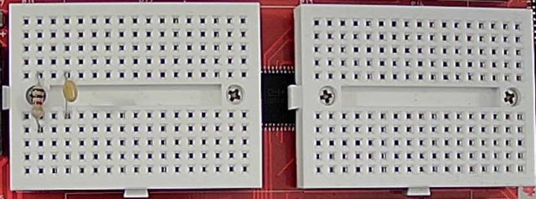
Step 2:
With the SCB connected to the computer over USB, Launch the Alice-universal-alpha.pyw python program. At this point the main Oscilloscope window and the AWG controls window can be minimized while configuring the SCB.
The controls to manually configure the SCB appear along the left side of the Cross Point Interface window (it might say either RED2 or RED3 depending on the hardware version of the SCB you have). In the center of the window is a graphical depiction of the breadboard. This is used to display how the various jumpers (JP1-16) are connected to the 67 possible breadboard locations. On the left side is an inventory of how the jumper resources are being used. That is generally not something you need to pay much attention to unless you have a very large circuit.
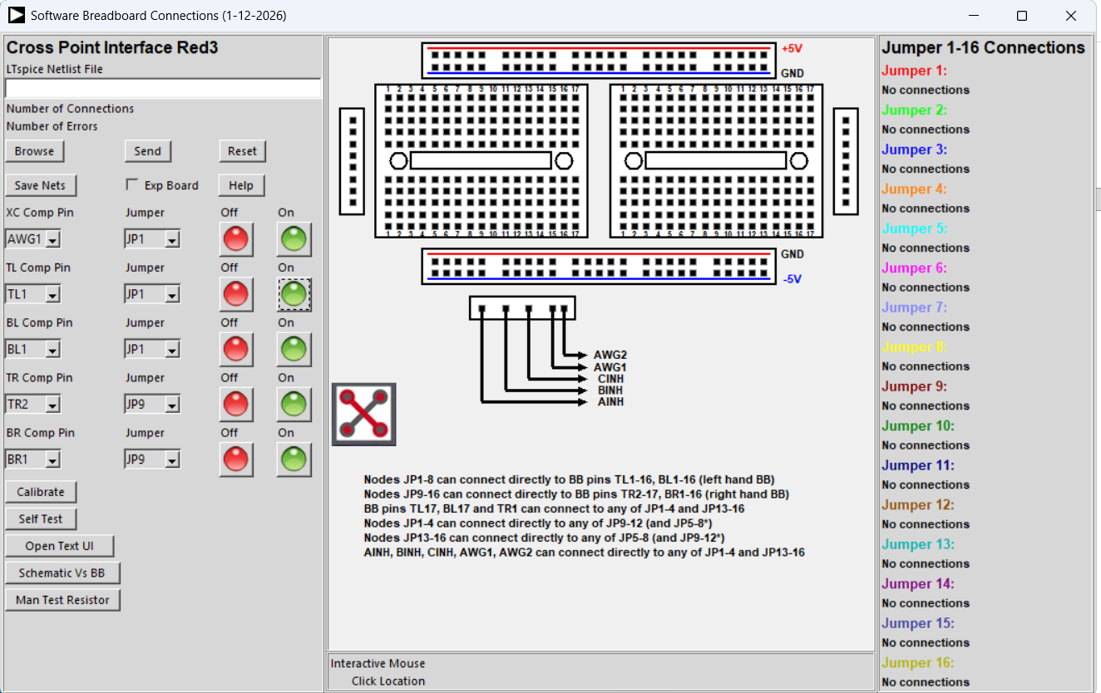
Click on the Open Text UI by clicking on the button on the right hand side of the Cross Point Interface window.
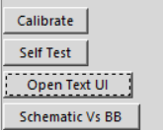
This will open the empty blank text editor / message display window.
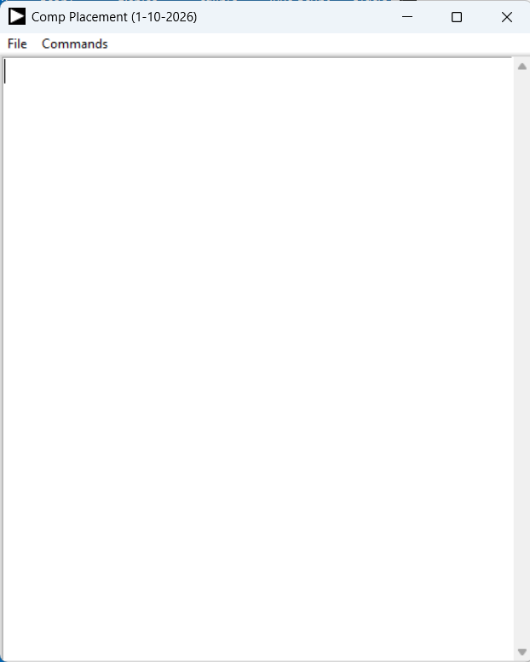
You now have to decide which of the 8 possible “jumpers” associated with the left side breadboard to assign to the three nodes in your circuit. The simplest approach is to simply start with JP1 for the end of R1, JP2 for the middle junction of R1 and C1 and JP3 for the end of C1.

JP1

JP2

JP3

To connect jumper JP1 to the top of resistor R1 there are two ways of doing this (more on the second way in Step 3). The first way is to select TL2 and JP1 using the TL set of the manual controls on the left side and clicking on the green On button to turn on the connection between TL2 and JP1:
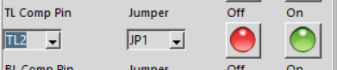
The TL2 location on the breadboard will now be colored with the color associated with JP1.
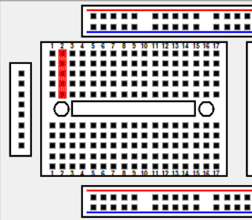
You will also notice that, with the Text Editor screen open, a line of text is added that lists this connection.
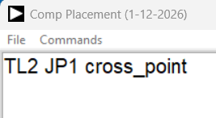
Similarly, to connect the other end of resistor R1 to JP2 select the BL2 and JP2 using the BL set of the manual controls on the left side and clicking on the green On button to turn on the connection between BL2 and JP2:
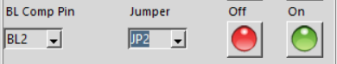
The BL2 location on the breadboard will now be colored with the color associated with JP2 and a second line of text is added in the Text Editor.
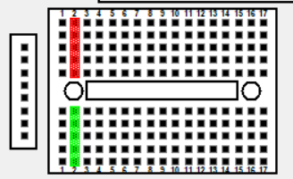
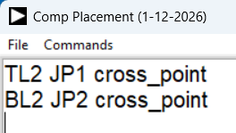
Do the same procedure for connecting C1 at TL4 and BL4 to JP2 and JP3. The results should look like this:
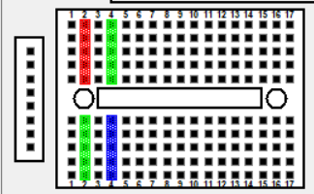
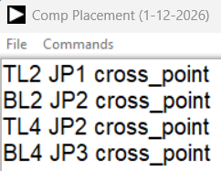
At this point we need to connect the two AWG outputs and the three Scope inputs to the circuit. These 5 connections are done using the XC Comp Pin control:
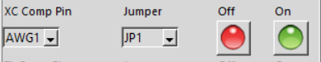
Select AWG1 and JP1, AWG2 and JP3, AINH and JP1, BINH and JP2, CINH and JP3 clicking on the green On button for each combination.
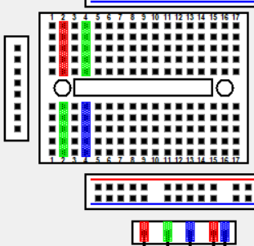
The Text Editor should now look like this with one line for each connection that is made:
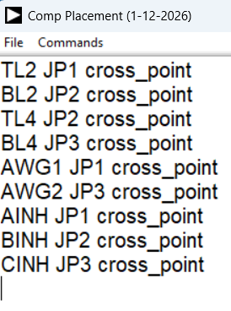
If you make any errors along the way simple remove the offending line from the Editor and redo the manual connection.

Step 3:
The second and perhaps faster way to program the connections once you get more familiar with using the SCB is to just type in the required connections to the Text Editor. Since you have already filled in most of the connections in Step 2, you can save this list to a file by clicking Save As in the Files drop down menu:
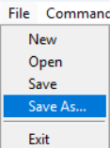
Enter the name you wish to save the file as.
There are two additions to the connections list that are needed to completely describe your circuit and that is the placement of R1 at TL2, BL2 and C1 at TL4, BL4. This is done by typing in the following two lines in the Editor:
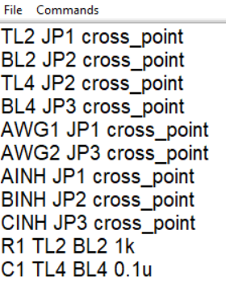
Again be sure to Save these additions to disk before moving to the final Step. The text file can be opened and edited to change any of the connections manually as needed.

Step 4:
Click on the Commands dropdown menu and select the Send From Editor command.
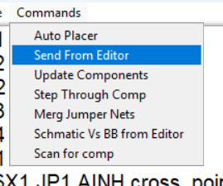
The SCB is Reset and the connections are now configured from this list of connections. The text screen will now be blanked (that is why we reminded you to save your work before doing this step) and the R1 and C1 locations will be displayed. To add back the Jumper connections click on the Merg Jumper Nets command.
To display where R1 and C1 have been placed on the breadboard graphic select the Update Components command.
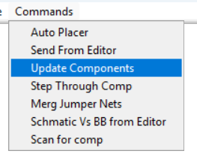
Resistor and Capacitor symbols will now be added to the breadboard display indicating where to insert R1 and C1.
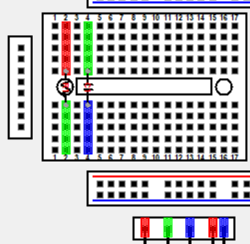
Text showing the location of R1 and C1 will also appear in the Text Editor window.
You can also step through the list of components one at a time by selecting the Step Through Comp command rather than Update Components.
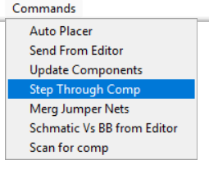
The SCB is now configured and you can procced with setting up the AWG and Scope channels to measure your circuit.

