**Company Manger Application Screenshots**

Ryan Pallas and Nikhit Gunturu

IRA A. Fulton School of Engineering, Arizona State University

IFT210 Fall 2024

Prof. Durgesh Sharma

November 17, 2024

**Company Manager Menu:**

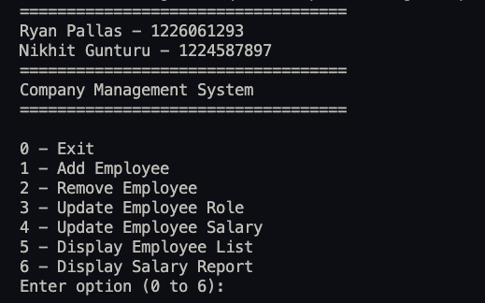

**Option 0: Exit Menu**

**Option 1: Add Employee**

**Option 2: Remove Employee**

**Option 3: Update Role**

**Option 4: Update Salary**

**Option 5: Display Employee List**

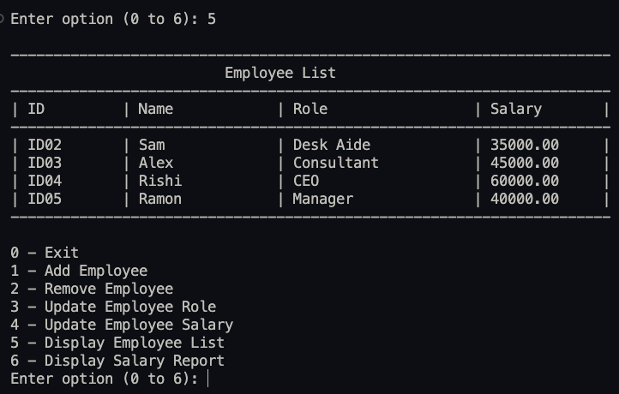

**Option 6: Display Salary Report**

**Default Option: Invalid Input** 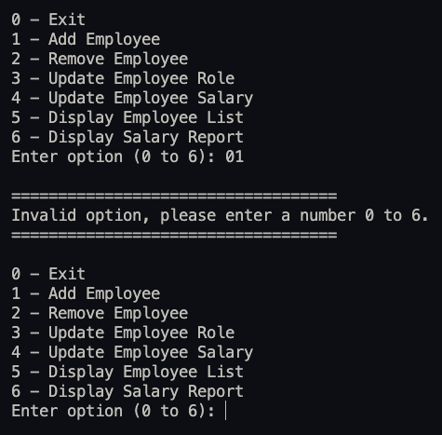

**Exit to Menu:**

