Temperature/Humidity IoT project with Arduino+DHT22+Python3

Main purpose:
The project allows to monitor temperature, humidity and heat index using a DHT22 sensor connected to an Arduino board sending information to a basic Python server and available to clients within the same LAN through a simple web app.

Project basic outline
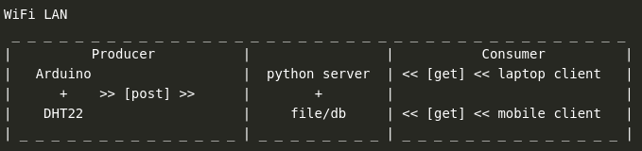
Main learning concepts:
- basic network (LAN) concepts
- the IoT pipeline: from sensor signal to data storage/plot
- Arduino settings, libraries and sketch
- python3 server setup
- client-server model
- JavaScript and Ajax for data update
- data storage (file, db, JSON, Django JSONField() )
- data visualization (ChartJS, HighchartJS)

OS and dev tools:
- Linux Ubuntu 20.04
- Arduino IDE
- Atom IDE
- Django 3.1

Arduino, components and sketch
Hardware:
- jumper wires [yellow: signal / red: power / black: ground]
- solderless breadboard
- DHT22 temperature and humidity sensor (3 pin or 4 pin) https://www.makerguides.com/dht11-dht22-arduino-tutorial/
- Arduino Uno Wifi (rev2) https://store.arduino.cc/arduino-uno-wifi-rev2
- 10 kΩ resistor (only with 4 pin sensor)
- Common 9V power battery (optional)
- Power battery adapter (optional)

PC powered version (and sketch upload)
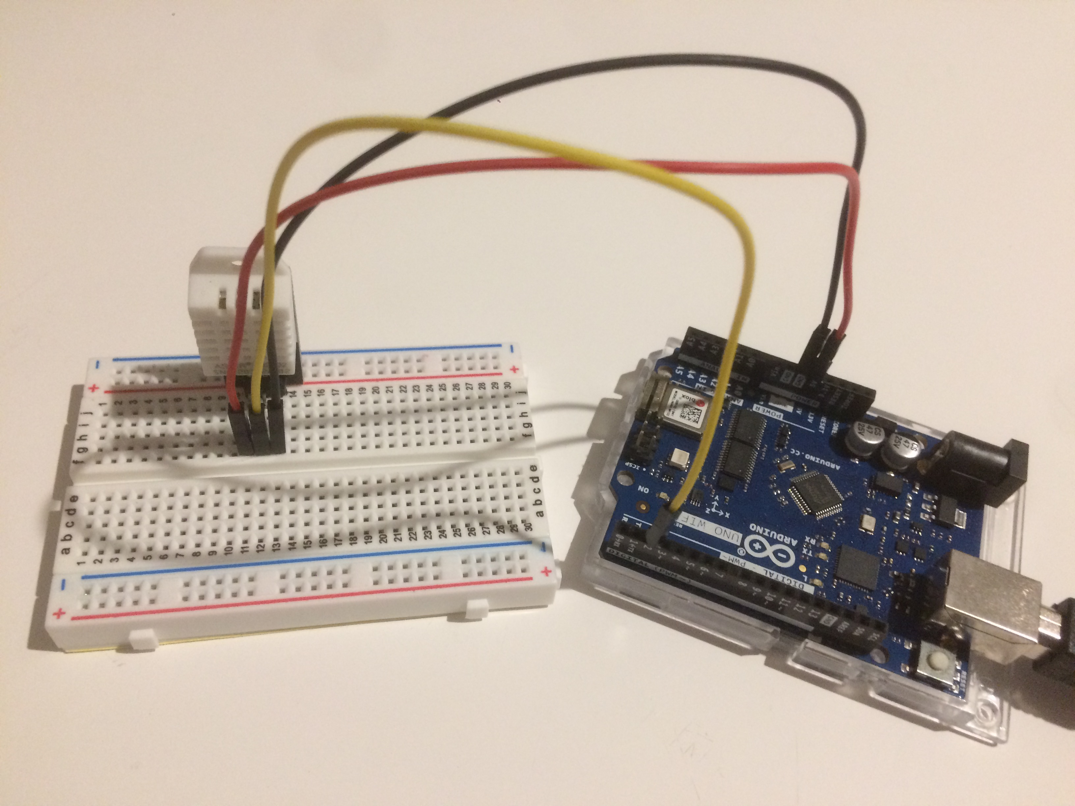

Portable version (limit is WiFi signal)
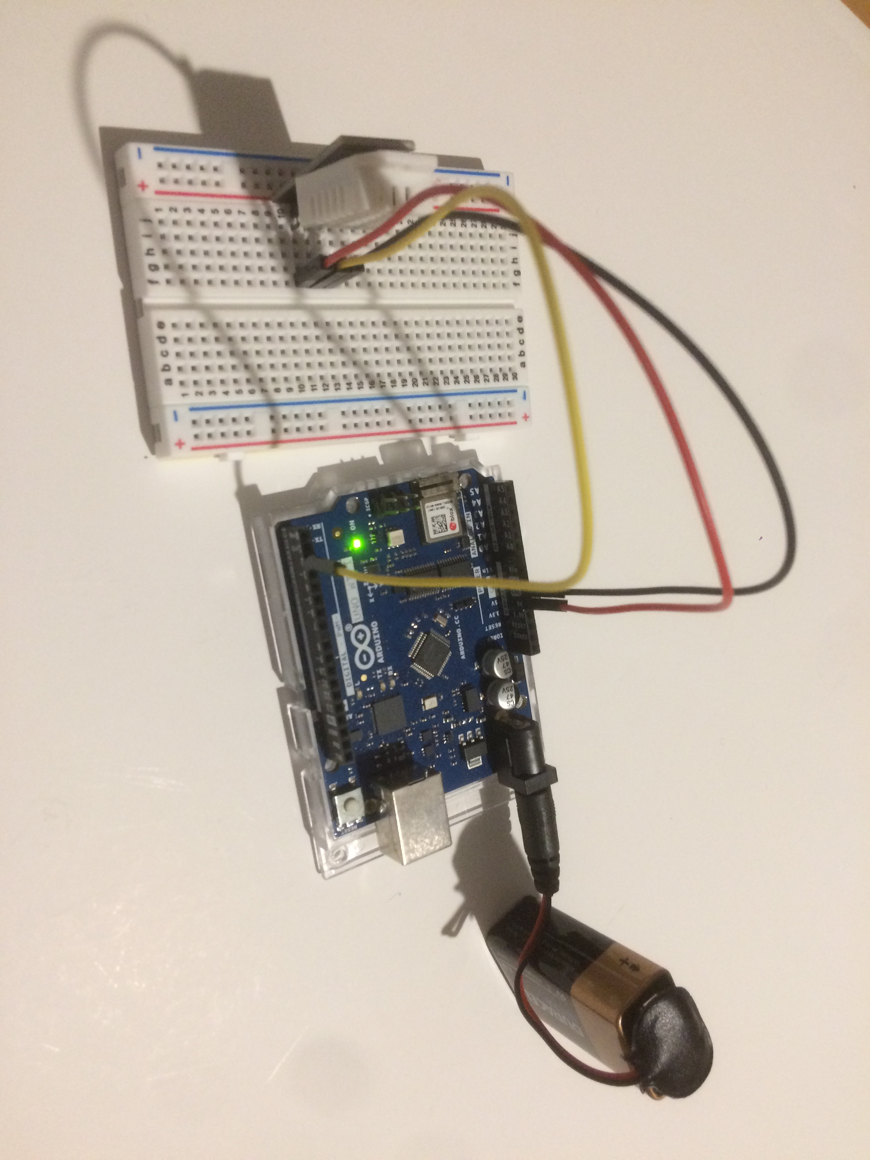

Software:
- Arduino IDE/console to write > compile > upload the sketch post_data.ino to board
- necessary libraries: SPI, WiFiNINA, ArduinoHttpClient, DHT

Any Arduino sketch is mainly based on a setup() and loop() methods.
Power connections (either via laptop or battery) triggers the sketch execution.

Setup: Arduino connection to LAN
The Arduino WiFi signal is received by the router that assigns a LAN IP as any other host in the network (e.g. laptops, smartphones, etc).
Loop: Arduino receiving data from sensor and sending to server
Arduino defines a DHT22 sensor instance and starts posting data to the server in the same LAN.

Python3 webserver
Python comes with a simple builtin HTTP server you can run from command line with
python3 -m http.server 8000 --bind 127.0.0.1
https://docs.python.org/3/library/http.server.html
With this HTTP server you can turn any directory in your system into your web server directory.
By default, server uses the current directory.

Server class [HttpServer]
class http.server.HTTPServer(server_address, RequestHandlerClass)
This class builds on the TCPServer class by storing the server address as instance variables named server_name and server_port.
The server is accessible by the handler, typically through the handler’s server instance variable.

Handler class [ArduinoWebServer]
class http.server.BaseHTTPRequestHandler(request, client_address, server)
This class is used to handle the HTTP requests that arrive at the server.
By itself, it cannot respond to any actual HTTP requests; it must be subclassed to handle each request method (e.g. GET or POST).
BaseHTTPRequestHandler provides a number of class and instance variables, and methods for use by subclasses. The handler will parse the request and the headers, then call a method specific to the request type. The method name is constructed from the request. All of the relevant information is stored in instance variables of the handler. Subclasses should not need to override or extend the __init__() method.
Finally, the run() method in the server.py will start the server and get it ready to receive POST requests from Arduino and GET requests from clients.
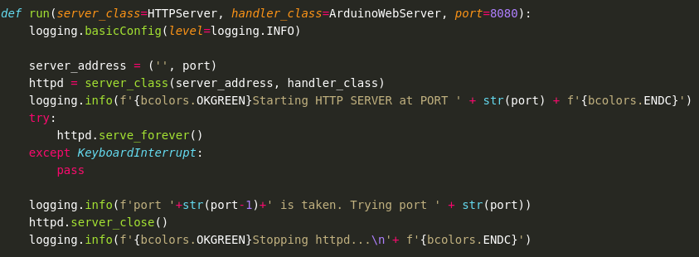
1_base
The basic project setup foresees POST requests every minute from Arduino to the python server (laptop). Temperature and humidity data are received and directly written in a dynamic HTML file hosted in the server itself, i.e. data are saved using a file.
When the GET request by the client is received, the previous temperature and humidity data are rendered in the web page. While Arduino continues to send updated data to server, client will receive updated information only refreshing the page, i.e. requesting the updated HTML file. Below, the client shows data from the first POST request despite a second one has been sent.

Arduino console
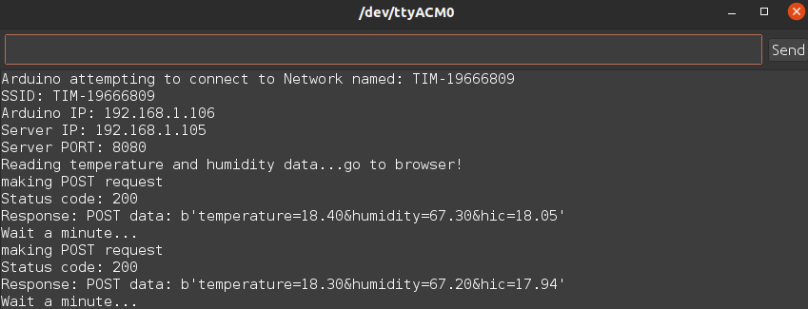
Server log
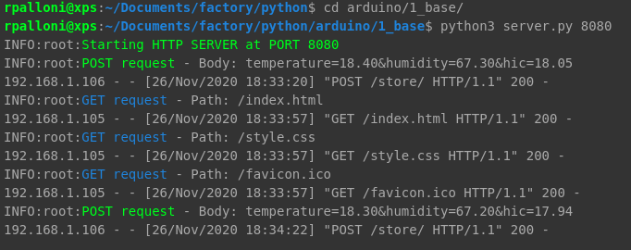
Client request
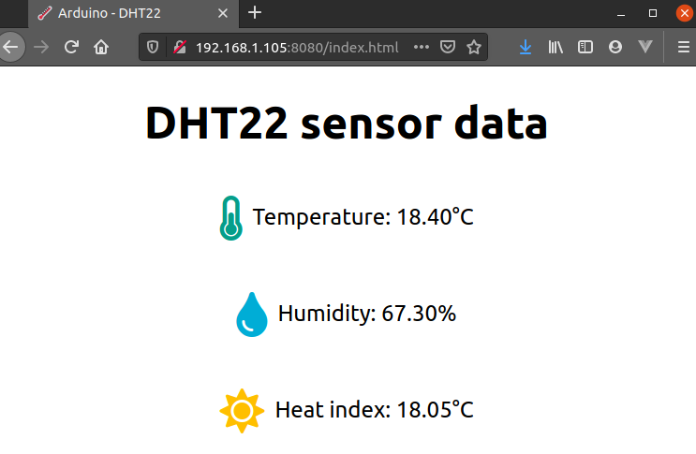

2_ajax
The 1_base version has a main drawback: lack of synchronized data without page refresh.
While Arduino continues to send updated sensor data to server every minute, the client page keeps showing old data unless the user reloads the page with a new GET request.
To avoid the user refreshing the page each time, the Javascript setTimeout() function could be added to the Javascript logic in the index.html page to schedule request for updated information every xxxxx milliseconds.
However, setTimeout() would still reload the entire page despite it would be sufficient to just align the numeric information of temperature, humidity and heat index.
To avoid page refresh, the Ajax technology is introduced client side: once the page is loaded with the first GET request, setTimeout() will trigger the new GET requests and the page will update the information without a complete (ugly) reload.
Furthermore, instead of the direct transcription in the html file, a JSON file stores and exposes data for the Ajax GET.

Ajax
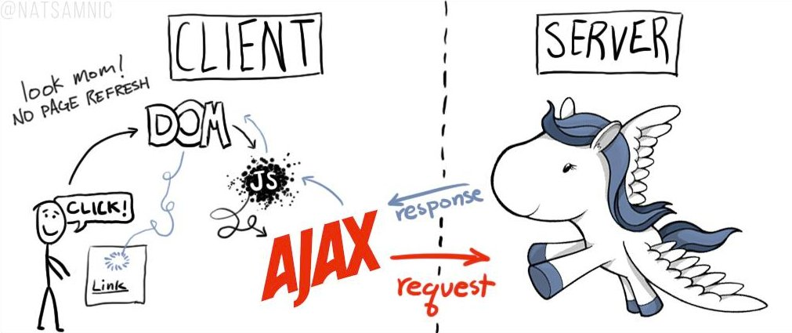

Ajax is another layer of technology between the client and the server handling the requests forced by setTimeout() and avoiding the need for refreshing the page for new data.
As it is visible from the server log, between the POST requests coming from Arduino, a series of GET requests for the tmpdata.json file are sent to the server from the client (without user actions) but the browser loading icons never shows up.

Arduino console
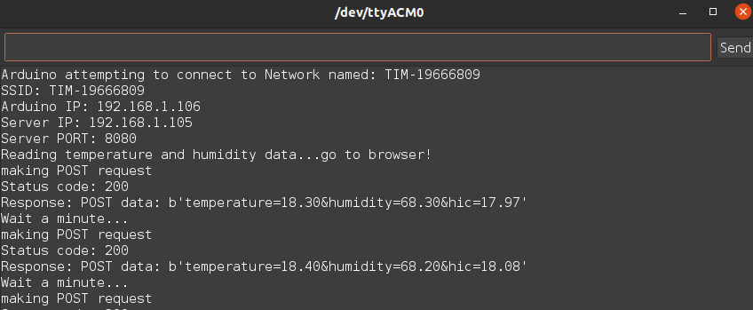

Server log
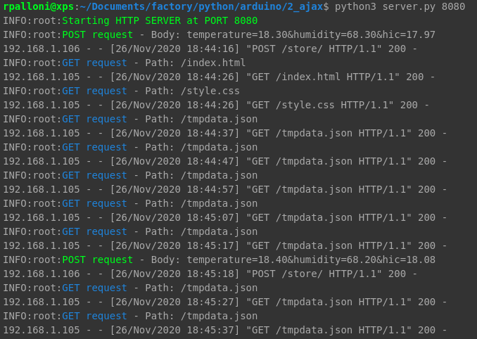
Client request
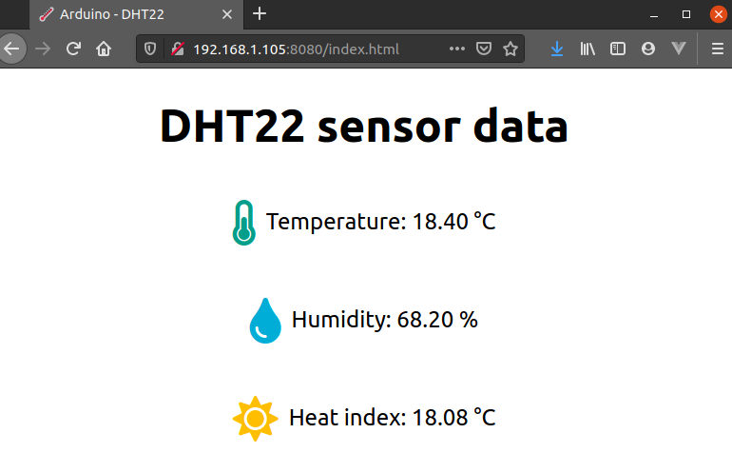

3_db
The two previous project versions are designed as a tool to get spot information on temperature and humidity each time someone needs to know exactly why he/she is freezing or sweating.
But what if it is important to monitor these data along a day or a week? For example, to tune the heating/cooling system in a room.
A different approach to data storage would be necessary and, despite a file could still server the purpose of recording data, a simple but more sophisticated approach would be adopted.
However, collecting data over time doesn’t provide a meaningful information per se.
Instead, using some statistics or a graph to synthesize data will.

Data collection and usage are handled by two functions in the dbms.py file called in the GET and POST requests of the server:
- store_data()
- fetch_data()

Both these functions enable a connection to a simple SQLite database and execute sql statements respectively to INSERT and to SELECT records.
Thus, when Arduino sends information to server the do_POST() function parses the data string from the request and calls the store_data function with an INSERT statement to the DHT22_DATA table.
The table storing the data looks like follows:
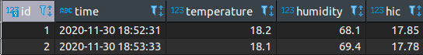

Similarly, when a clients ask for data, the do_GET() function calls the fetch_data function to retrieve the records and return a response.
Client side, data in the response are rendered in a time series plot using the ChartJS library.

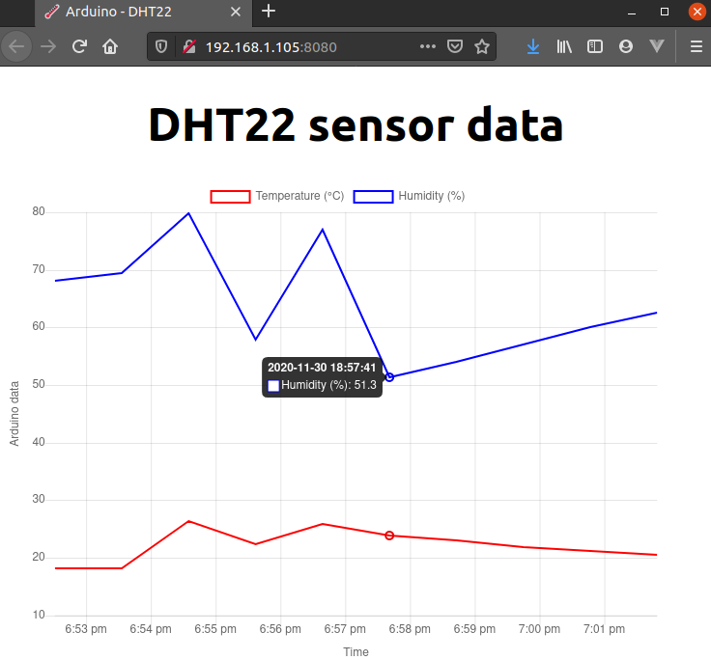

4_app [Django app]
The final version of the project is a Django project with a simple app.
The server and the database are the development server/db provided by the framework.
First, the project is hosted within a virtual environment where to install the Django framework

Project setup:

sudo apt install python3-pip
sudo apt install python3-venv
cd 4_app
python3 -m venv env
source env/bin/activate
pip install django [env/lib/python3.8/site-packages]

django-admin startproject dhtapp

cd dhtapp
python3 manage.py startapp core

In the project settings.py file the LAN IP of the laptop where the application is running has to be added to the ALLOWED_HOSTS and time zone adjusted to have consistent time in the database.

<settings.py>
ALLOWED_HOSTS = ['192.168.1.105']
TIME_ZONE = 'Europe/Rome'
USE_TZ = False
Add the ‘core’ app to INSTALLED_APP

Once settings are fixed, the server hosting the application will run on port 8080 to match Arduino settings.
python3 manage.py makemigrations
python3 manage.py migrate [commit]

python3 manage.py runserver 192.168.1.105:8080

Data storage: models.py
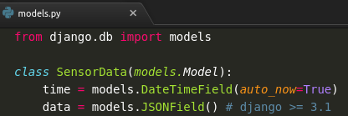

The JSONField() translates in the following data structure in the data column

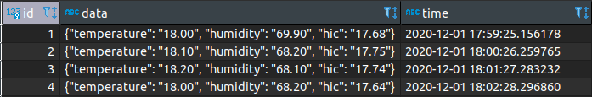

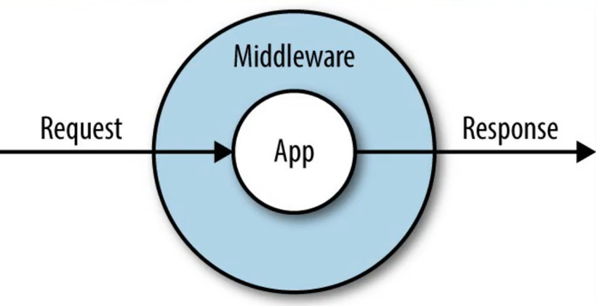
Data flows: views.py
1 - endpoint for arduino http://192.168.1.105:8080/store/

Add the @csrf_exempt decorator to allow Arduino posting to server
[django.middleware.csrf.CsrfViewMiddleware]

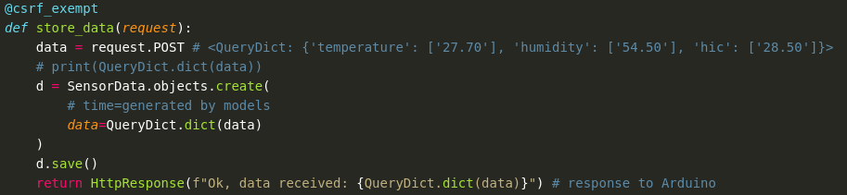

2 - endpoint for browser http://192.168.1.105:8080/plot/

Define a view to retrieve data from db and compose a dictionary with the whole set of information to create the plot with the Highcharts.chart() function

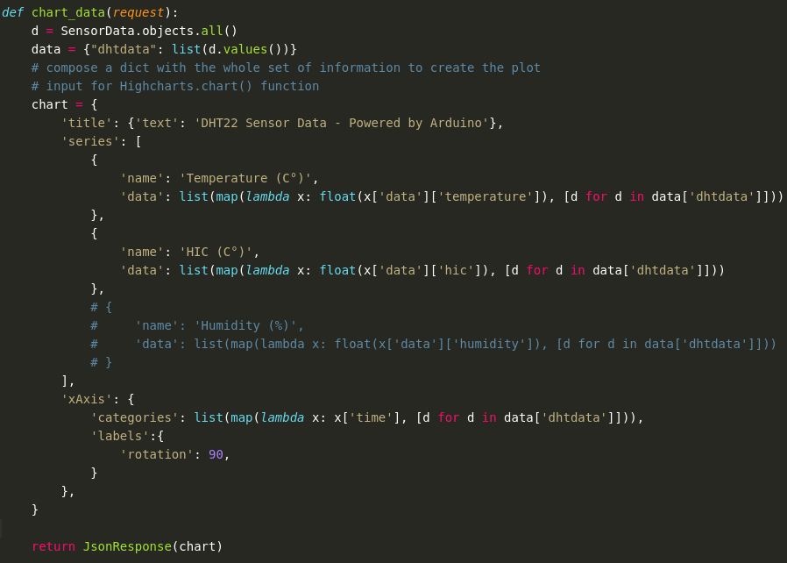

3 - endpoint for browser http://192.168.1.105:8080/view/

The frontend logic of the plot is based on the Javascritp functions:
- Highcharts.chart() to render the information in the dictionary
- setTimeout() to trigger the plot update with new data

