**PCF Exercise 1 – AutoComplete Option Set PCF Control**

Table of Contents

1. **Overview ………………………………………………………………………………………**
2. **Initialization of Project and Setup on VS Code …………………………………..**
3. **Installation Of All Required Package(Fluent Ui)…………………………………..**
4. **Update manifest File and Index.ts…………………………………………………….**
5. **Creation of React Component and make necessary changes……………….**
6. **Deployment Of PCF Solution Control……………………………………………….**
7. **Mandatory and Non Mandatory Scenario for Option Set ……………………..**
8. **Github Link ………………………………………………………………………………….**

1. **Overview**

This Document Contains steps for creation PCF Control of AutoComplete Option Set and deployment Process .

1. **Initialization of Project and Setup on VS Code**

**. Created PCF control by command - pac pcf init -ns Hsl.PCF -n Autocomplete -t field -npm.**

**.** this command willAutomatically Create a PCF Control and Index.ts file and manifest file**.**

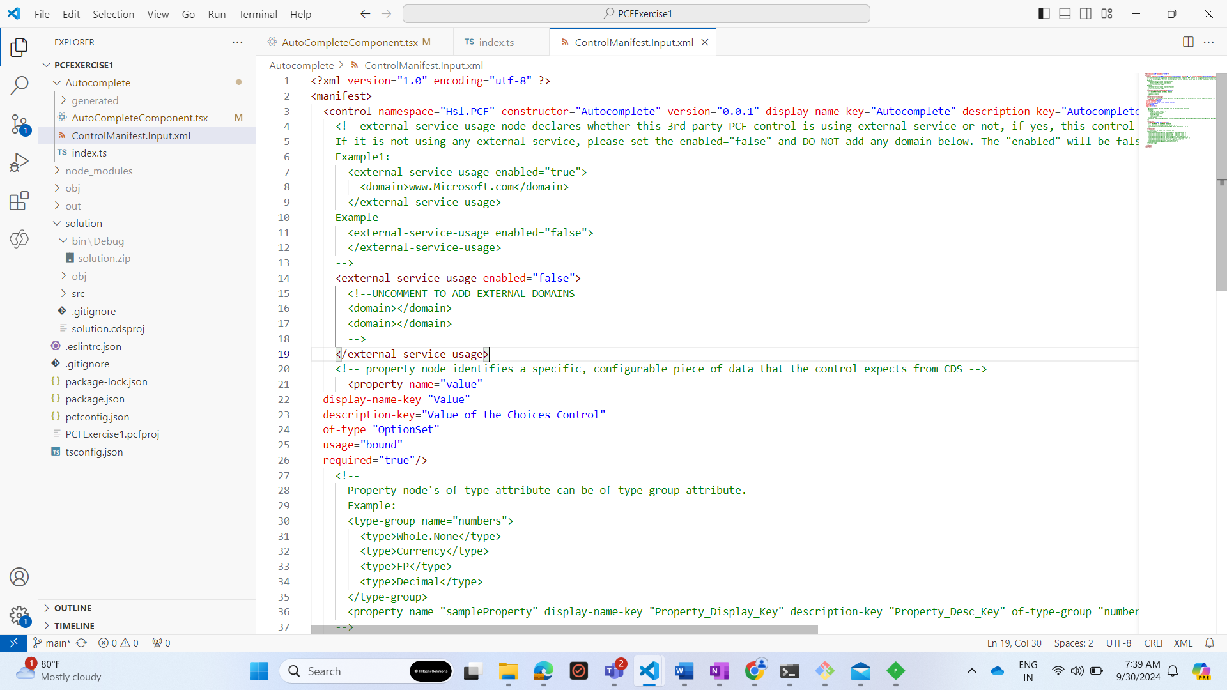

1. **Installation Of All Required Package(Fluent Ui)**

**. installed Fluent Ui in package by command - npm install react react-dom @fluentui/react .**

**.** This command will install fluent ui of react

1. **Update manifest File and Index.ts**

**.** created a new property of type option Set and name is value –

**.** and updated index file corresposnding

1. **Creation of React Component and make necessary changes**

**. created a React Functional component Name – AutoCompleteComponent.tsx**

**. implemented AutoCompleteComponent.tsx with FluentUi Combo box and logics for the same.**

**. then completed index.ts to add this component in index.ts and deploying -**

**For deploying command and steps are**

1. **Deployment Of PCF Solution Control**

**------------------------------------------------------------------------------------------------------------**

**1 – created a new folder solution and redirect in that folder and run command**

* **- pac solution init --publisher-name stu --publisher-prefix stu**
* **pac solution add-reference --path “C:\PCF\PCFExercise1”**
* **msbuild /t:build /restore for generating bundle file and zip file of that solution**
* **pac auth create --url <your organization url>**
* **pac pcf push --publisher-prefix stu**

1. **Mandatory and Non Mandatory Scenario for Option Set**

**For Mandatory Option set**

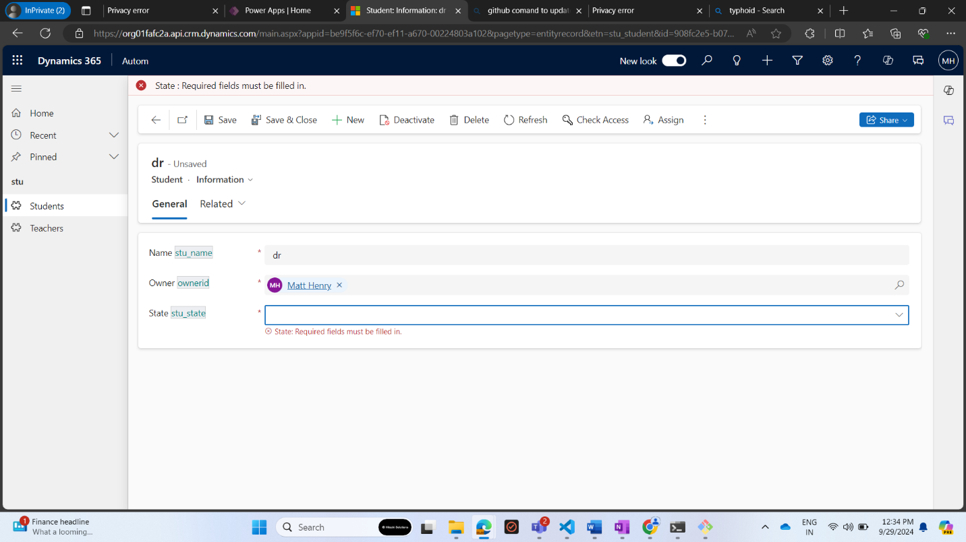

**For Non Mandatory Option Set**

**For Required Control**

--for Auto Complete Logics

**After pressing G only Gujrat and Goa is option and it is autocomplete also**

**We can find code -**

1. **Github Link**

All code for this control are deployed on github - -

GithubLink **-** [**rpandeyhitachisolutionscom/PCFAutoCompleteOptionSet (github.com)**](https://github.com/rpandeyhitachisolutionscom/PCFAutoCompleteOptionSet/tree/main)