Stimulants and Sedatives
Stimulant Mechanisms and Effects:
- Sympathetic Nervous System:
  - A1 (smooth muscle constriction), A2 (presynaptic), B1 (heart/kidney), B2 (smooth muscle dilation), B3 (adipose),
  - M1 (CNS/gastric), M2 (heart), M3 (smooth muscle, exocrine glands), M4/M5 (CNS).
- Peripheral Stimulants:
  - Example drugs: Phenylephrine (A1), Epinephrine (A1/2 B1/2), Norepinephrine (A1/2, B1) Ephedrine (Mixed A/B; crosses BBB) – primarily impacting cardiovascular functions through receptor activations.
- Psychostimulants:
  - Increase alertness, concentration, euphoria, energy, appetite suppression, motivation, sociability.
  - Associated with dopamine release and can paradoxically produce calming effects while improving cardiovascular function.
  - Possible adverse effects: Insomnia, hyperfocus, mood instability, malnutrition, addiction, anxiety, and cardiovascular risks like hypertension (HTN) and tachyarrhythmias.
Neurotransmitters:
- Adrenergic Receptors (Norepinephrine).
- Dopaminergic Receptors (Dopamine).
- Serotonin Receptors (Serotonin).
- Adenosine Receptors (Adenosine).
- Nicotinic Receptors (Acetylcholine).
- Trace Amines involved in stimulating effects.
NB: high degree of overlap of psychostimulant effects
Biochemistry of Monoamines:
- Synthesis Pathways:
  - Tryptophan is main component of serotonin
  - Tyrosine is main component of dopamine
  - Monoamine Oxidase (MAO) breaks down serotonin
  - Catechol-O-Methyltransferase (COMT) breaks down dopamine
- Transporters:
  - Monoamine reuptake transporters: NET (Norepinephrine transporter), DAT (Dopamine transporter), SERT (Serotonin transporter).
    - Inhibiting these leads to more monoamines in the terminal
  - Vesicular Monoamine Transporters (VMAT1/VMAT2) for transporting neurotransmitters into vesicles.
    - Inhibiting these leads to more monoamines in the cytoplasm where it is broken down less monoamines in the synaptic cleft
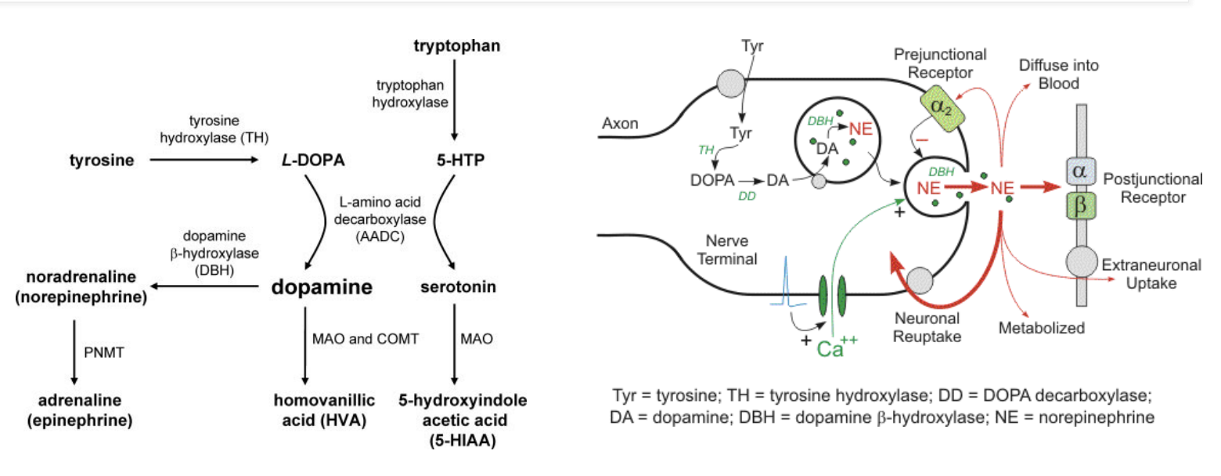

Serotonin
- Biosynthesis: Derived from tryptophan (AA) via decarboxylase
- Packaging: vesicular monoamine transporter (VMAT1 and VMAT2)
- Termination of action: reuptake at synapse by serotonin reuptake transporter (SERT)
- Metabolism (breakdown) by monoamine oxidase (MAO)
- Main modulatory receptor type: 5HT 1-7 isoforms, most are GPCRs except 5HT3 , which is a cation channel; ~13 known receptor isoforms including subtypes
- Functional buzzword: Happiness, libido, autonomic GI regulation

Norepinephrine
- Biosynthesis: Derived from phenylalanine/tyrosine via L-Dopa to Dopamine; methylation to epinephrine
- Packaging: Vesicular monoamine transporter (VMAT1 and VMAT2)
- Termination of action: reuptake at synapse by norepinephrine transporter (NET)
- Metabolism (breakdown) by monoamine oxidase (MAO) and Catechol-OMethyltransferase (COMT)
- Main modulatory receptor type: Alpha1, Alpha2, Beta1, Beta2 - GPCRs
- Functional buzzword: Arousal/Attention (in CNS)

Dopamine
- Biosynthesis: Derived from Phenylalanine/Tyrosine via L-Dopa
- Packaging: Vesicular monoamine transporter (VMAT1 and VMAT2)
- Termination of action: Reuptake at synapse by Dopamine Transporter (DAT)
- Metabolism (breakdown) by monoamine oxidase (MAO) and Catechol-O-Methyltransferase (COMT)
- Main modulatory receptor type: D1 family (Gs), D2 family (Gi) – GPCRs
- Functional buzzword: Reward, Movement
- Reward prediction error hypothesis of Addiction: Dopamine involved in “wanting” a thing
  - Getting bigger reward than expected, dopamine loves. Dopamine activity decreases if less than predicted reward occurs
  - involves reinforcement, learning and motivation, not euphoria/pleasure (and the implications for addiction)

Specific Drugs:
- Cocaine:
  - Blocks DAT, SERT, and NET. Nonselectively blocks reuptake of monoamines
    - At higher doses, it blocks Na and cardiac I_{kr} can throw into arrythmias
    - NB: Atomoxetine (in contrast) is NET selective
  - Primarily used as a local anesthetic due to vasoconstrictive properties, notable for high abuse potential.
  - Stimulant like coffee, but high addiction potential! (bcs of effect on dopaminergic system)
- Phenylethylamines:
  - Amphetamines:
    - 1) Release of monoamines from vesicular storage into the cytosol (thought perhaps via pH change?)
    - 2) Reverse monoamine reuptake transporters to increase release into the synaptic cleft
    - 3) At higher doses function as a MAO inhibitor
    - 4) Possibly as a direct agonist at some adrenoreceptors
    - 5) Some reuptake inhibition from the presynaptic cleft
    - NB: cocaine has predominantly intracellular effects, while amphetamines seem to do “everything”
    - Summary: net effect of amphetamines on monoamines in the synaptic cleft is a substantial increase in the levels of dopamine and norepinephrine, with moderate increases in serotonin, leading to pronounced stimulatory effects on the central nervous system.
    - Comes in multiple forms like mixed amphetamine salts (Adderall), Lisdexamfetamine (Vyvanse), Methamphetamine, MDMA (Ecstasy), Methylphenidate (Ritalin).
- Phenylethylamines
  - Our understanding is still evolving
  - Trace amines (p-tyramine, octopamine, betaphenylethylamine) exist in very small amounts in mammalian brains.
  - GPCR – trace-amine associated receptor 1 (TAAR1) – discovered 2001
  - Implicated in the function of amphetamines in ADHD; intracellular receptors whose secondary messenger systems affect trafficking of dopamine receptors
  - Ephedrine: Mixed Alpha/Beta Effects, used as a vasopressor mostly in perioperative settings; often contrasted to phenylephrine
    - Similar effects as norepinephrine, but we don’t give NE as bolus
  - Pseudoephedrine: Used as a decongestant, highly regulated. Works by vasoconstriction
- Other Stimulants:
  - Modafinil/Armodafinil: Used for narcolepsy, mechanism likely involves dopamine and norepinephrine reuptake inhibition. Less abuse potential
  - Phentermine: Used for weight loss, once combined with fenfluramine (Fen-Phen). Off-market bcs fenfluramine has serotonergic effects on heart valves causing valve fibrosis
- Usefulness of Stimulants
  - Increased wakefulness and alertness -> can be used to treat excessive daytime sleepiness (ie due to narcolepsy or sleep apnea)
  - increased frontal lobe activity -> can be used to treated ADD/ADHD (disorder of executive functioning deficits, primarily frontal lobe hypoactivity related).
  - increased mood -> can be used to augment/supplement treatment of depression
  - decreased appetite -> can be used as part of treatment for obesity/weight loss/binge eating disorders
  - various cardiovascular and pulmonary effects: increased heart rate, blood pressure, vasoconstriction, etc.
Nicotinic and Methylxanthines:
- Nicotinic Receptors:
  - Acetylcholine receptors are called cholinergic receptors and come in two varieties based on whether they selectively bind nicotine or muscarine.
  - Nicotine impacts the CNS, producing euphoria, arousal, and relaxation, increases attention, reaction time, suppresses appetite, while mildly increasing HR/BP peripherally.
  - Intermediary of sympathetic and parasympathetic NS
  - At the Neuromuscular junction skeletal muscle contraction
    - At low doses, nicotine doesn’t affect skeletal muscles bcs it is more selective for nAChR in the CNS
    - In overdose, can see skeletal muscle contraction paralysis, respiratory paralysis
  - CNS – attention, memory
  - Dopamine (addictive!)/ GABA/ serotonin/ NE release: Stimulants!
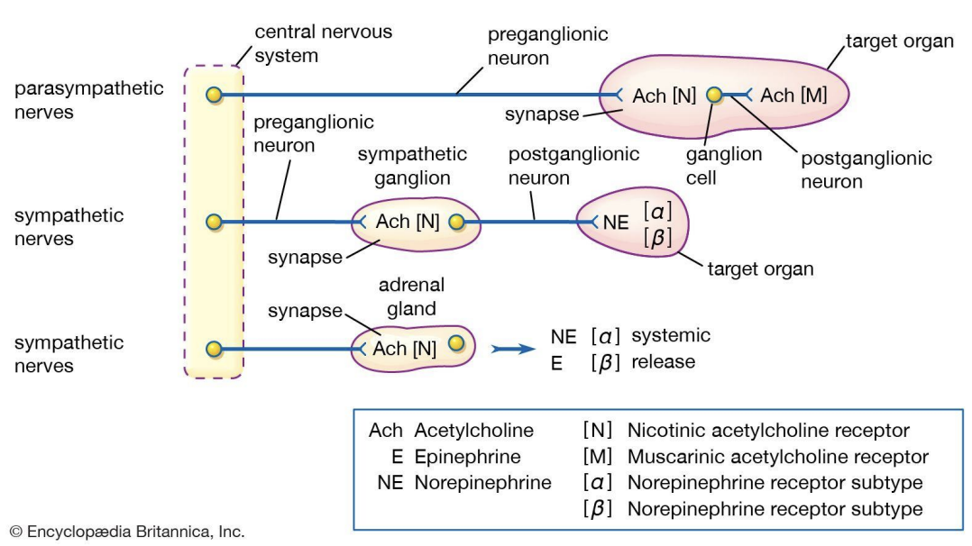
- Methylxanthines:
Adenosine Receptors
  - A1 and A2a: decreased myocardial oxygen demand/ slow cardiac conduction and Sleep/Circadian rhythm
  - A2b and A3: Bronchospasm and inflammation

  - Caffeine: Adenosine receptor antagonist (= increased HR), promotes alertness by inhibiting inhibitory adenosine effects.
  - Theophylline: Traditional pulmonary medication,
    - adenosine receptor antagonism (= bronchodilation and increased cardiac conduction), and phosphodiesterase inhibition. (increased cAMP bronchodilation, anti-inflammatory, increased diaphragm contractility, CNS stimulation, vasodilation, cardiac function)
  - Theobromine: chocolate
- Other stimulants as drugs of abuse:
  - Khat – contains cathinone
  - Mephedrone (synthetic cathinone marketed as bathsalts to avoid FDA oversight)
  - Fenethylline (captagon) – codrug of amphetamine and theophylline
  - NB: main driver of addiction is dopamine!
  - Tyramine (sympathomimetic) containing foods can cause HTN/adrenergic crises in pts taking MAOi’s (Parkinson’s disease) e.g. aged cheese, wine, pepperoni, cured meats
    - Normally broken down by MAOs
Sedatives and Hypnotics:
- Definitions:
  - Sedative: reduces anxiety.
  - Hypnotic: induces sleep.
- GABAa Agonists:
  - Benzodiazepines: Enhance GABA effects, used for anxiolysis, sedation, seizure control, muscle relaxation (e.g., Xanax, Valium, Ativan).
    - Increase frequency of channel opening (Cl- passes through channel) in response to GABA – positive allosteric modulators of GABA effect
  - NB: different isoforms of GABA-A receptors. Different drugs have different effects on the different isoforms
  - Moderate onset Benzos: Chlordiazepoxide, clonazepam, tamazepam
  - Fast onset: diazepam (valium)
  - Fast: alprazolam, lorazepam, midazolam
  - BZDs show: dependence, tolerance, addiction/abuse potential, withdrawal
  - Adverse effects: delirium, anterograde amnesia (impair ability to turn short term to long term memory), respiratory depression, motor incoordination, cognitive impairment
  - Z-Drugs: Bind specifically to GABAa receptors with alphal subunit (e.g., Zolpidem, zaleplon, Eszopiclone).
    - Sleep physiology and insomnia:
      - Pineal Gland: Releases melatonin in response to darkness.
      - Melatonin: Binds to MT1/MT2 receptors.
      - Suprachiasmatic Nucleus (SCN): Melatonin inhibits the SCN.
      - Inhibition of SCN: Allows activation of the ventral lateral preoptic nucleus (VLPO).
      - VLPO Activation: GABA-ergic; Promotes sleep by suppressing arousal centers.
      - Melatonin released in response to darkness suppresses the suprachiasmatic nucleus, activating the VLPO, which promotes sleep by releasing GABA.
        - Melatonin ↓SCN ↑VLPO ↑GABA ↑Sleep!
      - Arousal centers release orexin and histamine, inhibiting the VLPO, contributing to wakefulness.
        - Arousal ↑orexin and histamine ↓VLPO ↓GABA ↓Sleep!
      - Insomnia can be due to low melatonin/GABA or high orexin/histamine levels.
    - Insomnia is due to low melatonin, low GABA, high orexin, high histamine
    - NB: GABAa receptors: alpha 1 subunit – sleep, alpha 2 subunit – anxiety
      - Of the BDZs – Temazepam and Flurazepam are most selective for alpha 1
    - Z drugs show tolerance, but less withdrawal, less dependence/abuse potential.
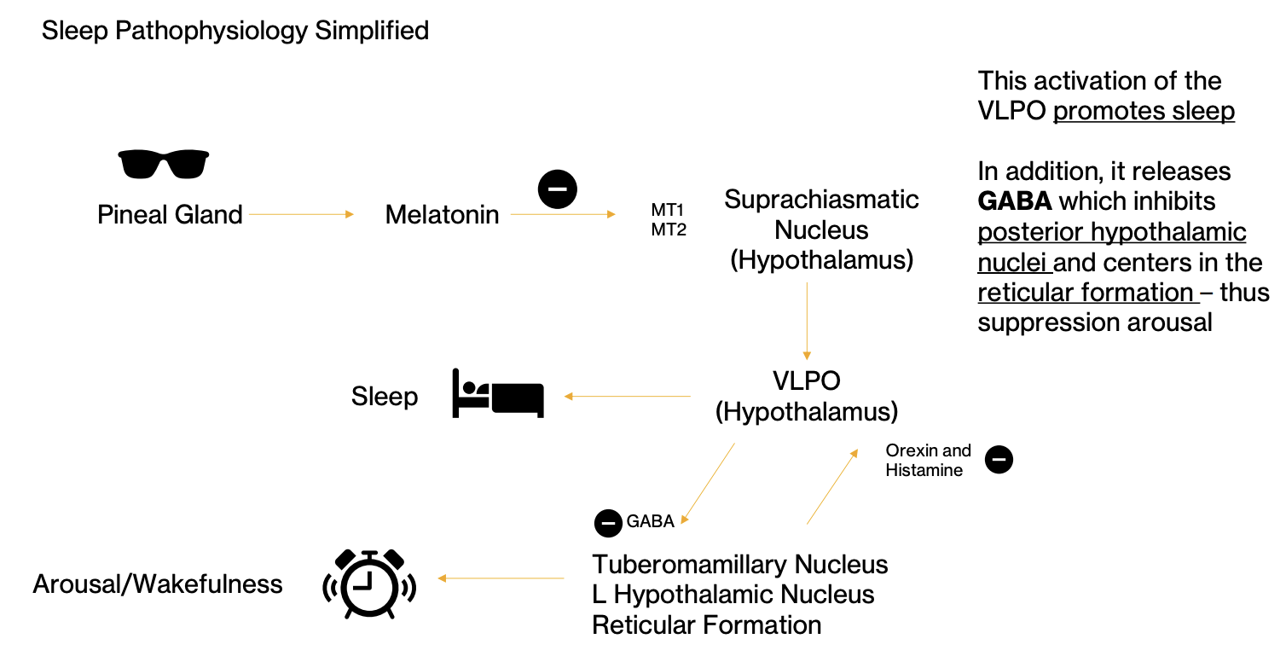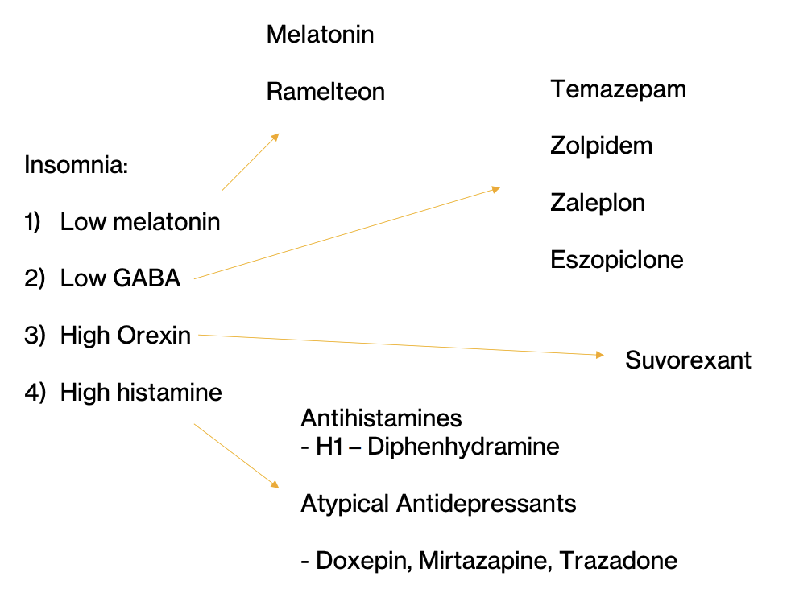

Feature | BDZs | GABA
Binding Site | Allosteric site (a-γ interface) | Orthosteric site (a-ß interface)
Effect on Receptor | Enhances GABA action | Directly activates receptor
Chloride Channel Action | Increases frequency of opening | Opens channel directly
Dependence on GABA | Requires GABA to exert effects | Acts independently
Clinical | Anxiolytic, sedative, muscle relaxant | Primary CNS inhibitory neurotransmitter
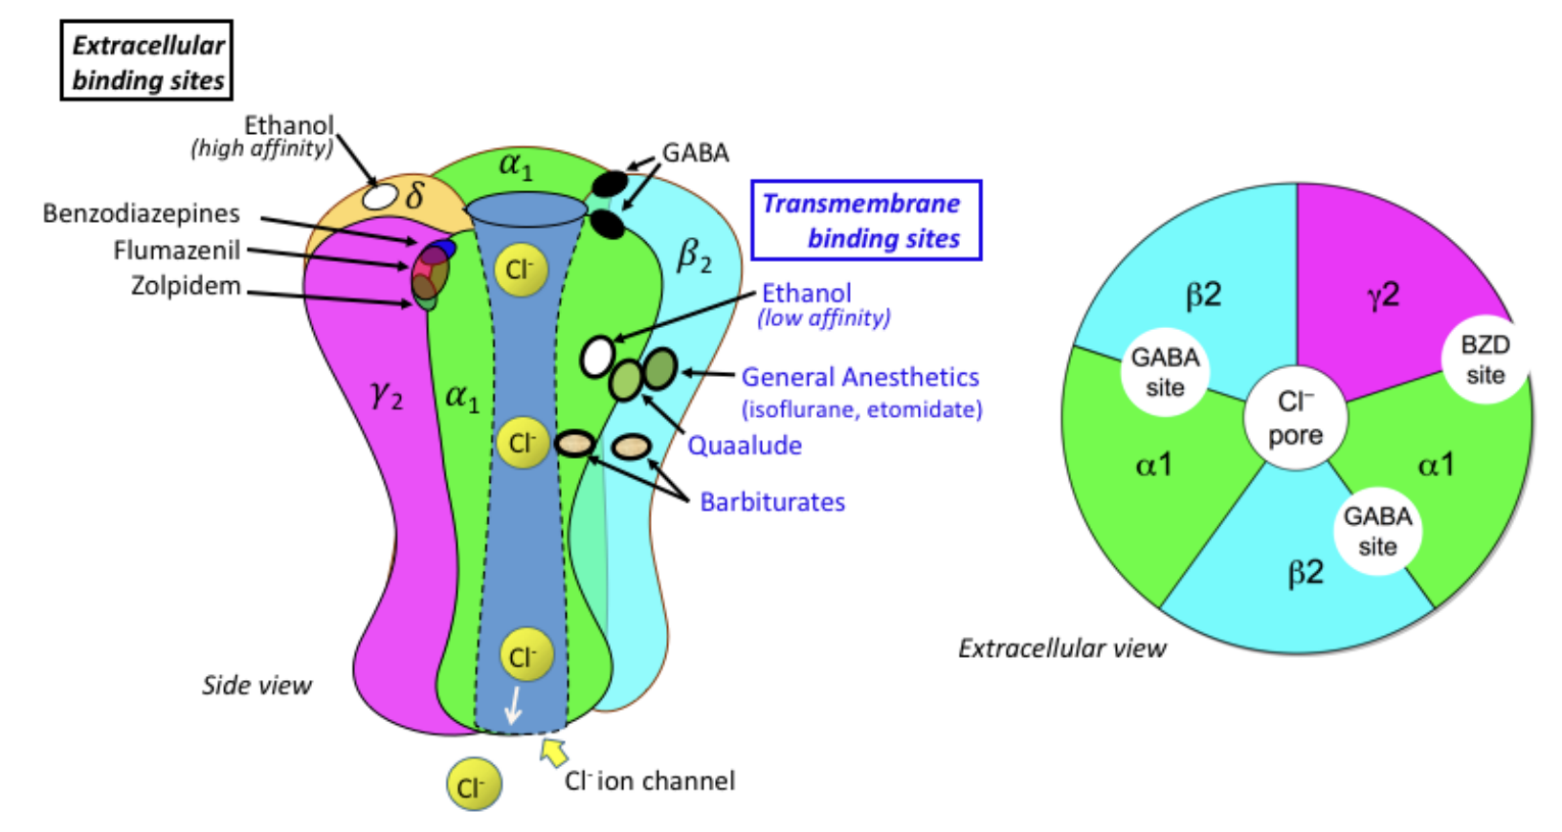
From shortest to longest half life | Speed of onset | Active metabolites?
Triazolam | Moderate | No
Oxazepam | Slow | No
Alprazolam (Xanax) | Fast | Yes
Temazepam (Restoril) | Moderate | No
Lorazepam (Ativan) | Fast | No
Chlordiazepoxide | Moderate | Yes
Clonazepam (Klonopin) | Moderate | Yes
Diazepam (Valium) | Very Fast | Yes
Flurazepam | Moderate | Yes
Midazolam | Very Fast | Yes

- Flumazenil – GABAa receptor antagonist that binds to site described for benzos.
  - Can precipitate seizures in pts with hx of epilepsy of in mixed overdoses
  - Can be used to reverse benzos and zolpidem (Z meds)

- Alpha-2 Agonists:
  - Sympatholytic
  - Used for augmentation in ADHD, sedation, BP control (e.g., Clonidine for BP, Guanfacine for ADHD – augment stimulants, Tizanidine for muscle relaxation).
Newer Agents and Their Targets:
- Orexin Receptor Antagonists: Target orexin-producing neurons to promote sleep (e.g., Suvorexant, Lemborexant).
- Melatonin Receptor Agonists: Target melatonin pathways to regulate sleep cycles (e.g., Ramelteon for difficulty with sleep onset, Tasimeltean often in blind indiviuals).

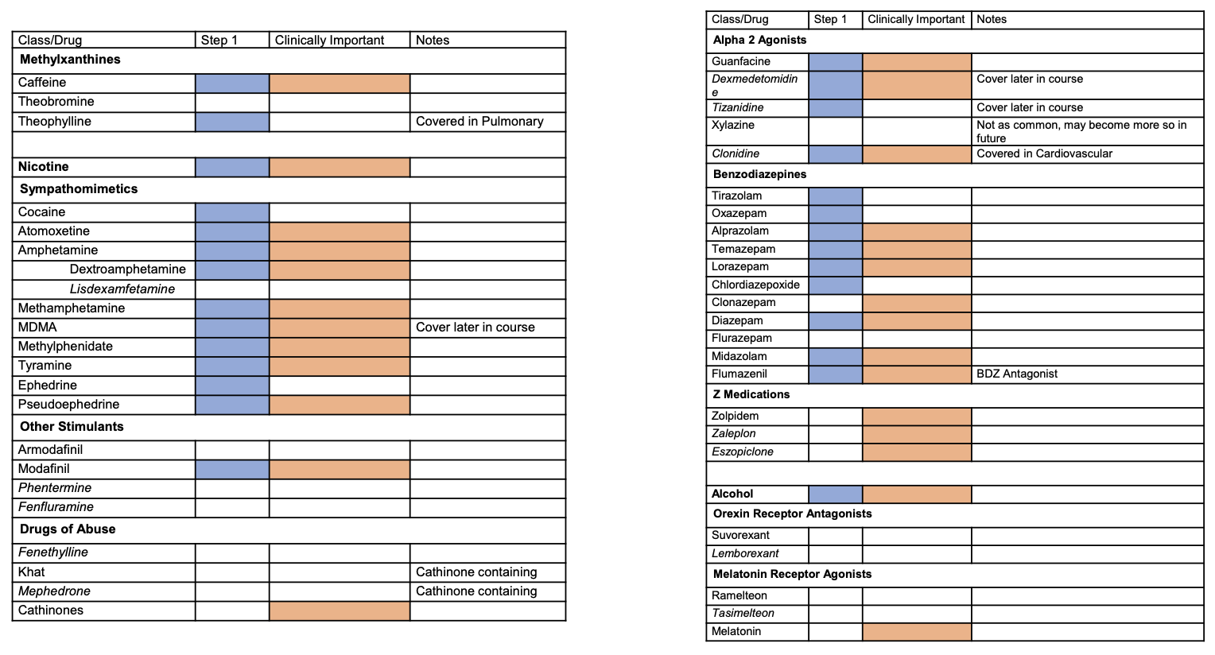

FDA Drug Discovery and Approval
Path to Drug Approval
- Preclinical Phase: Identification and screening of new drugs, animal testing for toxicity, reproductive effects, and carcinogenic/ mutagenic potential.
- Clinical Trials (Phases 1-4):
  - Phase 1: Small group testing in healthy volunteers to determine dosage and safety. Studies involve pharmacokinetics and pharmacodynamics.
    - Types include Single Ascending Dose, Multiple Ascending Dose, Bioavailability/Bioequivalence/Mass Balance, Food Effect, Drug Interaction, Organ Impairment, and QTc Effects.
  - Phase 2: 100s and patients. Does it work and what dose. Typically double-blind, placebo-controlled. Go/No-Go stage for development. E.g. dose-ranging studies
  - Phase 3: 1000s of patients. Is it safe and effective. Assesses clinical endpoints i.e. is there a decrease in number of strokes because the BP is lower? Offlabel use of drug means that no one has submitted phase 3 data e.g. if the drug has now lost patent, doesn’t make financial sense to run expensive large and long RCT required for phase 3
    - After phase 3 can submit New Drug Application (NDA) allowing marketing and sale of the drug
  - Phase 4: Post-marketing surveillance for long-term effects and new indications for additional patient populations (insurance may not cover off-label use). Studies may be done to demonstrate value to payors (e.g. CMS)
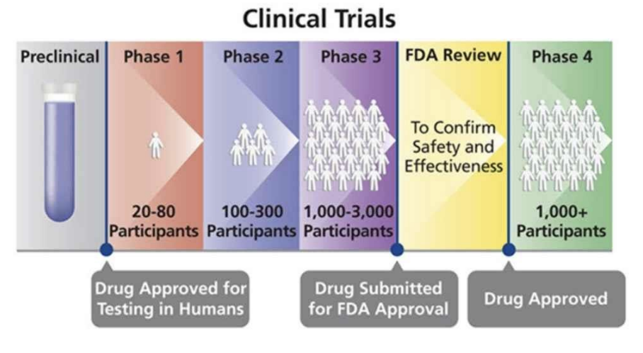
Drug Identification
- Screening compounds for biologic activity
- Chemical modification of a known active molecule
- Identification of a new drug target
- Rational design of a new molecule

IND Application (investigational new drug)
- Information on the composition and source of drug
- Chemical and manufacturing information
- All data from animal studies
- Proposed plan for clinical trials
- Individuals/physicians who will conduct clinical trials
- Any preclinical data in humans that may be available

In addition to FDA approval, need IRB approval to ensure scientific and ethical plans for testing in humans

Regulatory Milestones
- Drug Importation Act of 1848: Response to poor quality of drugs available during the Mexican-American War.
- Pure Food and Drug Act and Meat Inspection Act of 1906: Driven by muckraking journalism and Upton Sinclair’s "The Jungle," mandating accurate labeling and sanitary conditions.
- Federal Food, Drug, and Cosmetic Act of 1938: Came after the Elixir Sulfanilamide tragedy, requiring drug testing for safety (by the FDA)
  - Additive diethylene glycol caused metabolic acidosis, but this wasn’t tested. Drug and its components are important to test.
- Kefauver-Harris Amendment 1962: Mandated proof of drug efficacy and safety before FDA approval after the thalidomide tragedy. Dr Frances Kelsey denied thalidomide in US
- Chevron principle overturned in 2024: final interpretation of congress demands e.g. on safety and efficacy of drug used to be down to the regulatory agency (e.g. FDA determines how to interpret “drugs should be safe and efficacious”). Now final interpretation is down to the courts
Drug Development Challenges
- Eroom's Law: Highlights an 80-fold decrease in R&D efficiency since 1950. Causes include higher regulatory demands, necessity for large investments to be first to market, and lower risk tolerance among regulators and companies.
- Financial Impacts: High costs of drug development, lengthy approval processes.
Special Designations
- First-in-Class: Drugs with new mechanisms.
  - Orphan Drug: For rare diseases.
  - Accelerated Approval: Early approval based on predictive markers with additional post-approval testing.
  - Expanded Access: Allows use of investigational drugs for serious illnesses outside clinical trials.
  - Fast-Track: For treating unmet medical needs.
  - Emergency Use Authorization: Allows unapproved products in emergencies such as chemical biological radiological or nuclear threat). Used for COVID
  - Breakthrough Therapy: Drugs showing substantial improvement over existing therapies.

Part 2
Supplements Regulation:
- 1994 - Dietary Supplement Health and Education Act:
  - Supplements are classified as food, not drugs.
  - No pre-market approval; instead, they are monitored post-marketing.
  - Supplements cannot claim to treat, cure, or prevent diseases. E.g. can promote heart heart, can support joint health
Generics and Patents:
- 1984 - Hatch-Waxman Act:
  - Introduced Abbreviated New Drug Application.
  - Resulted in numerous generics entering the market.
  - Included a compromise for longer patent protections and exclusivity for new drugs.
  - Pharmaceutical companies may extend patents through various strategies and also use trade secrets.
- A generic drug is a copy of a brand-name drug that has the same active ingredients and works in the same way. Generally cheaper
- Once brand-name drug's patent expires, other manufacturers can produce & sell generic version.
- Drug companies must prove to the FDA that the generic is bioequivalent to the brand-name drug.
- The FDA approves generic drugs based on safety, strength, purity, and stability.
Drug Spending Trends:
- Increase in Retail Prescription Drug Spending:
  - Real per capita spending has increased over sevenfold since 1980, highlighting a significant economic impact.
Drug Pricing and Shortages:
- January 5, 2024 - Analysis by Caitlin Owens:
  - Low or high prices contribute to America's drug shortage issues, as noted by Janet Woodcock, FDA principal deputy commissioner.
  - If too cheap, supply chain can be compromised so can lose access. Companies go out of business if they attempt to manufacture
- FDA's Current Good Manufacturing Practice (cGMP) Regulations:
  - Enforced regulations covering key areas like materials, products, premises, people, procedures, and processes.
    - Focus on processes as opposed to the products i.e. too difficult to test 10 million pills but can ensure the process is great
  - Emphasis that testing alone is insufficient for quality assurance.
  - Noteworthy points:
    - 90% of U.S. medications are generics.
    - 40% of generics are produced in India.
    - 80% of active ingredients are made overseas.
    - How do you enforce manufacturing practices abroad.
  - In some conditions generics =/= brand name. There is tolerance in manufacturing processes. Some conditions require very carefully tuned content e.g. thyroid
Drug Recalls and Contaminations:
- FDA Recalls:
  - Noted a significant recall of 233,000 bottles of antidepressants due to potential cancerous chemicals.
- Impurities in Drugs:
  - Historical issues with impurities highlight failures in FDA quality control, significant in blood pressure medications.
Drug Shortages Statistics for 2023:
- Shortages and Solutions:
  - 224 shortages prevented, 33 new shortages, 94 ongoing shortages from previous years.
- Manufacturing Locations for Drugs in Shortages:
  - Major contributors include Italy (8%), Germany (8%), India (5%), among others.
Drug Development Trends and Challenges:
- Eroom’s Law (Moore’s Law Backwards):
  - Describes an 80-fold decrease in R&D efficiency since 1950 (logarithmic reduction in new drugs/spending)
  - Key reasons include:
    - Increasing regulatory evidence for approval and reimbursement.
    - Lower risk tolerance among regulators and companies.
    - Financial investment needed for first-to-market advantage.
  - Evidence of potential improvement in drug development since 2012.
Case Study: The Development of Atorvastatin:
- Historical Milestones:
  - 1850s: Lipid Hypothesis.
  - 1948: Framingham Heart Study began.
  - 1970s: First statin isolated by Dr. Akira Endo in Japan (Japan didn’t have a good enough infrastructure to produce)
  - 1985: Atorvastatin synthesized (by small company)
  - 1986: Patent approved (Merck had worse statin)
  - 1994: Merck study showed statin benefits.
  - 1996: Atorvastatin brought to market through a partnership with Pfizer.
    - Small company had to partner with Pfizer to bring to market bcs Merck was overpowering them
  - 2000: Pfizer acquired Warner-Lambert.
  - 2011: Patent expired after generating $125 billion in sales.
Drug-Resistant Gonorrhea and New Antibiotics:
- Zoliflodacin Development:
  - Effective against drug-resistant gonorrhea.
  - Developed by a non-profit foundation due to lack of commercial interest from pharmaceutical companies.
    - They actually did the phase III trials didn’t develop it per se
  - This is bcs Abx are not commercially attractive to pharma firms
Drug Approval Process:
- Phases of Drug Development:
  - Preclinical: Basic research and discovery.
  - Clinical Trials: Phases I (small groups), II (hundreds), III (thousands).
  - FDA Review and Post-Approval Monitoring: Ensuring continued safety and efficacy.
  - Significant timelines and costs to bring drugs to market:
    - Average length: 10-15 years.
    - Costs have escalated significantly, sometimes exceeding $2.17 billion.
    - AI can help remove some of the costs
Remdesivir Case Study:
- Development Timeline:
  - Early Origin:
    - Initially developed for Hepatitis C and RSV in 2009.
    - 2015: Investigated for Ebola but not effective.
    - Late 2019: Reactivated for pneumonia in Wuhan, China.
  - Rapid Deployment Against COVID-19:
    - Quickly adapted to target SARS-CoV-2.
    - January 2020: FDA approved for emergency use.
- Manufacturing and Economic Impact:
  - Process reduced from 12 to 6 months.
  - Gilead’s revenue from remdesivir in 2021 reached 4.5 billion dollars, sparking debates about pricing and responsibility.

Medications for Mood Disorders
See folder '/Users/fikunwa/Library/CloudStorage/Box-Box/CMR_Group/Users/Fikunwa Kolawole/Classes/2025 Winter/Pharm/01142025_MedsForMoodDisorders' for handouts

Notes from Class
- All antidepressants treat major depression.
- Used for anxiety as well
- Monoamine systems: 5HT, NE, DA (Histamine also). Vast majority of antidepressants work on these systems
- Most antidepressants (used for unipolar depression
  - Similar effectiveness
  - About same speed of onset: 2-3 weeks after taking med
  - Not addictive (in tolerance model i.e. downregulation of receptor model)
    - Some antidepressants have discontinuation side effects but not the same neuro-addictive model
    - Discontinuation doesn’t make more likely to need antidepressant later. I.e. no rebound depression following discontinuation
  - So we generally differentiate/choose antidepressants based on side effects/toxicity, ease of use, cost, durability, and lack of interactions
- No antidepressant class that works on Glutamate (not Monoamine transmitter but amino transmitter). Currently 2 FDA approved that are NMDA antagonists (receptor for glutamate). May provoke neurotrophy
- Reuptake inhibitors amplify the signals between nerves (don’t provoke!) i.e. more NT in the terminal
- TCAs are SERT and NET inhibitors but they interact with undesirable ancillary systems
- Meds with short half life more likely to cause discontinuation effects. E.g. SSRIs
  - E.g. fluoxetine has long half life and has discontinuation effects
- SSRIs are generally very safe! Usually not lethal. And danger of serotonin syndrome is low unless combined with TCAs and MAO-is
- TCAs are generally unsafe
- NB: D/C = discontinuation syndrome
- Dopamine doesn’t help anxiety much
- NE is important for neuropathic pain and ADHD, so SNRIs and also TCAs can be used for neuropathic pain and ADHD
- 5HT2 is inhibitory i.e. reduce serotonin release increase anxiety
- 5HT1 is excitatory i.e. release more serotonin decrease anxiety
- Glutamate increasers via NMDA inhibition (NB: glutamate is primary excitatory NT in CNS)
  - S-ketamine and dextromethorphan + bupoprion combination
  - These work faster onset. Between 1 week and 2 weeks
  - Generally safe, as long as they’re not abused. May have addictive effects
  - Good for depression but unclear if they’re helpful for anxiety disorders
  - Expensive: can get around by giving dextromethorphan and buprioprion separately. Both not as expensive
- How does inhibiting NMDA receptors (receptor for glutamate) increase extracellular glutamate levels
  - Decreased glutamate uptake by transporters.
  - Disruption of feedback inhibition mechanisms.
  - Compensatory release of glutamate to maintain homeostasis.
  - Influence on other neurotransmitter systems, like reduced GABAergic inhibition.
  - Increased neuronal activity, leading to more glutamate release.
Bipolar
- Mood stabilizers help some piece of bipolar more than others. So pts usually end up on cocktail of meds
- Phases of Bipolar are Mania, Bipolar Depression and Maintenance
  - Prodromal stage: This phase occurs before a manic or depressive episode and can include changes in mood, behavior, or functioning. Symptoms can include anxiety, depression, or disrupted sleep.
  - Acute stage: This is when a full mood episode occurs, such as mania, depression, or a mixed episode.
  - Maintenance stage: This is when the focus is on managing the disorder and maintaining stability through medication and therapy.
- Mania can be divided into:
  - pure/euphoric or
  - mixed/dysphoria/irritable (i.e. with depressive symptoms). People present with aggression, belligerence and anger
- Meds used for bipolar depression aren’t antidepressants! Antidepressants also have risk of flipping people from depression into mania (esp mixed mania)

Meds for Bipolar
- Lithium: best for pure euphoric mania
  - Reduces suicidal thinking
  - Can be used for augmentation of depression treatment i.e. treatment resistant
  - Not as useful for bipolar depression or maintenance (+/-)
  - Narrow therapeutic index mostly because of nephrotoxicity
  - Minor side effects (i.e. not lethal): tremor, GI side effects, nephrogenic DI, acne (sweat out and irritate the skin; shower side effects!)
  - Major side effects: cognitive side effects, anomia, hypothyroid, overdose, teratogen (ebstein anomaly)
  - Narrow therapeutic index
- Anticonvulsants e.g. Valproate
  - Mania is overexcitation problem, no leap to see that anticonvulsants (epileptics) can help as mood stabilizers
  - Best for mixed mania
  - Acts quick
  - No effect on depression
  - Wide therapeutic index
  - Minor AE: weight gain (long term), sedation
  - Major AE: hepatotoxicity, teratogenic (more than Li+; neural tube defects; anyone who can get pregnant shouldn’t be on it bcs risk is super high)
- Anticonvulsant e.g. Carbamezapine
  - Has 3 ring structure. May have some TCA effects
  - Great for mixed Mania, +/- for Bipolar depression, Not used for maintenance
  - Moderate Therapeutic index
- Lamotrigine
  - Great for maintenance, +/- for Bipolar depression
  - Wide therapeutic index but risk of stevens johnsons
    - Risk of rash is dependent on how quickly you dose it up. So takes 6-8 weeks to ramp it up. Partly why its not great for acute mania

Emerging
- Psychedelics
- Electroconvulsive therapy
- Transcranial magnetic therapy
  - These all promote neutrophy
- Talk therapy especially for mild depression

Summary on Meds for Bipolar/Mania

Medication | Mania  (Pure/Euphoric) | Mania  (Mixed/Dysphoric/Irritable) | Bipolar  Depression | Maintenance | Tx Index
Lithium | + | +/- | +/- | +/- | Narrow
Valproic Acid | +/- | + | X |  | Wide
Carbamazepine |  | + | +/- |  | Moderate
Lamotrigine |  |  | +/- | + | Wide

Clinical Trials and Pharmacological Principles and Practices
Clinical Trials and Population Demographics:
- Phase 1 Subjects:
  - Age usually 18-40, predominantly Caucasian, normal hepatic and renal function, lower BMI, excluding pregnancy.
- Phase 3 Patients:
  - Higher percentage of older individuals, diverse racial representation, and minor degrees of organ impairment, including higher obesity rates and excluding pregnancy.
Actionable Genetic Results:
- Genes provide guidance on drug selection, dosing, potential monitoring, and needed adjustments based on specific patient genetic profiles.
Black Box Warnings:
- Separated from regular text in the package insert, originated from Phase IV results.
- Examples:
  - Fluoroquinolones: Tendon rupture, peripheral neuropathy.
  - Antidepressants: Increased risk of suicidal thoughts.
  - NSAIDs: Increased risk of heart attack and stroke.
  - Valproic Acid: Hepatotoxicity and pancreatitis.
  - Carbamazepine: Potential to cause serious dermatological conditions; genetic testing for HLA-B*15:02 allele recommended.
    - Immune mediated, so lots of other symptoms outside of skin sloughing off
HLA-B*15:02 Genetic Variation:
- Strongly associated with Stevens Johnson’s and toxic epidermal necrolysis
- Implications differ among ethnicities with specific recommendations for screening in East and South Asians, Indigenous populations, and others.

Pregnancy and Teratogenic Drug Effects: Previous Teratogenicity Categories:
- A: No risk in humans.
- B: No evidence of risk in humans despite risk in animals.
- C: Risk cannot be ruled out (absence of adequate studies).
- D: Positive evidence of risk (potential benefits may outweigh the risks).
- X: Contraindicated in pregnancy (fetal risk clearly outweighs any possible benefit).
Current Labeling System (PLLR):
- Pregnancy Section: Detailed information including fetal risk, clinical considerations, and supporting studies.
- Lactation Section: Addresses drug presence in breast milk and effects on nursing infants.
- Females and Males of Reproductive Potential: Information on pregnancy testing, contraception, and infertility.
Known Teratogenic Drugs:
- W/TERATOgenic
  - Warfarin
  - Thalidomide
  - Epileptic drugs: phenytoin, valproate, carbamazepine
  - Retinoid
  - ACE inhibitors
  - Third element: lithium
  - OCP and other hormones

Drug Scheduling and Regulation:
Drug Scheduling:
- Determined by FDA and DEA, enforced by DEA. This incorporates factors of the potential for abuse, addiction, and medical utility.
- Schedules I-V:
  - Schedule I: No accepted medical use, high abuse potential (e.g., LSD, heroin, cannabis federally).
  - Schedule II: High potential for abuse; accepted medical uses (e.g., methadone, oxycodone, fentanyl).
  - Schedule III-IV: Moderate to lower potential for abuse (e.g., anabolic steroids, some stimulants and benzodiazepines respectively).
  - Schedule V: Lowest potential for abuse; medications like cough preparations with less than 200 mg of codeine per 100 ml.
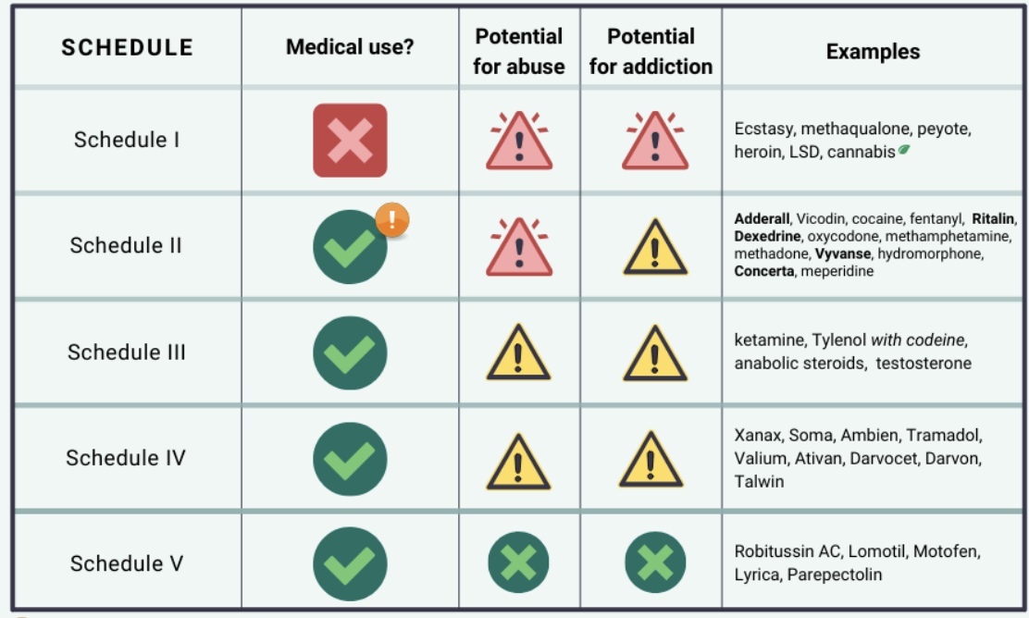
Human Abuse Liability Studies (HAL):
- Assess effects on mood, perception and behavior compared to known substances of abuse.
- Tested on volunteers who are recreational drug users. Wow !

Other notes
- Scope of practice is determined by the State
- The drug scheduling is determined by Federal and State. But Federal trumps state e.g. cannabis is California vs Federal

RISK EVALUATION AND MITIGATION STRATEGIES (REMS)
- Mandated drug safety programs by the FDA
  - Generally medications with serious side effects, such as high potential for abuse, severe side effects, or teratogenic side effects
  - Elements to Assure Safe Use (ETASU)
    - Special training or certification for prescribers/dispensers
    - Patient enrollment in a registry
    - Dispensing only in specific settings (e.g. hospitals)
    - Monitoring requirements, like regular follow-up or lab tests
  - Drug manufacturers are responsible for implementing and maintain their REMS programs

Risk Evaluation and Mitigation Strategies (REMS):
- Mandated by FDA for drugs with serious side effects and higher potential for abuse.
- ETASU Components:
  - Special training or certification of prescribers/dispensers.
  - Patient registry enrollment.
  - Dispensing only in certain settings.
  - Monitoring requirements (e.g., lab tests).

Special Populations and Pharmacokinetics/Pharmacodynamics (PK/PD):

Pregnancy and PK/PD Changes:
- Changes during pregnancy (e.g., trimester differences):
  - PK: Absorption, Distribution, Metabolism, and Elimination are key principles.
    - “What the body does to the drug”
  - Increased body fat and water causing altered drug distribution.
  - Lower protein levels leading to increased free fractions of drugs.
  - Increased liver enzyme activity in mid-to-late pregnancy affecting drug metabolism.
  - Enhanced glomerular filtration rate potentially leading to faster drug clearance.

Other notes
- NB: Milk to plasma ratio is often used as a surrogate to understand drug safety
  - For anesthesia drugs: Pump and dump was the previous recommendation but most of the drugs don’t get to the baby in meaningful concentrations
    - New recommendation is based on data. Few anesthesia drugs either have too little data to recommend or not. Most drugs you can return to normal breastfeeding after
- Ion trapping and differences in pH of blood. Fetal pH is lower than maternal pH
  - Fetal blood is more acidic (lower pH) than maternal blood.
  - Ion Trapping happens when drugs move from the mother to the fetus.
    - Drug Movement: Drugs pass from maternal to fetal blood.
    - pH Difference: Fetal blood is more acidic.
    - Ionization: Due to the lower pH, drugs can become ionized (charged) in the fetal blood.
    - Trapping: Once ionized, these drugs can't easily move back to the maternal blood and get "trapped" in the fetal blood.
  - Weak base drugs are more likely to get trapped in the fetal compartment because the fetal blood's lower pH causes these drugs to ionize and prevent them from diffusing back to the maternal blood.

Children (Clinical Pharmacology):
- Neonates are 80% water (water soluble drugs considerations); protein conc. lower for first year of life
  - This distribution changes over life
- Liver is maturing over life – hepatic metabolism is immature at birth
  - Dealkylation normal
  - Conjugation reduced for 1st month
  - Glucuronidation normalizes 3-6 months
  - Oxidation normalizes 6-12 months
  - Cytochrome activity normalizes over years
- GFR is reduced, and reaches adult levels at 3 months and then exceeds for a while
- The fact that children are dynamic makes drug studies hard (just like in pregnancy)
Aging/Geriatrics:
- Absorption (decreased gastric acid and decreased bowel surface area)
- distribution changes (increased body fat), ? decreased p-glycoprotein activity
  - P-glycoprotein (P-gp) is a protein in cell membranes that pumps harmful substances out of cells. It's also known as multidrug resistance protein 1 (MDR1).
  - Higher concentration of CNS active drugs! Partly explains why neurologic symptoms are more likely in elderly
- decreased hepatic metabolism,
- decreased renal clearance (GFR drops): drugs are eliminated slower
  - conflicts with the absorption decrease
- Recommendation: start at smaller dose for elderly and gradually increase dose based on tolerance
Organ Impairment:
- Liver Dysfunction (CYP450 metabolism) and Renal Dysfunction affect drug metabolism
  - Also consideration about whether the drug could damage the liver
- Child-Pugh Score to estimate hepatic function from grade A to grade C (decompensated liver disease).
Body Composition:
- Different weights
  - Ideal body weight,
  - total body weight and
  - lean body weight (used for dosing lipophilic drugs)
- Propofol Example: is lipophilic (loves brain)
  - For bolus: Dosing should be based on lean body mass. To give the dose required for brain
  - For infusion: long term dosing should be based on total body fat too (stored here and released slowly; so dose a bit slower)

Antipsychotics
See folder '/Users/fikunwa/Library/CloudStorage/Box-Box/CMR_Group/Users/Fikunwa Kolawole/Classes/2025 Winter/Pharm/01212025_Antipsychotics' for handouts

Effects of Blocking Dopamine (D2 receptor) in different brain tracts
- Tuberoinfundibular Tract (hypothalamus to pituitary)
  - Hyperprolactinemia: dopamine is prolactin inhibitory factor
- Nigrostriatal (substantia nigra to striatum – caudate, putamen, and ventral striatum of basal ganglia)
  - Parkinsonism (blocked dopamine effect in this tract is similar to loss of dopamine in Parkinson’s)
  - Acute extrapyramidal side effects (EPS):
    - acute dystonia (muscle cramps; usually in head and neck area)
      - oculogyric crises: painful eyes rolling back
      - tongue stuck out
      - neck stuck sideways
      - can happen hours after
    - akathisia – “cant sit/stand still”
      - few days after
    - parkinsonism triad
      - motor rigidity (cogwheel rigidity with passive movement; ratcheting when you move hand),
      - tremor (resting tremor that is slower than action/tension tremor; pill rolling repetitive rhythmic tremor)
      - bradykinesia – slow movement and speech. Can extend to facial muscles. Important to distinguish from schizophrenia which presents with facial flatness (emotional flatness)
      - days - weeks
  - Tardive dyskinesia: “tardive = late”
    - chronic movement disorder that causes involuntary, repetitive body movements
    - writhing snakelike movement
    - Random and asynchronous movement
    - Risk is cumulative over time with D2 antagonism
    - It may not go away even with med cessation
  - Neuroleptic malignant syndrome
    - Rhabdo: Think of it as so stiff that muscle starts to break down!
    - Hyperthermia from contracting muscles all the time
    - Low risk and rare
    - Risk associated with strong D2 antagonists used at high doses for long time
More notes
    - Pyramids are the major motor tracts i.e. the ones that tell the muscle to flex or extend)
    - Extrapyramidal affects regulation of the pyramids
- Mesolimbic/Mesocortical system
  - Goal is to affect the Mesolimbic system to remove the positive symptoms of schizophrenia. May make the negative symptoms worse
  - Mesocortical: bad for executive functioning and cognition

Dopamine Tract | Origin | Termination | Function
Nigrostriatal Pathway | Substantia nigra pars compacta (SNc) | Striatum (caudate nucleus and putamen) | Motor control and coordination. Degeneration causes Parkinson’s disease.
Mesolimbic Pathway | Ventral tegmental area (VTA) | Nucleus accumbens, amygdala, hippocampus | Reward, pleasure, motivation. Implicated in addiction and schizophrenia.
Mesocortical Pathway | Ventral tegmental area (VTA) | Prefrontal cortex (PFC) | Executive functions (decision-making, working memory, attention). Implicated in schizophrenia and depression.
Tuberoinfundibular Pathway | Arcuate nucleus of the hypothalamus | Anterior pituitary | Inhibits prolactin release. Dysregulation causes hyperprolactinemia.

Generations
- Potency: how much drug (mg) required to get same level of D2 blockade
- Generations: which ones came first
- The balance between acetylcholine and dopamine is kinda what causes parkinsons signs. You can either drop Ach to meet dopamine or raise dopamine to meet Ach to reduce movement disorders. Don’t want to increase dopamine in psychotics
- SDA (serotonin-dopamine antagonists): these are the atypical (2nd gen) antipsychotics. Have lower risk of extrapyramidal side effects compared to first gen. Unsure why. 5HT2 antagonism might play a role. Might also be because the meds are newer so dose finding studies were better
- DPRAs (dopamine receptor partial agonists): also a subcategory of atypical (2nd gen) antipsychotics – still have net effect of decreasing dopamine
  - Inhibit dopamine but agonize the receptor less strongly than dopamine would have done previously
    - May increase dopamine activity if dopamine activity is low
  - Theoretically better for extrapyramidial side effects than SDA but its about the same
- The second gen are good for mood regulation (better than first gen)! Bcs of Serotonin 5HT2 blockade
- KarXT – almost zero risk of extrapyramidal sides
  - M4 agonism leads to the antipsychotic effect
  - Add the non specific antimuscarinic (anticholinergic) to remove the muscarinic effects peripherally (urination, pooping = DUMBELLS). But it doesn’t cross the BBB so doesn’t block the CNS M4 agonism!
- Clozapine
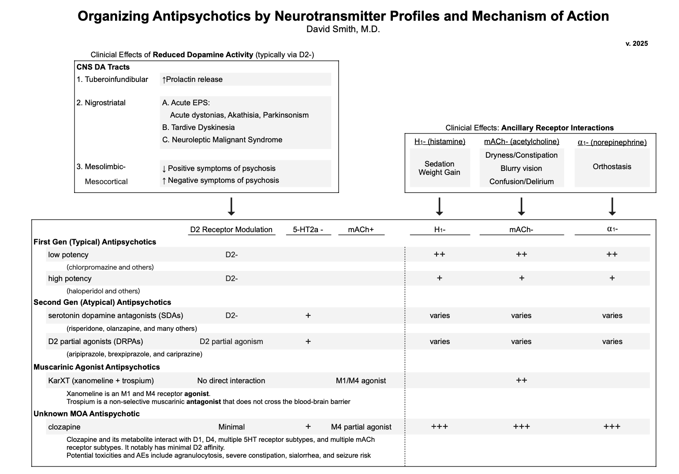

Feature | SDA (Serotonin-Dopamine Antagonists) | DRPA (Dopamine Receptor Partial Agonists)
Mechanism | Blocks 5-HT2A and D2 receptors | Partial agonism at D2 receptors, blocks 5-HT2A
Examples | Risperidone, Olanzapine, Quetiapine | Aripiprazole, Brexpiprazole, Cariprazine
Positive Symptoms | Effective | Effective
Negative Symptoms | Effective | Effective
Cognitive Symptoms | Moderate effect | Better effect
Metabolic Side Effects | High risk (weight gain, diabetes) | Lower risk
EPS Risk | Low to moderate | Very low

Dopamine Pathway | Activity in Schizophrenia | Symptoms
Mesolimbic | Hyperactive | Positive symptoms (hallucinations, delusions, disorganized thought).
Mesocortical | Hypoactive | Negative symptoms (avolition – lack of motivation, anhedonia, flat affect) and cognitive deficits.

