Stimulants and Sedatives
Stimulant Mechanisms and Effects:
- Sympathetic Nervous System:
  - A1 (smooth muscle constriction), A2 (presynaptic), B1 (heart/kidney), B2 (smooth muscle dilation), B3 (adipose),
  - M1 (CNS/gastric), M2 (heart), M3 (smooth muscle, exocrine glands), M4/M5 (CNS).
- Peripheral Stimulants:
  - Example drugs: Phenylephrine (A1), Epinephrine (A1/2 B1/2), Norepinephrine (A1/2, B1) Ephedrine (Mixed A/B; crosses BBB) – primarily impacting cardiovascular functions through receptor activations.
- Psychostimulants:
  - Increase alertness, concentration, euphoria, energy, appetite suppression, motivation, sociability.
  - Associated with dopamine release and can paradoxically produce calming effects while improving cardiovascular function.
  - Possible adverse effects: Insomnia, hyperfocus, mood instability, malnutrition, addiction, anxiety, and cardiovascular risks like hypertension (HTN) and tachyarrhythmias.
Neurotransmitters:
- Adrenergic Receptors (Norepinephrine).
- Dopaminergic Receptors (Dopamine).
- Serotonin Receptors (Serotonin).
- Adenosine Receptors (Adenosine).
- Nicotinic Receptors (Acetylcholine).
- Trace Amines involved in stimulating effects.
NB: high degree of overlap of psychostimulant effects
Biochemistry of Monoamines:
- Synthesis Pathways:
  - Tryptophan is main component of serotonin
  - Tyrosine is main component of dopamine
  - Monoamine Oxidase (MAO) breaks down serotonin
  - Catechol-O-Methyltransferase (COMT) breaks down dopamine
- Transporters:
  - Monoamine reuptake transporters: NET (Norepinephrine transporter), DAT (Dopamine transporter), SERT (Serotonin transporter).
    - Inhibiting these leads to more monoamines in the terminal
  - Vesicular Monoamine Transporters (VMAT1/VMAT2) for transporting neurotransmitters into vesicles.
    - Inhibiting these leads to more monoamines in the cytoplasm where it is broken down less monoamines in the synaptic cleft
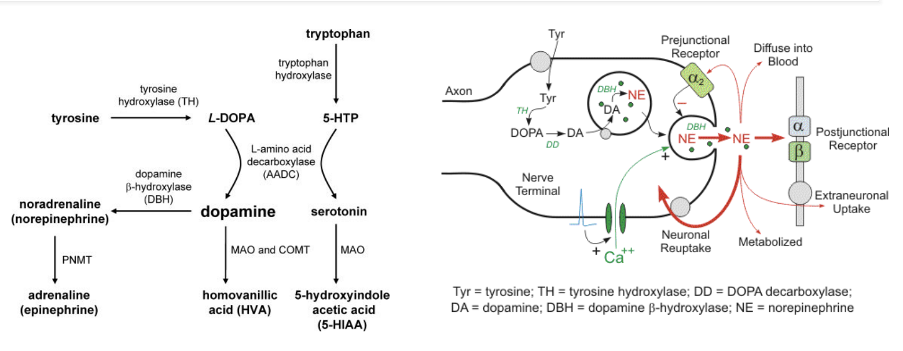

Serotonin
- Biosynthesis: Derived from tryptophan (AA) via decarboxylase
- Packaging: vesicular monoamine transporter (VMAT1 and VMAT2)
- Termination of action: reuptake at synapse by serotonin reuptake transporter (SERT)
- Metabolism (breakdown) by monoamine oxidase (MAO)
- Main modulatory receptor type: 5HT 1-7 isoforms, most are GPCRs except 5HT3 , which is a cation channel; ~13 known receptor isoforms including subtypes
- Functional buzzword: Happiness, libido, autonomic GI regulation

Norepinephrine
- Biosynthesis: Derived from phenylalanine/tyrosine via L-Dopa to Dopamine; methylation to epinephrine
- Packaging: Vesicular monoamine transporter (VMAT1 and VMAT2)
- Termination of action: reuptake at synapse by norepinephrine transporter (NET)
- Metabolism (breakdown) by monoamine oxidase (MAO) and Catechol-OMethyltransferase (COMT)
- Main modulatory receptor type: Alpha1, Alpha2, Beta1, Beta2 - GPCRs
- Functional buzzword: Arousal/Attention (in CNS)

Dopamine
- Biosynthesis: Derived from Phenylalanine/Tyrosine via L-Dopa
- Packaging: Vesicular monoamine transporter (VMAT1 and VMAT2)
- Termination of action: Reuptake at synapse by Dopamine Transporter (DAT)
- Metabolism (breakdown) by monoamine oxidase (MAO) and Catechol-O-Methyltransferase (COMT)
- Main modulatory receptor type: D1 family (Gs), D2 family (Gi) – GPCRs
- Functional buzzword: Reward, Movement
- Reward prediction error hypothesis of Addiction: Dopamine involved in “wanting” a thing
  - Getting bigger reward than expected, dopamine loves. Dopamine activity decreases if less than predicted reward occurs
  - involves reinforcement, learning and motivation, not euphoria/pleasure (and the implications for addiction)

Specific Drugs:
- Cocaine:
  - Blocks DAT, SERT, and NET. Nonselectively blocks reuptake of monoamines
    - At higher doses, it blocks Na and cardiac I_{kr} can throw into arrythmias
    - NB: Atomoxetine (in contrast) is NET selective
  - Primarily used as a local anesthetic due to vasoconstrictive properties, notable for high abuse potential.
  - Stimulant like coffee, but high addiction potential! (bcs of effect on dopaminergic system)
- Phenylethylamines:
  - Amphetamines:
    - 1) Release of monoamines from vesicular storage into the cytosol (thought perhaps via pH change?)
    - 2) Reverse monoamine reuptake transporters to increase release into the synaptic cleft
    - 3) At higher doses function as a MAO inhibitor
    - 4) Possibly as a direct agonist at some adrenoreceptors
    - 5) Some reuptake inhibition from the presynaptic cleft
    - NB: cocaine has predominantly intracellular effects, while amphetamines seem to do “everything”
    - Summary: net effect of amphetamines on monoamines in the synaptic cleft is a substantial increase in the levels of dopamine and norepinephrine, with moderate increases in serotonin, leading to pronounced stimulatory effects on the central nervous system.
    - Comes in multiple forms like mixed amphetamine salts (Adderall), Lisdexamfetamine (Vyvanse), Methamphetamine, MDMA (Ecstasy), Methylphenidate (Ritalin).
- Phenylethylamines
  - Our understanding is still evolving
  - Trace amines (p-tyramine, octopamine, betaphenylethylamine) exist in very small amounts in mammalian brains.
  - GPCR – trace-amine associated receptor 1 (TAAR1) – discovered 2001
  - Implicated in the function of amphetamines in ADHD; intracellular receptors whose secondary messenger systems affect trafficking of dopamine receptors
  - Ephedrine: Mixed Alpha/Beta Effects, used as a vasopressor mostly in perioperative settings; often contrasted to phenylephrine
    - Similar effects as norepinephrine, but we don’t give NE as bolus
  - Pseudoephedrine: Used as a decongestant, highly regulated. Works by vasoconstriction
- Other Stimulants:
  - Modafinil/Armodafinil: Used for narcolepsy, mechanism likely involves dopamine and norepinephrine reuptake inhibition. Less abuse potential
  - Phentermine: Used for weight loss, once combined with fenfluramine (Fen-Phen). Off-market bcs fenfluramine has serotonergic effects on heart valves causing valve fibrosis
- Usefulness of Stimulants
  - Increased wakefulness and alertness -> can be used to treat excessive daytime sleepiness (ie due to narcolepsy or sleep apnea)
  - increased frontal lobe activity -> can be used to treated ADD/ADHD (disorder of executive functioning deficits, primarily frontal lobe hypoactivity related).
  - increased mood -> can be used to augment/supplement treatment of depression
  - decreased appetite -> can be used as part of treatment for obesity/weight loss/binge eating disorders
  - various cardiovascular and pulmonary effects: increased heart rate, blood pressure, vasoconstriction, etc.
Nicotinic and Methylxanthines:
- Nicotinic Receptors:
  - Acetylcholine receptors are called cholinergic receptors and come in two varieties based on whether they selectively bind nicotine or muscarine.
  - Nicotine impacts the CNS, producing euphoria, arousal, and relaxation, increases attention, reaction time, suppresses appetite, while mildly increasing HR/BP peripherally.
  - Intermediary of sympathetic and parasympathetic NS
  - At the Neuromuscular junction skeletal muscle contraction
    - At low doses, nicotine doesn’t affect skeletal muscles bcs it is more selective for nAChR in the CNS
    - In overdose, can see skeletal muscle contraction paralysis, respiratory paralysis
  - CNS – attention, memory
  - Dopamine (addictive!)/ GABA/ serotonin/ NE release: Stimulants!
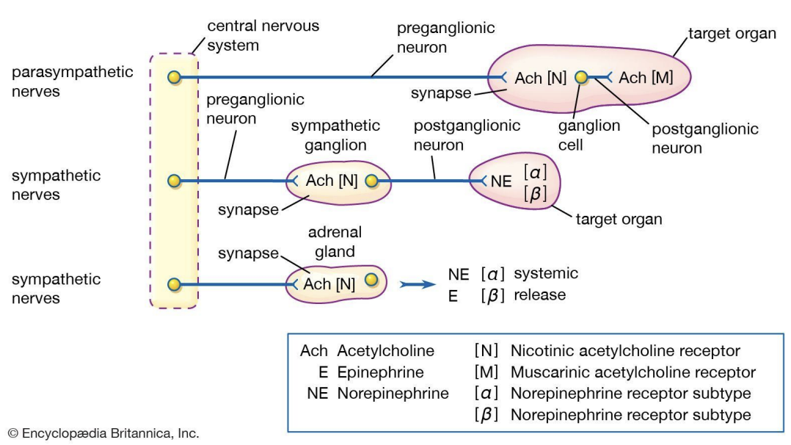
- Methylxanthines:
Adenosine Receptors
  - A1 and A2a: decreased myocardial oxygen demand/ slow cardiac conduction and Sleep/Circadian rhythm
  - A2b and A3: Bronchospasm and inflammation

  - Caffeine: Adenosine receptor antagonist (= increased HR), promotes alertness by inhibiting inhibitory adenosine effects.
  - Theophylline: Traditional pulmonary medication,
    - adenosine receptor antagonism (= bronchodilation and increased cardiac conduction), and phosphodiesterase inhibition. (increased cAMP bronchodilation, anti-inflammatory, increased diaphragm contractility, CNS stimulation, vasodilation, cardiac function)
  - Theobromine: chocolate
- Other stimulants as drugs of abuse:
  - Khat – contains cathinone
  - Mephedrone (synthetic cathinone marketed as bathsalts to avoid FDA oversight)
  - Fenethylline (captagon) – codrug of amphetamine and theophylline
  - NB: main driver of addiction is dopamine!
  - Tyramine (sympathomimetic) containing foods can cause HTN/adrenergic crises in pts taking MAOi’s (Parkinson’s disease) e.g. aged cheese, wine, pepperoni, cured meats
    - Normally broken down by MAOs
Sedatives and Hypnotics:
- Definitions:
  - Sedative: reduces anxiety.
  - Hypnotic: induces sleep.
- GABAa Agonists:
  - Benzodiazepines: Enhance GABA effects, used for anxiolysis, sedation, seizure control, muscle relaxation (e.g., Xanax, Valium, Ativan).
    - Increase frequency of channel opening (Cl- passes through channel) in response to GABA – positive allosteric modulators of GABA effect
  - NB: different isoforms of GABA-A receptors. Different drugs have different effects on the different isoforms
  - Moderate onset Benzos: Chlordiazepoxide, clonazepam, tamazepam
  - Fast onset: diazepam (valium)
  - Fast: alprazolam, lorazepam, midazolam
  - BZDs show: dependence, tolerance, addiction/abuse potential, withdrawal
  - Adverse effects: delirium, anterograde amnesia (impair ability to turn short term to long term memory), respiratory depression, motor incoordination, cognitive impairment
  - Z-Drugs: Bind specifically to GABAa receptors with alphal subunit (e.g., Zolpidem, zaleplon, Eszopiclone).
    - Sleep physiology and insomnia:
      - Pineal Gland: Releases melatonin in response to darkness.
      - Melatonin: Binds to MT1/MT2 receptors.
      - Suprachiasmatic Nucleus (SCN): Melatonin inhibits the SCN.
      - Inhibition of SCN: Allows activation of the ventral lateral preoptic nucleus (VLPO).
      - VLPO Activation: GABA-ergic; Promotes sleep by suppressing arousal centers.
      - Melatonin released in response to darkness suppresses the suprachiasmatic nucleus, activating the VLPO, which promotes sleep by releasing GABA.
        - Melatonin ↓SCN ↑VLPO ↑GABA ↑Sleep!
      - Arousal centers release orexin and histamine, inhibiting the VLPO, contributing to wakefulness.
        - Arousal ↑orexin and histamine ↓VLPO ↓GABA ↓Sleep!
      - Insomnia can be due to low melatonin/GABA or high orexin/histamine levels.
    - Insomnia is due to low melatonin, low GABA, high orexin, high histamine
    - NB: GABAa receptors: alpha 1 subunit – sleep, alpha 2 subunit – anxiety
      - Of the BDZs – Temazepam and Flurazepam are most selective for alpha 1
    - Z drugs show tolerance, but less withdrawal, less dependence/abuse potential.
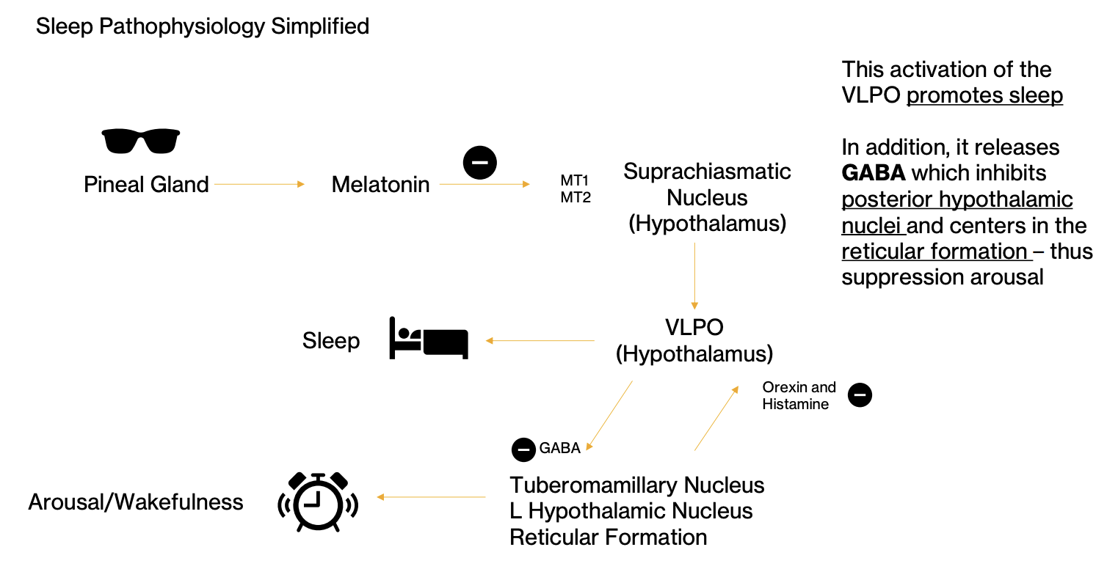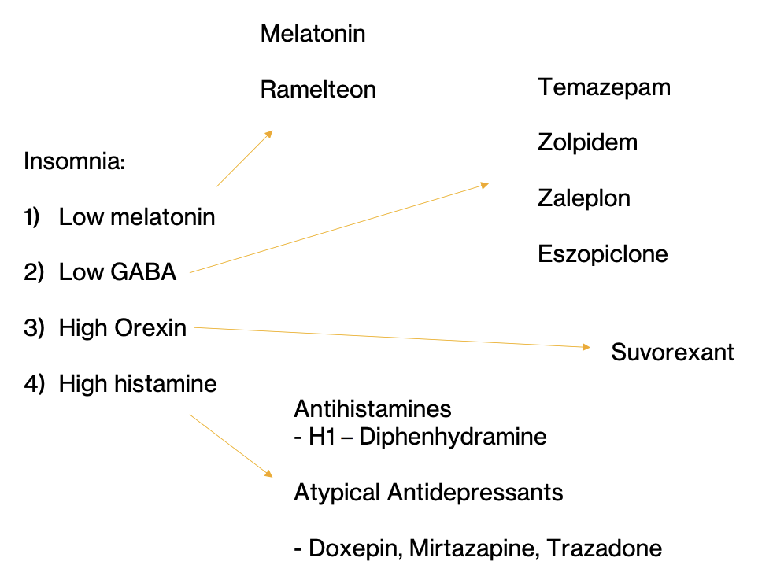

Feature | BDZs | GABA
Binding Site | Allosteric site (a-γ interface) | Orthosteric site (a-ß interface)
Effect on Receptor | Enhances GABA action | Directly activates receptor
Chloride Channel Action | Increases frequency of opening | Opens channel directly
Dependence on GABA | Requires GABA to exert effects | Acts independently
Clinical | Anxiolytic, sedative, muscle relaxant | Primary CNS inhibitory neurotransmitter
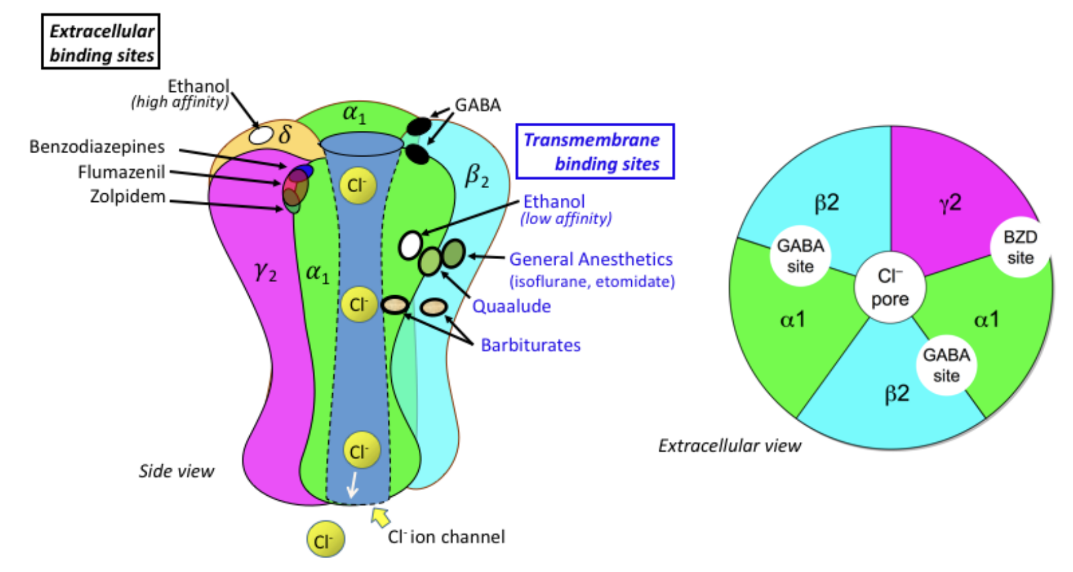
From shortest to longest half life | Speed of onset | Active metabolites?
Triazolam | Moderate | No
Oxazepam | Slow | No
Alprazolam (Xanax) | Fast | Yes
Temazepam (Restoril) | Moderate | No
Lorazepam (Ativan) | Fast | No
Chlordiazepoxide | Moderate | Yes
Clonazepam (Klonopin) | Moderate | Yes
Diazepam (Valium) | Very Fast | Yes
Flurazepam | Moderate | Yes
Midazolam | Very Fast | Yes

- Flumazenil – GABAa receptor antagonist that binds to site described for benzos.
  - Can precipitate seizures in pts with hx of epilepsy of in mixed overdoses
  - Can be used to reverse benzos and zolpidem (Z meds)

- Alpha-2 Agonists:
  - Sympatholytic
  - Used for augmentation in ADHD, sedation, BP control (e.g., Clonidine for BP, Guanfacine for ADHD – augment stimulants, Tizanidine for muscle relaxation).
Newer Agents and Their Targets:
- Orexin Receptor Antagonists: Target orexin-producing neurons to promote sleep (e.g., Suvorexant, Lemborexant).
- Melatonin Receptor Agonists: Target melatonin pathways to regulate sleep cycles (e.g., Ramelteon for difficulty with sleep onset, Tasimeltean often in blind indiviuals).

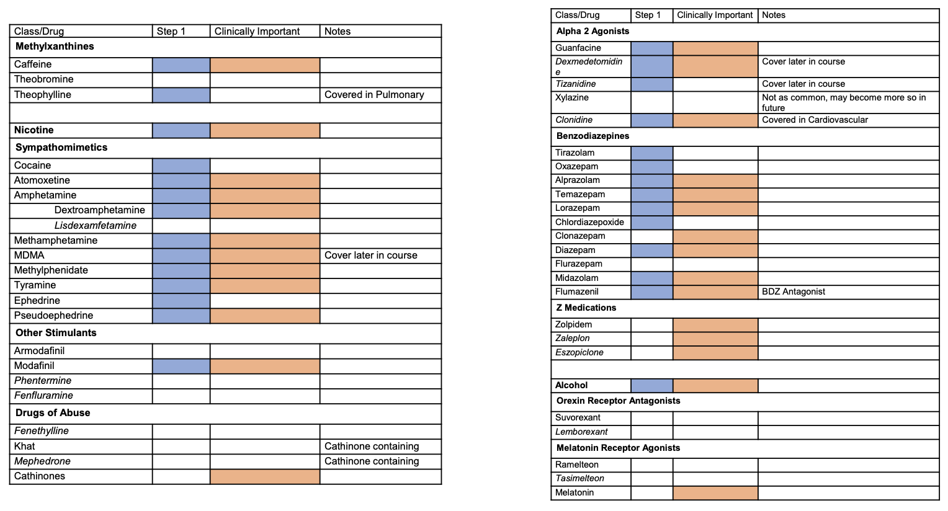

Medications for Mood Disorders
See folder '/Users/fikunwa/Library/CloudStorage/Box-Box/CMR_Group/Users/Fikunwa Kolawole/Classes/2025 Winter/Pharm/01142025_MedsForMoodDisorders' for handouts

Notes from Class
- All antidepressants treat major depression.
- Used for anxiety as well
- Monoamine systems: 5HT, NE, DA (Histamine also). Vast majority of antidepressants work on these systems
- Most antidepressants (used for unipolar depression
  - Similar effectiveness
  - About same speed of onset: 2-3 weeks after taking med
  - Not addictive (in tolerance model i.e. downregulation of receptor model)
    - Some antidepressants have discontinuation side effects but not the same neuro-addictive model
    - Discontinuation doesn’t make more likely to need antidepressant later. I.e. no rebound depression following discontinuation
  - So we generally differentiate/choose antidepressants based on side effects/toxicity, ease of use, cost, durability, and lack of interactions
- No antidepressant class that works on Glutamate (not Monoamine transmitter but amino transmitter). Currently 2 FDA approved that are NMDA antagonists (receptor for glutamate). May provoke neurotrophy
- Reuptake inhibitors amplify the signals between nerves (don’t provoke!) i.e. more NT in the terminal
- TCAs are SERT and NET inhibitors but they interact with undesirable ancillary systems
- Meds with short half life more likely to cause discontinuation effects. E.g. SSRIs
  - E.g. fluoxetine has long half life and has discontinuation effects
- SSRIs are generally very safe! Usually not lethal. And danger of serotonin syndrome is low unless combined with TCAs and MAO-is
- TCAs are generally unsafe
- NB: D/C = discontinuation syndrome
- Dopamine doesn’t help anxiety much
- NE is important for neuropathic pain and ADHD, so SNRIs and also TCAs can be used for neuropathic pain and ADHD
- 5HT2 is inhibitory i.e. reduce serotonin release increase anxiety
- 5HT1 is excitatory i.e. release more serotonin decrease anxiety
- Glutamate increasers via NMDA inhibition (NB: glutamate is primary excitatory NT in CNS)
  - S-ketamine and dextromethorphan + bupoprion combination
  - These work faster onset. Between 1 week and 2 weeks
  - Generally safe, as long as they’re not abused. May have addictive effects
  - Good for depression but unclear if they’re helpful for anxiety disorders
  - Expensive: can get around by giving dextromethorphan and buprioprion separately. Both not as expensive
- How does inhibiting NMDA receptors (receptor for glutamate) increase extracellular glutamate levels
  - Decreased glutamate uptake by transporters.
  - Disruption of feedback inhibition mechanisms.
  - Compensatory release of glutamate to maintain homeostasis.
  - Influence on other neurotransmitter systems, like reduced GABAergic inhibition.
  - Increased neuronal activity, leading to more glutamate release.
Bipolar
- Mood stabilizers help some piece of bipolar more than others. So pts usually end up on cocktail of meds
- Phases of Bipolar are Mania, Bipolar Depression and Maintenance
  - Prodromal stage: This phase occurs before a manic or depressive episode and can include changes in mood, behavior, or functioning. Symptoms can include anxiety, depression, or disrupted sleep.
  - Acute stage: This is when a full mood episode occurs, such as mania, depression, or a mixed episode.
  - Maintenance stage: This is when the focus is on managing the disorder and maintaining stability through medication and therapy.
- Mania can be divided into:
  - pure/euphoric or
  - mixed/dysphoria/irritable (i.e. with depressive symptoms). People present with aggression, belligerence and anger
- Meds used for bipolar depression aren’t antidepressants! Antidepressants also have risk of flipping people from depression into mania (esp mixed mania)

Meds for Bipolar
- Lithium: best for pure euphoric mania
  - Reduces suicidal thinking
  - Can be used for augmentation of depression treatment i.e. treatment resistant
  - Not as useful for bipolar depression or maintenance (+/-)
  - Narrow therapeutic index mostly because of nephrotoxicity
  - Minor side effects (i.e. not lethal): tremor, GI side effects, nephrogenic DI, acne (sweat out and irritate the skin; shower side effects!)
  - Major side effects: cognitive side effects, anomia, hypothyroid, overdose, teratogen (ebstein anomaly)
  - Narrow therapeutic index
- Anticonvulsants e.g. Valproate
  - Mania is overexcitation problem, no leap to see that anticonvulsants (epileptics) can help as mood stabilizers
  - Best for mixed mania
  - Acts quick
  - No effect on depression
  - Wide therapeutic index
  - Minor AE: weight gain (long term), sedation
  - Major AE: hepatotoxicity, teratogenic (more than Li+; neural tube defects; anyone who can get pregnant shouldn’t be on it bcs risk is super high)
- Anticonvulsant e.g. Carbamezapine
  - Has 3 ring structure. May have some TCA effects
  - Great for mixed Mania, +/- for Bipolar depression, Not used for maintenance
  - Moderate Therapeutic index
- Lamotrigine
  - Great for maintenance, +/- for Bipolar depression
  - Wide therapeutic index but risk of stevens johnsons
    - Risk of rash is dependent on how quickly you dose it up. So takes 6-8 weeks to ramp it up. Partly why its not great for acute mania

Emerging
- Psychedelics
- Electroconvulsive therapy
- Transcranial magnetic therapy
  - These all promote neutrophy
- Talk therapy especially for mild depression

Summary on Meds for Bipolar/Mania

Medication | Mania  (Pure/Euphoric) | Mania  (Mixed/Dysphoric/Irritable) | Bipolar  Depression | Maintenance | Tx Index
Lithium | + | +/- | +/- | +/- | Narrow
Valproic Acid | +/- | + | X |  | Wide
Carbamazepine |  | + | +/- |  | Moderate
Lamotrigine |  |  | +/- | + | Wide

Antipsychotics
See folder '/Users/fikunwa/Library/CloudStorage/Box-Box/CMR_Group/Users/Fikunwa Kolawole/Classes/2025 Winter/Pharm/01212025_Antipsychotics' for handouts

Effects of Blocking Dopamine (D2 receptor) in different brain tracts
- Tuberoinfundibular Tract (hypothalamus to pituitary)
  - Hyperprolactinemia: dopamine is prolactin inhibitory factor
- Nigrostriatal (substantia nigra to striatum – caudate, putamen, and ventral striatum of basal ganglia)
  - Parkinsonism (blocked dopamine effect in this tract is similar to loss of dopamine in Parkinson’s)
  - Acute extrapyramidal side effects (EPS):
    - acute dystonia (muscle cramps; usually in head and neck area)
      - oculogyric crises: painful eyes rolling back
      - tongue stuck out
      - neck stuck sideways
      - can happen hours after
    - akathisia – “cant sit/stand still”
      - few days after
    - parkinsonism triad
      - motor rigidity (cogwheel rigidity with passive movement; ratcheting when you move hand),
      - tremor (resting tremor that is slower than action/tension tremor; pill rolling repetitive rhythmic tremor)
      - bradykinesia – slow movement and speech. Can extend to facial muscles. Important to distinguish from schizophrenia which presents with facial flatness (emotional flatness)
      - days - weeks
  - Tardive dyskinesia: “tardive = late”
    - chronic movement disorder that causes involuntary, repetitive body movements
    - writhing snakelike movement
    - Random and asynchronous movement
    - Risk is cumulative over time with D2 antagonism
    - It may not go away even with med cessation
  - Neuroleptic malignant syndrome
    - Rhabdo: Think of it as so stiff that muscle starts to break down!
    - Hyperthermia from contracting muscles all the time
    - Low risk and rare
    - Risk associated with strong D2 antagonists used at high doses for long time
More notes
    - Pyramids are the major motor tracts i.e. the ones that tell the muscle to flex or extend)
    - Extrapyramidal affects regulation of the pyramids
- Mesolimbic/Mesocortical system
  - Goal is to affect the Mesolimbic system to remove the positive symptoms of schizophrenia. May make the negative symptoms worse
  - Mesocortical: bad for executive functioning and cognition

Dopamine Tract | Origin | Termination | Function
Nigrostriatal Pathway | Substantia nigra pars compacta (SNc) | Striatum (caudate nucleus and putamen) | Motor control and coordination. Degeneration causes Parkinson’s disease.
Mesolimbic Pathway | Ventral tegmental area (VTA) | Nucleus accumbens, amygdala, hippocampus | Reward, pleasure, motivation. Implicated in addiction and schizophrenia.
Mesocortical Pathway | Ventral tegmental area (VTA) | Prefrontal cortex (PFC) | Executive functions (decision-making, working memory, attention). Implicated in schizophrenia and depression.
Tuberoinfundibular Pathway | Arcuate nucleus of the hypothalamus | Anterior pituitary | Inhibits prolactin release. Dysregulation causes hyperprolactinemia.

Generations
- Potency: how much drug (mg) required to get same level of D2 blockade
- Generations: which ones came first
- The balance between acetylcholine and dopamine is kinda what causes parkinsons signs. You can either drop Ach to meet dopamine or raise dopamine to meet Ach to reduce movement disorders. Don’t want to increase dopamine in psychotics
- SDA (serotonin-dopamine antagonists): these are the atypical (2nd gen) antipsychotics. Have lower risk of extrapyramidal side effects compared to first gen. Unsure why. 5HT2 antagonism might play a role. Might also be because the meds are newer so dose finding studies were better
- DPRAs (dopamine receptor partial agonists): also a subcategory of atypical (2nd gen) antipsychotics – still have net effect of decreasing dopamine
  - Inhibit dopamine but agonize the receptor less strongly than dopamine would have done previously
    - May increase dopamine activity if dopamine activity is low
  - Theoretically better for extrapyramidial side effects than SDA but its about the same
- The second gen are good for mood regulation (better than first gen)! Bcs of Serotonin 5HT2 blockade
- KarXT – almost zero risk of extrapyramidal sides
  - M4 agonism leads to the antipsychotic effect
  - Add the non specific antimuscarinic (anticholinergic) to remove the muscarinic effects peripherally (urination, pooping = DUMBELLS). But it doesn’t cross the BBB so doesn’t block the CNS M4 agonism!
- Clozapine
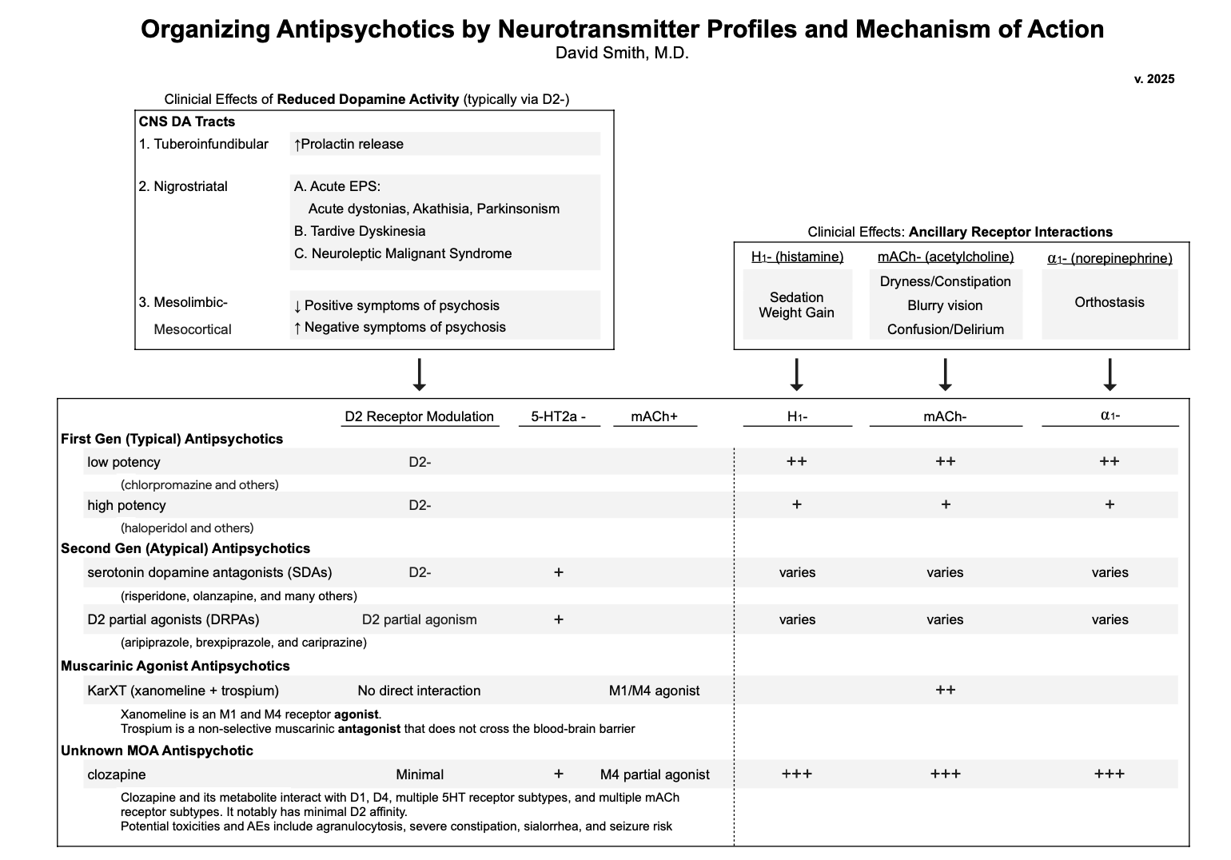

Feature | SDA (Serotonin-Dopamine Antagonists) | DRPA (Dopamine Receptor Partial Agonists)
Mechanism | Blocks 5-HT2A and D2 receptors | Partial agonism at D2 receptors, blocks 5-HT2A
Examples | Risperidone, Olanzapine, Quetiapine | Aripiprazole, Brexpiprazole, Cariprazine
Positive Symptoms | Effective | Effective
Negative Symptoms | Effective | Effective
Cognitive Symptoms | Moderate effect | Better effect
Metabolic Side Effects | High risk (weight gain, diabetes) | Lower risk
EPS Risk | Low to moderate | Very low

Dopamine Pathway | Activity in Schizophrenia | Symptoms
Mesolimbic | Hyperactive | Positive symptoms (hallucinations, delusions, disorganized thought).
Mesocortical | Hypoactive | Negative symptoms (avolition – lack of motivation, anhedonia, flat affect) and cognitive deficits.
Local Anesthetic Board Talk Companion

Cocaine
- Origin: Introduced by Andean civilizations
- Mechanism of Action: Inhibits dopamine, serotonin, and norepinephrine reuptake
  - Effects: Euphoria, addiction, cardiac effects
Tetrodotoxin (TTX)
- Origin: Mentioned in Chinese texts
- Mechanism: Inhibits sodium channels (extracellularly)
  - Source: Toxin in puffer fish, used for research
Mechanism of Action for Local Anesthetics
- Block voltage-gated sodium channels intracellularly
  - Toxins block extracellularly making them more dangerous. Also they don’t have as much use dependence as the local anesthetics
- Prefer inactive or open states (use-dependent/phasic block)
Adjuvants for Local Anesthetics
- Epinephrine: Vasoconstriction, prolonged effect
- Opioids/Steroids/Clonidine: Prolonged effect
Types of Local Anesthetics
- Esters:
  - Examples: Cocaine, Procaine, Benzocaine, Chloroprocaine
  - Metabolism: Hydrolysis via pseudocholinesterase so don’t last long in the body!
- Amides:
  - Examples: Lidocaine, Bupivacaine, Mepivacaine, Ropivacaine
    - Rule of “I’s” lets you know the local anesthetic is an amide
  - Metabolism: Hepatically metabolized so last longer in the body
  - We pretty much only use the amides clinically
Clinical Uses of local anesthetics
- Class 1b antiarrhythmic – “caines”
- Inhibition of neuronal function (anesthesia)
  - Differential blockade with neuraxial use (Sympathetic > Pain/Temperature > Touch > Motor)
    - i.e. sympathetic function lost first (e.g. get flushed bcs vasoconstriction of SNS is lost)
  - Smaller and less myelinated nerves block faster
- Pain management (IV infusion, other receptors e.g. NMDA, sigma receptors/anti-inflammatory)
  - E.g. post operative pain, post-trauma
- Use dependence - Local anesthetics prefer sodium channels in the active and inactive (flipping from active into inactive) state
  - So with more use dependence, there is a preference for quickly firing neurons/cardiac cells that are depolarizing
  - Reason why 1b prefer ventricles or death cardiac tissue bcs they are the least use dependent

Pharmacokinetics of Local Anesthetics
- Metabolism: Esters have shorter duration
- Potency: Correlates to lipid solubility
- Duration of Action: Correlates to protein binding
- Speed of Onset: Relates to pKa of drug and pH of environment
  - Acidic environments slow onset
  - Sodium bicarbonate can speed up onset
Other info
- NB: local anesthetics differ by
  - speed of onset determined by the pKa of the drug (pH at which is it 50% ionized and 50% unionized)
    - local anesthetics are week bases (pH > physiological pH)
    - You want them to be un-ionized to pass through the bilipid membrane. So the closer the anesthetic is to physiologic pH the faster the onset e.g. lidocaine works fast, bupivacaine is slower
    - Can add NaHCO3 to make the env more basic, so it works faster
  - Potency is dependent on how lipophilic (more will cross the lipid bilayer)
  - Duration of action is due to ability to bind to alpha 1 glycoproteins
- How Epinephrine Affects Duration of Action:
  - Vasoconstriction: Epinephrine is a vasoconstrictor, (alpha-1 adrenergic receptors. This vasoconstriction reduces local blood flow in the area where the anesthetic is administered.
  - Reduced Local Blood Flow: By reducing blood flow, epinephrine helps in keeping the local anesthetic at the site of injection for a longer period because there is less blood flow to carry the drug away from the site.
  - Prolonged Drug Effect: Anesthetics are cleared from the site of action via the bloodstream. By limiting this clearance through vasoconstriction, epinephrine effectively prolongs the duration of action of the anesthetic.
Adverse Effects
- Local Anesthetic Systemic Toxicity (LAST)
  - CNS: Numbness, tinnitus, anxiety, seizures, coma
    - Go from positive symptoms to -ve i.e. seizures, tinnitus to coma
  - Cardiac: PVCs, QRS widening, arrhythmia, asystole
  - Treatment: Intralipid. Bcs the anesthetics are lipophilic. Have the fat bind them
- Methemoglobinemia
  - Common with benzocaine/procaine
  - Note: Bupivacaine has more cardiac toxicity

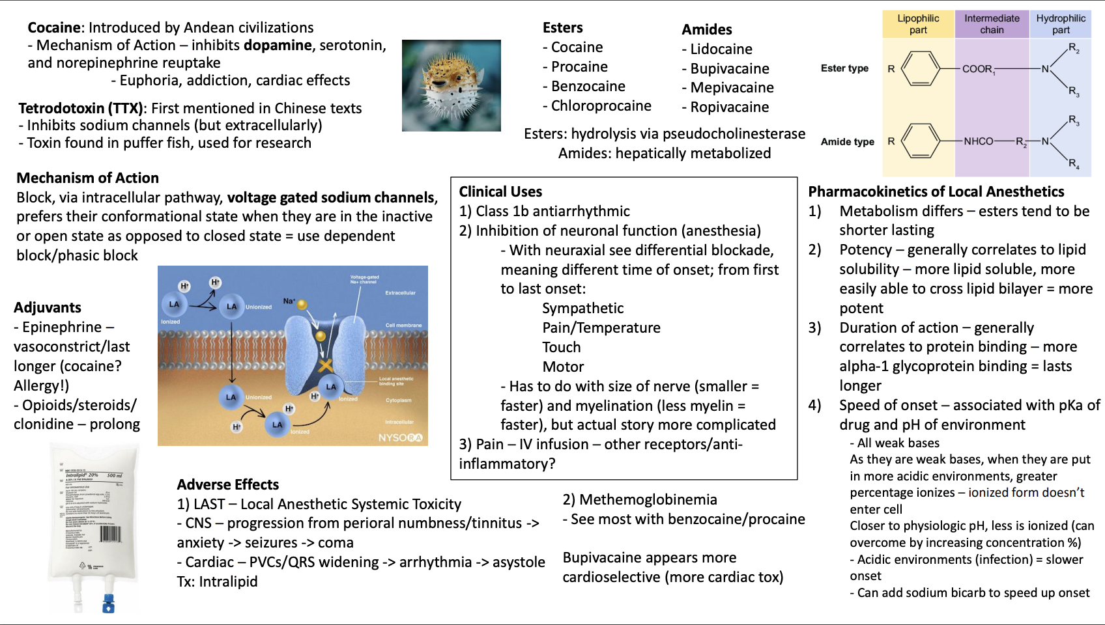

Neuromuscular Junction Pharmacology
Introduction
- Neuromuscular Junction (NMJ): Critical for muscle contraction and relaxation during surgeries.
- Paralysis in Surgery: Complete paralysis is often required for many surgical procedures.
- Case Study: RaDonda Vaught, a nurse, mistakenly administered vecuronium (a paralytic) instead of midazolam, leading to patient death. This highlights the importance of understanding neuromuscular blockers.

Historical Context
- Curare: Used by Amazonian and Caribbean communities for hunting. Sir Walter Raleigh documented its use in 1596.
- Development in Medicine:
  - 1780s: Found to affect voluntary muscles but not nerves or the heart.
  - 1832: Preparation methods and animal experiments began.
  - Mid-20th Century: Curare (D-tubocurarine) was introduced into medical practice.
- Richard Gill: Brought curare to the U.S. for medical use after suffering spasticity from an injury.

Acetylcholine Receptors
- Nicotinic Receptors (Ionotropic):
  - Nn (Neuronal-type): Found in parasympathetic ganglia, sympathetic ganglia, adrenal gland, and CNS.
  - Nm (Muscle-type): Located at the skeletal neuromuscular junction.
- Muscarinic Receptors (Metabotropic - GPCRs):
  - M1: CNS and secretions (tears, sweat, gastric acid).
  - M2: Heart (bradycardia, decreased contractility).
  - M3: Smooth muscle (bronchoconstriction, bladder, GI) and eye (miosis).

Neuromuscular Junction Mechanism
- Action Potential Arrival: Depolarization opens voltage-gated sodium and calcium channels.
- Acetylcholine Release:
  - Acetylcholine is stored in vesicles and released via exocytosis.
  - SNARE proteins (synaptotagmin, synaptobrevin, SNAP-25, syntaxin) facilitate vesicle fusion.
    - V-Snare – vesicular snare e.g. synaptobrevin (VAMP);
    - T-snare on the target membrane (e.g. presynaptic membrane) e.g. snap-25 and syntaxin
    - Interaction of v and t snare leads to vesicular fusion
- Muscle Contraction:
  - Two acetylcholine molecules bind to nicotinic receptors, causing sodium influx and depolarization.
  - Depolarization spreads across the sarcolemma and into the T-tubules (invaginations of the muscle cell membrane) activates RyR1 receptors on sarcoplasmic reticulum Ca2+is released from the SR muscle contraction.
- Termination of Signal:
  - Acetylcholinesterase breaks down acetylcholine.
  - Butyrylcholinesterase (pseudocholinesterase) metabolizes acetylcholine in systemic circulation.

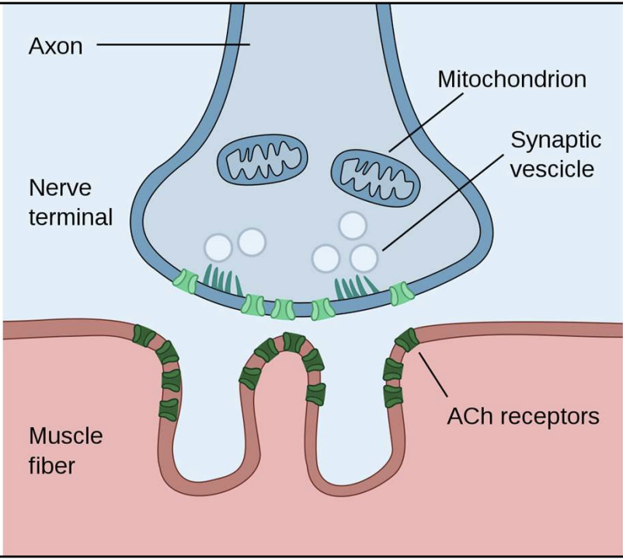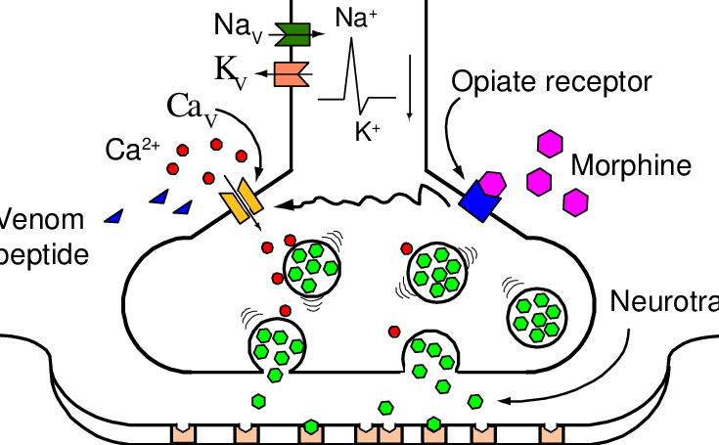

Neuromuscular Blockers
- Depolarizing Blockers:
  - Succinylcholine: Composed of two acetylcholine molecules. Causes initial fasciculations, then paralysis. Rapid depolarization throws muscles into refractory phase
    - Side Effects:
      - Transient Hyperkalemia (all muscles repolarize simultaneously when membranes are repolarizing releasing a ton of K+)
        - Consideration for renal failure, predisposed to arrythmia
      - malignant hyperthermia,
      - prolonged paralysis in pseudocholinesterase deficiency.
        - Fast off: Pseudocholinesterases get rid of succinylcholine not AChE
    - Duration: Short (5-10 minutes), terminated by diffusion.
      - Fast on fast off (may be adequate for intubation). Resets via K+ efflux repolarize the membranes
    - NB: normally AChE gets rid of
- Non-Depolarizing Blockers:
  - Competitive Inhibitors: Bind to nicotinic receptors, preventing acetylcholine from activating them.
  - Last longer e.g. for hours!
  - Reversed by acetylcholinesterase inhibitors e.g. neostigmine, Physostigmine
    - Will get muscarinic symptoms
    - Give an antimuscarinic to reverse the muscarinic symptoms e.g. Glycopyrrolate (doesn’t cross BBB), or atropine (crosses BBB)
  - Examples:
    - Rocuronium: Fast onset, used for rapid sequence intubation.
      - Causes allergies
    - Vecuronium: Longer duration, metabolized in the liver.
    - Cisatracurium: Organ-independent metabolism (Hofmann elimination), ideal for renal/hepatic impairment.
    - Pancuronium: Long duration, vagolytic effects (tachycardia).

Reversal of Neuromuscular Blockade
- Succinylcholine: Not typically reversed; effects wear off as it is metabolized.
- Non-Depolarizing Blockers:
  - Cholinesterase Inhibitors: Increase acetylcholine levels to outcompete blockers.
    - Examples: Neostigmine, pyridostigmine, physostigmine.
  - Anticholinergics: Co-administered to prevent muscarinic side effects (e.g., glycopyrrolate, atropine).
  - Sugammadex: Binds steroidal blockers (rocuronium, vecuronium) directly, providing rapid reversal. Bind the curare and renally clears the complex
    - Side Effects: Inactivates hormonal birth control, renally cleared.

Monitoring Neuromuscular Blockade
- Train-of-Four (TOF) Stimulation:
  - Phase I Block (Succinylcholine): Equal but diminished twitches.
  - Phase II Block (Prolonged Succinylcholine): Fade in twitch response.
  - Non-Depolarizing Block: Fade in twitch response.
- Sites for Monitoring:
  - Facial Nerve: Reflects diaphragm and laryngeal recovery.
  - Ulnar Nerve: More sensitive for overall paralysis depth.

Other Neuromuscular Agents
- Botulinum Toxin:
  - Mechanism: Inhibits acetylcholine release by cleaving SNARE proteins.
  - Uses: Treats muscle spasticity, migraines, hyperhidrosis, and cosmetic purposes.
- Muscle Relaxants:
  - Baclofen: GABA-B agonist, reduces spasticity.
  - Tizanidine: Alpha-2 agonist, reduces excitatory neurotransmission.
  - Dantrolene: Inhibits RyR1, reduces muscle contraction.
  - Cyclobenzaprine: TCA-like effect, reduces tonic motor activity.

Tetanus Toxin
- Mechanism: Cleaves synaptobrevin in inhibitory interneurons, blocking GABA and glycine release.
- Effect: Unopposed alpha motor neuron activity → muscle spasms (spastic paralysis).
- Symptoms: Trismus (lockjaw), opisthotonos, respiratory failure.

Organophosphates
- Mechanism: Irreversibly inhibit acetylcholinesterase, leading to cholinergic overstimulation.
- Symptoms: Muscle paralysis, bronchorrhea, seizures, respiratory failure.
- Treatment:
  - Atropine: Blocks muscarinic receptors.
  - Pralidoxime (2-PAM): Reactivates acetylcholinesterase.

Neuromuscular Disorders
- Lambert-Eaton Myasthenic Syndrome (LEMS):
  - Mechanism: Antibodies target presynaptic calcium channels, reducing acetylcholine release.
  - Symptoms: Muscle weakness that improves with activity.
- Myasthenia Gravis (MG):
  - Mechanism: Antibodies target postsynaptic acetylcholine receptors.
  - Symptoms: Fatigable muscle weakness, ptosis, diplopia.

Venoms and Toxins
- Bungarotoxins:
  - Mechanism: Bind irreversibly to nicotinic receptors, causing flaccid paralysis.
- Dendrotoxins:
  - Mechanism: Inhibit potassium channels, enhancing acetylcholine release → hyperexcitability → paralysis.
- Global Impact:
  - Snakebites: 5.4 million annually, 81,000-138,000 deaths.
  - Scorpion Stings: 1.2 million annually, thousands of deaths.
  - Antivenom Production: Challenges in access and distribution.

Medical Applications of Toxins
- Exenatide: Derived from Gila monster venom, used for type 2 diabetes.
- Captopril: Derived from Brazilian pit viper venom, an ACE inhibitor for hypertension.
- Funnel-Web Spider Toxin: Potential for protecting against cell death in heart attacks and strokes.

Conclusion
- Neuromuscular Pharmacology: Essential for surgical paralysis and managing neuromuscular disorders.
- Key Agents:
  - Depolarizing Blockers: Succinylcholine.
  - Non-Depolarizing Blockers: Rocuronium, vecuronium, cisatracurium.
  - Reversal Agents: Neostigmine, sugammadex.
- Toxins and Venoms: Both harmful and beneficial, with applications in medicine and challenges in treatment.

