Practical-9

JSP-CustomTagSorting/

│── src/

│ ├── com/example/tags/

│ │ ├── SortNumbersTag.java

│── WebContent/

│ ├── WEB-INF/

│ │ ├── tlds/

│ │ │ ├── customtags.tld

│ │ ├── web.xml

│ ├── index.jsp

│ ├── result.jsp

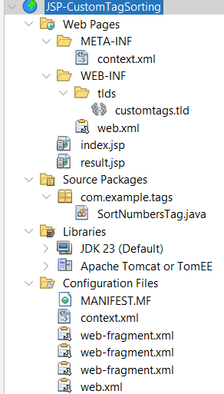

customtags.tld [choose tag library descipter]

<?xml version="1.0" encoding="UTF-8"?>

<taglib xmlns="http://java.sun.com/xml/ns/javaee"

xmlns:xsi="http://www.w3.org/2001/XMLSchema-instance"

xsi:schemaLocation="http://java.sun.com/xml/ns/javaee

http://java.sun.com/xml/ns/javaee/web-jsptaglibrary_2_1.xsd"

version="2.1">

<tlib-version>1.0</tlib-version>

<short-name>CustomTags</short-name>

<tag>

<name>sortNumbers</name>

<tag-class>com.example.tags.SortNumbersTag</tag-class>

<body-content>empty</body-content>

<attribute>

<name>numbers</name>

<required>true</required>

<rtexprvalue>true</rtexprvalue>

</attribute>

<attribute>

<name>order</name>

<required>false</required>

<rtexprvalue>true</rtexprvalue>

</attribute>

</tag>

</taglib>

web.xml

<?xml version="1.0" encoding="UTF-8"?>

<web-app xmlns="http://xmlns.jcp.org/xml/ns/javaee"

xmlns:xsi="http://www.w3.org/2001/XMLSchema-instance"

xsi:schemaLocation="http://xmlns.jcp.org/xml/ns/javaee http://xmlns.jcp.org/xml/ns/javaee/web-app_3_1.xsd"

version="3.1">

<session-config>

<session-timeout>

30

</session-timeout>

</session-config>

<display-name>JSP Custom Tag Sorting</display-name>

</web-app>

index.jsp

<%@ page language="java" contentType="text/html; charset=UTF-8" pageEncoding="UTF-8"%>

<html>

<head>

<title>Custom Tag Sorting</title>

</head>

<body>

<h2>Enter 10 Numbers (comma separated)</h2>

<form action="result.jsp" method="post">

<label>Numbers:</label>

<input type="text" name="numbers" required placeholder="e.g. 5, 2, 9, 1, 3, 8, 7, 4, 6, 0"/><br><br>

<label>Sort Order:</label>

<select name="order">

<option value="asc">Ascending</option>

<option value="desc">Descending</option>

</select><br><br>

<input type="submit" value="Sort Numbers"/>

</form>

</body>

</html>

result.jsp

<%@ page language="java" contentType="text/html; charset=UTF-8" pageEncoding="UTF-8"%>

<%@ taglib prefix="ct" uri="/WEB-INF/tlds/customtags.tld" %>

<%

String numbers = request.getParameter("numbers");

String order = request.getParameter("order");

%>

<html>

<head>

<title>Sorted Numbers</title>

</head>

<body>

<h2>Sorted Numbers Result</h2>

<ct:sortNumbers numbers="<%= numbers %>" order="<%= order %>"/>

<br><br>

<a href="index.jsp">Go Back</a>

</body>

</html>

SortNumbersTag.java

package com.example.tags;

import javax.servlet.jsp.tagext.TagSupport;

import javax.servlet.jsp.JspWriter;

import javax.servlet.jsp.JspException;

import java.io.IOException;

import java.util.Arrays;

import java.util.Collections;

import java.util.List;

import java.util.stream.Collectors;

public class SortNumbersTag extends TagSupport {

private String numbers;

private String order;

public void setNumbers(String numbers) {

this.numbers = numbers;

}

public void setOrder(String order) {

this.order = order;

}

@Override

public int doStartTag() throws JspException {

JspWriter out = pageContext.getOut();

try {

// Convert input numbers to a list

List<Integer> numberList = Arrays.stream(numbers.split(","))

.map(String::trim)

.map(Integer::parseInt)

.collect(Collectors.toList());

// Sort in specified order

if ("desc".equalsIgnoreCase(order)) {

Collections.sort(numberList, Collections.reverseOrder());

} else {

Collections.sort(numberList);

}

// Output sorted numbers

out.print("<h3>Sorted Numbers (" + order.toUpperCase() + "): " + numberList + "</h3>");

} catch (IOException | NumberFormatException e) {

throw new JspException("Error processing numbers", e);

}

return SKIP_BODY;

}

}