PRD: Multi-Agent Clinical Decision Support & Guideline Validation
Oct 5, 2026 · @Richard Parr

Summary and problem
We will build a clinical decision support assistant where one supervisor agent routes a clinician's question to three specialist agents (radiology guidelines, similar patients, billing) and returns one cited answer. Version 1 runs only on synthetic data and is built on the open-source AWS sample Multi-Agent Healthcare System with S3 Vectors.
The problem. Before ordering an imaging study or submitting a claim, a clinician or coder must check the patient's chart against long, rigid documents: radiology appropriateness criteria, payer fee schedules, coverage limits and prior authorization rules. This is manual, slow and easy to get wrong. A wrong call shows up as an inappropriate scan, a denied claim or a delayed treatment.
The opportunity. The sample shows that agents can search guidelines, patient records and billing rules at the same time and combine the results. This PRD turns that demo into a defined product: who it serves, what it must do, how we measure it, what it costs, and what must be true before it touches real patients.
Hospital value (hypothesis to prove). Fewer guideline errors in imaging orders, and fewer coding and prior authorization mistakes on claims. The sample does not measure either today, so the pilot must (see Goals).

Users
The primary user is the ordering clinician; coders and students are secondary.
Persona | Role | What they ask | What they need back
Ordering clinician | Hospitalist, ED or primary care physician | "Is a chest X-ray appropriate for this admitted patient with no cardiopulmonary symptoms?" | A guideline verdict with the ACR rating and the passage it came from
Radiologist | Reads and signs imaging reports | "Does this report meet ACR structure and completeness standards?" | Gaps in the report, each tied to a guideline
Respiratory therapist or case manager | Arranges home respiratory supplies | "What will a new COPD patient need, and what needs prior authorization?" | Supply list with codes, fees, limits and PA flags
Medical coder or biller | Prepares claims | "What is the code, fee and limit for sterile water for nebulizers?" | Code, fee, coverage limit and PA rule, with the source row
Student (course setting) | Health informatics or business student | "How does the supervisor decide which agent to call?" | A working system and visible agent traces to learn from
Out of scope as users: patients, and payers' own staff.

Goals, non-goals and metrics
The pilot succeeds if answers are correct and cited at least 90% of the time on a fixed test set, and if users finish a guideline-plus-billing check faster than by hand.
Goals
- Answer guideline, patient-similarity and billing questions from one chat box, with the right specialist agent chosen automatically.
- Cite the source passage or data row behind every factual claim.
- Combine agents on one question (for example, a COPD supply plan with clinical rationale and costs).
- Flag guideline mismatches in a pasted radiology report or imaging order.
- Flag codes that need prior authorization or exceed coverage limits.
Non-goals for version 1
- No real patient data (PHI), no EHR integration, no writing back to any clinical system.
- No autonomous decisions: the tool advises, a human decides.
- No diagnosis, treatment prescribing or patient-facing use.
- Guidelines beyond ACR chest imaging, and payers beyond Washington State HCA respiratory care.
Success metrics (measured on a 50-question gold set written and graded by a clinician and a coder)
Metric | Target | How measured
Routing accuracy | 95% of questions sent to the right agent(s) | AgentCore traces vs. expected agent
Answer correctness | 90% graded correct | Clinician/coder grading
Citation rate | 100% of factual claims cite a source | Grading rubric
Unsafe answers | 0 answers that invent a guideline, code or fee | Grading rubric
Billing code accuracy | 95% exact match on code, fee and limit | Compare to source fee schedule
Time to answer | Under 30 seconds at the 90th percentile | Runtime logs
Time saved | 50% less time than a manual lookup on 10 timed tasks | Timed user study
User trust | 4 of 5 average on "I would use this answer" | Post-task survey

Scope and user stories
Version 1 keeps the sample's three data sources and adds the validation, citation and evaluation pieces the sample lacks.
Area | In version 1 | Later
Guidelines | ACR chest imaging (2 PDFs in the sample) | More ACR topics, hospital protocols
Patient records | Synthetic FHIR R4 bundles (5 in the sample, expand to 100+ with Synthea) | De-identified or live EHR data via FHIR API
Billing | WA HCA respiratory care fee schedule (466 items) | Other payers, CMS, ICD-10 and CPT cross-checks
Interface | Streamlit chat app from the sample | EHR side panel (SMART on FHIR)
Validation | Order and report checks against guidelines | Claim scrubbing before submission
User stories
- As a clinician, I ask whether an imaging study is appropriate for a patient, and get the ACR rating with the cited passage.
- As a radiologist, I paste a report and get a list of missing or non-standard elements, each linked to a guideline.
- As a case manager, I describe a COPD patient's needs and get supplies, codes, monthly cost and prior authorization flags.
- As a coder, I look up a code and see its fee, limit and PA rule, with the source row.
- As a clinician, I select a synthetic patient and get similar patients with their conditions and outcomes.
- As any user, I ask one question that spans guidelines and billing, and get one combined answer that says which agent supplied which part.
- As an instructor, I open a trace for any answer and show students which agents and tools were called.

Functional requirements
P0 items must ship in the pilot; the "Sample today" column shows what the AWS repo already does, so the build effort is the gap.
ID | Requirement | Priority | Sample today
FR-1 | Supervisor routes each question to one or more specialist agents and merges their answers | P0 | Yes: medical_supervisor_orchestrator.py, "agents as tools"
FR-2 | Guidelines agent searches ACR guidelines and returns passages with source and score | P0 | Yes: search_medical_guidelines over a Bedrock Knowledge Base
FR-3 | Report and order validation returns a pass/gap list, each gap tied to a guideline passage | P0 | Partial: validate_radiology_report only retrieves 3 passages; no checklist or verdict
FR-4 | Patient similarity agent finds similar synthetic patients by demographics and conditions | P1 | Yes: find_similar_patients over S3 Vectors (5 records)
FR-5 | Billing agent returns code, fee, coverage limit and PA rule | P0 | Yes: query_medical_billing over S3 Vectors
FR-6 | Supply cost calculator totals monthly cost for a care plan | P1 | Yes: calculate_supply_costs
FR-7 | PA checker flags items needing prior authorization or over their limit | P0 | Partial: check_authorization_requirements flags PA by similarity search, no limit check
FR-8 | Chart-to-guideline check: given a selected FHIR patient and a planned order, report whether the order fits the guideline and the patient's data | P0 | No: agents never combine a specific patient's chart with a guideline
FR-9 | Every answer shows citations and which agent produced each part | P0 | Partial: tools return sources, the UI does not enforce citations
FR-10 | The system says "I don't know" when retrieval scores fall below a threshold | P0 | No
FR-11 | Trace view shows agent calls, tool calls and timings | P1 | Partial: AgentCore observability exists, not shown in the app
FR-12 | Clinician feedback (thumbs up/down plus reason) is stored per answer | P1 | No
FR-13 | Evaluation harness runs the 50-question gold set and reports the metrics table | P0 | No
FR-14 | Visible disclaimer: synthetic data, decision support only, not medical advice | P0 | Partial: README only

Non-functional requirements
Version 1 handles synthetic data only, so HIPAA does not yet apply; every design choice must still be one that would pass a HIPAA review later.
Data and privacy
- NFR-1 Synthetic or public data only. A check at ingestion rejects files that look like real records (real names with MRNs, SSNs, real addresses). Synthea is the source for more FHIR patients.
- NFR-2 Before any real data: a signed AWS Business Associate Addendum, only HIPAA-eligible services, a privacy officer sign-off and an IRB or hospital data-governance approval.
- NFR-3 No PHI in prompts sent to logs, traces or the feedback store; log redaction is on by default.
- NFR-4 Bedrock Guardrails for PII detection and denied topics (diagnosis for patients, dosing advice).
Security
- NFR-5 Encryption at rest with KMS (the sample's CloudFormation already creates a KMS key) and TLS in transit.
- NFR-6 Least-privilege IAM role per runtime; no long-lived keys.
- NFR-7 App sign-in via Amazon Cognito or the university's SSO; no anonymous access.
- NFR-8 CloudTrail and CloudWatch audit log of every question, agent call and data source touched, kept 1 year.
Safety and quality
- NFR-9 Human in the loop: no answer triggers an order, claim or record change.
- NFR-10 Answers cite sources and show the guideline version and data extraction date (the billing data is dated January 5, 2025).
- NFR-11 A clinician reviews the gold set before each release; a release is blocked if any metric misses its target.
- NFR-12 FDA posture: stay within non-device clinical decision support (the clinician can see and review the basis for each suggestion). Counsel confirms before any hospital use.
Performance and operations
- NFR-13 90th percentile response under 30 seconds; single-agent questions under 15 seconds.
- NFR-14 Supports 30 concurrent users (one class section).
- NFR-15 One-command deploy and one-command teardown (deploy.sh, scripts/cleanup.sh) so idle cost goes to zero between terms.
- NFR-16 One model version pinned per release. The sample mixes Claude Sonnet 4.5 (agents), Claude 3.5 Sonnet (config.yaml) and Claude 3 Sonnet (Knowledge Base model ARN); version 1 aligns them.

Architecture
We keep the sample's architecture: a Strands Agents supervisor on AgentCore Runtime calls three specialist agents, each over its own vector store.
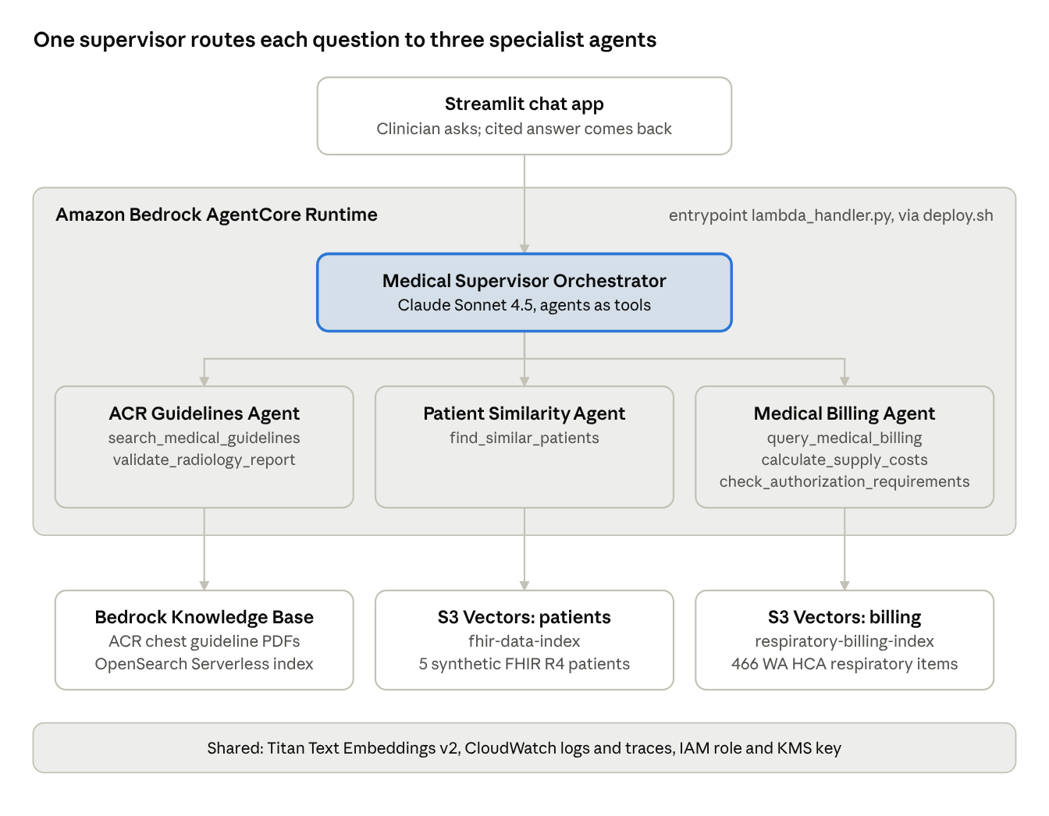
System architecture, as built in the AWS sample
Each agent embeds the question with Titan Text Embeddings v2 (1024 dimensions) and queries its own index; the supervisor merges the results. Infrastructure comes from infrastructure.yaml (CloudFormation), data loading from the vector_pipeline/ scripts.
Changes for version 1
- Move the ACR Knowledge Base from OpenSearch Serverless to S3 Vectors, so all three stores are S3 Vectors and idle cost is near zero.
- Add a chart-to-guideline tool (FR-8) that reads one FHIR patient and checks a planned order against the ACR criteria.
- Turn validate_radiology_report into a checklist that returns pass/gap per item (FR-3).
- Add a coverage-limit check beside the prior authorization check (FR-7).
- Add Bedrock Guardrails, a citation and refusal step in the supervisor, and an evaluation harness (FR-9, FR-10, FR-13).
- Show AgentCore traces in the Streamlit app (FR-11).

Cost
As the sample is built, a pilot month costs roughly $450 to $550, and about $350 of that is the OpenSearch Serverless collection, which bills even when nobody uses it. Moving the guidelines Knowledge Base onto S3 Vectors brings a pilot month to roughly $100 to $175.
Assumptions: us-east-1, 30 users asking 50 questions each per month (1,500 questions), about 4 model calls and 20,000 input plus 2,000 output tokens per multi-agent question. Figures are approximate, from AWS list prices; check the Bedrock, AgentCore and OpenSearch Serverless pricing pages before budgeting.
Component | As in the sample (USD/month) | Recommended (USD/month) | Why
Claude Sonnet 4.5 on Bedrock | 75 to 150 | 75 to 150 | About $0.05 to $0.10 per question; scales with use
OpenSearch Serverless (ACR Knowledge Base) | about 350 | 0 | Minimum 2 OCUs at $0.24/hour, always on; replace with S3 Vectors
S3 Vectors (FHIR, billing, guidelines) | under 5 | under 5 | Tiny indexes; pay per GB and per query
AgentCore Runtime | 5 to 15 | 5 to 15 | Billed for active CPU and memory only
Titan Embeddings v2 | under 1 | under 1 | $0.02 per million tokens
CloudWatch, S3, Lambda, KMS | 5 to 15 | 5 to 15 | Logs and traces dominate
Total | about 450 to 550 | about 100 to 175
The earlier single-agent class demo in this project was estimated at $5 to $15 a month; this system costs more because each question calls several agents and the sample keeps a search cluster running. Running scripts/cleanup.sh at the end of each term stops all charges.

Risks
The biggest risk is a confident wrong answer about a guideline or a code; the mitigations are citations, a refusal threshold and a graded gold set that gates every release.
Risk | Impact | Mitigation
Model invents a guideline, code or fee | Unsafe order or wrong claim | Cite every claim (FR-9); refuse below a retrieval threshold (FR-10); zero-tolerance metric on the gold set
Tiny data set (5 patients, 2 guideline PDFs) makes results look better than they are | Pilot overstates value | Expand to 100+ Synthea patients and more ACR topics before measuring
"Validation" is retrieval only in the sample | Users trust a check that never happened | Build FR-3 and FR-8 as explicit checklists with a pass/gap verdict
Billing data goes stale (extracted January 5, 2025) | Wrong fees or PA rules | Show extraction date; re-run billing_info_fetcher.py each term
Supervisor routes to the wrong agent | Partial or wrong answer | Routing accuracy metric; trace view; tune supervisor prompt
Idle infrastructure cost | Budget overrun | Move Knowledge Base to S3 Vectors; teardown script; AWS Budgets alert at $100
Real PHI uploaded by a user | Privacy breach | Synthetic-only rule, upload screening (NFR-1), Guardrails PII filter
Regulatory status changes with real use | Product treated as a medical device | Keep within non-device CDS criteria; legal review before hospital pilot
Model versions drift between files | Inconsistent behavior | Pin one model per release (NFR-16)

Milestones and open questions
The pilot takes about 12 weeks, one semester, and the evaluation gate decides whether it runs at all.
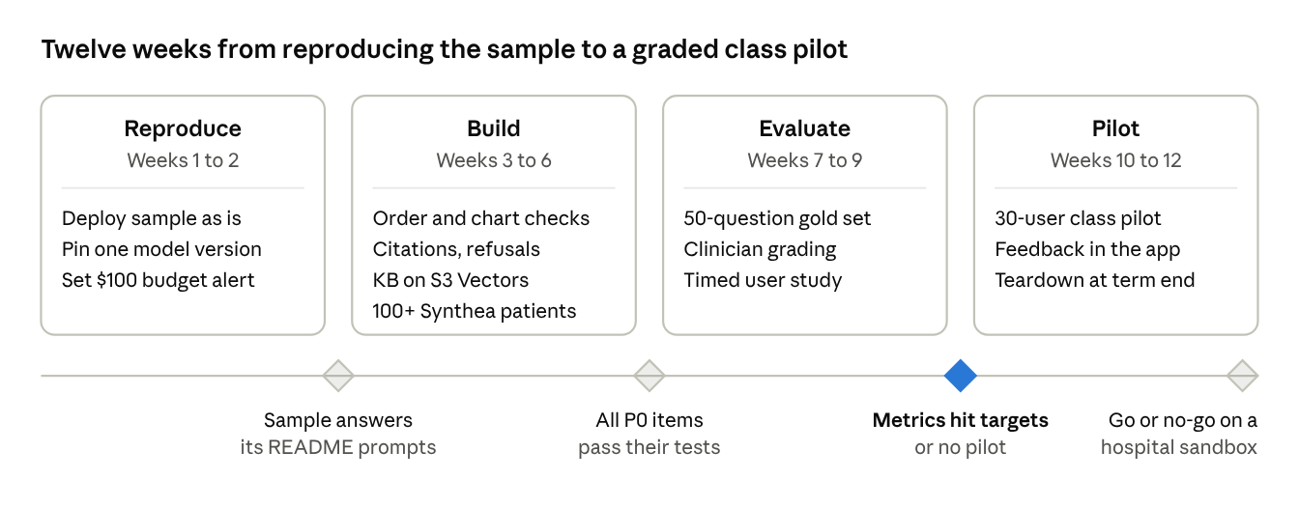
Roadmap · 4 phases, 4 gates
A hospital sandbox with de-identified data would be a separate phase, starting only after a BAA, IRB approval and legal review (NFR-2, NFR-12).
Open questions
- ☐ Is this for teaching (students build and study it) or a pitch to a hospital partner? The metrics and timeline change with the answer.
- ☐ Which clinician and coder will write and grade the 50-question gold set?
- ☐ Which AWS account and budget will host it, and who owns teardown?
- ☐ Stay with Washington State HCA billing data, or swap in a payer closer to the partner hospital?
- ☐ Expand guidelines beyond ACR chest imaging in version 1, or hold for version 2?

Sources
- aws-samples/sample-bedrock-agentcore-healthcare-s3vectors: README, strands_agentcore/ agents, infrastructure.yaml, config.yaml, deploy.sh, read October 5, 2026
- ACR Appropriateness Criteria
- Washington State HCA billing guides and fee schedules

