**Using new church site**

* New google account to manage **calendar** and **email**
  + This account it linked to a google account but the login will use an email address from our website
  + **Login information (**<https://accounts.google.com/signin/v2/sl/pwd?hl=en&flowName=GlifWebSignIn&flowEntry=ServiceLogin> **)**
    - Email
      * [Lafayetteumc@lafayetteumc.net](mailto:Lafayetteumc@lafayetteumc.net)
    - Password
      * purpleMonkeys135!
    - Email may appear as [lafayetteumcmailing@gmail.com](mailto:lafayetteumcmailing@gmail.com) but that is basically the same as the email I provided. I needed to create that account for gmail to work but they are linked together and no one should ever see the [lafayetteumcmailing@gmail.com](mailto:lafayetteumcmailing@gmail.com) however is logging in isn’t working you can try that email address instead of the one provided above.
  + **Calendar**
    - <https://calendar.google.com/>
      * Or when on google.com you should see a square icon to click then you can get to calendar from there
      * 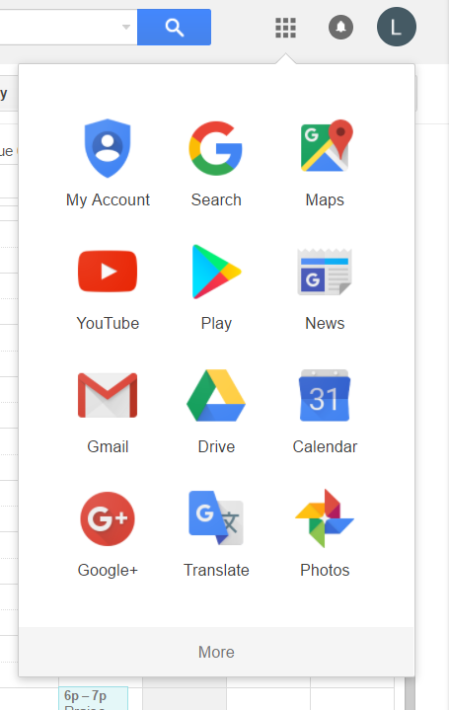
    - Any event you add to this calendar will be added to the churches website
  + **Gmail**
    - You should be able to access gmail from that same picture above
    - Any email sent from this gmail should say the email is come from [lafayetteumc@lafayetteumc.net](mailto:lafayetteumc@lafayetteumc.net)
      * Technically the gmail is linked to [lafayetteumcmailing@gmail.com](mailto:lafayetteumcmailing@gmail.com) but I have set a setting to make it so when ever an email is sent it will appear as though [lafayetteumc@lafayetteumc.net](mailto:lafayetteumc@lafayetteumc.net) sent it
    - To send a new email select compose on the left side of the screen. Then to access the mailing list I added either type ‘church mailing list’ into the to field or click the To. Then from there all your contacts should appear and in the upper left you should see ‘My contacts’ if you click that you can change it to the church mailing list and from there select all.
    - **Adding contacts**
      * In the upper left, you should see the word Gmail select that and then click contacts (you should be redirected to another page)
      * From there just make sure to select the church mailing list and hit the + in the bottom right side of the screen. That’s all that should be needed to add to the mailing list.
* **Administration section on website**
  + To login you can use the same credentials for the google account
    - Email
      * [Lafayetteumc@lafayetteumc.net](mailto:Lafayetteumc@lafayetteumc.net)
    - Password
      * purpleMonkeys135!
  + Once logged in there are two things that can be done.
    - Adding images to home slider. You can upload new images or delete images so that way those can stay up to date.
    - Adding additional links to the side menu. If there is ever anything that needs to be added to the side bar you can easily add an item to the side bar by providing a display name and URL.