Rhea Patel sitemap, photos, links

Project Images

<https://www.youtube.com/watch?v=pgYmY6--DjI>

Discovery Channel UK Official Youtube

Labeled for reuse: 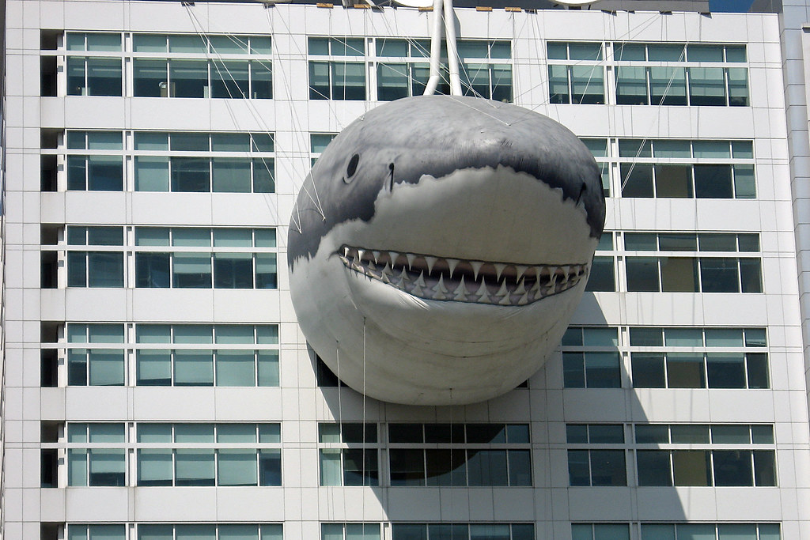



<https://pxhere.com/en/photo/23047>

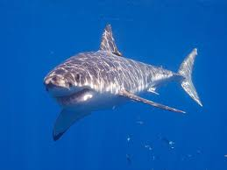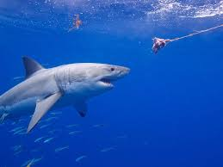

Shark conservation companies

<https://www.projectaware.org/sharks?gclid=Cj0KCQjwt5zsBRD8ARIsAJfI4BgdXWEsH6JRI3QTg_KTVEEp8S52dJWfOPWALqOWErm3dtws36dSWJwaAg_WEALw_wcB>

<https://4ocean.com/shark-bracelet/?gclid=Cj0KCQjwt5zsBRD8ARIsAJfI4BifN2U-mEmcpHNrcRMmnU3F_Gu5TzFc2GjdZs8elwtKbOVE-b8LyCMaAkUREALw_wcB>

|  |  |  |
| --- | --- | --- |
| Photo/Video | Source | Usage |
| Whiteshark.jpg | <https://en.wikipedia.org/wiki/File:White_shark.jpg> | Yes |
| discovery | <https://www.flickr.com/photos/order_in_chaos/5129859111> | Yes |
| Lemon Shark | <https://pxhere.com/en/photo/23047> | Yes |
| Breach compilation | <https://www.youtube.com/watch?v=pgYmY6--DjI> | Yes |
| Shark conservation and why they are important | <https://www.youtube.com/watch?v=dmz3My3nUi0> | [yes](https://www.youtube.com/watch?v=dmz3My3nUi0) |