**Challenge #1**

I have taken below point as consideration.  
  
1) I have taken backend db as an RDS.

2) DB password i have stored in .tfvar file with sensitive security. For more security we can stor this on AWS SSM as well and take in.

3) I have created R53 entry and would like to add this instance as value in R53 DNS. We can add multiple server name or we create ELB and provide endpoint.

4) provider – In provider I have taken AWS. Not entered access and secrete key, terraform is smart to take our .aws default configuration that we have configure on our shell.

**Challenge #2**

I have considered here I have to collect required data from our EC2 metadata field.

I have create one bash script to provide required output.  
  
Output:-   
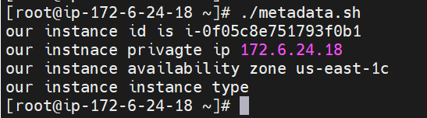

**Challenge #3**

1. Here I have used bash scripting to do get this nested output. Please find attached screenshot for more details. I have run some test and verified required output.

