Rich Patino 5/6/2021

Dr. Alaa Al-Ghazo ECE532 – Parking Garage Final Project

**Introduction**

The purpose of this project was to design and implement a parking garage using the MPLAB X and PICSimLab software. Three pushbuttons were used to indicate if a new car has arrived, a car is leaving, and if an emergency has occurred. The output of each pushbutton was displayed on an LED. Once a car arrives, the user is prompted to enter their username and password using one of the given combinations. The program was also responsible for keeping track of the number of cars in the parking garage by removing and adding a specific amount at a time.

**Approach**

When designing the required features for the parking garage it was important to keep in mind how to implement each scenario into MPLABX using the C programming language. As shown in the figure on the next page, it shows the overview design of the project. Once the user clicks button RD2, the LCD will display the USER message asking the person to enter the correct USER. IF the user is wrong the program won’t let the user through the gate. If it is correct, the screen will display PASS and prompt the user to enter their PASSWORD that matches the USER that they entered. To ensure each pushbutton was pressed, three if-statements were coded to ensure one loop handled the new car, another handled a car leaving, and the last to ensure an emergency would occur. Inside the new car if statement was a nested if-statement what printed the message LOT FULL when the counter, vehicle, was equal to the value 10. Therefore, a car was only allowed to enter the garage successfully when the vehicle counter was not equal to 10. The emergency alert was completed by printing EMERGENCY on the LCD and using a for-loop to turn on and off the LED RA2 using a 150ms delay. The USER and PASSWORD using the keypad was done by setting the keypress into a variable. If statements were used to check which buttons were pressed in a certain order and check if it was correct or not. The password function worked similarly in that if the User1 flag was high in the user function, and the correct password buttons were pushed then the system will light the corresponding LED with 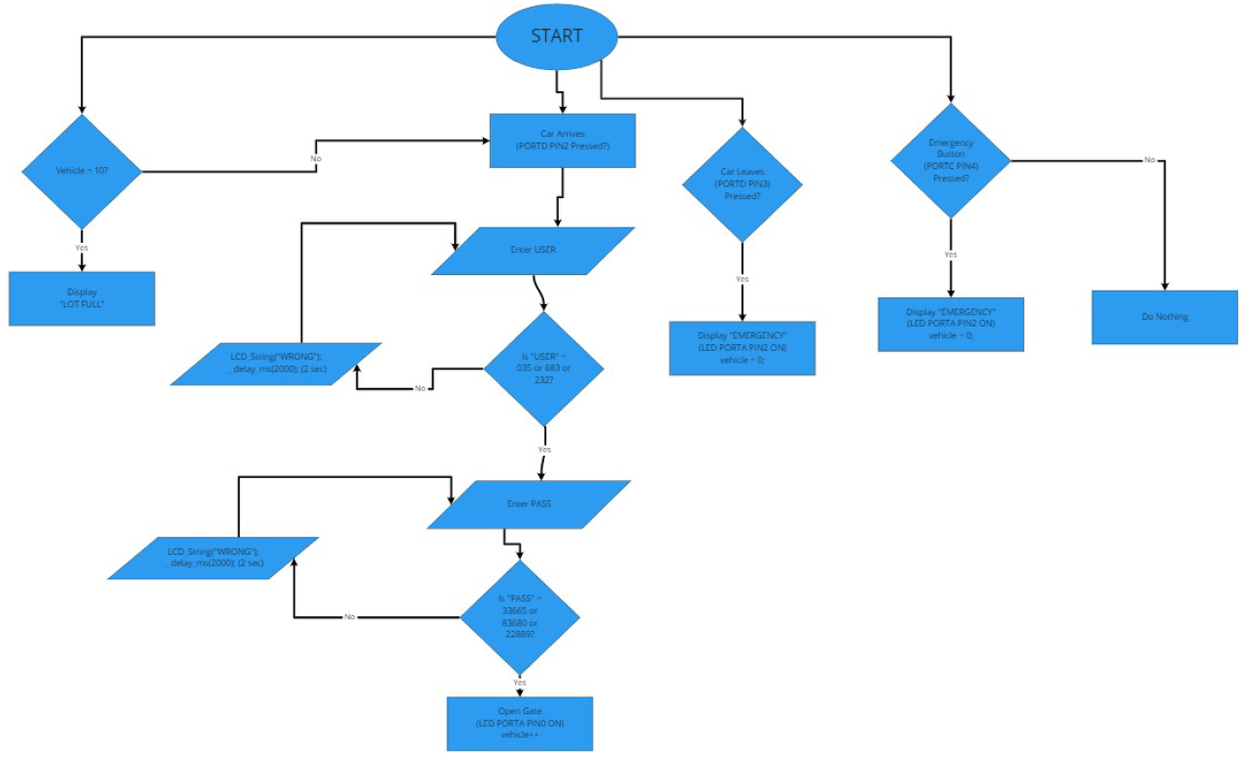the message on the LCD display.

Figure 1 – Flowchart Design

**Results**

After testing each section at a time by first testing the pushbuttons and LED, the most challenging section was getting the keypad to work with the LCD screen. An issue with the keypad that was brought up to the professors attention was that the first column containing the characters ‘1’, ‘4’, ‘7’, and ‘*’ had some sort of issue in the given keypad_scanner() function. When one button was pressed another one will show up on the screen. The most efficient way to solve the issue for this project was to use the keypad numbers that functioned correctly. Another similar bug was that the right side of the keypad worked just fine but rarely the key ‘8’ and ‘0’ would print out the digit ‘2’. In summary, the project was indeed successful by being fully functional and it was very interesting on implementing a parking garage using 4 devices.