**INTRODUCTION**

**OVERVIEW:-**

A warm welcome to everyone!!! I am Catherine R team leader of our Naan Mudhalvan project. Our topic is "**VISUALIZATION TOOL FOR ELECTRIC VEHICLE CHARGE AND RANGE ANALYSIS**". Our team members are

PAVITHRA R

MALINI S

SHANMATHI E

Here we explained about EV cars and range analysis in india. We gave complete details about the project in dashboard and story. In our project we explained about the purpose, advantage and disadvantage, application of electric cars in india

**PURPOSE:-**

Pure EVs have zero tailpipe emissions, which reduces air pollution. Since the electric motor of the EV operates on a closed circuit, it does not emit any harmful gases. Pure electric cars do not require petrol or diesel, which is excellent for the environment.

**PROBLEM DEFINING AND DESIGN THINKING**

**EMPATHY MAP**

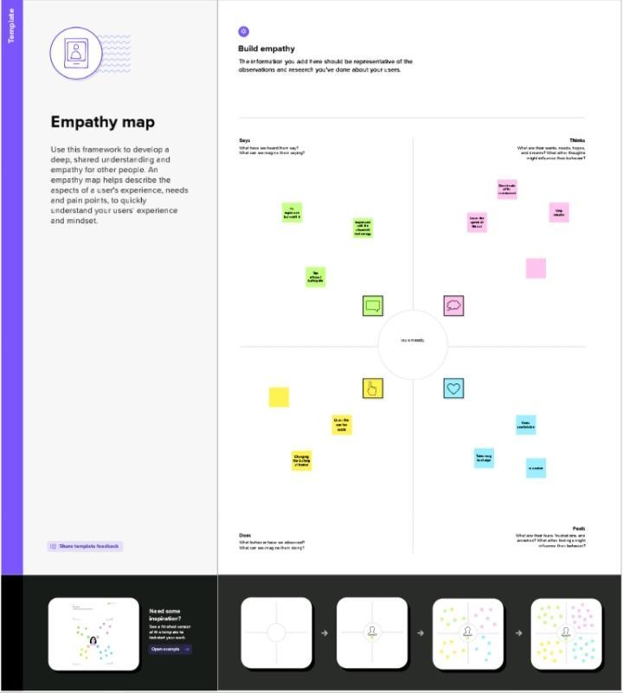

**BRAINSTORM:-**

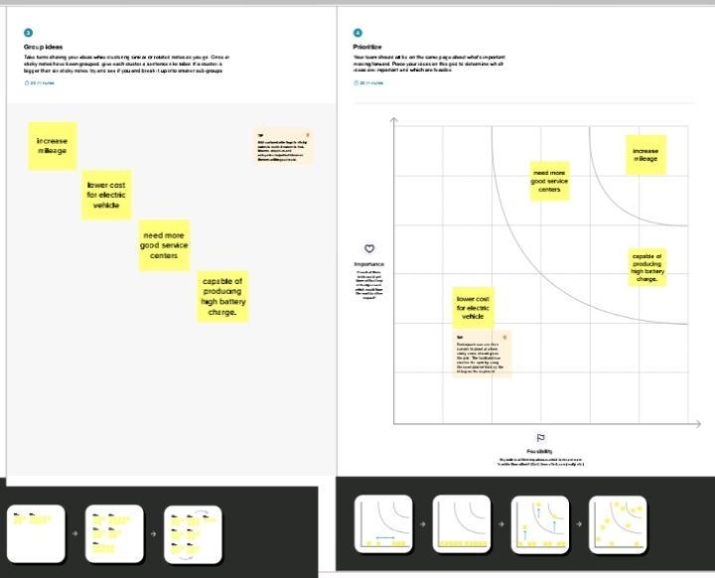

**RESULT:-**

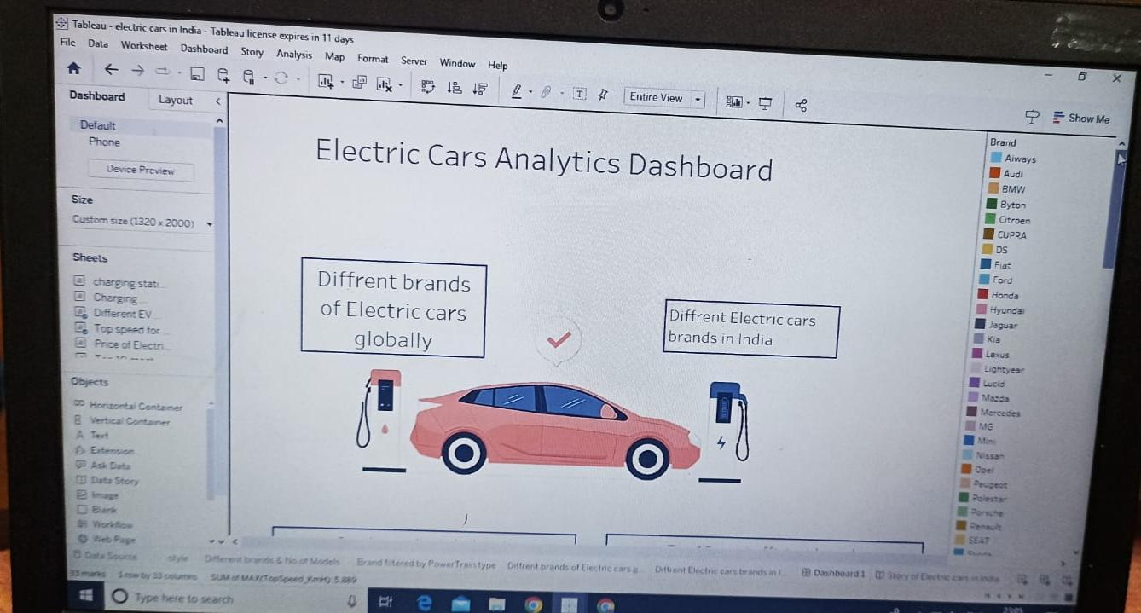

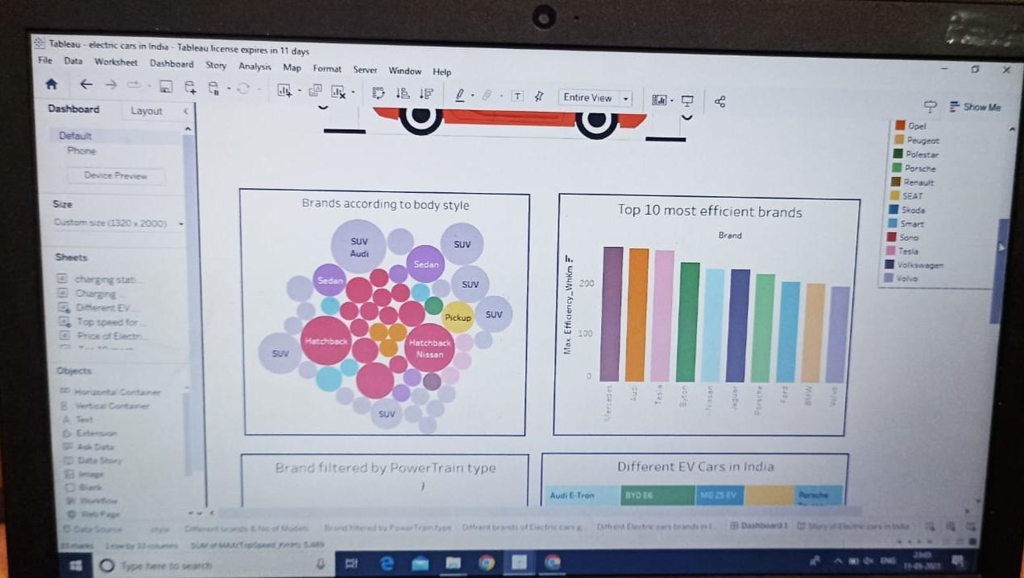

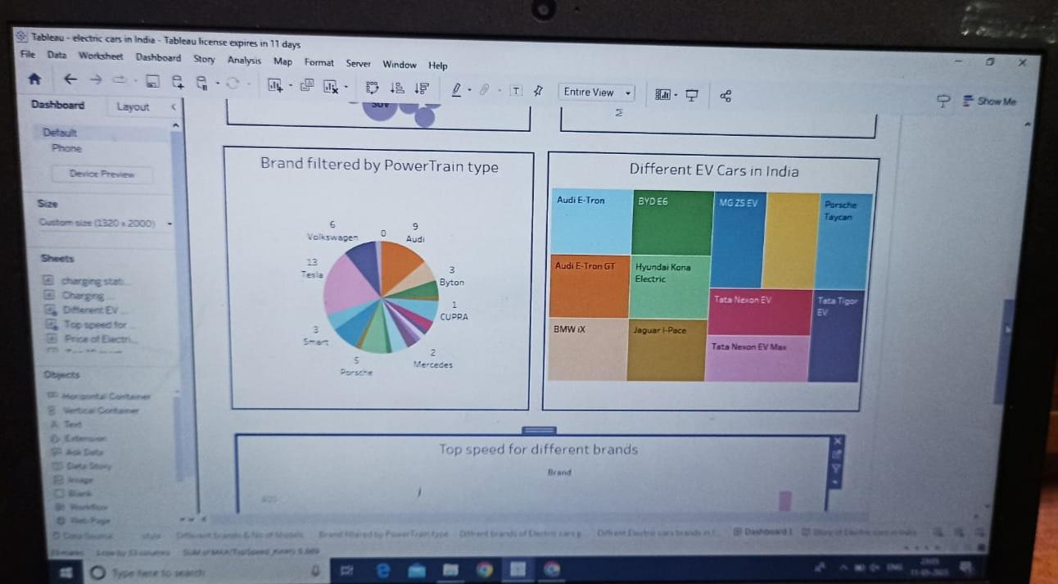

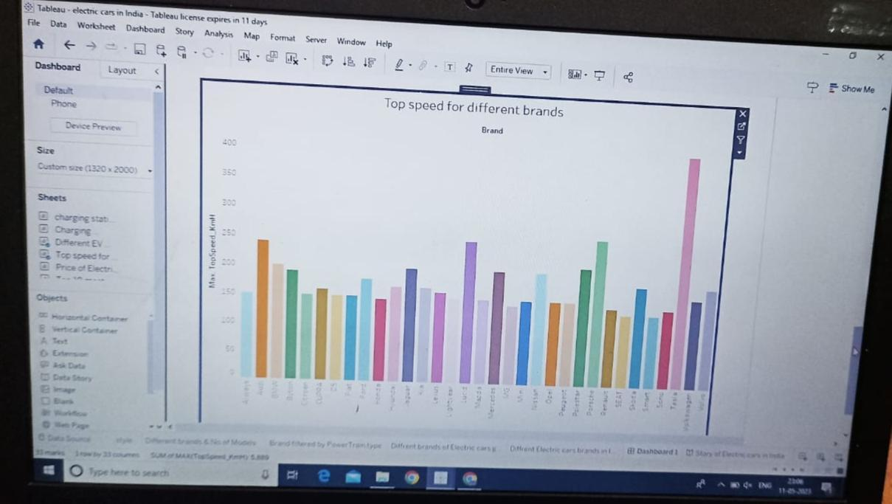

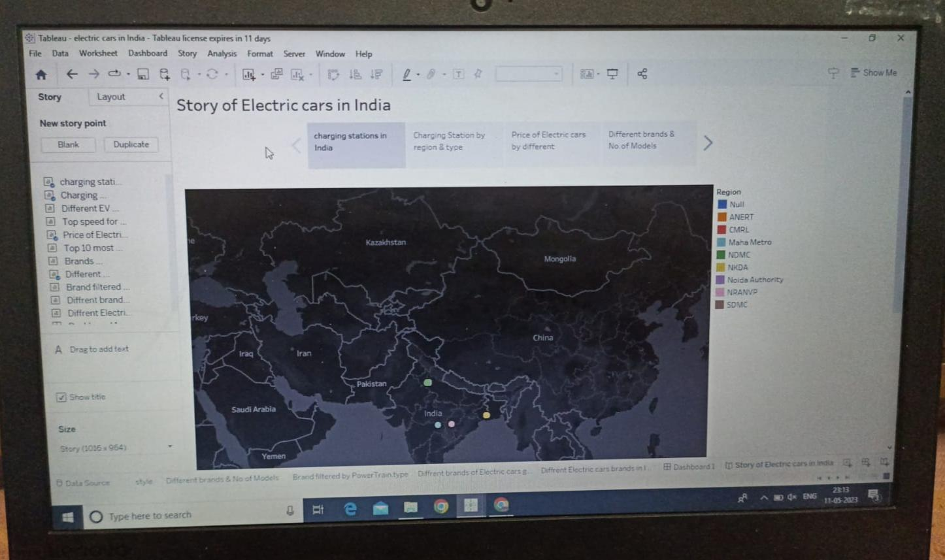

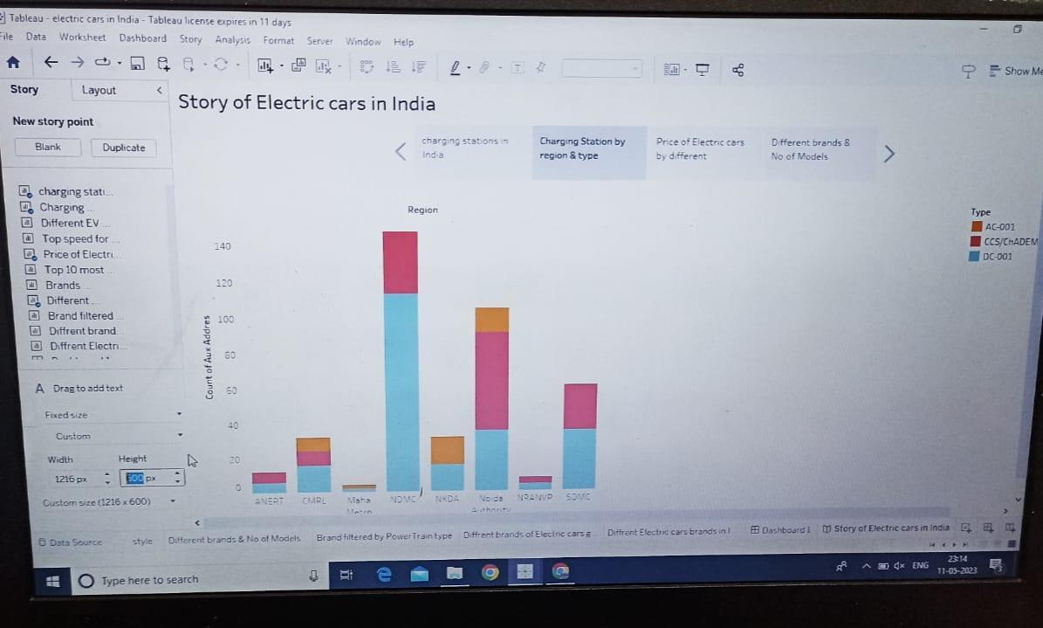

Hmm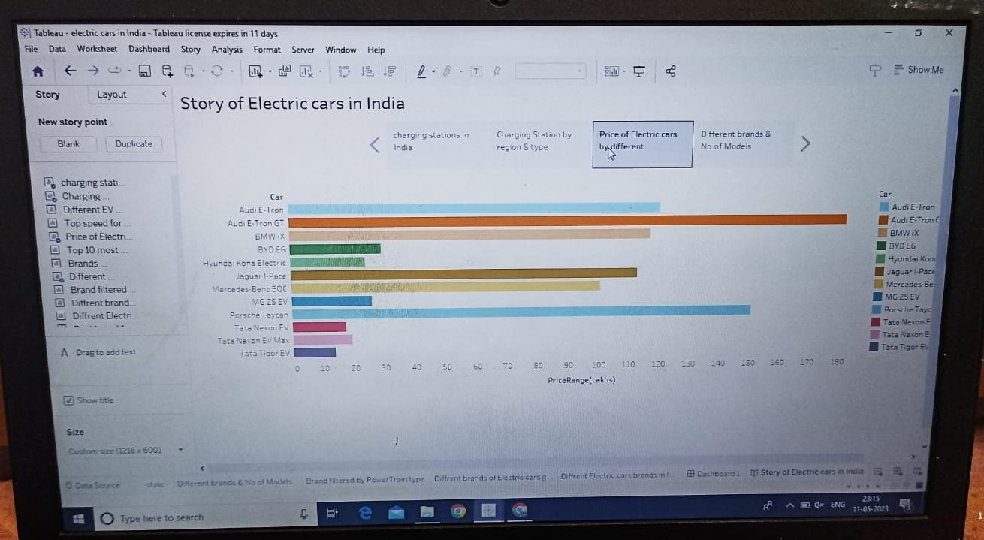

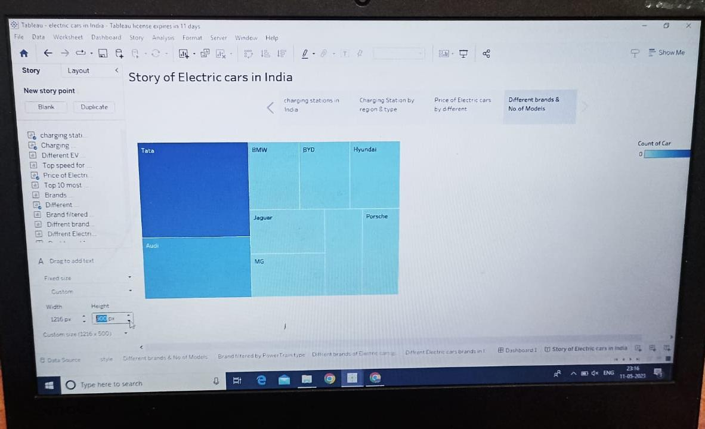

**ADVANTAGES:-**

* Eco-friendly
* Renewable energy source
* Less noise and smoother motion
* Cost-effective
* Low maintenance

**DISADVANTAGES:-**

* High initial cost
* Charging station limitation
* Recharging takes time

Limited options

* Less driving range

**APPLICATION:-**

It is used in the electric motors, batteries, inverters, wiring and in charging stations because of its durability, malleability, reliability and superior electrical conductivity.

**CONCLUSION:-**

The Indian electric vehicle market was worth USD 1,434.04 million in 2021, and it is predicted to grow to USD 15,397.19 million by 2027, at a CAGR of 47.09% during the forecast period (2022-2027).

**FUTURE SCOPE**

[**https://intellipaat.com**](https://intellipaat.com)

Visit the above website to know about the scope of EV cars in india.

**APPENDIX**

**SOURCE CODE**

[**https://www.ibef.org**](https://www.ibef.org)

Visit the above website to know about the source and development of EV cars in india.

**THANK YOU☺️**