1. List all classrooms with a capacity greater than 50.

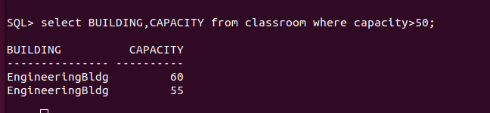
2. Find the names of all instructors in the "Computer Science" department.

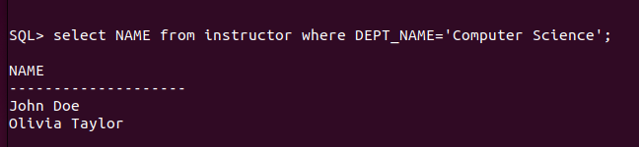
3. Retrieve the titles of all courses offered in the "Spring" semester of 2023.

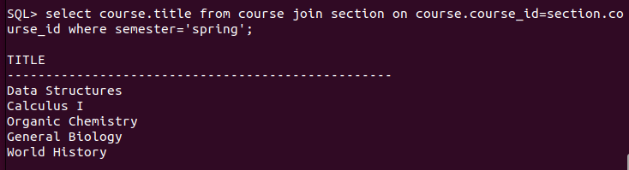
4. List all students who have taken more than 50 total credits.
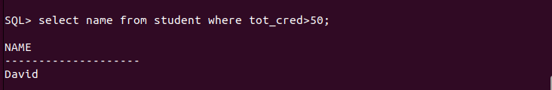
5. Find the names of all departments with a budget greater than ₹1,000,00.

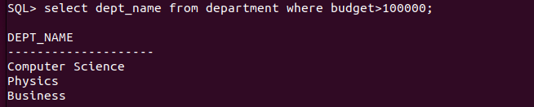
6. List all departments and their respective buildings.
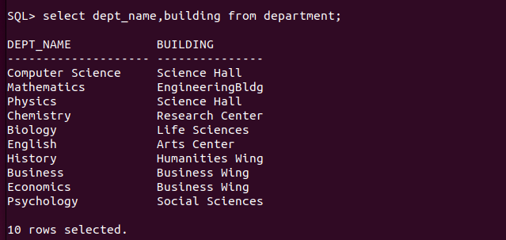
7. Find the names of all students enrolled in the "computer science" department.
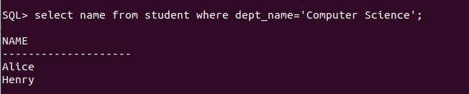

8. Retrieve the titles of all courses with 3 credits.

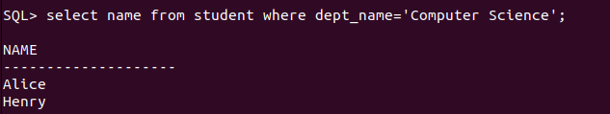
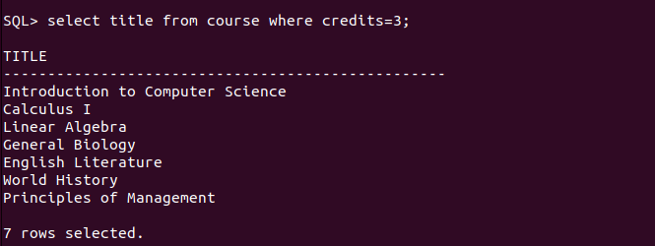
9. List all instructors who do not belong to any department.
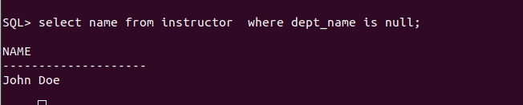
10. Find the total number of classrooms in each building.

14. List all instructors who earn a salary greater than ₹50,000.

