Name : Rahul Pandey , Rollno.:_244ca039, Assignment:-5
1.Create the following tables with the following attributes and constraints on them
a. Bank (bk_code, bk_name, bk_address):-
CREATE TABLE Bank (
bk_code VARCHAR(10) PRIMARY KEY,
bk_name VARCHAR(50) NOT NULL,
bk_address VARCHAR(100) NOT NULL
);
b. Branch (br_id, br_name, br_address, bk_code):-
CREATE TABLE Branch
( br_id VARCHAR(10) PRIMARY KEY,
br_name VARCHAR(50) NOT NULL,
br_address VARCHAR(100) NOT NULL,
bk_code VARCHAR(10),
FOREIGN KEY (bk_code) REFERENCES Bank(bk_code) ON DELETE CASCADE );
c. Customer (cust_ID , cust_name, phone_no, address)
CREATE TABLE Customer (
cust _ID INT PRIMARY KEY,
cust _name VARCHAR(50) NOT NULL,
phone _no VARCHAR(15) UNIQUE NOT NULL,
address VARCHAR(100) NOT NULL
);
d. Account (acc_no, acc_type, balance, br_id)
CREATE TABLE Account ( acc_no INT PRIMARY KEY,
acc_type VARCHAR(20) NOT NULL CHECK (acc_type IN ('Savings', 'Current', 'Fixed Deposit')),
balance DECIMAL(10,2) CHECK (balance >= 0),
br_id VARCHAR(10),
FOREIGN KEY (br_id) REFERENCES Branch(br_id) ON DELETE CASCADE );

e. Customer_Account (cust_ID, acc_no)
CREATE TABLE Customer_Account (
cust_ID INT,
acc_no INT,
PRIMARY KEY (cust_ID, acc_no),
FOREIGN KEY (cust_ID) REFERENCES Customer(cust_ID) ON DELETE CASCADE, FOREIGN KEY (acc_no) REFERENCES Account(acc_no) ON DELETE CASCADE )
f. Loan (loan_ID, loan_type, amount, br_id)
CREATE TABLE Loan (
loan_ID INT PRIMARY KEY,
loan_type VARCHAR(20) NOT NULL CHECK (loan_type IN ('Home Loan', 'Vehicle Loan', 'Personal Loan')),
amount DECIMAL(10,2) CHECK (amount > 0),
br_id VARCHAR(10),
FOREIGN KEY (br_id) REFERENCES Branch(br_id) ON DELETE CASCADE );

g. Customer_Loan (cust_ID, loan_ID)
CREATE TABLE Customer_Loan (
cust_ID INT
, loan_ID INT,
PRIMARY KEY (cust_ID, loan_ID),
FOREIGN KEY (cust_ID) REFERENCES Customer(cust_ID) ON DELETE CASCADE, FOREIGN KEY (loan_ID) REFERENCES Loan(loan_ID) ON DELETE CASCADE );
Insert into Bank table:
INSERT INTO Bank VALUES ('B001', 'HDFC Bank', 'MG Road, Bangalore');
INSERT INTO Bank VALUES ('B002', 'ICICI Bank', 'NITK, Surathkal');
INSERT INTO Bank VALUES ('B003', 'SBI Bank', 'Whitefield, Bangalore');
INSERT INTO Bank VALUES ('B004', 'Axis Bank', 'Marathahalli, Bangalore');
INSERT INTO Bank VALUES ('B005', 'Kotak Bank', 'Andheri, Mumbai');
Insert into Branch table
INSERT INTO Branch VALUES ('BR01', 'MG Road Branch', 'MG Road, Bangalore', 'B001');
INSERT INTO Branch VALUES ('BR02', 'Surathkal Branch', 'NITK, Surathkal', 'B002');
INSERT INTO Branch VALUES ('BR03', 'Whitefield Branch', 'Whitefield, Bangalore', 'B003');
INSERT INTO Branch VALUES ('BR04', 'Marathahalli Branch', 'Marathahalli, Bangalore', 'B004');
INSERT INTO Branch VALUES ('BR05', 'Andheri Branch', 'Andheri, Mumbai', 'B005');
Insert into customer:
INSERT INTO Customer VALUES (101, 'Amit', '9876543210', 'Mumbai');
INSERT INTO Customer VALUES (102, 'Ravi', '9988776655', 'Chennai');
INSERT INTO Customer VALUES (103, 'Sita', '9090909090', 'Delhi');
INSERT INTO Customer VALUES (104, 'Krishna', '8777888899', 'Kolkata');
INSERT INTO Customer VALUES (105, 'Radha', '7666555444', 'Pune');
Insert into
INSERT INTO Account VALUES (2001, 'Savings', 15000, 'BR01');
INSERT INTO Account VALUES (2002, 'Current', 5000, 'BR02');
INSERT INTO Account VALUES (2003, 'Savings', 2000, 'BR03');
INSERT INTO Account VALUES (2004, 'Fixed Deposit', 50000, 'BR04');
INSERT INTO Account VALUES (2005, 'Savings', 8000, 'BR05');
INSERT INTO Customer_Account VALUES (101, 2001);
INSERT INTO Customer_Account VALUES (102, 2002);
INSERT INTO Customer_Account VALUES (103, 2003);
INSERT INTO Customer_Account VALUES (104, 2004);
INSERT INTO Customer_Account VALUES (105, 2005);
INSERT INTO Loan VALUES (3001, 'Home Loan', 500000, 'BR01');
INSERT INTO Loan VALUES (3002, 'Vehicle Loan', 300000, 'BR02');
INSERT INTO Loan VALUES (3003, 'Personal Loan', 200000, 'BR03');
INSERT INTO Loan VALUES (3004, 'Home Loan', 700000, 'BR04');
INSERT INTO Loan VALUES (3005, 'Vehicle Loan', 250000, 'BR05');
INSERT INTO Customer_Loan VALUES (101, 3001);
INSERT INTO Customer_Loan VALUES (102, 3002);
INSERT INTO Customer_Loan VALUES (103, 3003);
INSERT INTO Customer_Loan VALUES (104, 3004);
INSERT INTO Customer_Loan VALUES (105, 3005);
3. List the details of all customers.
4. Find the cust_ID and phone number of customer ‘Ravi’.
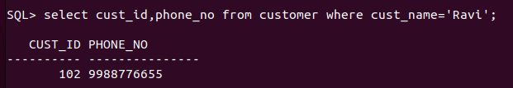
5. Find the Address of all branches of br_01.
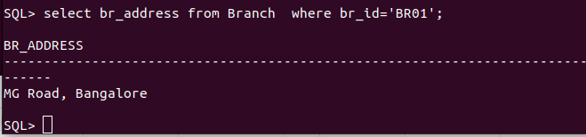
6. Find the details of Customer having ID 103.
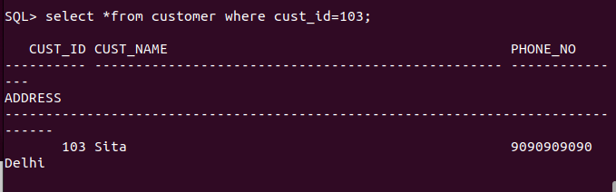
7. List the account details having balance more than 10000.

8. List the account details of branch br_02.
select *from account where br_id='BR02';
9. List the loan details of branch br_01.
select *from loan where br_id='BR01';
10. List the account details with their branch address.
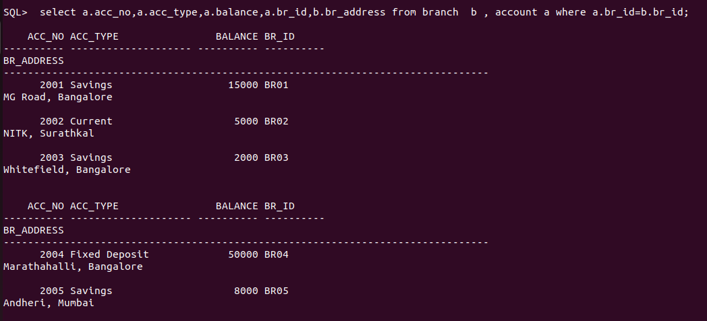
11. List the customer details with their account details.
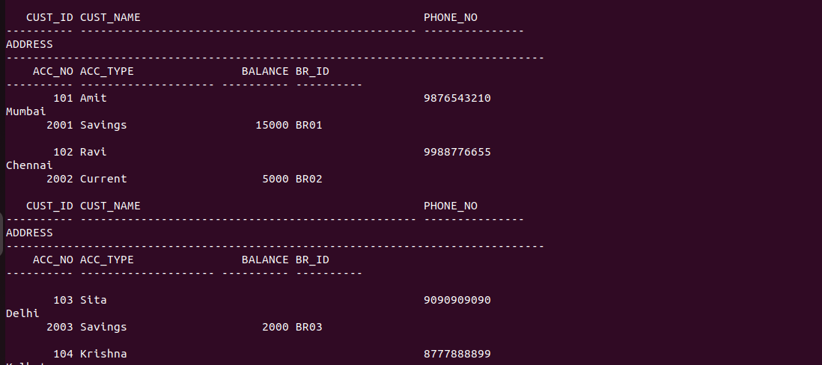
12. List the customer details having account type ‘savings’.
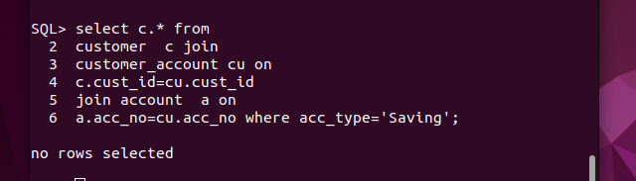
13. List the customer details having vehicle loan.
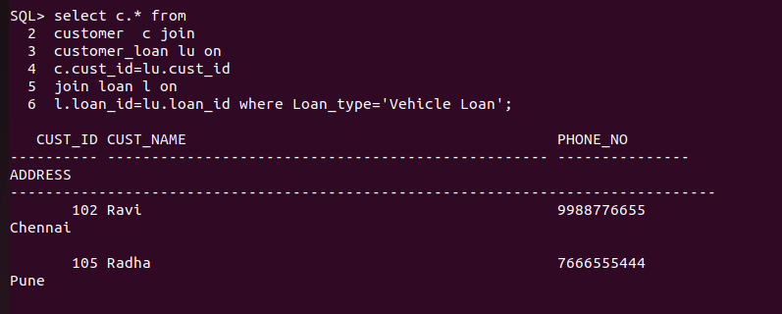
14. List the branch names of all accounts.
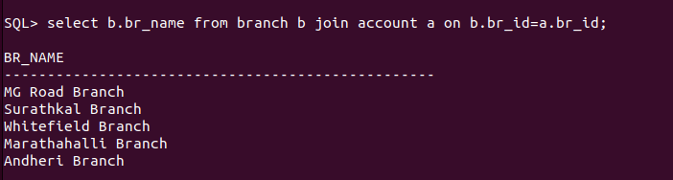
15. List the customer details going to ‘Surathkal’ branch.
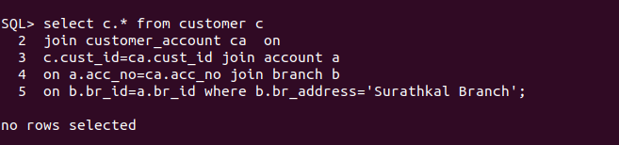
16. List the customers having loan account in ‘MG Road’ branch.
17. Find the customers having balance between 1000 to 10000 .
18. Give a bonus of rupees 100 to customers having more than 10000 balance.

19. Deduct 50 rupees from customers having less than 500 rupees in balance.

20. Give the customer details having home loan.
22. Add a column NOMINEE to the customer table with data type varchar (50).
23. List all the account numbers in ascending order of their balance.
24. Count the number of customers having account type savings.
25. Count the number of customers for each account type.
26. Find the total balance in Savings account.
27. Find the average balance of Current account.
28. Find the average balance for each account type.
29. Find the customer details having maximum balance.
30. Find the average amount for vehicle loan.
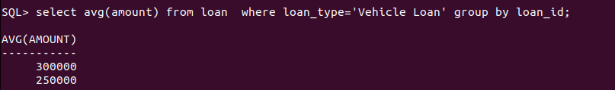
31. Find the average balance in each branch
