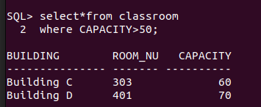
Q1

SQL> select*from classroom
2 where CAPACITY>50;


Q2

SQL> select instructor.name
2 from instructor
3 where dept_name='Computer Science'
4 ;


Q3

SQL> select distinct course.title
2 from course
3 join teaches on course.course_id=teaches.course_id
4 and teaches.semester='Spring' AND teaches.year=2024
5 ;

Q4


SQL> select student.name
2 from student
3 where tot_cred>50;


Q5
SQL> select department.dept_name
2 from department
3 where budget>1000000
4 ;

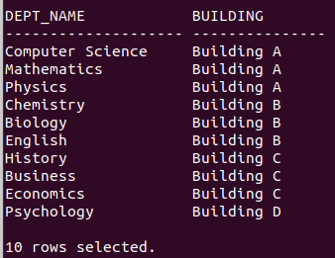

Q6
SQL> select department.dept_name,department.building
2 from department
3 ;


Q7

SQL> select student.name
2 from student
3 where dept_name='Computer Science'
4 ;


Q8
SQL> select course.title
2 from course
3 where credits=3
4 ;


Q9

SQL> select i.name
2 from instructor i
3 LEFT JOIN department d ON i.dept_name=d.dept_name
4 WHERE d.dept_name IS NULL;

Q10
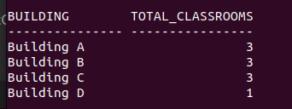
SQL> select building,COUNT(room_number) as total_classrooms
2 from classroom
3 GROUP BY building;


Q11
SQL> select course.title
2 from instructor, course,teaches
3 where instructor.ID='IJ01' AND instructor.ID=teaches.ID AND teaches.course_id=course.course_id
4 ;

Q12

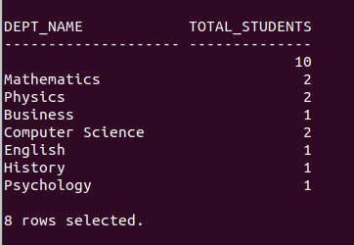
SQL> SELECT dept_name, COUNT(id) AS total_students
2 from student
3 GROUP BY dept_name;

Q13


SQL> SELECT student.name
2 from student
3 JOIN takes ON student.ID=takes.ID
4 JOIN course ON takes.course_id=course.course_id
5 WHERE course.course_id='AA110' AND takes.grade='A'
6 ;


Q14

SQL> select instructor.name
2 from instructor
3 where salary>50000
4 ;

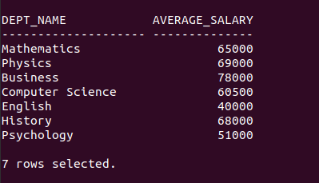
Q15
SQL> select dept_name,AVG(salary) AS average_salary
2 from instructor
3 group by dept_name;

Q16


Q17
SQL> select course_id
2 from prereqSQL> SELECT building, COUNT(*)AS total_sections
2 from section
3 group by building;
3 where prereq.course_id='AA110'
4 ;

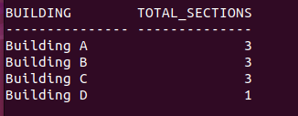
Q18
SQL> SELECT building, COUNT(*)AS total_sections
2 from section
3 group by building;

Q19

SELECT DISTINCT s.name
FROM student s
JOIN takes t ON s.student_id = t.student_id
WHERE t.semester = 'Fall' AND t.year = 2022;

Q20


SQL> SELECT c.building,c.room_number
2 FROM classroom c
3 LEFT JOIN section s
4 ON c.building=s.building AND c.room_number=s.room_number
5 WHERE s.room_number IS NULL
6 ;


Q21
SQL> SELECT course_id,title
2 from course
3 where dept_name='Mathematics'
4 ;


Q22
SQL> SELECT s.name
2 FROM student s
3 JOIN takes t ON s.ID=t.ID
4 GROUP BY s.ID,s.name
5 HAVING SUM(CASE WHEN t.semester='Fall' THEN 1 ELSE 0 END)>0
6 AND SUM(CASE WHEN t.semester='Spring' THEN 1 ELSE 0 End)>0;

Q23

SQL> SELECT i.name
2 FROM instructor i
3 JOIN teaches t ON i.ID=t.ID
4 GROUP BY i.ID,i.name
5 HAVING COUNT(t.sec_id)>5;

Q24
SQL> select c.course_id,c.title
2 from course c
3 LEFT JOIN prereq p ON c.course_id=p.course_id
4 WHERE p.course_ID IS NULL;

Q25
SQL> select s.dept_name,AVG(c.credits) AS average_credits
2 FROM student s
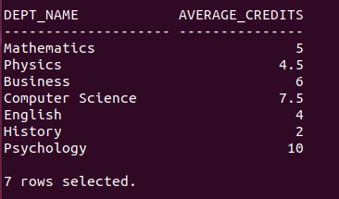
3 join takes t on s.ID=t.ID
4 join course c on t.course_id=c.course_id
5 GROUP BY s.dept_name;


Q26
SQL> select sum(budget) AS total_budget
2 FROM department;

