1. List all classrooms with a capacity greater than 50.

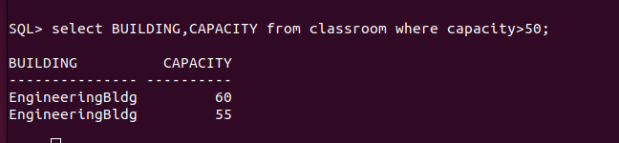
2. Find the names of all instructors in the "Computer Science" department.

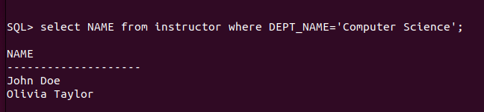
3. Retrieve the titles of all courses offered in the "Spring" semester of 2023.

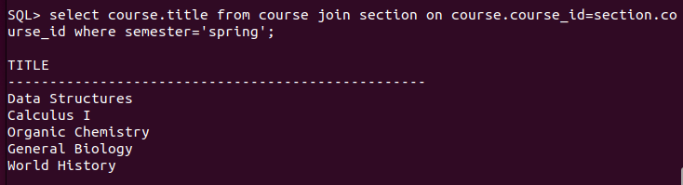
4. List all students who have taken more than 50 total credits.
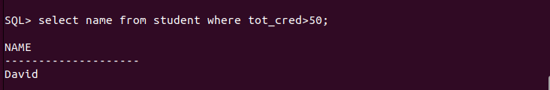
5. Find the names of all departments with a budget greater than ₹1,000,00.

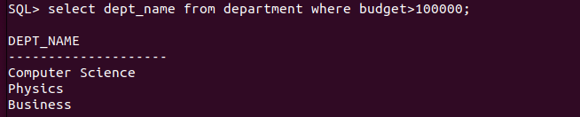
6. List all departments and their respective buildings.
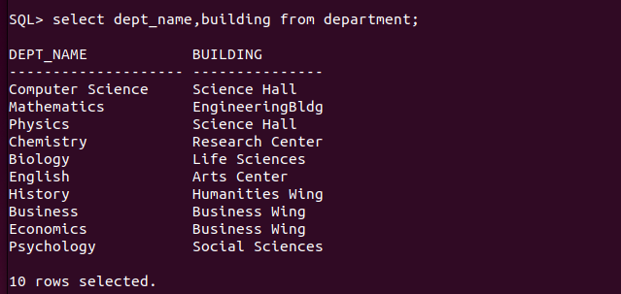
7. Find the names of all students enrolled in the "computer science" department.
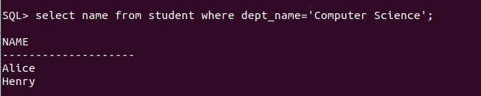

8. Retrieve the titles of all courses with 3 credits.

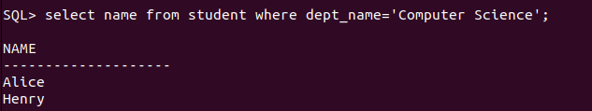
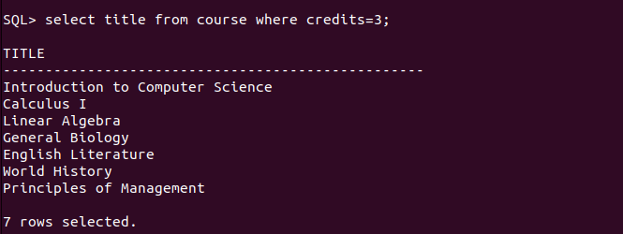
9. List all instructors who do not belong to any department.
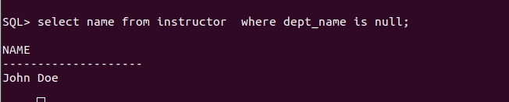
10. Find the total number of classrooms in each building.
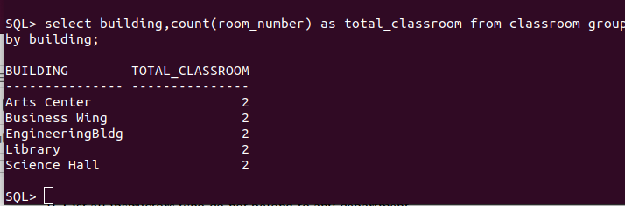
12. Find the total number of students enrolled in each department.
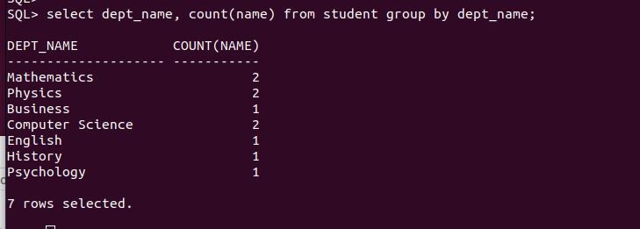
14. List all instructors who earn a salary greater than ₹50,000.

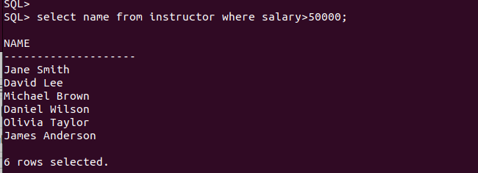
15. Find the average salary of instructors in each department.
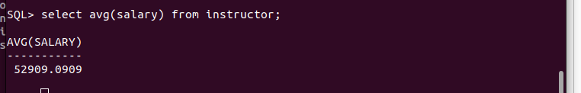
13.Retrieve the names of students who have taken the course "CS-101" and received an
"A" grade.
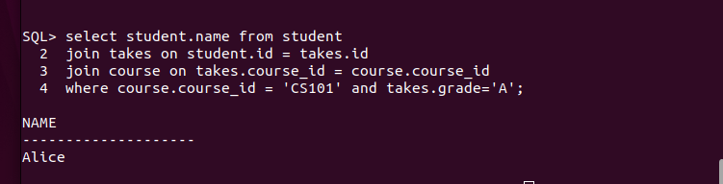
16. Retrieve the names of students who have not been assigned an advisor.

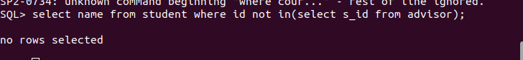
17. List all courses that have "CS-101" as a prerequisite.
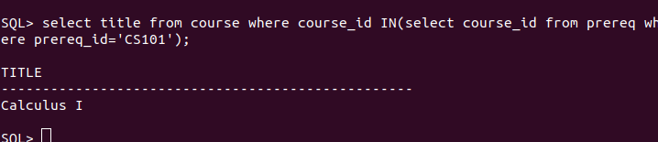
18. Find the total number of sections taught in each building.
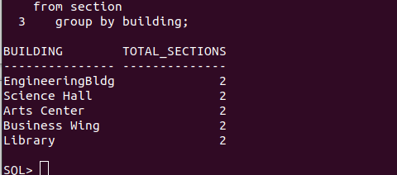

19. Retrieve the names of students who have taken at least one course in the "Fall"
semester of 2022.
26. Retrieve the names of students who have taken courses with the instructor "JHON DOE”;

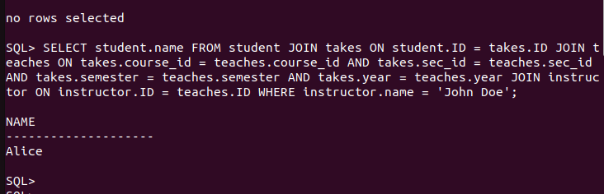
27. List all sections that are held in the "aRTS CENTER" building.
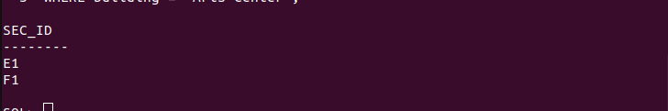
28. Find the total budget allocated to all departments.
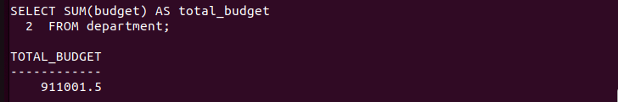
29. Retrieve the names of students who have taken at least one course with a grade of "B".
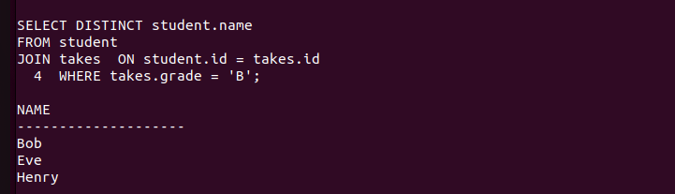

30. List all instructors who have not taught any courses.
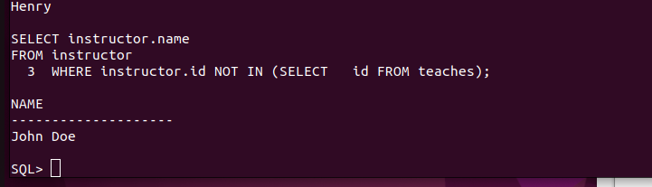

31. Find the names of students who have taken all courses offered by the "Computer
Science" department.
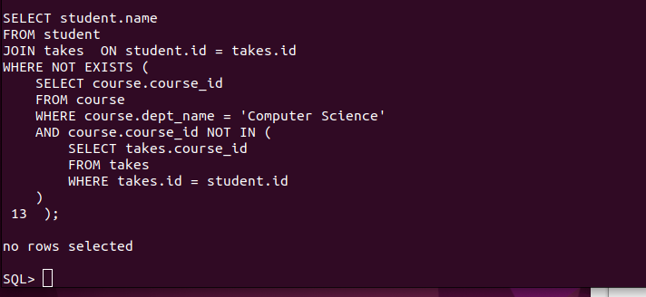

32. Retrieve the names of instructors who have taught every course in their department.
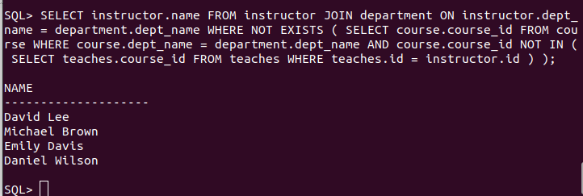

33. List all students who have taken at least one course with every instructor in their
department.
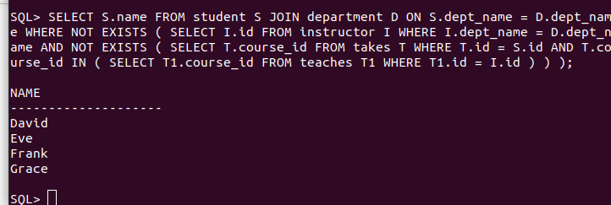
34. Find the courses that have the highest number of prerequisites.

35. Retrieve the names of students who have taken the same course more than once.
36. List all instructors who have taught in every semester (Fall, Winter, Spring, Summer) in
the year 2023.
37. Find the departments where the average instructor salary is greater than the overall
average salary
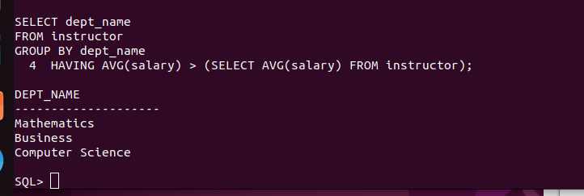
38. Retrieve the names of students who have taken courses in all available time slots.
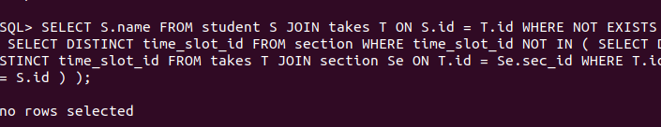
39. List all courses that have no prerequisites but are prerequisites for other courses.
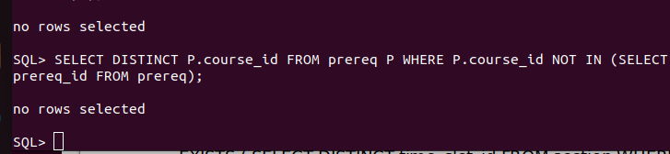
40. Find the students who have taken the most number of courses in a single semester.
41. Find the students who have taken courses from all departments.

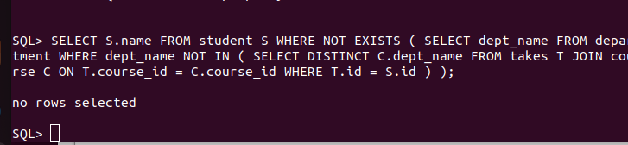
42. Retrieve the names of instructors who have taught the same course in multiple
semesters.SELECT T.course_id
FROM takes T
GROUP BY T.course_id
ORDER BY COUNT(T.id) DESC
LIMIT 1;
43. List all courses that are prerequisites for more than 3 other courses.
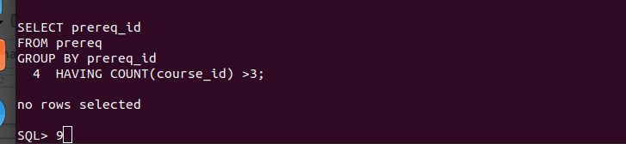
44. Find the departments where the total student credits exceed the department budget.
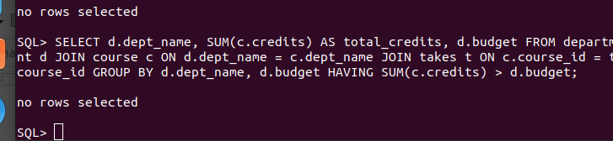
45. Retrieve the names of students who have taken courses with every instructor in their
department.
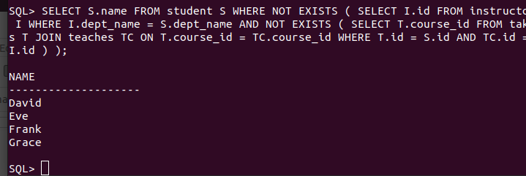
46. List all courses that have been taught in every semester.
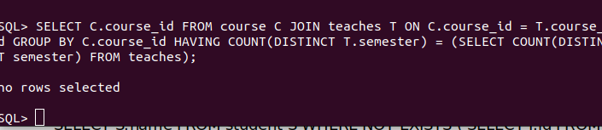
47. Find the students who have taken the most number of courses overall.
48. Retrieve the names of instructors who have taught courses in all buildings.
49. List all students who have taken courses with overlapping time slots.
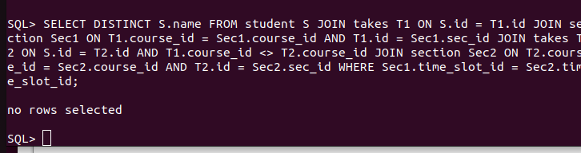
50. Find the courses that have the highest enrollment across all semesters.

