1. Retrieve the names of all instructors who teach at least one course in the 'Computer
Science' department.
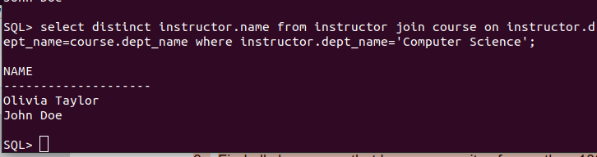
2. List all students who have taken at least one course in 'Fall' and 'Spring' semesters in
the same year.
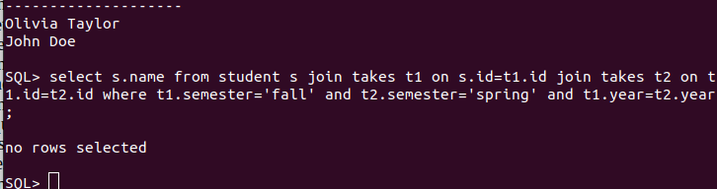
3. Find all classrooms that have a capacity of more than 100 but are not assigned to any
section.
4. Display all courses along with their prerequisites, including courses that have no
prerequisites.
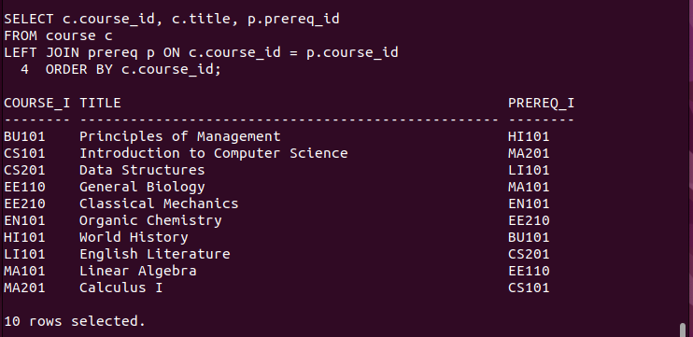
5. Retrieve the list of instructors who have never taught a course.


6. Find the total budget allocated to all departments that have at least one instructor
earning more than ₹100,000.

7. Find the average salary of instructors grouped by department but only include
departments with more than 5 instructors.

8. Find the total number of students enrolled in each course for every semester, and sort by
semester and number of students (descending).
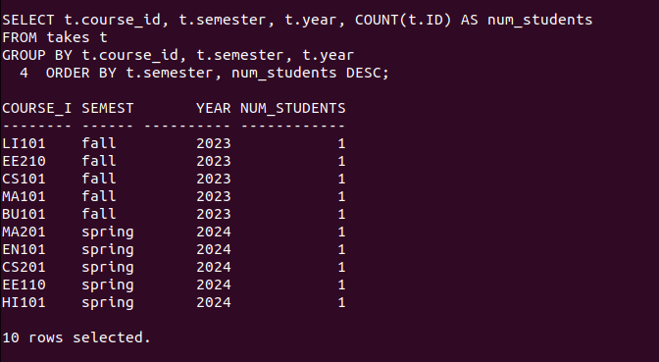
9. Determine which department has the highest average course credit.
10. Find the top 3 courses with the most students enrolled across all semesters.
11. Find all students who have taken every course taught by the instructor 'John Doe'.
12. Retrieve the names of students who have the same name as their advisor.
13. Find all instructors who have taught at least one course that they did not belong to the
department of.
14. List all students who have taken a course in a classroom that has a capacity less than
the number of students enrolled.
15. Find students who have taken every course offered by their department.
16. Identify the department(s) with the largest number of distinct courses offered.
17. Find students who have taken a course but have not received a grade.
18. Retrieve the details of instructors who have the exact same salary as another instructor.
19. Identify all courses that have prerequisites, but the prerequisite itself has no prerequisite.
20. Find all students who have taken courses in every semester (Fall, Winter, Spring,
Summer) at least once.
21. Find all prerequisite chains for a given course (i.e., if A is a prerequisite for B, and B is a
prerequisite for C, return A → B → C).
22. List all courses that have at least two levels of prerequisites (i.e., a prerequisite has
another prerequisite).
23. Find the shortest prerequisite chain for any course that eventually leads to a specific
course, say 'CS101'.
24. Identify students who have taken a course whose prerequisite they have never taken.
25. Find all instructors who have taught a course that has another course as a prerequisite.

