for Case when ('Attrition', 'Age'):

When C is 0.1 and gamma is 0.1, the score of prediction is: 0.839590

When C is 0.1 and gamma is 1, the score of prediction is: 0.839590

When C is 0.1 and gamma is 10.0, the score of prediction is: 0.839590

When C is 1 and gamma is 0.1, the score of prediction is: 0.839590

When C is 1 and gamma is 1, the score of prediction is: 0.839590

When C is 1 and gamma is 10.0, the score of prediction is: 0.843003

When C is 10.0 and gamma is 0.1, the score of prediction is: 0.839590

When C is 10.0 and gamma is 1, the score of prediction is: 0.832765

When C is 10.0 and gamma is 10.0, the score of prediction is: 0.822526

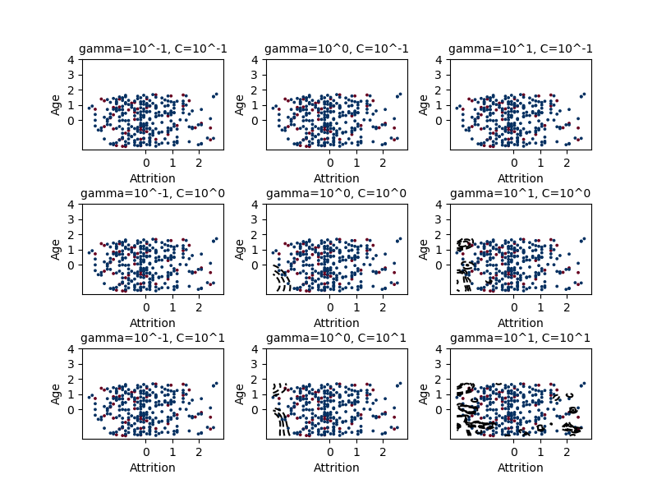

for Case when ('Attrition', 'DailyRate'):

When C is 0.1 and gamma is 0.1, the score of prediction is: 0.839590

When C is 0.1 and gamma is 1, the score of prediction is: 0.839590

When C is 0.1 and gamma is 10.0, the score of prediction is: 0.839590

When C is 1 and gamma is 0.1, the score of prediction is: 0.839590

When C is 1 and gamma is 1, the score of prediction is: 0.832765

When C is 1 and gamma is 10.0, the score of prediction is: 0.832765

When C is 10.0 and gamma is 0.1, the score of prediction is: 0.839590

When C is 10.0 and gamma is 1, the score of prediction is: 0.832765

When C is 10.0 and gamma is 10.0, the score of prediction is: 0.819113

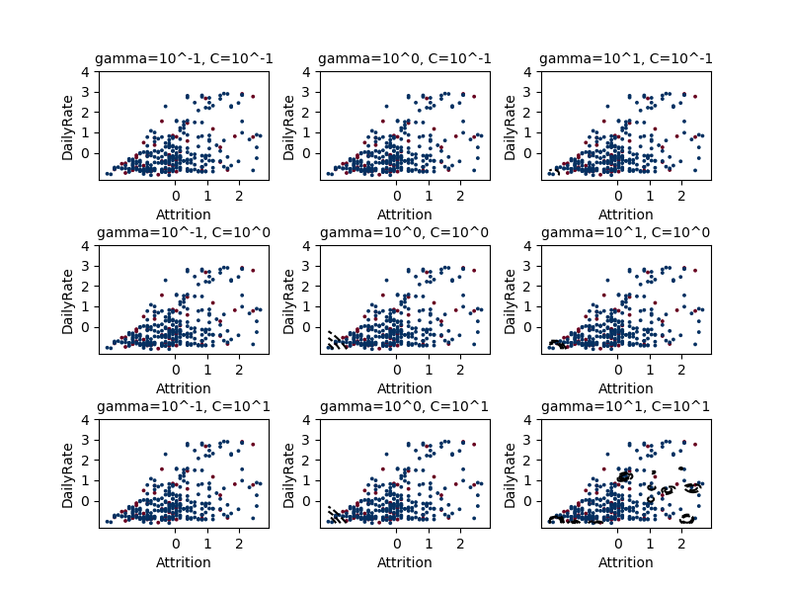

for Case when ('Attrition', 'MonthlyIncome'):

When C is 0.1 and gamma is 0.1, the score of prediction is: 0.839590

When C is 0.1 and gamma is 1, the score of prediction is: 0.839590

When C is 0.1 and gamma is 10.0, the score of prediction is: 0.839590

When C is 1 and gamma is 0.1, the score of prediction is: 0.839590

When C is 1 and gamma is 1, the score of prediction is: 0.839590

When C is 1 and gamma is 10.0, the score of prediction is: 0.832765

When C is 10.0 and gamma is 0.1, the score of prediction is: 0.839590

When C is 10.0 and gamma is 1, the score of prediction is: 0.832765

When C is 10.0 and gamma is 10.0, the score of prediction is: 0.822526

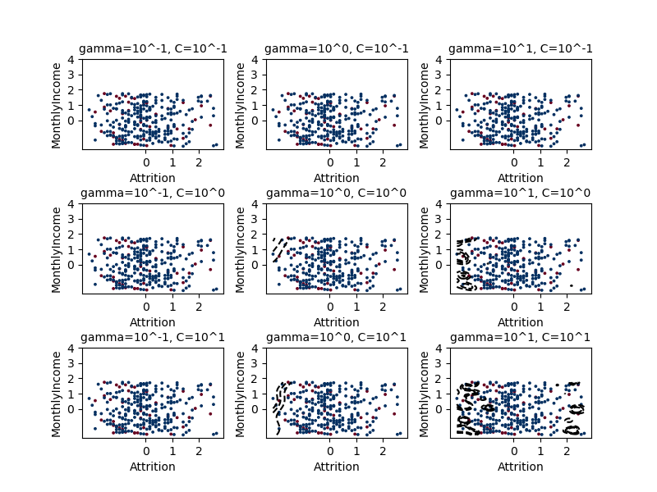

for Case when ('Attrition', 'MonthlyRate'):

When C is 0.1 and gamma is 0.1, the score of prediction is: 0.839590

When C is 0.1 and gamma is 1, the score of prediction is: 0.839590

When C is 0.1 and gamma is 10.0, the score of prediction is: 0.839590

When C is 1 and gamma is 0.1, the score of prediction is: 0.839590

When C is 1 and gamma is 1, the score of prediction is: 0.822526

When C is 1 and gamma is 10.0, the score of prediction is: 0.819113

When C is 10.0 and gamma is 0.1, the score of prediction is: 0.839590

When C is 10.0 and gamma is 1, the score of prediction is: 0.819113

When C is 10.0 and gamma is 10.0, the score of prediction is: 0.798635

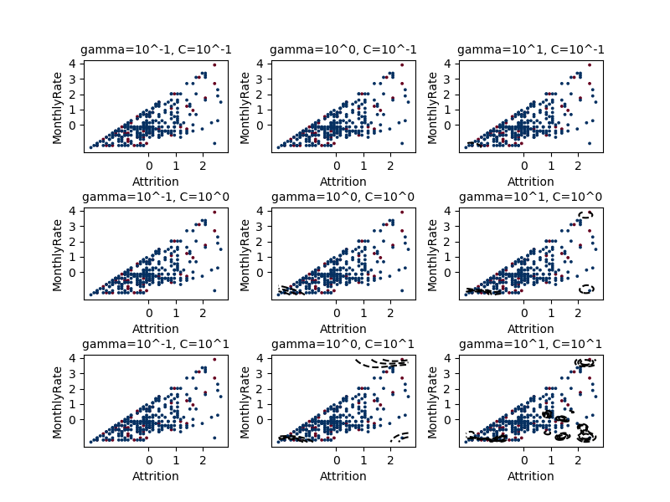

for Case when ('Age', 'DailyRate'):

When C is 0.1 and gamma is 0.1, the score of prediction is: 0.839590

When C is 0.1 and gamma is 1, the score of prediction is: 0.839590

When C is 0.1 and gamma is 10.0, the score of prediction is: 0.839590

When C is 1 and gamma is 0.1, the score of prediction is: 0.839590

When C is 1 and gamma is 1, the score of prediction is: 0.839590

When C is 1 and gamma is 10.0, the score of prediction is: 0.836177

When C is 10.0 and gamma is 0.1, the score of prediction is: 0.839590

When C is 10.0 and gamma is 1, the score of prediction is: 0.839590

When C is 10.0 and gamma is 10.0, the score of prediction is: 0.825939

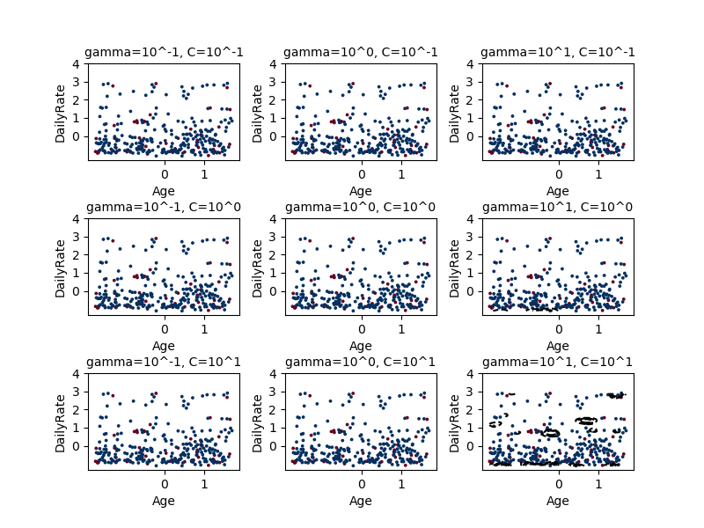

for Case when ('Age', 'MonthlyIncome'):

When C is 0.1 and gamma is 0.1, the score of prediction is: 0.839590

When C is 0.1 and gamma is 1, the score of prediction is: 0.839590

When C is 0.1 and gamma is 10.0, the score of prediction is: 0.839590

When C is 1 and gamma is 0.1, the score of prediction is: 0.839590

When C is 1 and gamma is 1, the score of prediction is: 0.839590

When C is 1 and gamma is 10.0, the score of prediction is: 0.839590

When C is 10.0 and gamma is 0.1, the score of prediction is: 0.839590

When C is 10.0 and gamma is 1, the score of prediction is: 0.839590

When C is 10.0 and gamma is 10.0, the score of prediction is: 0.829352

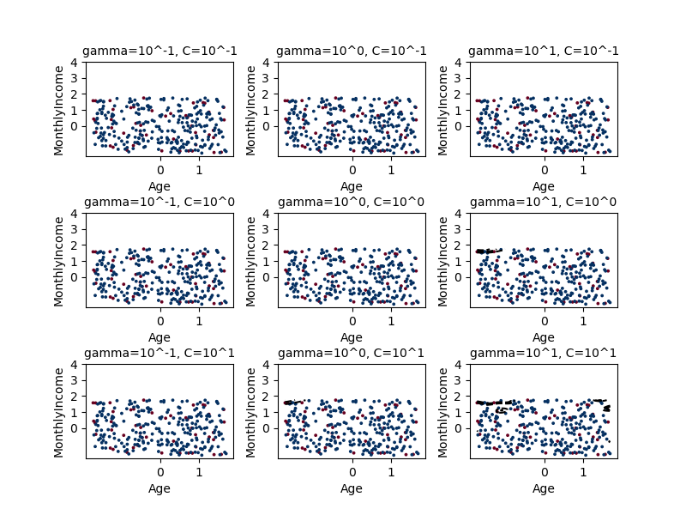

for Case when ('Age', 'MonthlyRate'):

When C is 0.1 and gamma is 0.1, the score of prediction is: 0.839590

When C is 0.1 and gamma is 1, the score of prediction is: 0.839590

When C is 0.1 and gamma is 10.0, the score of prediction is: 0.839590

When C is 1 and gamma is 0.1, the score of prediction is: 0.839590

When C is 1 and gamma is 1, the score of prediction is: 0.839590

When C is 1 and gamma is 10.0, the score of prediction is: 0.822526

When C is 10.0 and gamma is 0.1, the score of prediction is: 0.839590

When C is 10.0 and gamma is 1, the score of prediction is: 0.832765

When C is 10.0 and gamma is 10.0, the score of prediction is: 0.795222

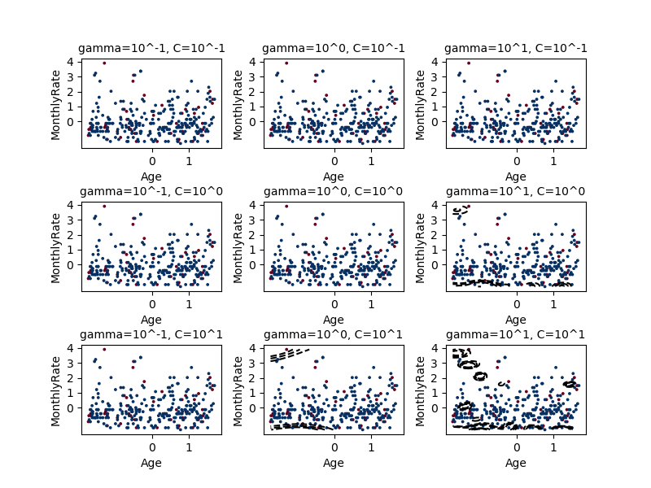

for Case when ('DailyRate', 'MonthlyIncome'):

When C is 0.1 and gamma is 0.1, the score of prediction is: 0.839590

When C is 0.1 and gamma is 1, the score of prediction is: 0.839590

When C is 0.1 and gamma is 10.0, the score of prediction is: 0.839590

When C is 1 and gamma is 0.1, the score of prediction is: 0.839590

When C is 1 and gamma is 1, the score of prediction is: 0.839590

When C is 1 and gamma is 10.0, the score of prediction is: 0.839590

When C is 10.0 and gamma is 0.1, the score of prediction is: 0.839590

When C is 10.0 and gamma is 1, the score of prediction is: 0.839590

When C is 10.0 and gamma is 10.0, the score of prediction is: 0.829352

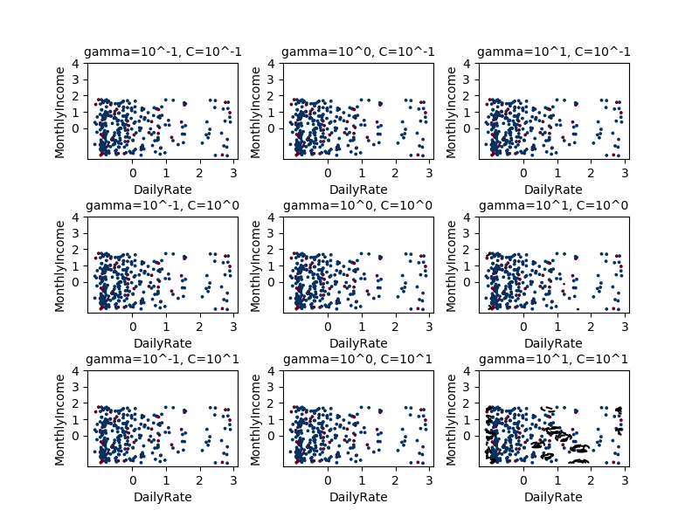

for Case when ('DailyRate', 'MonthlyRate'):

When C is 0.1 and gamma is 0.1, the score of prediction is: 0.839590

When C is 0.1 and gamma is 1, the score of prediction is: 0.839590

When C is 0.1 and gamma is 10.0, the score of prediction is: 0.839590

When C is 1 and gamma is 0.1, the score of prediction is: 0.839590

When C is 1 and gamma is 1, the score of prediction is: 0.839590

When C is 1 and gamma is 10.0, the score of prediction is: 0.812287

When C is 10.0 and gamma is 0.1, the score of prediction is: 0.839590

When C is 10.0 and gamma is 1, the score of prediction is: 0.829352

When C is 10.0 and gamma is 10.0, the score of prediction is: 0.795222

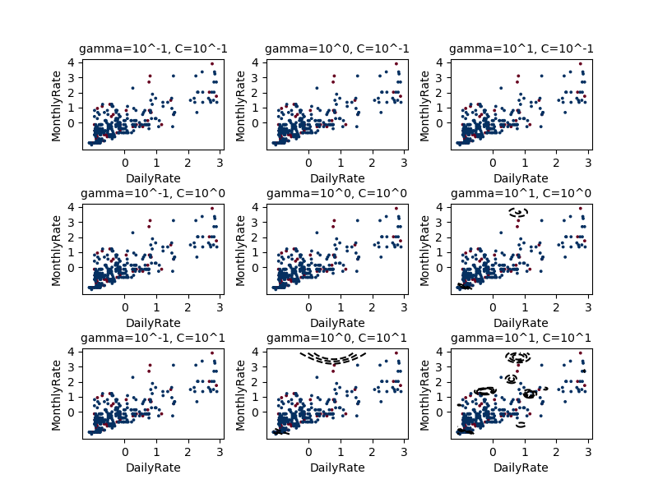

for Case when ('MonthlyIncome', 'MonthlyRate'):

When C is 0.1 and gamma is 0.1, the score of prediction is: 0.839590

When C is 0.1 and gamma is 1, the score of prediction is: 0.839590

When C is 0.1 and gamma is 10.0, the score of prediction is: 0.839590

When C is 1 and gamma is 0.1, the score of prediction is: 0.839590

When C is 1 and gamma is 1, the score of prediction is: 0.839590

When C is 1 and gamma is 10.0, the score of prediction is: 0.825939

When C is 10.0 and gamma is 0.1, the score of prediction is: 0.839590

When C is 10.0 and gamma is 1, the score of prediction is: 0.839590

When C is 10.0 and gamma is 10.0, the score of prediction is: 0.802048

