|  |
| --- |
| CEA LIST |
| Constraint Generation from the profile Developper Guide |
| [Tapez le sous-titre du document] |

|  |
| --- |
| TESSIER Patrick  12/04/2013 |



Sommaire

Requirements 3

Use Cases 3

1. Generate constraints directly into the definition 3

2. Generate constraints as EMF validation plugins 3

2.1. Constraint in OCL 3

2.2. Constraint in Java 3

Solution proposition 4

Test Use case 5

# Requirements

**ValidationReq001**: Papyrus shall validate constraints from profiles on models

**ValidationReq002**: User can precise on constraints if they may be validated live or batch mode, the associated error message and if it is activated by default

# Use Cases

In order to validate constraints from a profile, first creation of constraint with specific annotations will be explained and then generation of validation will be explained.

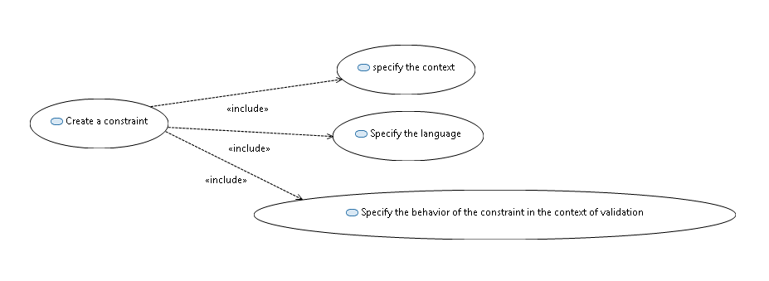

Figure 1: Constraint creation

## Create a constraint

In the context of the construction of a profile, it is possible to add constraints.

A constraint is a condition or restriction expressed in a language for the purpose of declaring some of the semantics of an element.

## Specify the context

Before editing a constraint, it is important to specify the constraint; it can be a stereotype, an operation.

## Specify the language

It is possible to precise the language of the constraint into Papyrus. The constraint body may be written into OCL, JAVA, or natural language. In order to make constraints usable by the Papyrus, constraint must be written in OCL or JAVA.

## Specify the behavior of the constraint in the context of validation

Into Papyrus, the behavior of the constraint during the validation can be precised.

It is possible to precise:

* The mode, if the validation of the constraint can be done, in t “batch” or “live” mode.
* The severity: The severity of the problem if the constraint is violated. This correlates to the severity of tasks in the Tasks view of the Eclipse environment. The default severity (if none specified) is ERROR. The CANCEL severity should be used with caution, as it causes the validation operation to be interrupted, possibly resulting in the loss of valuable diagnostic information from other constraints.
* The message: the message that will be displayed if the constraints is violated
* The description: a description of the constraint
* If it is enable by default: Indicates if this constraint should be enabled by default.

For advanced user you can also precise:

* The Id : the constraint id
* The status code: The plug-in unique status code, useful for logging.
* the target of validation, the element to be validated

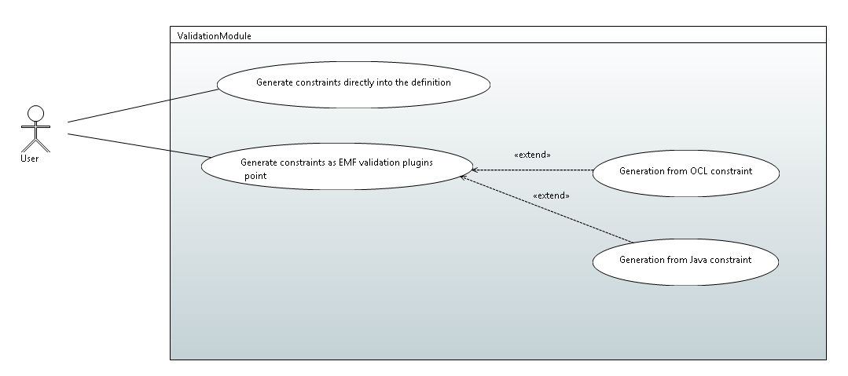

## Generate constraints directly into the definition

Constraint written in OCL in the profile can be generated into the definition of the profile and taken in charge during the validation of the model.

The problem with this use case is to know if it is possible to respect the requirement ValidationReq002.

## Generate constraints as EMF validation plugins

The user can generate plugins that wrap constraint and can be used in the EMF plugin validation.

The constraint can be generated in Java code, or directly from OCL.

### Generation from OCL constraint

From OCL constraints, Papyrus can product a EMF validation plugin that can be installed in the platform and used to validate a model

### Generation from Java constraint

From Java constraints, Papyrus can product a EMF validation plugin that can be installed in the platform and used to validate a model

# Solution proposal

# Test Use case