|  |
| --- |
| CEA LIST |
| Composite Diagram Developer |
| [Tapez le sous-titre du document] |

|  |
| --- |
| TESSIER Patrick |



Sommaire

Requirements 3

Use Cases 3

1. Create a port 4

1.1 Create a behavioral port 4

2. Drop a behavioral port 4

3. Delete from diagram a behavioral port 4

4. Delete from model a behavioral port 4

5. Move a behavioral port 4

Solution proposal 5

Test Use case 7

6. Test the create of the behavioral port 7

6.1 Creation from the palette 7

7.1 Open a file with a bad display of a behavioral port 7

7. Test the move a behavioral port 7

8. Test the Drop a behavioral port 7

9. Test the deletion from diagram a behavioral port 7

10. Test the deletion from model a behavioral port 7

# Requirements

**CompositeDiagram001** :

Composite structure diagram editor shall support the behavior port notation (<https://bugs.eclipse.org/bugs/show_bug.cgi?id=399865>)

To explain that, I quote the text from UML:

“A behavior port is indicated by a port being connected through a line to a small state symbol drawn inside the symbol representing the containing classifier. (The small state symbol indicates the behavior of the containing classifier.) Figure 9.17 shows the behavior port p, as indicated by its connection to the state symbol representing the behavior of the Engine class. Its provided interface is powertrain. In addition, a required interface, power, is shown also.”



# Use Cases

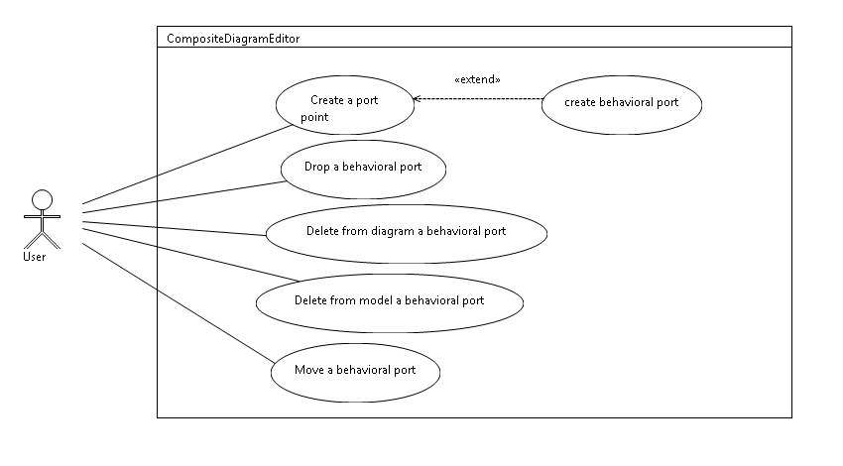

## Create a port

In the composite diagram, the user can create a port on a classifier or on a part

### Create a behavioral port

The user can create a behavioral port; to do that the user creates a port and set the property is behavioral to true.

## Drop a behavioral port

The user can drop from the model explorer the behavioral port into a composite. In this case the representation of the behavioral port must be displayed.

## Delete from diagram a behavioral port

The user can remove from the diagram, the behavioral port. The symbol of the behavior disappears also.

## Delete from model a behavioral port

The user can remove from the model, the behavioral port. The symbol of the behavior disappears also.

## Move a behavioral port

The port can move around the composite, this also the case for the behavioral port. The symbol of the behavior can move independently from the port.

When the port moves, the symbol of the behavioral port does not move.

# Solution proposal

The following scheme represents editpart set to display a behavioral port.

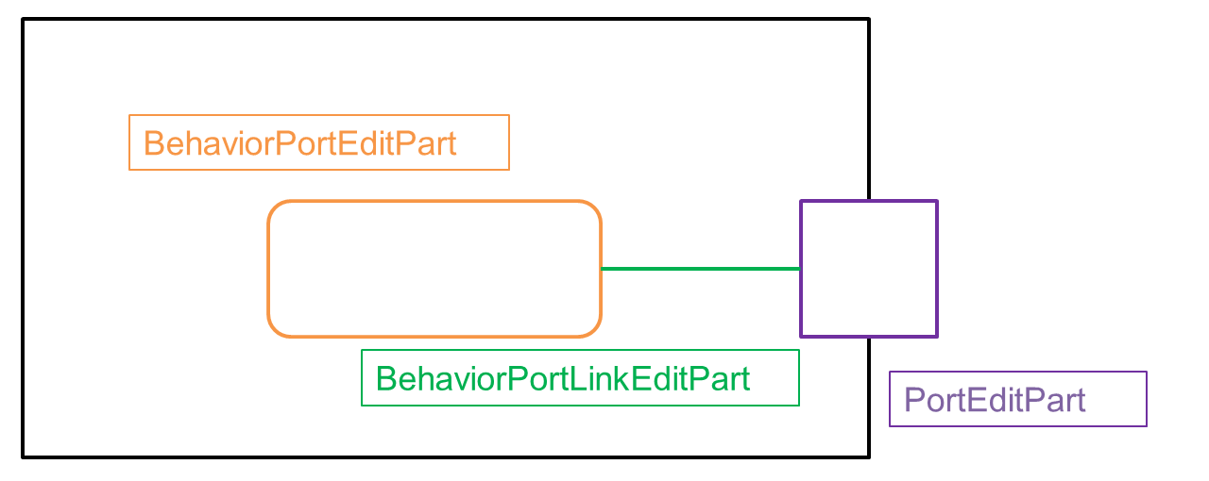

Figure 1:schema of editparts

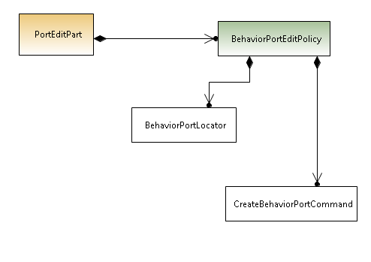

Figure 2:BehaviorPortEditPolicy

**PortEditPart**

The portEditpart that represent the port has now an editPolicy BehaviorPortEditPolicy. This editpolicy has in charge to create notation element that represent the symbol.

**BehaviorPortEditPolicy**

This editpolicy is a listener that listen the feature *is_behavior* of the port. It launches a synchronous thread to create a notation node and the link.

This editpolicy calls explicitly *BehaviorPortLocator* in order to place the symbol behavior at the good place (inside the composite).

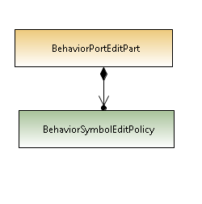

Figure 3: BehaviorPortEditPart

**BehaviorPortEditPart**

This editpart represents the controller of the symbol behavior. In order to ensure its deletion when the port is removed from the diagram, it has got a listener BeahviorSymbolEditPolicy.

**BehaviorSymbolEditPolicy**

This editpolicy listen the notation node of the PortEditpart, when it is removed the notation representation of the symbol is removed.

Each editpart has been generated from the gmfgen. But in the case of BehaviorPortEditPart and BehaviorLinkEditPart no semantic has been associated. In this manner, semantic command creation has not been created.

# Test Use case

## Test the create of the behavioral port

### Creation from the palette

Create a port from the palette,

Set it as behavior, the behavior symbol must be displayed

### Open a file with a bad display of a behavioral port

In the UML model the port is behavioral, but it representation is not behavior, the model was bad build.

When the model is open with papyrus, the symbol must appear.

## Test the move a behavioral port

The port must move around the composite, the behavior symbol must not follow.

## Test the Drop a behavioral port

When a behavioral port is drop, the symbol must be created.

## Test the deletion from diagram a behavioral port

When the port is deleted from the diagram, the symbol must disappear.

## Test the deletion from model a behavioral port

When the port is deleted from the model, the symbol must disappear.

## Test the move of behavioral port

The behavioral port cannot move from a container to another container

## Test the reconnection of the behavioral port link

The reconnection of the behavioral port link cannot be possible