|  |
| --- |
| CEA LIST |
| Composite Diagram UserGuide |
| [Tapez le sous-titre du document] |

|  |
| --- |
| TESSIER Patrick |



Sommaire

Requirements 3

Use Cases 3

1. Create a behavioral port 4

2. Drop a behavioral port 4

3. Delete from diagram a behavioral port 4

4. Delete from model a behavioral port 4

5. Move a behavioral port 5

# Requirements

**CompositeDiagram001** :

Composite structure diagram editor shall support the behavior port notation (<https://bugs.eclipse.org/bugs/show_bug.cgi?id=399865>)

To explain that, I quote the text from UML:

“A behavior port is indicated by a port being connected through a line to a small state symbol drawn inside the symbol representing the containing classifier. (The small state symbol indicates the behavior of the containing classifier.) Figure 9.17 shows the behavior port p, as indicated by its connection to the state symbol representing the behavior of the Engine class. Its provided interface is powertrain. In addition, a required interface, power, is shown also.”



# Use Cases

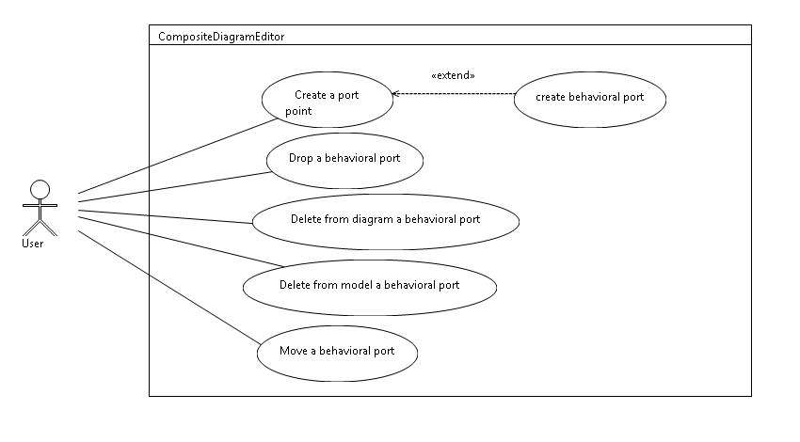

## Create a behavioral port

The user can create a behavioral port; to do that the user creates a port and set the property is behavioral to true.

#### How to:

Create a port from the palette or from the model explorer

In the property set the port as behavior:

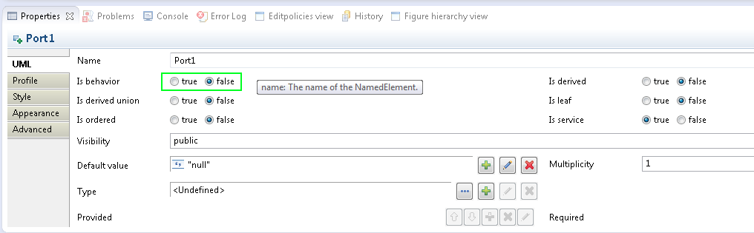

Figure 1: property view to set the port as behavior

Normally we obtain the following display:

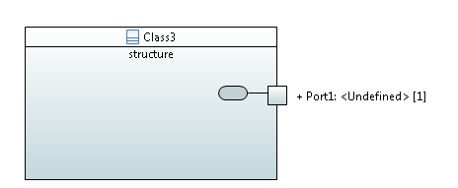

Figure : A behavioral port

## Drop a behavioral port

The user can drop from the model explorer the behavioral port into a composite. In this case the representation of the behavioral port must be displayed.

## Delete from diagram a behavioral port

The user can remove from the diagram, the behavioral port. The symbol of the behavior disappears also.

## Delete from model a behavioral port

The user can remove from the model, the behavioral port. The symbol of the behavior disappears also.

## Move a behavioral port

The port can move around the composite, this also the case for the behavioral port. The symbol of the behavior can move independently from the port.

When the port moves, the symbol of the behavioral port does not move.