|  |
| --- |
| CEA LIST |
| New Child |
| [Tapez le sous-titre du document] |

|  |
| --- |
| TESSIER Patrick  19/11/2013 |



Sommaire

Introduction 3

Requirements 3

Use Cases 4

1. UseCreateMenu 4

2. Create or modify ElementCreationModel 4

3. Generate "ElementCreationModel" from a profile 4

4. Hide, change order or add submenus 4

5. Create or modify ElementCreationModel at runtime thanks to a GUI 4

6. Add post actions 4

Solution proposal 4

Perspectives 4

Test 4

References 4

# Introduction

The goal of this document is to explain the functionality “New Child” of Papyrus?

# Requirements

* **AddNewChild** Papyrus shall add in the menu new child for new customized element by using extended type
* **HideElement** Papyrus shall not display all UML or SysML element creation
* **newChildFromProfile** Papyrus shall add the creation of new element from a subset of profile
* **newChildMenuDisplay** Papyrus shall be able to associated icons to folder or creation menu
* **RoleAndElementCreation** When an element can created from several roles for a container, Papyrus shall let the possibility to choose the role or to let to the possibility to be created from all role.

# Use Cases

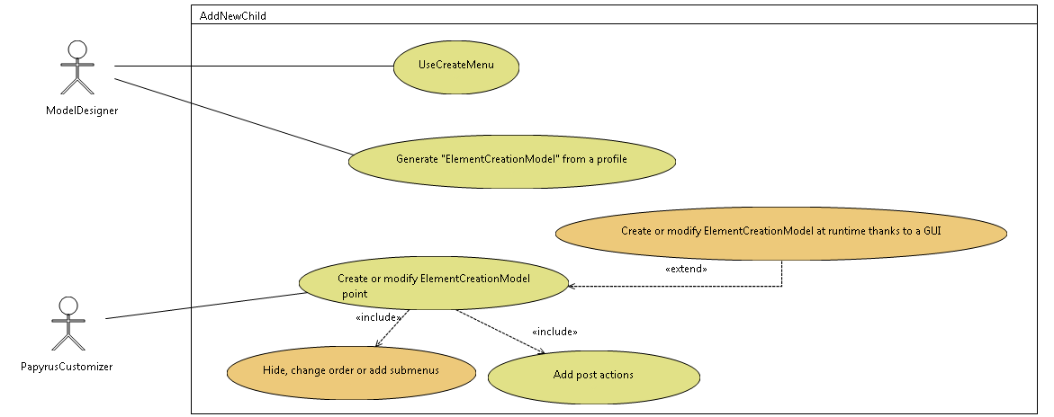

Figure : Use Cases

## UseCreateMenu

The Papyrus user uses this functionality from the model explorer in order to create elements in the model.

All this menus are based on a model: “ElementCreationMenuModel”.

## Create or modify ElementCreationModel

An advanced user is able to create of modify this model. This model references the model of Element types.

It can decide to display or not this element creation

## Generate "ElementCreationModel" from a profile

From a stereotyped profile, a model of element type and an ElementCreationMenuModel can be generated.

## Hide, change order or add submenus

The User can modify bay adding submenus; order about new child menu, precise if the role must be displayed.

## Create or modify ElementCreationModel at runtime thanks to a GUI

The User can edit the ElementCreationMenuModel and the elementType model by using a GUI as the palette functionality

# Solution proposal

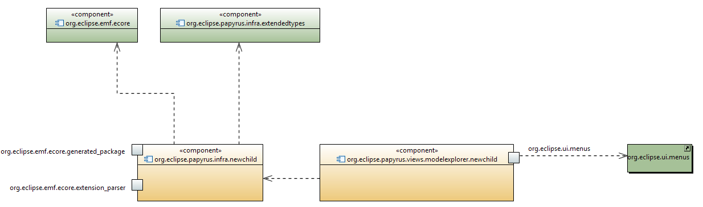

The system is done by two plugins:

* org.eclipse.papyrus.infra.newchild

It has in charge to provide and construct swt.Menu from the ecore model. To do that the developer has to:

* + instantiate a CreationMenuFactory,
  + ask to get all Root model and populate it

CreationMenuFactory creationMenuFactory= **new** CreationMenuFactory(editingDomain);

ArrayList<Folder> folders= creationMenuRegistry.getRootFolder();

Iterator<Folder> iterFolder= folders.iterator();

**while** (iterFolder.hasNext()) {

Folder currentFolder= iterFolder.next();

creationMenuFactory.populateMenu(menu, currentFolder,eObject);

}

* org.eclipse.papyrus.views.modelexplorer.newchild

It has in charge to add menu in the model explorer of papyrus.

This the structure of EMF model for model

* CreationMenu
* It correspond to a menu
* The ElemenTypeIDRef correspond a reference to the element Type.
* The role can be filled in order to specify the role play by the element.
* If displayAllRole is set to true, it displays all roles played by the element if the number of roles is greater than 1. By default this property is true;
* Folder
* It is possible to add owns label an icon.

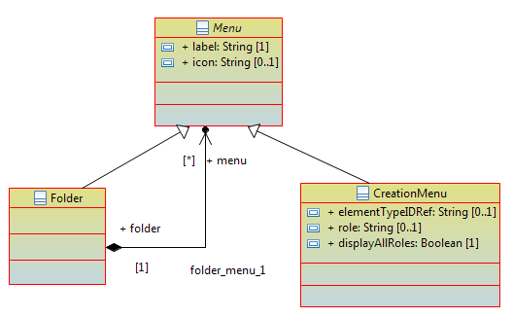

See an example of xml files:

<?xml version="1.0" encoding="ASCII"?>

<ElementCreationMenuModel:Folder

xmi:version="2.0"

xmlns:xmi="http://www.omg.org/XMI"

xmlns:xsi="http://www.w3.org/2001/XMLSchema-instance"

xmlns:ElementCreationMenuModel="http://ElementCreationMenuModel"

xsi:schemaLocation="http://ElementCreationMenuModel ../../../org.eclipse.papyrus.infra.newchild/resource/elementCreationMenuModel.ecore"

label="SimpleUMLTest">

<menu xsi:type="ElementCreationMenuModel:CreationMenu"

label="Package"

icon="platform:/plugin/org.eclipse.papyrus.infra.newchild.test/icon/O.gif"

elementTypeIdRef="org.eclipse.papyrus.uml.Package"/>

<menu xsi:type="ElementCreationMenuModel:CreationMenu"

label="Class"

elementTypeIdRef="org.eclipse.papyrus.uml.Class"/>

<menu xsi:type="ElementCreationMenuModel:Folder"

label="ElementWithFeature">

<menu xsi:type="ElementCreationMenuModel:CreationMenu"

label="NestedClass"

icon="platform:/plugin/org.eclipse.papyrus.infra.newchild.test/icon/M.gif"

elementTypeIdRef="org.eclipse.papyrus.uml.Class"

role="nestedClassifier"/>

<menu xsi:type="ElementCreationMenuModel:CreationMenu"

label="Integer"

elementTypeIdRef="org.eclipse.papyrus.uml.LiteralInteger"/>

<menu xsi:type="ElementCreationMenuModel:CreationMenu"

label="MyActivity"<!--display role-->

icon="platform:/plugin/org.eclipse.papyrus.infra.newchild.test/icon/O.gif"

elementTypeIdRef="org.eclipse.papyrus.uml.Activity"/><!--defined element type-->

</menu>

</ElementCreationMenuModel:Folder>

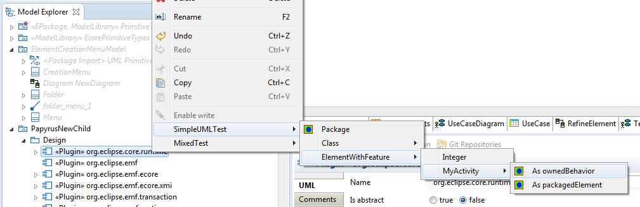

# Perspectives

# Test

# References

[1] “Help - Platform Plug-in Developer Guide - Eclipse Platform.” [Online]. Available: http://help.eclipse.org/juno/index.jsp?topic=%2Forg.eclipse.platform.doc.isv%2Freference%2Fmisc%2Fbundle_manifest.html. [Accessed: 19-Nov-2013].

[2] O. Alliance, “OSGi Service Platform, Core Specification, Release 5,” aQute, Mar. 2012.