Civil Air Patrol V-SAR
Airborne & Ground Radio Systems
Technical Feature Specifications, Cockpit Avionics & Operational Use Cases
Authority: CAPR 100-1, CAPR 100-3, MART Vol. II, ICUT Syllabus | Version: 2.4 | Status: Operational

1. Executive Overview & Regulatory Doctrine
The Civil Air Patrol Virtual Search and Rescue (CAP V-SAR) simulation platform provides a high-fidelity training environment for search-and-rescue aircrews, flight line personnel, and ground incident command teams. Realistic communications fidelity is central to the training value of the platform: direction-finding physics, radio propagation degradation, audio panel interlocks, and authentic fleet codeplugs prepare crews for actual emergency services sorties.
All simulated radio equipment, audio routing mechanisms, and user controls are engineered to reflect the strict operational, technical, and radiotelephone doctrine defined by official Civil Air Patrol publications and equipment manufacturer operating handbooks:
• CAPR 100-1 (Radio Communications Policy): Governs national and wing frequency allocations, standard fleet codeplugs, communications plans, and formal station recordkeeping requirements.
• CAPR 100-3 (Radiotelephone Procedures): Regulates formal communications discipline, prohibited practices (including 10-codes), mandatory prowords (ROGER, OVER, OUT, WAIT, SAY AGAIN), and aircraft phonetics.
• CAP Pamphlet 100-3 & CAP Form 110: Standard radio communications guide and the mandatory continuous radio log maintained by Mission Radio Operators (MRO) during operational exercises.
• CAP Introductory Communications User Training (ICUT): Outlines foundational user competency across base, mobile, and airborne stations, including stuck-mic recognition and transmitter time-out limits.
• CAP Mission Aircrew Reference Text (MART) Vol. II: Specific technical and procedural guide for Mission Observers (MO) and SAR Mission Pilots (MP) operating airborne direction finders and VHF-FM tactical transceivers.
• Manufacturer Technical Manuals: Technisonic TDFM-136B (TiL 08RE399A), Garmin GMA 1347 Pilot's Guide (190-00378-01), Becker SAR-DF 517 DCU Manual, RHOTHETA RT-600 Manual, and Motorola APX 4500 User Guide.
[DOCTRINAL REQUIREMENT: RADIOTELEPHONE DISCIPLINE]
Under CAPR 100-3 §1-3, Civil Air Patrol stations operate in compliance with federal standards (NTIA/FAA). Amateur jargon and '10-codes' are strictly prohibited on all CAP nets. Standard military/civilian prowords, ITU phonetics, 24-hour UTC (Zulu) time, and clear-text tactical brevity codes are mandatory.

2. Airborne Radio Systems & Cockpit Specifications
The simulated Cessna 182T NAV III (Garmin G1000) cockpit features a fully integrated Mission Observer avionics console. The observer station accommodates tactical mission communications, inter-crew intercom isolation, and electronic search direction finding.

2.1 Technisonic TDFM-136B VHF-FM Tactical Airborne Transceiver
The Technisonic TDFM-136B is the standard airborne VHF-FM tactical radio deployed across the Civil Air Patrol Cessna fleet. In CAP V-SAR, the instrument is modeled down to the hardware control panel, internal dual-receiver pathways, authentic fleet memory plan, and physical transmitter protection timers.
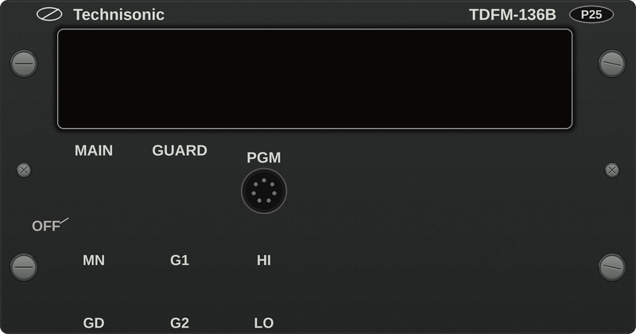
Figure 1: CAP V-SAR rendering of the Technisonic TDFM-136B control head as simulated.
System Parameter | Simulated Engineering Specification
Frequency Range | 136.0000 MHz to 174.0000 MHz continuous coverage
Channel Spacing | 25.0 kHz (Wideband) and 12.5 kHz (Narrowband)
Operating Modes | Analog FM and APCO Project 25 (P25) Phase 1 Digital Conventional
Receiver Architecture | Dual Independent Receivers: Main Agile Transceiver + Dedicated Guard Receiver
Memory Capacity | 200 Programmed User Memories + 30 Dedicated Scan/Guard Channels
RF Output Power | Selectable: HIGH Power (10.0 Watts) or LOW Power (1.0 Watt) via front panel switch
CTCSS / NAC Capability | Full Continuous Tone-Coded Squelch (PL Tones) & P25 Network Access Codes ($293 standard)
Transmitter Protection | Hardware 60-Second Time-Out Timer (TOT) stuck-mic unkey with lockout warning
Scanning Engine | Operational timer-driven state machine: 250 ms dwell, carrier halt, 2000 ms hang time, PTT pause
Audio Interface | Dual rotary concentric volume potentiometers for independent Main and Guard audio mixing

Key TDFM-136B Functional Capabilities in CAP V-SAR:
1. Independent Guard Receiver Architecture: In strict accordance with hardware manuals, the TDFM-136B houses two distinct physical receivers. The Guard receiver continuously monitors GD1 (168.650 MHz AIRGUARD) or GD2 (121.500 MHz VHF Emergency) in the background. Guard audio mixes continuously with Main audio, allowing mission base or emergency stations to break into the observer's headset regardless of what channel the Main receiver is working.
2. Authentic 200-Channel CAP Fleet Plan: The radio comes pre-loaded with official CAP fleet nomenclature, frequencies, CTCSS tones, and P25 NACs. Channels include TAC 1 (148.150 MHz), TAC 2 (149.275 MHz), CC 1 (150.225 MHz), CC 2 (150.525 MHz), AIR 1 (150.550 MHz), AIR 2 (149.525 MHz), SAR 1 (148.475 MHz), and inter-agency channels (VFIRE 21, VTAC 11, CALCORD). Trainees can dial channels via 3-digit direct numeric entry (e.g. 012 for SAR 1).
3. Transmitter Time-Out Timer (TOT): Continuous keying of the transmitter beyond 60 seconds triggers automatic carrier cutoff, illuminates '*** TIME OUT ***' across the LCD, and locks out the transmitter until the PTT is released.
4. Operational Scan Engine: Engaging scan (L1-5) cycles programmed fleet memories on a 250 ms dwell. Squelch opening (cap_fm_main_rx) instantly freezes the scan; carrier drop initiates a 2000 ms hold timer before scan resumption.
[OPERATIONAL NOTICE: AIRBORNE REPEATER TONE REQUIREMENT]
When operating on tactical repeaters (e.g., CAP Rptr 1 or regional mountain repeaters), transmitting without the correct CTCSS subaudible access tone (e.g., Tone 8 / 110.9 Hz) will fail to open the repeater receiver. In CAP V-SAR, the published cap_fm_ctcss_tone variable is verified by backend repeater logic.

2.2 Garmin GMA 1347 Airborne Audio Panel & Intercom System (ICS)
The Garmin GMA 1347 handles all cockpit audio routing, microphone switching, and crew intercom isolation for the Garmin G1000 integrated avionics suite. The simulated Mission Observer station operates a dedicated copilot/observer audio panel.
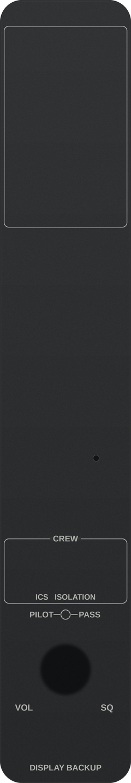
Figure 2: CAP V-SAR rendering of the GMA 1347 audio panel as simulated.
Audio Panel Feature | Operational Implementation
Transceiver Inputs | COM1 (VHF-AM ATC), COM2 (VHF-AM Auxiliary/Air-to-Air), COM3 (CAP Tactical VHF-FM TDFM-136B)
Microphone Selection | Exclusive interlock: Only one COM transmitter can be keyed at a time
Audio vs. MIC Interlock | Independent audio monitoring vs. transmission keying (primary operational error trap)
ICS Isolation Modes | ALL (unrestricted), PILOT (isolated on COM1), COPILOT (isolated), CREW (cockpit isolated from cabin)
Split COM Capability | Pilot locked to COM1; Copilot/MO locked to COM2; Mission Observer isolated from tactical net
Digital Clearance Recorder | 16-block circular buffer capturing 2.5 minutes of incoming COM audio with reverse playback
Squelch & Volume Modes | Concentric dual rotary knobs with push-button Manual Squelch (MAN SQ) override
Fail-Safe Mode | Automatic passive analog hard-wire connection linking Pilot headset and PTT directly to COM1 on bus power loss

Critical GMA 1347 Training Features in CAP V-SAR:
• Audio vs. MIC Selection Interlock: Trainees frequently press 'COM3' (audio monitor) and assume they can transmit. The GMA 1347 enforces authentic hardware behavior: listening requires the COM3 audio key, while transmitting strictly requires selecting the 'COM3 MIC' key. Transmitting without COM3 MIC produces no RF carrier.
• Intercom System (ICS) Isolation: Governed by G1000 Table 6A.3.2. Selecting 'PILOT' isolates the pilot to focus on air traffic control, while the Mission Observer and scanner continue tactical discussion. Selecting 'CREW' allows the front-seat aircrew to coordinate search tactics while isolating passengers in the rear cabin.
• Split COM Operation: During critical flight regimes (such as entering congested tower airspace while maintaining a search grid), activating Split COM allows the pilot to work ATC on COM1 while the copilot works air-to-air on COM2. The tactical mission radio (COM3) is automatically de-asserted from the observer's audio path to prevent distraction.
• Digital Clearance Recorder (PLAY): The GMA 1347 continuously digitizes and buffers the last 2.5 minutes of incoming radio traffic across COM1, COM2, and COM3 into a 16-block memory buffer. Pressing PLAY replays the latest block; successive presses step backward through historical radio calls. Pressing any other key instantly cancels playback.
[CLASSIC MISSION OBSERVER PITFALL: THE COM3 MIC TRAP]
The single most frequent mistake made by trainee Mission Observers is listening to tactical traffic on COM3 Audio and attempting to transmit without selecting COM3 MIC. The GMA 1347's amber annunciators clearly distinguish between audio reception (COM3) and active microphone authorization (COM3 MIC).

2.3 Becker SAR-DF 517 Airborne Direction Finder
The Becker SAR-DF 517 is a precision multi-band pseudo-Doppler airborne direction finding system. It computes real-time relative bearings to analog and digital emergency distress transmitters.
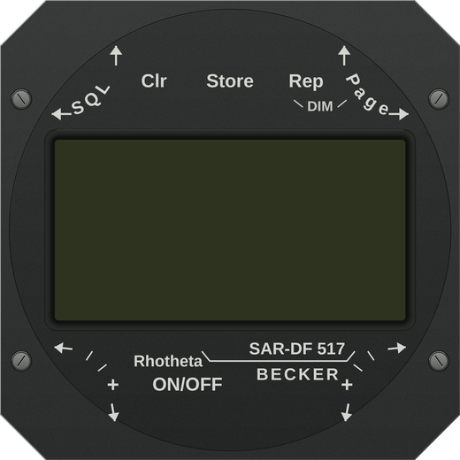
Figure 3: CAP V-SAR rendering of the Becker SAR-DF 517 display control unit as simulated.
System Feature | Becker SAR-DF 517 Specification
Frequency Coverage | VHF: 121.500 MHz | UHF: 243.000 MHz | 406 MHz: 4-channel adjustable training suite
406 MHz Channels | Emergency: 406.025 MHz | Training: 406.022 MHz, 406.025 MHz, 406.028 MHz, 406.037 MHz
Acoustic Profile | 3 kHz pseudo-Doppler AM tone modulation; tone-suppressed clean analog sweep via STORE key
SNR Degradation | Dynamic receiver discriminator noise mixing inversely against RF signal strength (cap/df/signal)
Display Unit | 128x64 LCD dot-matrix with 360° circular bearing needle, numeric bearing, spread, and signal bar
Digital Frame Decode | Decodes 406 MHz COSPAS-SARSAT frames: 15-hex ID, country code, protocol, and coordinates
Bearing Averaging | Multi-sample circular averaging filter producing realistic aircraft course-change drag error
Installation Calibration | Selectable TOP vs. BOTTOM antenna mounting and configurable angular offset correction

Key Operational Characteristics of the Becker 517:
• Pseudo-Doppler AM Modulation: The DF antenna array switches four quarter-wave monopoles at a 3 kHz rotation rate, phase-modulating the received carrier. In CAP V-SAR, this distinctive 3 kHz warble is synthesized in real time. Engaging the STORE key activates tone suppression, delivering a clean audio sweep for aural null homing.
• Dynamic Signal-to-Noise Ratio (SNR) Hiss: Unlike legacy simulators where audio was either perfect or absent, CAP V-SAR blends band-limited discriminator hiss (elt_noise.wav) inversely against signal strength. At maximum distance or behind mountain ridges, the ELT sweep is heavily masked by receiver static.
• 406 MHz Channel Limitation: The Becker 517 covers four discrete 406 MHz channels in Training mode (406.022 to 406.037 MHz). It cannot tune channels above 406.037 MHz, representing a major doctrinal training point for aircrews.

2.4 RHOTHETA RT-600 Advanced Airborne SAR Direction Finder
The RHOTHETA RT-600 is the modern advanced direction finding system utilized on newer Civil Air Patrol aircraft. It provides full-spectrum COSPAS-SARSAT digital tracking and dual-frequency scanning.
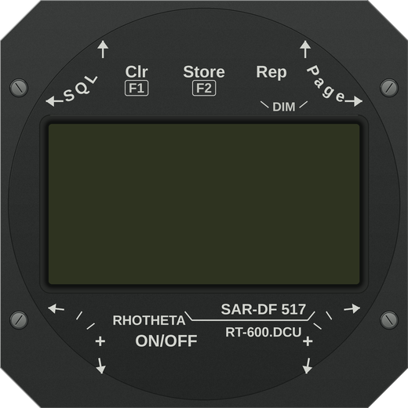
Figure 4: CAP V-SAR rendering of the RHOTHETA RT-600 DCU 600 as simulated.
System Feature | RHOTHETA RT-600 Specification
Frequency Coverage | VHF Airband (118–137 MHz), Maritime VHF (156–162 MHz), UHF (243 MHz), 406 MHz COSPAS-SARSAT
COSPAS-SARSAT Grid | Full 19-Channel Grid: 406.022 MHz to 406.076 MHz across 7 CPSAR groups (A through S)
Dual-Watch Scanning | Simultaneously sweeps 406 MHz burst channels while scanning 121.500 MHz and 123.100 MHz
Timehold Persistence | Holds bearing during 50-second 406 burst gap while allowing background receiver scanning
Airframe Shadowing | Attitude-dependent wing null attenuation modeling fuselage and wing shielding (up to 24 dB loss)
Digital Protocol Support | Standard ELT, PLB, EPIRB, Maritime DSC Channel 70 (156.525 MHz), and Test Protocols

Key Differences Between Becker 517 and RHOTHETA RT-600:
1. 406 MHz Frequency Coverage: The RT-600 spans the entire 19-channel COSPAS-SARSAT international allocation (406.022 to 406.076 MHz in 3 kHz steps). An exercise with an ELT on 406.040 MHz will be completely silent to a Becker 517, but readily tracked by an RT-600—teaching crews the importance of knowing their aircraft equipment.
2. Multi-Channel CPSAR Sweeping: The RT-600 scans pre-programmed channel pairs or whole CPSAR groups, ensuring that distress bursts on unknown channels are intercepted during search sweeps.
3. Airframe Shadowing & Wing Null Dynamics: High-wing Cessna aircraft exhibit significant RF shielding when the wing dips between the belly antenna and the beacon. CAP V-SAR models this with 24 dB of peak attenuation, enabling crews to execute authentic wing-dip ambiguity verification procedures.

3. Ground Mission Base Radio Systems & MRO Console
Ground operations at Mission Base, forward operating bases, and mobile incident command posts are operated by qualified Mission Radio Operators (MRO). CAP V-SAR models the full ground communications stack, including tactical transceivers, airband base stations, and doctrinal logging systems.

3.1 Motorola APX 4500 / APX 6500 & EFJohnson 5300 Tactical Base Radios
The primary tactical radio at a CAP Mission Base is a high-power VHF-FM mobile or base station, typically a Motorola APX series (O2 or O5 control head) or EFJohnson 5300 transceiver.
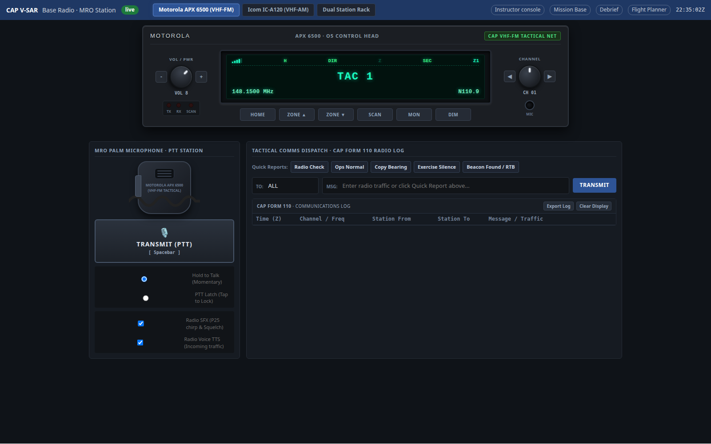
Figure 5: Motorola APX Tactical VHF-FM Ground Control Head with CAP Zone/Channel Plan.
Feature | Ground Tactical Radio Implementation
Operating Frequencies | VHF High-Band: 136.0000 MHz to 174.0000 MHz conventional analog FM & P25 digital
Channel Organization | Multi-Zone Fleet Architecture: Zone 1 (Command/Tactical), Zone 2 (Ground), Zone 3 (Interop)
Acoustic Feedback | Authentic 3-tone P25 talk-permit chirp (941/1336/1209 Hz), channel busy tone, squelch tail
Transmit Server Lease | Server-enforced 60-second transmit timeout gate (TransmitGate) preventing stuck microphones
Display & Ergonomics | High-contrast dot-matrix display, zone/channel name annunciator, signal RSSI meter
Monitor Mode (MON) | Instant squelch override allowing reception of marginal signals from low-altitude aircraft

3.2 Icom IC-A120 VHF Aeronautical Base Station Transceiver
Under CAP regulations and ICUT doctrine, a Mission Base cannot rely solely on tactical VHF-FM. Base stations must maintain dedicated VHF-AM aeronautical airband capability to coordinate directly with aircraft on aviation frequencies.
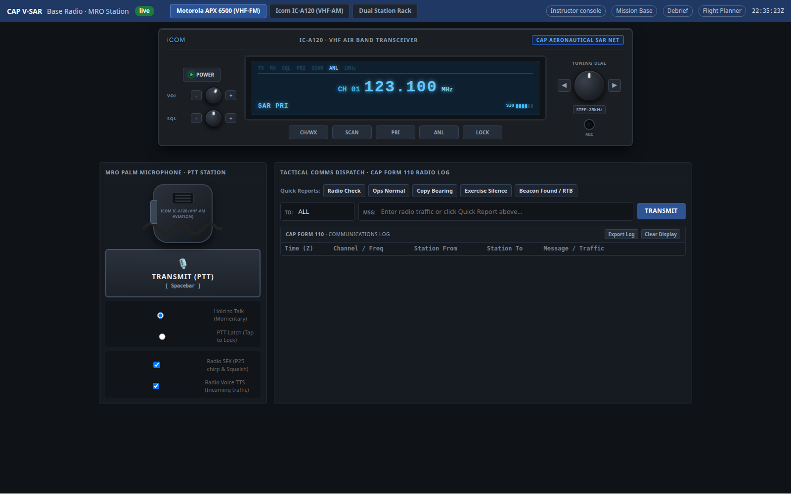
Figure 6: Icom IC-A120 Ground Airband VHF-AM Base Station Transceiver.
System Feature | Icom IC-A120 Operational Specification
Frequency Range | 118.000 MHz to 136.992 MHz (VHF-AM aviation airband, 8.33 kHz and 25 kHz channel spacing)
Dual-Watch Monitoring | Simultaneous monitoring of Primary SAR (123.100 MHz) with priority watch on 121.500 MHz
Noise Limiter (ANL) | Automatic Noise Limiter suppressing pulse-type engine and electrical interference
Side-Tone Verification | Internal side-tone allowing operator to monitor outgoing transmission quality on headset
Primary CAP Frequencies | 123.100 MHz (National SAR Air-to-Ground), 122.900 MHz (SAR Secondary), 121.500 MHz (Guard)

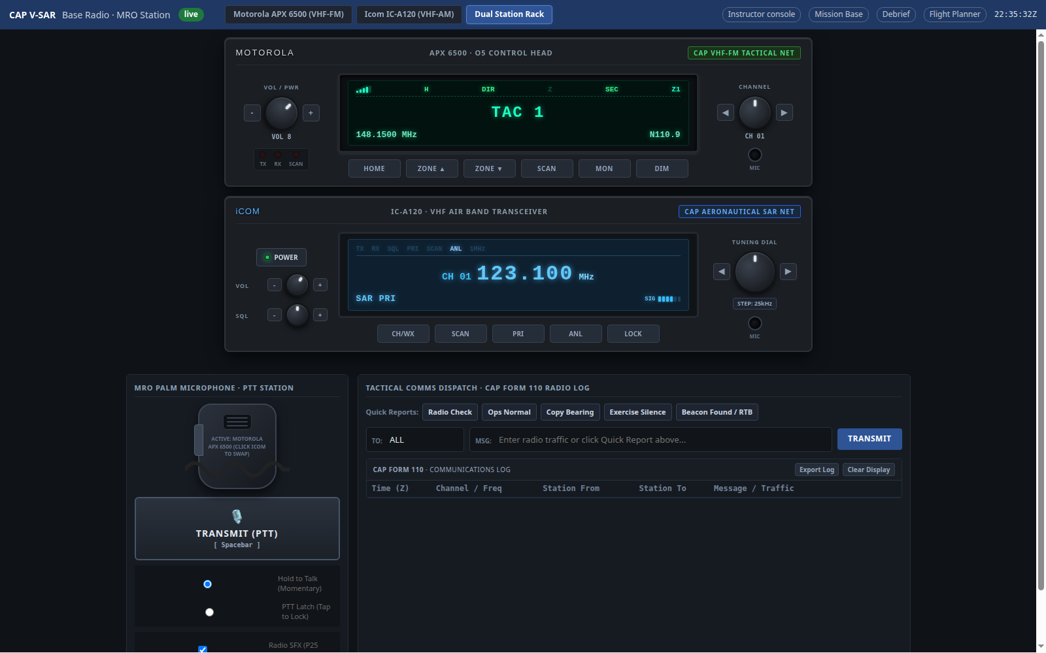
Figure 7: Dual-Station Mission Base Console: Motorola APX Tactical VHF-FM & Icom IC-A120 Aeronautical SAR.

3.3 CAP Form 110 Radio Communications Log System
CAPR 100-1 §5-3 mandates that every operational radio station maintain a continuous communications log. The CAP V-SAR ground console integrates a real-time digital CAP Form 110 logging system.
[DOCTRINAL MANDATE: THE CAP FORM 110 COMMUNICATIONS LOG]
The Mission Radio Operator's primary legal and operational duty is maintaining an unbroken record of all radio traffic. In the event of an aircraft accident, overdue sortie, or lost crew, the Form 110 provides the official evidentiary record of last-known position, fuel status, and emergency distress messages.

Core Capabilities of the CAP V-SAR Form 110 Logger:
• Automatic Zulu Timestamping: Every log entry captures UTC timestamping synchronized with the exercise clock.
• Fast Tactical Shortcut Buttons: One-click logging for standard operational transmissions: 'Ops Normal', 'Radio Check', 'Bearing Report', 'Departing Airport', 'In-Grid', 'Out-of-Grid', and 'Overhead Beacon'.
• Aircraft Track Synchronization: Captures reported bearing, coordinates, and altitude directly into the session database.
• Persistent Storage & CSV Export: Entries survive console restarts and can be exported as standard CSV records for the Communications Unit Leader (COML) and Planning Section Chief.

4. Operational Use Cases & Doctrinal Procedures
The following operational use cases demonstrate how the simulated radio ecosystem is utilized during Civil Air Patrol search and rescue exercises (SAREX) and disaster relief missions.

4.1 Use Case 1: Electronic Search & Rescue (ELT / EPIRB Localization)
Context: An overdue general aviation aircraft has crashed in mountainous terrain. The Air Force Rescue Coordination Center (AFRCC) alerts Civil Air Patrol to localize the emergency beacon.
[OPERATIONAL PROCEDURE: DUAL-ANTENNA DF SEARCH (MART VOL. II CH. 5)]
Step 1: En Route Monitoring. While transiting to the search area at altitude, tune the Becker 517 / RT-600 to 121.500 MHz and 406.025 MHz. Verify audio squelch opens.
Step 2: Digital Decode Acquisition. Upon receiving a 406 MHz burst, record the 15-hex beacon ID and country code. Verify position coordinates if GPS-encoded.
Step 3: Signal-to-Noise Ratio (SNR) Assessment. Note the receiver hiss. As the aircraft approaches the beacon, the 3 kHz pseudo-Doppler sweep clarifies and static subsides.
Step 4: Wing-Dip Ambiguity Resolution. If the bearing needle fluctuates due to reflections, bank the aircraft 20° to drop the wing toward the beacon. The belly antenna is shielded by the wing (wing null loss up to 24 dB), confirming that the beacon lies on the side of the lowered wing.
Step 5: Aural Null / Tone Suppression. Inside 1 NM, the bearing needle will oscillate rapidly. Engage the STORE key to suppress the 3 kHz Doppler tone, using clean analog receiver volume to execute an aural null overhead confirmation.

4.2 Use Case 2: Tactical Air-to-Ground Coordination (Observer to Base)
Context: The airborne crew coordinates search progress with Mission Base on the tactical VHF-FM mission net.
Step-by-Step Procedure:
1. Audio Panel Setup: The Mission Observer selects 'COM3' Audio on the GMA 1347 to monitor the net. To talk, the observer presses 'COM3 MIC', verifying that the amber MIC annunciator illuminates.
2. TDFM Channel Selection: Dial channel '001' (TAC 1, 148.150 MHz). Confirm that the LCD renders 'MN TAC 1'.
3. Radio Check: Key the observer PTT. Transmission audio is gated by the 60-second hardware TOT. Base responds: 'CAP-STONE 423, MISSION BASE, READ YOU LOUD AND CLEAR'.
4. Routine Ops Normal Check: Every 30 minutes, the crew transmits: 'MISSION BASE, CAP-STONE 423, OPS NORMAL, GRID 142A, 4500 FEET, REMAINING FUEL 3.5 HOURS'. The MRO clicks 'Ops Normal' on the CAP Form 110 console.
5. Guard Receiver Monitoring: While working TAC 1 on Main, the TDFM's secondary Guard receiver continuously listens on AIRGUARD (168.650 MHz). When Mission Base issues an urgent weather alert on Guard, it mixes into the crew's headset without requiring the crew to leave TAC 1.

4.3 Use Case 3: Cockpit Intercom Management & Crew Resource Management
Context: The search aircraft enters busy class D airspace near the search grid. The pilot must coordinate with Air Traffic Control while the Mission Observer continues working the tactical search net.
Cockpit Execution via GMA 1347:
• Pilot Isolation (ICS PILOT): Pressing PILOT isolates the pilot on COM1 (Tower). Intercom chatter from the Mission Observer and scanner is muted in the pilot's headset, ensuring zero distraction during ATC clearances.
• Split COM Activation: Engaging Split COM locks the pilot to COM1 and copilot to COM2, automatically de-asserting COM3 to prevent tactical radio chatter from bleeding into air-to-air traffic.
• Clearance Recorder Recovery: If the pilot misses an ATC altimeter setting or the observer misses a grid reference read by base, pressing the 'PLAY' key replays the recorded transmission cleanly without requiring a 'SAY AGAIN'.

4.4 Use Case 4: Mission Radio Operator (MRO) Base Operations & Dual-Watch
Context: Mission Base manages communications for three airborne search sorties and two ground search teams (UDF).
Ground Station Management:
• Dual-Watch Monitoring: The MRO monitors tactical traffic on the Motorola APX 4500 (TAC 1 / 148.150 MHz) while keeping the Icom IC-A120 unmuted on 123.100 MHz (Aeronautical SAR Air-to-Ground). When an aircraft departs tower airspace, it reports in on 123.100 MHz; once established in the grid, it shifts to tactical VHF-FM.
• Continuous Form 110 Logging: All position reports, fuel checks, and beacon bearings are logged into the digital Form 110 console. If an aircraft goes quiet, the MRO uses the Form 110 time log to initiate overdue aircraft protocols.
• Talk-Around Simplex Operation: When coordinating with mobile vans in the immediate parking area, the MRO selects Talk-Around to bypass the regional mountain repeater, preventing net saturation.

4.5 Use Case 5: Disaster Relief & Multi-Agency Interoperability
Context: Civil Air Patrol aircraft provide airborne damage assessment and emergency communications relay following a major wildland fire or earthquake.
Interoperability Procedures:
• Mutual Aid Frequency Steering: The Mission Observer dials pre-programmed national interop channels on the TDFM-136B: Channel 016 (VFIRE 21 / 154.2800 MHz) to communicate with CAL FIRE / USFS ground commanders, or Channel 017 (VTAC 11 / 151.1375 MHz) for local search and rescue teams.
• P25 Digital Common Access: When interoperating with federal and military agencies (e.g. FEMA, National Guard), the radio operates in P25 digital mode utilizing the standardized Network Access Code ($293).
• Plain Language Requirement: Prowords and plain English descriptions replace all agency-specific jargon.

4.6 Use Case 6: Communications Contingencies & Fail-Safe Operations
Context: Equipment failures, stuck microphones, and terrain masking challenge aircrew survival and mission completion.
Simulated Contingency Handling in CAP V-SAR:
1. Stuck Microphone Mitigation: If an airborne PTT switch sticks closed, the TDFM-136B hardware Time-Out Timer unkeys the transmitter after 60 seconds, displaying '*** TIME OUT ***' and freeing the tactical net for emergency traffic.
2. Complete Avionics Power Loss: If the aircraft electrical bus fails, the GMA 1347 drops into fail-safe mode. Internal analog relays mechanically bypass all digital circuitry, directly connecting the pilot's headset to COM1.
3. Terrain Masking & Radio Horizon Recovery: When an aircraft descends into a mountain canyon, signals attenuate by >40 dB. Trainees learn the radio horizon formula: Distance = 1.23 * (sqrt(h_ac) + sqrt(h_base)). Crews climb to regain line-of-sight propagation with the base repeater.

5. Consolidated Radio Model & Feature Matrix
The following master reference matrix cross-references every simulated radio model across operational station, frequency bands, audio characteristics, safety guards, and regulatory references.
Radio Model | Station | Frequency Range | Modulation & Standards | Key Simulated Features | Regulatory Reference
Technisonic TDFM-136B | Airborne Cockpit (MO Station) | 136.0000 – 174.0000 MHz | Analog FM (25/12.5 kHz) & P25 Digital Conventional | Dual independent receivers (Main + Guard dual-watch), 200 CAP memories, 60s TOT, 250ms scan engine, CTCSS/NAC | MART Vol. II Ch. 4, TiL 08RE399A, CAPR 100-1 §5
Garmin GMA 1347 | Airborne Cockpit (G1000 Nav III) | Audio Management (COM1/2/3, NAV, ICS) | Digital Audio Matrix & Hardwire Analog Fail-Safe | COM3 Audio vs. MIC interlock, Table 6A.3.2 ICS isolation (ALL/PILOT/COPLT/CREW), Split COM, 2.5-min Clearance Recorder | Garmin Guide 190-00378-01, G1000 Nav III Pilot Guide
Becker SAR-DF 517 | Airborne DF (Cockpit DCU 517) | 121.500, 243.000 MHz, 4-ch 406 MHz suite | Pseudo-Doppler 3 kHz AM & 406 COSPAS-SARSAT | Dynamic SNR hiss mixing, STORE tone suppression, 128x64 LCD, 15-hex decode, course-change drag error, TOP/BOTTOM mount | Becker SAR-DF 517 Manual, MART Vol. II Ch. 5
RHOTHETA RT-600 | Airborne DF (Cockpit DCU 600) | 118–137 MHz, 156–162 MHz, 243 MHz, 19-ch 406 | Multi-band Doppler & 406 COSPAS-SARSAT | Full 19-ch 406 grid (A–S), dual-channel scan, 24 dB wing null airframe shadowing, 50s burst timehold, DSC Ch 70 | RHOTHETA RT-600 Manual, CAP Basic DF Training Guide
Motorola APX 4500 / 6500 | Ground Station (Mission Base) | 136.0000 – 174.0000 MHz | Analog FM & APCO P25 Phase 1/2 Digital | Authentic CAP fleet codeplug, 3-tone P25 talk permit chirp, 60s server TransmitGate, RSSI signal meter, MON mode | CAPR 100-1 §5-2, Motorola APX 4500 User Guide
EFJohnson 5300 Series | Ground Station (Command Mobile) | 136.0000 – 174.0000 MHz | Analog FM & P25 Conventional | Multi-zone channel selection, hardware squelch override, priority scan, mobile van command post dispatch | EFJohnson 5300 Series Manual, ICUT Syllabus
Icom IC-A120 | Ground Station (Airband Base) | 118.000 – 136.992 MHz | VHF-AM Aviation (8.33 / 25 kHz spacing) | Dual-watch (123.100 MHz SAR + 121.500 MHz Guard), Automatic Noise Limiter (ANL), headset sidetone feedback | Icom IC-A120 Manual, CAPR 100-1 §5-4, ICUT Ch. 4
CAP Form 110 System | Ground Station (MRO Console) | Software Application (Web Audio) | REST / WebSocket Real-Time Telemetry | Zulu timestamping, tactical quick-report buttons, aircraft track synchronization, CSV export, duplicate suppression | CAPR 100-1 §5-3, CAP Pamphlet 100-3, CAP Form 110

