CAP V-SAR — User Guide
The mission base console, radio console, flight planner and debrief.
Written 14 September 2026 against the running lab system on ms01.
SIMULATION USE ONLY. CAP V-SAR is a training simulator. Nothing in it is approved for real-world flight planning, navigation, dispatch, or actual search and rescue. Charts, airport data and weather may be stale, incomplete or wrong, and no NOTAMs are provided. Performance and weight-and-balance figures are estimates and are not a substitute for the aircraft POH or AFM. For an actual flight, use current FAA charts, an official weather briefing and the approved aircraft documents. The practice beacon frequencies used here are training frequencies; do not transmit on distress frequencies.
About these screenshots. Every image is a real capture of the running system on 14 September 2026, not a mock-up. They show the build currently deployed on ms01, which predates the access-control work committed on 13 September. Once that work is deployed, three things change and are called out where they apply: you will sign in with a participant badge before reaching any page, badges are reissued, and the engineering deck moves off the network. The screens themselves are otherwise the ones you will use.
Not covered here: the X-Plane cockpit, the Mission Observer station in Air Manager, and the DF heads. The simulator was not running when this was written, so rather than describe them from memory they are left out. See the Flight Operations Handbook for the aircraft and panel.

1. The pieces, and where they are
CAP V-SAR is four browser surfaces plus the simulator. You do not need all of them; you need the one for the seat you are filling.
You are | You use | Address on the mission network
Exercise Director / instructor | Exercise console | https://ms01:8743/
Mission base — IC, AOBD, MRO | Mission Base view | https://ms01:8743/base
Mission Radio Operator | Base radio console | https://ms01:8743/radio
AOBD / aircrew planning | Flight planner | http://ms01:8090/
Anyone, after a sortie | Debrief | https://ms01:8743/debrief
Aircrew | X-Plane 12 + Air Manager MO station | on your own workstation
Use the HTTPS address for anything with a microphone. Browsers only grant microphone access on a secure page, so the radio console will send you to the HTTPS address if you arrive over plain HTTP. The lab uses its own certificate authority: install the trusted certificate once per device, from /radio-ca.crt on the console, or the browser will warn you every time. The setup notes linked from the radio page cover the tablet and computer steps.

2. Exercise console — the director's seat
Instructors only. This is the one screen that can see the answer.
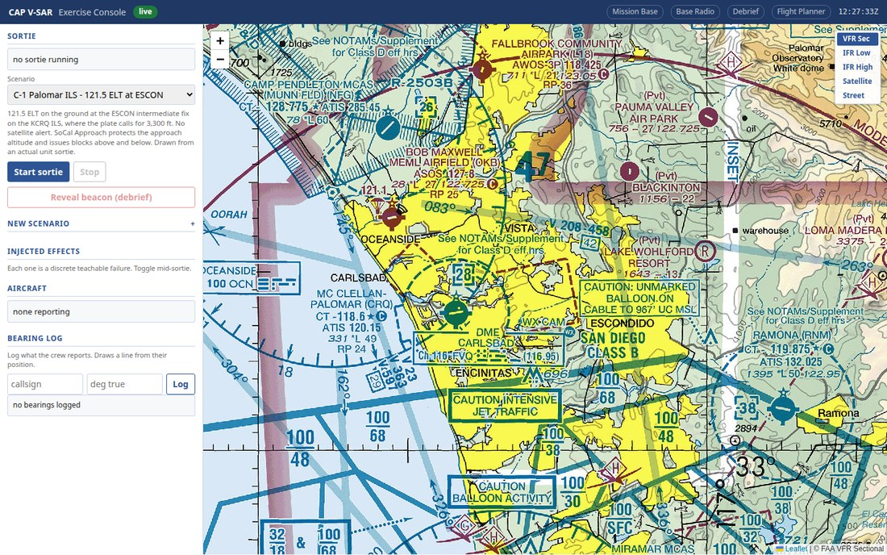
Figure 1 — The exercise console. Scenario selector, sortie controls, injected effects, and the bearing log, over a VFR sectional.
Everything the director does during a session happens in the left rail:
- Sortie. Shows what is running, or no sortie running. Pick a scenario from the dropdown, then Start sortie. Stop ends it.
- Scenario. The incident itself. The notes under the selector are the briefing — in Figure 1, a 121.5 ELT on the ground at the ESCON intermediate fix on the KCRQ ILS, drawn from an actual unit sortie.
- Reveal beacon (debrief). Releases the true beacon position. Until you press it, no other view in the system can obtain it — that is the whole teaching mechanism, so leave it alone until the debrief.
- Injected effects. Each one is a discrete teachable failure, toggled mid-sortie: radio horizon, terrain masking, 406 burst cadence, cone of confusion, multipath, airframe shadowing.
- Aircraft. Who is reporting position. none reporting means no plugin is connected.
- Bearing log. Callsign and degrees true. Logging a bearing draws a cut from that aircraft's position at the moment you log it.
Effects are the lesson. The point of injecting cone of confusion as an aircraft nears the beacon is that the crew learns to recognise a swinging bearing as a symptom rather than chase it. Inject when the aircraft is positioned to learn something, not on a timer.

3. Mission Base — the base staff view
IC, AOBD and MRO work from this screen.
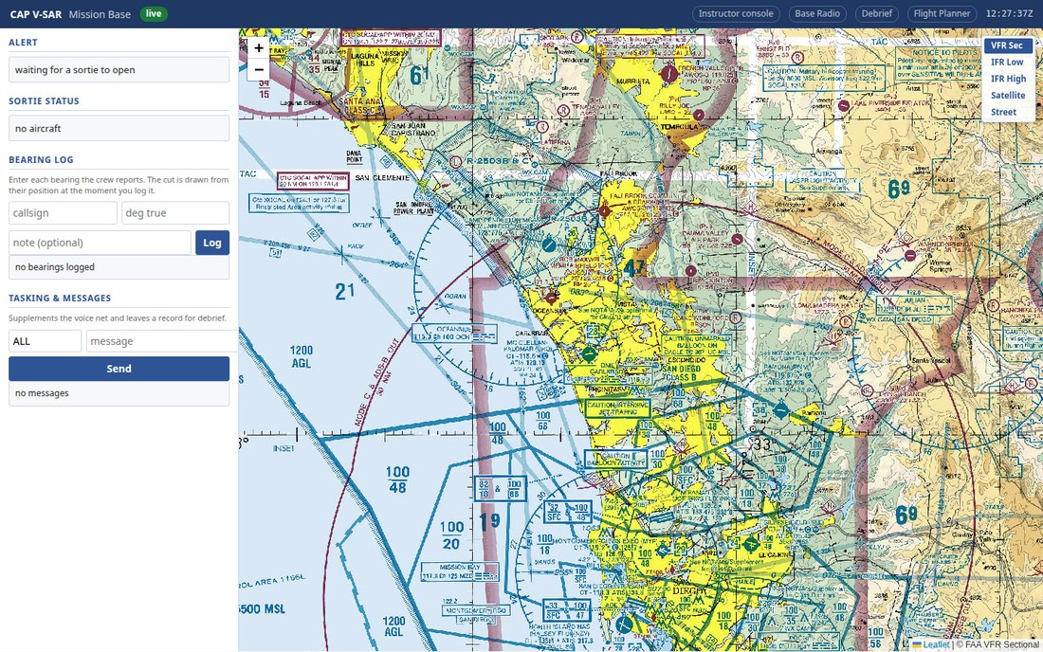
Figure 2 — Mission Base. Alert, sortie status, bearing log with notes, and tasking and messages. No beacon truth appears here, by design.
- Alert. The incident as it came in. Before a sortie opens it reads waiting for a sortie to open.
- Sortie status. Aircraft currently reporting.
- Bearing log. As bearings come over the net, enter callsign and degrees true; the cut is drawn from the aircraft's position at the moment you log it. The optional note is where you record anything about the bearing's quality.
- Tasking & messages. Supplements the voice net and leaves a record for the debrief. Address ALL or a single callsign.
Base is meant to cross-check the cockpit. When a plotted cut disagrees with the previous three, that is usually multipath off terrain, and catching it from base — then asking the crew to re-fly the leg — is one of the things a SAREX exists to practise. Log the disagreement in the note field so it is in the debrief.

4. Base radio console
The MRO's station on the mission net.
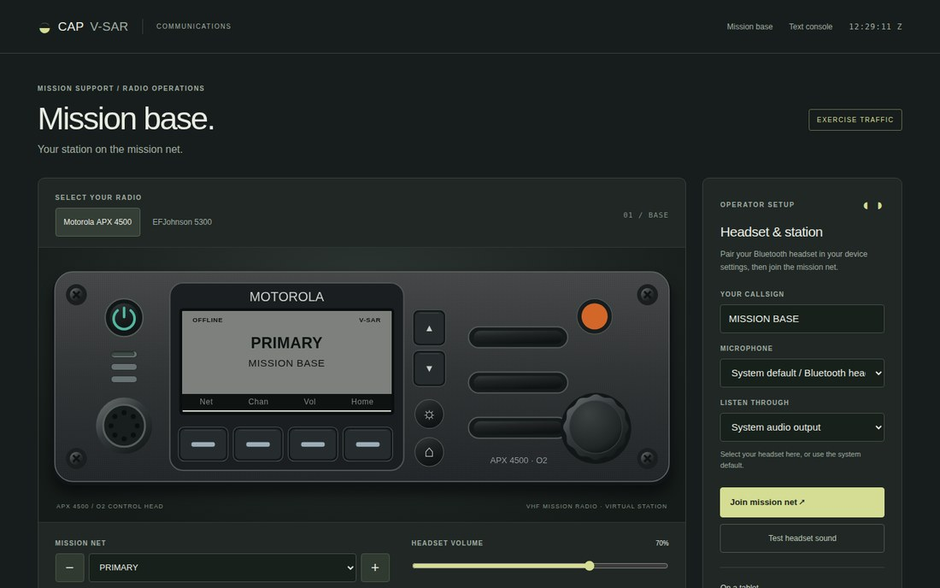
Figure 3 — The base radio console over HTTPS, showing the Motorola APX 4500 control head and the operator setup panel.

Before the exercise
- Pair your headset in your device's own Bluetooth settings first. The page cannot do it for you.
- Open the console over HTTPS. On plain HTTP you will get a Headset access notice instead of a working radio.
- Check Your callsign in the operator setup panel — MISSION BASE in Figure 3.
- Set Microphone and Listen through to your headset rather than the system default.
- Test headset sound, then Join mission net.

Working the net
- Select your radio. Motorola APX 4500 or EFJohnson 5300. The control head is operable — it is the radio you would use at a real base.
- Mission net. Choose the channel. Convention is Primary for position reports and Alternate for DF traffic; follow the communications plan for the exercise.
- Headset volume is separate from your device volume.
After the September access-control work is deployed, your callsign is taken from your participant badge rather than typed, so it cannot be set to another station's.

5. Flight planner
The AOBD builds the route and the search patterns here.
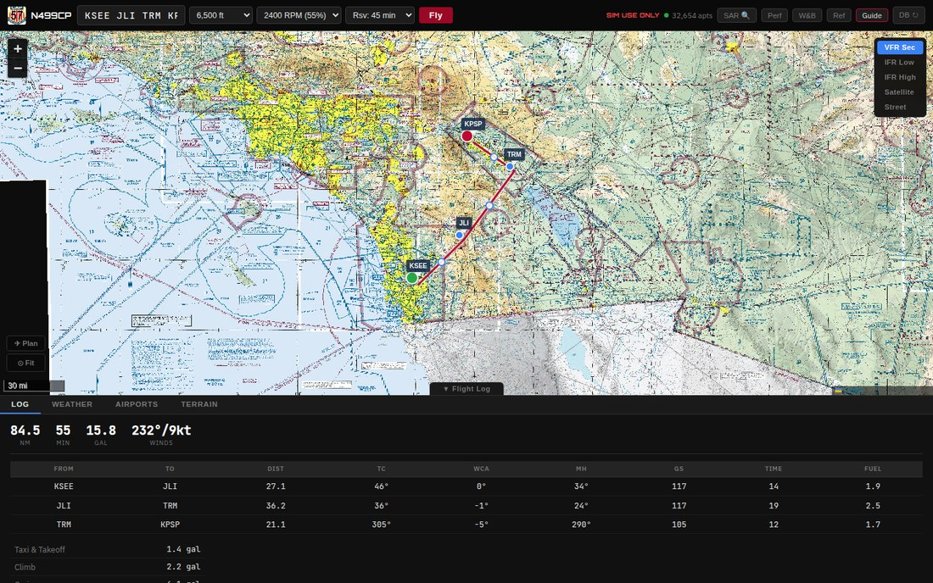
Figure 4 — A computed route, KSEE to KPSP via JLI and TRM: 84.5 NM, 55 minutes, 15.8 gallons, winds 232°/9kt, with the per-leg navigation log below.
Type the route in the box at top left as a list of identifiers (KSEE JLI TRM KPSP), set cruise altitude, power and reserve, then press Fly. The log below the chart gives, per leg: distance, true course, wind correction angle, magnetic heading, groundspeed, time and fuel, then the fuel breakdown by phase.
The tabs under the chart are Log, Weather, Airports and Terrain. The chart layer selector at top right switches between VFR sectional, IFR low, IFR high, satellite and street.
The toolbar at top right carries SAR (search pattern generation), Perf (performance), W&B (weight and balance), Ref and Guide.
Check the terrain profile before you brief a search leg. A creeping line drawn across a ridge will look fine on the chart and be unflyable at the altitude you assigned. Re-drawing the leg higher on a Tuesday evening is the correction that a real briefing would otherwise have to make on the day.

6. Debrief
After the sortie. This is where the training value is collected.
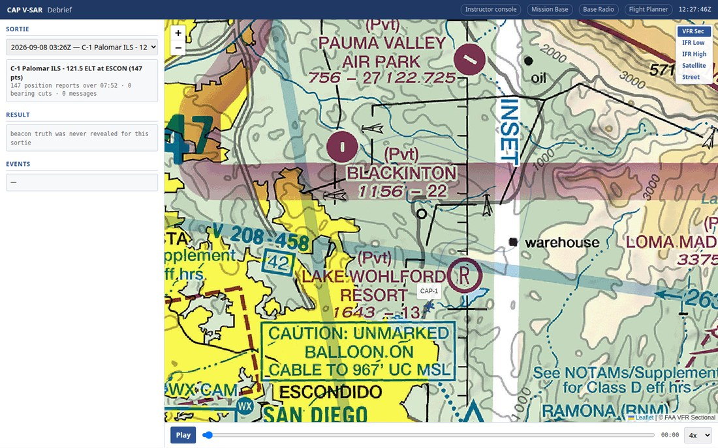
Figure 5 — Debrief for a past sortie: 147 position reports over 07:52, with track playback and a speed control. The result line records that beacon truth was never revealed for this sortie.
Choose the sortie from the dropdown. The summary gives position reports, bearing cuts and messages logged. Play replays the track against time, and the speed selector runs it faster than real time.
If the director revealed the beacon, the debrief scores each reported bearing against truth in degrees and shows closest point of approach. If truth was never revealed — as in Figure 5 — the result line says so plainly rather than showing a misleading zero.

What a SET can read from a debrief
Measure | What it tells you
Bearing error per report, in degrees | DF technique; whether multipath and the cone of confusion were recognised
Closest point of approach, and time to first good cut | Homing effectiveness
Track efficiency against the assigned pattern | Pattern discipline
Ops-normal report timing per aircraft | Communications discipline, in the cockpit and at base
Rejected or corrected cuts | Whether base cross-checked the aircraft
Change across the three rehearsal sessions | Whether the rehearsal worked

7. AI Pilot deck (engineering)
Not a participant surface. Included so you recognise it if you are shown it.
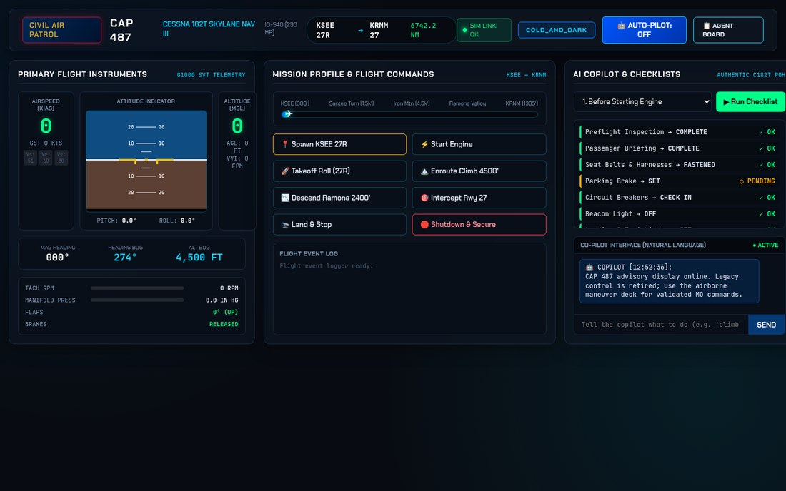
Figure 6 — The AI Pilot deck: primary flight instruments, mission profile, and the C182T POH checklists with a natural-language copilot pane.
The deck is an engineering and flight-test tool for CAP 487, not part of an exercise. It shows live telemetry, the authentic C182T POH checklists, and an advisory copilot. Note the copilot's own message in Figure 6: legacy aircraft control is retired, and live control is restricted to the validated maneuver server with an explicit control lease.
This surface is moving. After the September changes it binds to the local machine only and requires an engineering credential, so it will no longer answer on the network address. That is deliberate — it can rewrite the agent work queue, and it has no place on a participant network.

8. If something is wrong
Symptom | Usual cause
Radio page shows "Open the secure radio page" | You are on HTTP. Use the HTTPS address.
Browser warns about the certificate | The lab CA is not installed on that device yet. Install /radio-ca.crt.
Microphone does nothing | Headset not paired at the device level, or not selected in operator setup.
Aircraft panel says "none reporting" | The X-Plane plugin is not connected, or its station file names a different console.
Base map shows no assigned pattern | The pattern was exported but not pushed to the console from the planner.
Debrief shows no bearing errors | The beacon was never revealed for that sortie.

9. Known limits
- Bearing intersections are not computed. Cuts are drawn, but the system does not calculate pairwise intersections or a confidence area; base does that by eye. (Tracker item F-8.)
- Base cannot monitor the airband SAR net alongside the mission net. (F-10.)
- Mid-flight retasking with a pushed assignment is not implemented; the assignment view is the base map with pushed patterns. (CalTopo phase 2.)
- Stick force and buffet are not modelled and cannot be inferred. Report control displacement, trim demand and simulated cues only.
- The deployed build predates the September access-control work. Until it is redeployed, the console does not ask who you are. Treat the mission network as the only boundary, and do not expose it beyond the lab.
Related documents. docs/USE_CASE_SAREX_REHEARSAL.md — how a three-session rehearsal runs end to end. CAP_V-SAR_Seat_User_Stories.docx — what each seat may and may not see. docs/CONNECT.md — joining the mission network. docs/BUG_TRACKER.md — the authoritative status of every known defect.

