Interview Summary

Need Finding:

1. Mr. Cabaya

We have interviewed Mr. Cabaya, one of APC’s guards. According to Mr. Cabaya, the current process for issuing violations includes:

* 1. Informing the students of the violations committed
  2. Asking the students to write his/her information in two violation slips
  3. Guards asking for school ID to confirm information
  4. Guard completing the two violation slips and signing it
  5. Giving the student a copy of their slip

At the end of the day, guards will have to submit the compiled violation slips to the discipline office. An average of 30 violation slips are issued per day.

1. Rosemarie Alejandro

For me, issuing a violation slips are not eco-friendly and it is a waste of paper.

1. Dayle Igno
2. It is a bit of a hassle to fill up a violation slip. For example, if you are running late and you still have to fill it up, the time that I consumed filling it up is a waste.
3. It will be efficient if we will be using our issued ID’s for violations to make it paperless.

Paper Prototype Interview of DO, Guards and Students:

1. Mr. Quilang

We have interviewed Mr. Quilang, one of APC’s guards. According to Mr. Quilang, the proposed paper prototype is good for them and it will lessen their work as a guard. There are some feedback and suggestions that Mr. Quilang would like to add to the system.

* There should be a process in which the students would verify their violation inputted by the guards.
* The students should be able to sign or include a signature box in the system for verification because students can reason out that the submitted violation is a false report.

1. Sir Raymart Cabiten

Sir Raymart Cabiten is the DO in APC. One of the things he does is to track all the violations of the students in APC. To know how many times the student violates the rules and to know what punishment fits to the students for violating rules. We present to Sir Cabiten our paper prototype and gave suggestions that can be added to the proposed prototype.

There are his suggestions/feedback:

* In issuing violations, he would want us to set that instead of the detailed dress code violations the buttons can be the Minor offense, Major offense, etc and in remarks is the report for the incident. Also, the total violations of students should also be included in the said interface.
* In View violations and for counseling, we should include the transactions, sending email, and return button. In transactions, it indicates in what level of violation does the student undergo. In sending email, he said that we should include a send email button if the student exceeds the number of violations to notify the student on what will be his/her punishment in violating rules. In return button, he would also like to add this function to know that the student returned the hard copy of the email he sent because the letter should have the signature of the student’s parent.
* In counseling schedule, it is good for him because he said that it can easily track his schedule and set a schedule.

1. Russell Dela Virgen

Russell said that the proposed prototype is good for him and to other students. It is good that the students are aware with their violations because some students lost track with their committed violations. He also suggests that there should be a cancel or request button to cancel their violation in case the guard misunderstood what they’re wearing.

1. Andrei Lagsac

Andrei also agreed with the proposed prototype and his suggestion is to know the number of violations in every term.

Digital Mock-Up Interview of DO, Guards and Students:

1. Mr. Ely

Mr. Ely is one of the APC’s guards. We present to him our proposed digital mockup and he said that he is good with the project. The project will help them to lessen their work and to finish their tasks quick. His only concern is where it will be placed if the proposed project is implemented.

1. Sir Raymart Cabiten
2. Via Tubon

Via’s feedback with the proposed project is that it will really help her to track her violations and it will be easy for her and to other students to cancel their violations. They just must click the cancel button to send a request to the DO and the DO will set a meeting with them.

1. Ivan Jasper Evangelista

Ivan’s only concern is if the other guards/professors will have an access to view his number of violations he committed because his privacy is important to him.

User Needs

1. Guards needs a way to issue violations faster.

Guards stationed at the entrances are tasked to issue violations on top of their security responsibilities. Performing both these tasks at the same time are not only tedious but also time-consuming. Apprehended students sometimes must wait for the guards to check all the bags of students before a violation slip is issued for them.

1. Guards needs to be able to check student credentials faster.

There were numerous reports of students using the credentials of other students. Because of this, guards also check the I.D. of the student upon issuing violations.

1. Guards needs a way to issue violations without using paper.

The current system uses papers. A single violation requires two violation slip, one for the student and another for the Discipline Office. This is costly, and a waste of resources. Also, this is one of the few remaining tedious and manual task in Asia Pacific College, a center for excellence in Information Technology.

1. Guards needs a way to issue violations in legible form.

Both students and guards may not write legibly on the form which has been difficult for the guards themselves and Discipline Office to understand and record appropriately.

1. Students needs a way to monitor their violations.

There is no other way for students to track their violations except for manually keeping the violation slip issued to them.

1. Student needs a way to cancel violations.
2. Discipline Office needs a way to monitor student violations easily.

The Discipline Office manually records all violations based on their copy of the violation slip. Everyday, guards submit the violation slips to the Discipline Office for recording.

1. Discipline’s Office needs a way to cancel violations without searching for violation paper issued.

Upon cancellation of violations, the Discipline Head must take note of the cancellation or find the paper in the records of violation.

Point of View

An electronic violation system can minimize issuing time, allow transparency and ease of access for all users.

* Issuing violations shouldn’t be a tedious task for security guards.
* Violations can be issued electronically, especially in an IT enabled school.
* By using NFCs in student ID, student verification can be quick and easy.
* Students and the Disciplines Office can use FLAVIO to track their violations.

**WIREFRAMES:**

* **FOR GUARDS:**

* **FOR STUDENTS:**

* A screenshot of a cell phone

  Description automatically generated**FOR D.O**

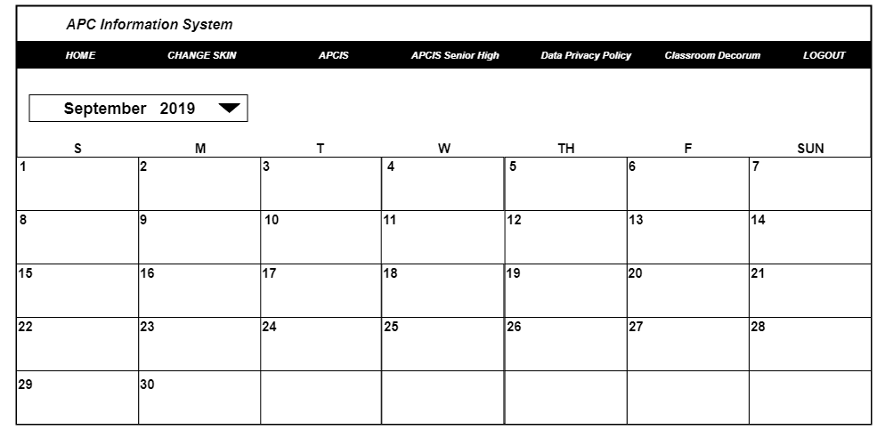

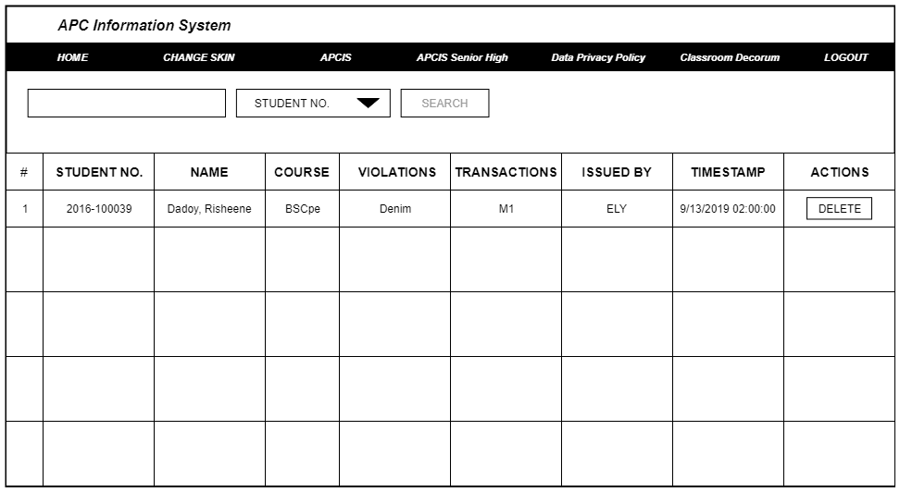

**SCREEN LINK:**

<https://userdes-apcisv2.herokuapp.com/index.html?fbclid=IwAR2hvKxUc_JN-AvUxKrY6gt9W3K7lXjnq6nr1YMtBcAOBKPBk4MPbhVteII>

**DEVELOPMENT PLAN:**

|  |  |  |  |  |  |
| --- | --- | --- | --- | --- | --- |
| **Week #** | **To Do** | **Owned by** | **Deadline** | **Status** | **Comments** |
|  |  |  |  |  |  |
| Week 7 - Start up | Set up collab repository | Risheene | Aug 5,2019 |  |  |
| *Notes: Aug 5 - 12* | User needs | All | Aug 7, 2019 |  | high priority |
|  | interview DO | All | Aug 8, 2019 |  |  |
|  | interview students | All | Aug 9,2019 |  |  |
|  | Interview guards | All | Aug 10,2019 |  |  |
|  | paper prototype | Jamie | Aug 12,2019 |  | high priority |
|  |  |  |  |  |  |
| Week 8 - Interview with Paper Proto | Interview DO with proto | All | Aug-13 |  |  |
| *Notes: 13-20* | Interview guards with proto | All | Aug-14 |  |  |
|  | Interview students with proto | All | Aug-15 |  |  |
|  | Revise User needs | All | Aug-17 |  |  |
|  | Point of view | All | Aug-18 |  |  |
|  | Plan changes | All | Aug-20 |  |  |
|  |  |  |  |  |  |
| Week 9 - Digital Mockup | create ui for guard | risheene | Aug-21 |  |  |
| *Notes: 21-28* | create ui for students | risheene | Aug-22 |  |  |
|  | create ui for DO | jamie | Aug-23 |  |  |
|  | Design | jamie | Aug-24 |  |  |
|  | interview DO with digital mock up | all | Aug-26 |  |  |
|  | interview guard with digital mock up | all | Aug-27 |  |  |
|  | interview students with digital mock up | all | Aug-28 |  |  |
|  |  |  |  |  |  |
| *Week 10 - Adjustments for needfinding* | do suggestions of the DO | jamie | Aug-29 |  |  |
|  | do suggestions of the Guards | risheene | Aug-30 |  |  |
| Notes: 29- sept 5 | do suggestions of the students | risheene | Aug-31 |  |  |
|  | plan html/css | jamie | Sep-05 |  |  |
|  |  |  |  |  |  |
| Week 11 - Plan website | login page | risheene | Sep-06 |  |  |
| Notes: sept 6 - 13 | home page for students | jamie | Sep-07 |  |  |
|  | assign buttons needed | all | Sep-08 |  |  |
|  | home page for guards | jamie | Sep-09 |  |  |
|  | home page for DO | risheene | Sep-10 |  |  |
|  | Viewing lists for students | jamie | Sep-11 |  |  |
|  | viewing list for DO | jamie | Sep-12 |  |  |
|  | issue violations for guards and DO | jamie | Sep-13 |  |  |
|  |  |  |  |  |  |
| Week 12 - Finalize paper and website | finalize UI for guards | jamie | Sep-14 |  |  |
| Notes: sept 14 - 16 | finalize UI for students | jamie | Sep-14 |  |  |
|  | finalize UI for DO | jamie | Sep-14 |  |  |
|  | Revise Documentation | risheene | Sep-16 |  |  |
|  |  |  |  |  |  |