**Book Buddies**

Charleston Book Buddies is a one-on-one tutorial program for second grade students. Its goal is to help ensure that the students it tutors read at grade level by the end of the year.

**https://websitebuilder.1and1.com/resource/static/image/blank.gif  
What to Expect:**

When you volunteer at Charleston Book Buddies, you'll work one-on-one with a second grade child who has fallen behind in reading.

* Each tutoring session is 45 minutes.
* Volunteers can tutor once or twice a week. (Children are tutored twice a week.)
* Volunteers follow a lesson plan which is written specifically for the child he tutors.
* A reading specialist observes and works with all tutoring pairs so there is plenty of expert support if it's needed.
* Tutoring takes place at local schools that have a relationship with Charleston Book Buddies.

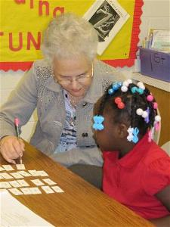Volunteers must commit to a minimum of one hour/week for one semester (approx. 16 weeks) in order to provide consistency for our students. If you don't anticipate being able to do this, we would encourage you to consider being a substitute tutor.

**Why it Works:**

* Structured, phonics-based program which includes comprehension and writing
* Trained, certified, site coordinators leading the program at each school
* Orientation and ongoing training for tutors
* Students engaged in one-on-one tutoring two times per week with same tutor
* Lesson plans based on individual needs
* Progress and performance tracking provided by pre- and post-testing

Become a Tutor (same link as on home page)