This project was created to assess crime trends in Los Angeles, California. The dataset used in this project was found on https://catalog.data.gov/dataset/crime-data-from-2020-to-present and is dating from January 2020 to the present day.

The goal of this project was to establish trends in crime data to see which locations and around what times crimes usually take place. This project was also intended to discover who is most likely to be a victim of a crime, based on age, gender, and ethnicity.

In our analysis of 761582 crimes, we found that 63% of crimes committed were property crimes and 31% were violent crimes. We find distinct differences in the manner of occurrence of the two crime types across the time of day, day of the week, and month of the year, as shown on the figures below. When looking at all types together we observe a manner of occurrence similar to that of property crimes, due to those crimes making up the majority of total crimes. Thus, we need to separate out violent crimes to determine their distinct manner of occurrence.

When looking at the time of occurrence for crimes, we see an unusual spike at noon. For crimes other than violent crimes, there is a 75% increase and then 75% decrease from 11 a.m. to noon and from noon to 1 p.m., with most of the crimes occurring at exactly noon. We believe that because of the possible absence of victims at the scene of the crime, many of these values are simply placeholders for unknown times. We also found ages 35 and 50 treated this way, likely for similar reasons. Ignoring the spike at noon, we see property crime peaking between the hours of 5 p.m. and 7 p.m. and violent crime peaking between 8 p.m. and 10 p.m., with both types reaching a low at 5 a.m. Looking at crime across the days of the week, violent crime peaks on Friday, compared to property crime peaking on Sunday, with Saturday as the 2nd highest day for both crimes. Over the course of the year we observe that violent crime peaks during the summer and reaches a low in the winter months. For property crimes, we do not observe a seasonal pattern. However, there was a decrease in property crime at the beginning of 2020 when the Covid lockdowns took effect, where previous levels were not again reached until October 2021 with crime continuing to rise afterward. This long-term variation does not exist for other types of crime.

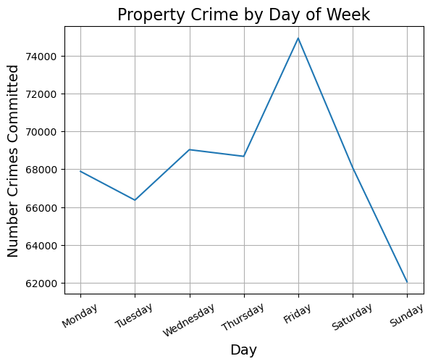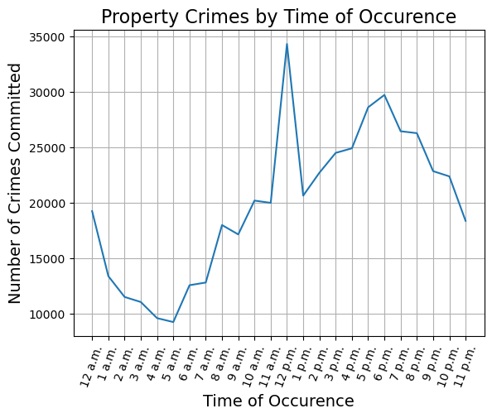

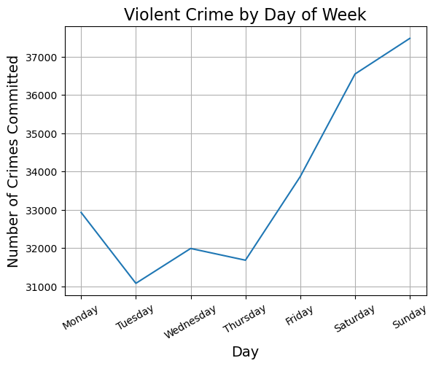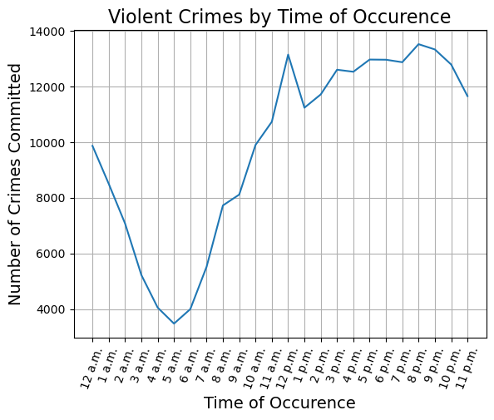

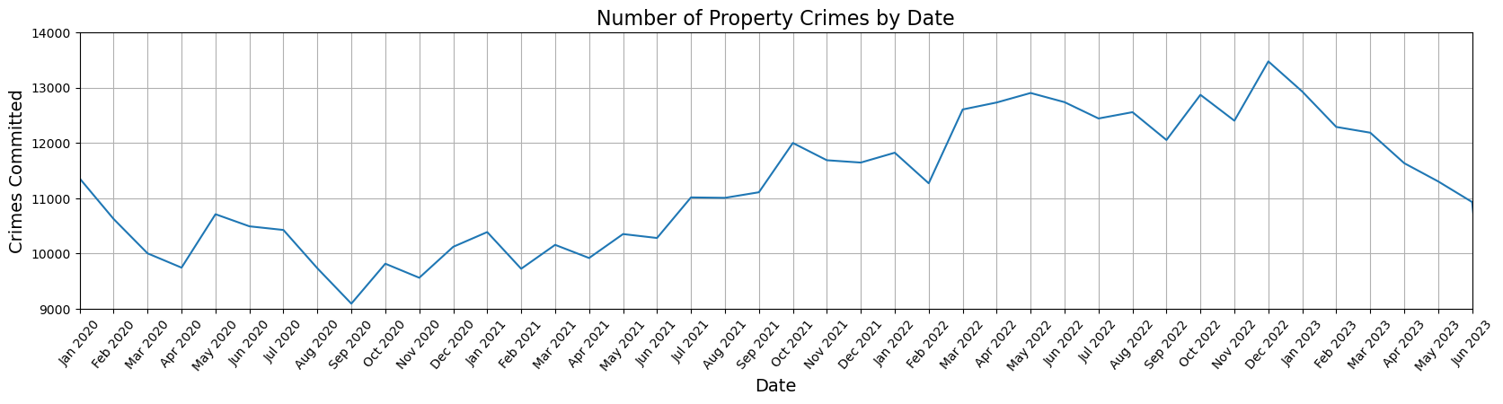

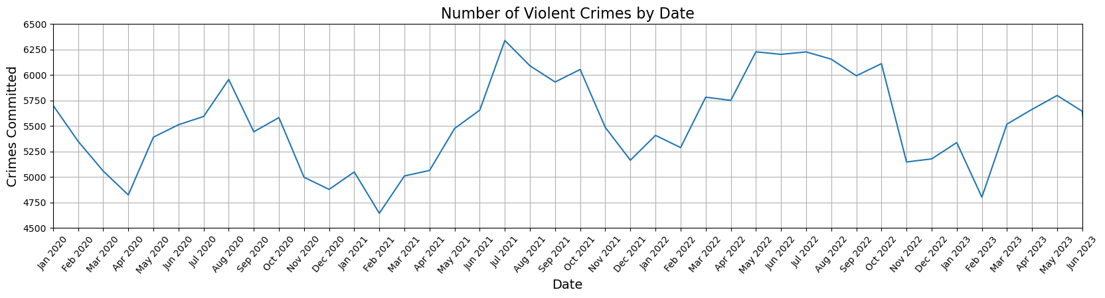

It is found that most of the victims are between 20 to 40 years old according to Victim Age by Crime Type. By breaking down to crime types, such as other, property and violent crimes, it shows that violent crimes mostly involve victims aged 20 and below.

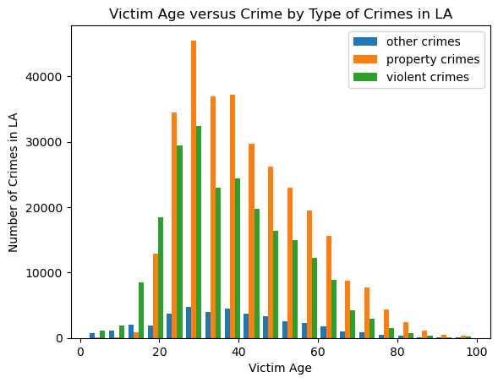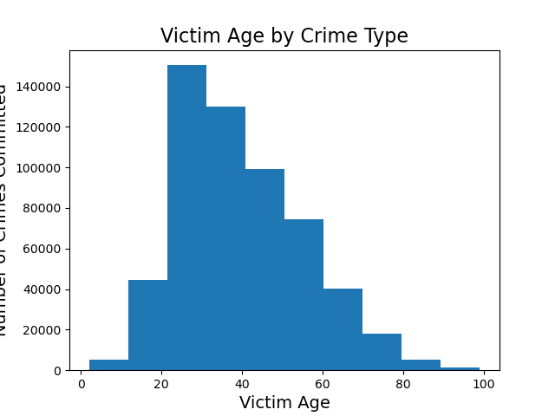

Based on female to male ratio and male to female ratio versus crime description, it is found that female victims experience sexually related crimes. The top five crime description indicates that female are likey to be the victims of sexually related crimes, such as human trafficking- commercial sex acts, pimping, and rape. On the other hand, males are mostly the victims of violent crimes such as battery on a firefighter, assault with deadly weapon on police officer, failure to yield, and resisting arrest.

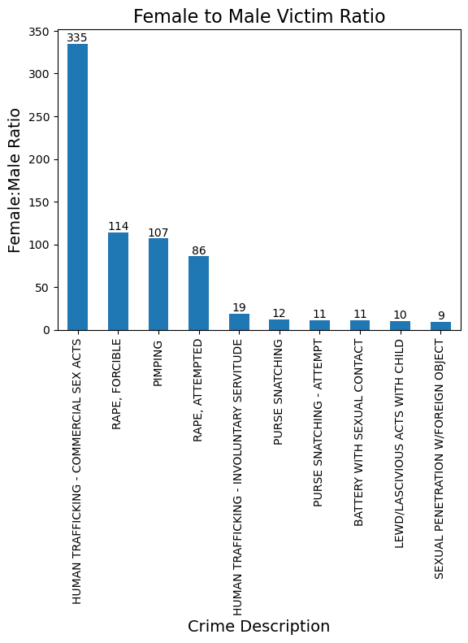 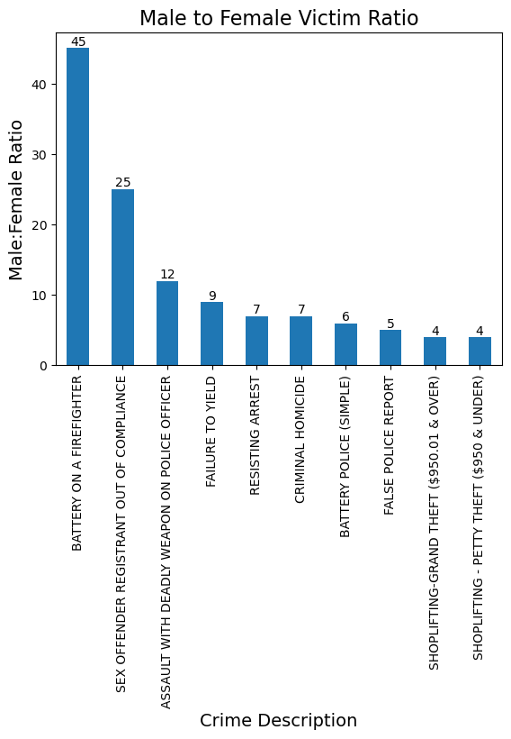

To find the location where most of the crimes occur in Los Angeles, an API key was created with google maps to display each of the 21 reported areas in the dataset.

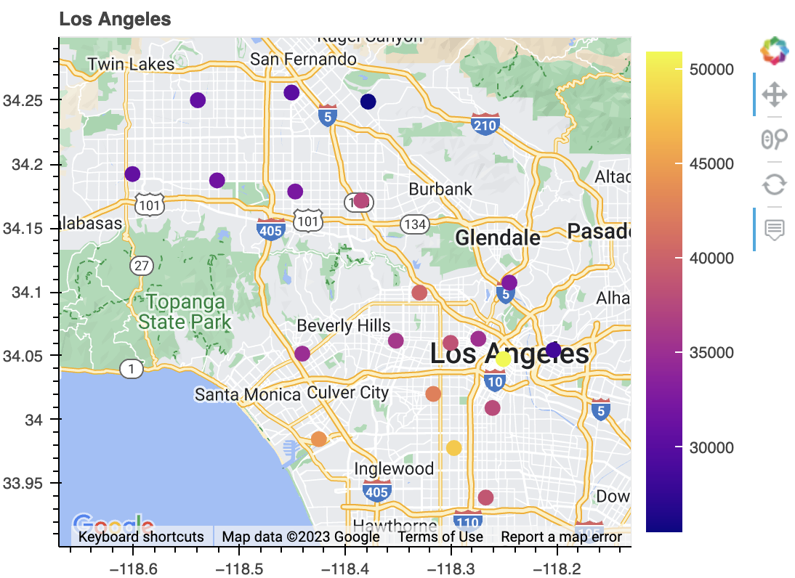

With this API, the yellow dot location shows Central Los Angeles, and it has over 50,000 crimes committed in that area. The dark blue dot indicates Foothill in Los Angeles, and that location has under 30,000 crimes committed since January 2020. Crimes are concentrated around the city center with much lower crime around the northwestern portion of the city. We also see significant crime rates south and southwest of the city center, especially in the areas of Newton and Pacific respectively.