Tooling assignment
Step 1 AWS account setup

1.
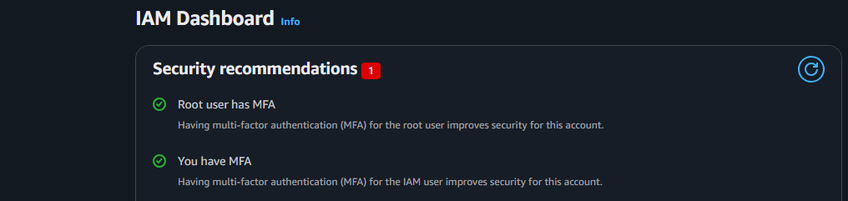
2.
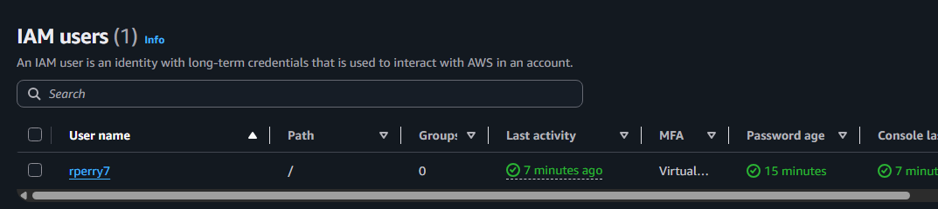
3.
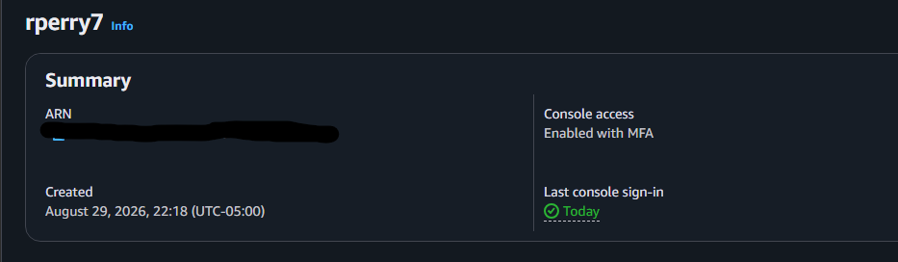
4.
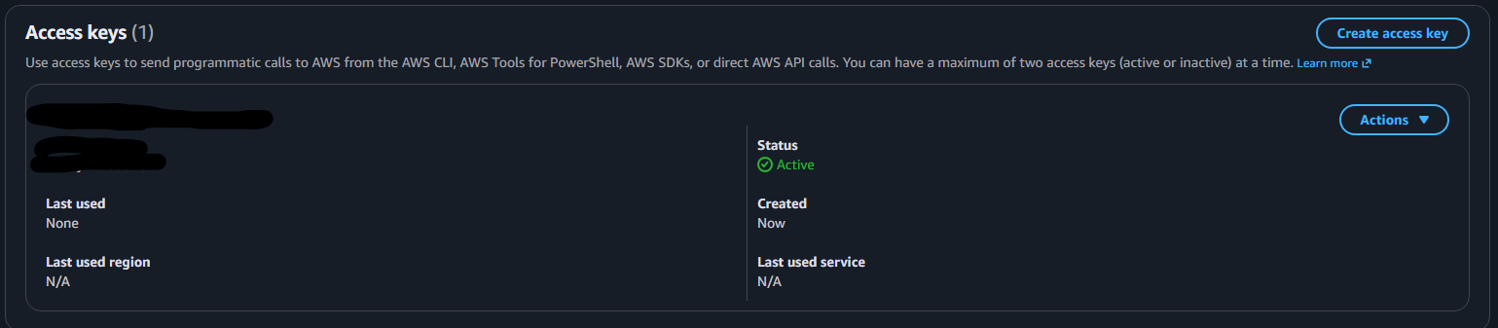
5.
Root user MFA and least-privilege IAM users are important because they help protect cloud accounts from being misused. MFA adds an extra layer of security, so even if someone gets the root password, they will still need another form of verification. Least-privilege IAM users only get the permissions they need to do their job, which helps limit damage if an account is hacked or used incorrectly. Together, these security practices make cloud environments safer.
Step 2 Linux container setup
1.
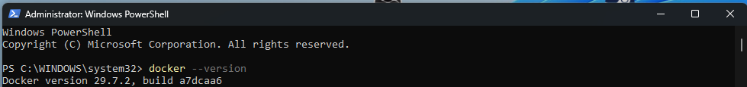
2.
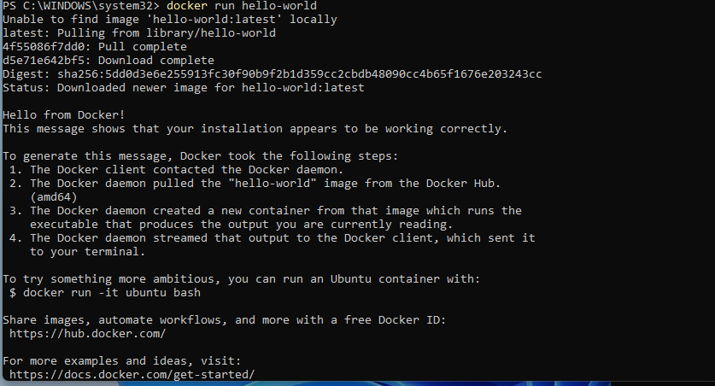
3.
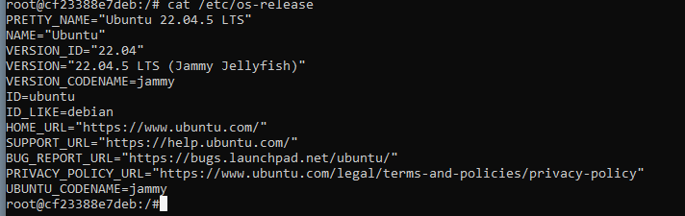
4.
Before
After
5.
A Docker image is like a blueprint that contains everything needed to run an application, such as the code and settings. A Docker container is the actual running version of that image. In simple terms, the image is what you use to create the container, while the container is the application running from that image.
Step 3 AWS/GitHub setup
1.
2.
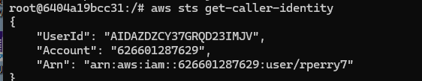
3.
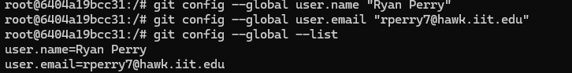
4.
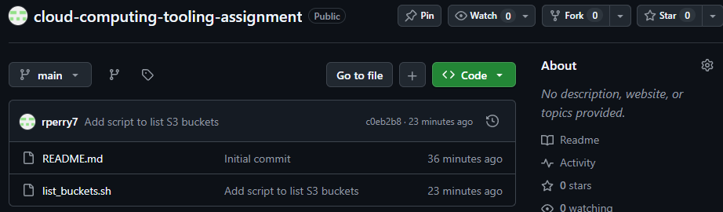
5.
You should never commit AWS credentials or GitHub tokens to a repository because someone could find them and use them to access your accounts. Even if the repository is private, it could still be shared or hacked. If someone gets your credentials, they could create resources, access private information, or cause expensive charges. It is safer to keep credentials out of your code and use secure methods to store them.

