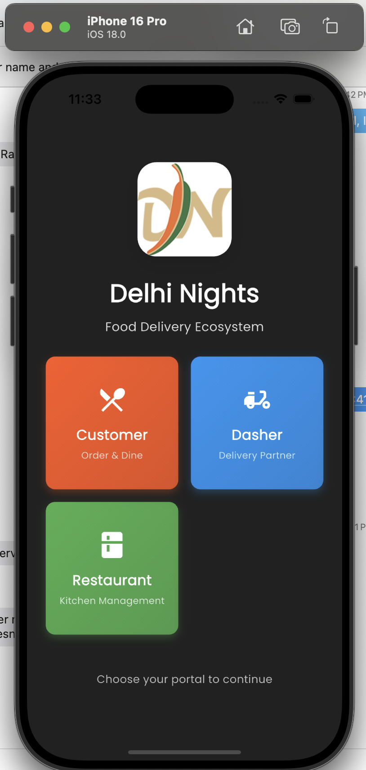
Staff Management
To proceed with the design of your restaurant staff management app, we'll start by outlining the key screens necessary for its functionality. Here are some initial screen suggestions:
- Staff Check-in/Check-out Kiosk: A screen for staff to easily check in and out using their unique ID or a QR code.
- Weekly Roster Management: An admin-only screen to create and oversee the weekly staff schedule, including drag-and-drop functionality for assigning staff to shifts.
- Staff Assignment: A screen that allows admins to assign roles and responsibilities for each shift and manage shift swaps or replacements.
- Reporting & Analytics Dashboard: A screen for admins to view weekly staff work hour reports and other analytics, with options to export data.
- Staff Schedule View: A screen for staff to view their assigned weekly schedules.

- Weekly Roster Management: This admin-only screen facilitates the creation and management of weekly staff schedules, featuring a drag-and-drop interface for assigning staff to shifts within a clear weekly calendar layout.
- Staff Assignment: Designed for admins, this screen allows the assignment of specific roles and responsibilities to staff for each shift and supports dynamic management of shift swaps and replacements.
- Reporting & Analytics Dashboard: This dashboard provides admins with a visual overview of staff work hours and attendance, including the ability to generate and export weekly reports in PDF or Excel format.
- Staff Schedule View: This screen enables staff to view their assigned weekly work schedules, ensuring they are well-informed about their shifts and responsibilities.
