**Rajshree Phadol**

**IT6863 Database Security & Auditing**

**16 October 2017**

**ERD:**

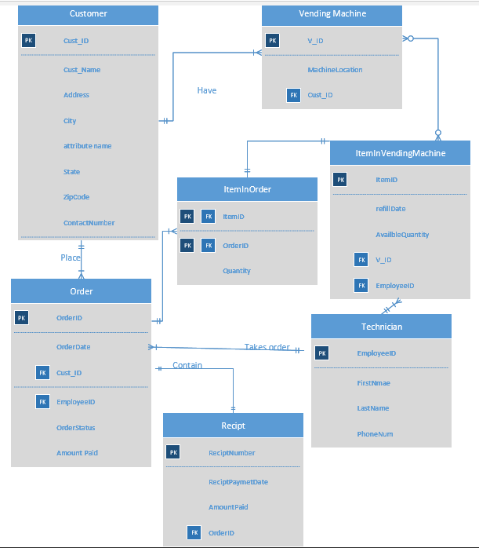

**--a) Table CUSTOMER**

**CREATE TABLE CUSTOMER**

**(**

**CUST_ID INT PRIMARY KEY,**

**CUST_NAME VARCHAR (50),**

**ADDRESS VARCHAR(50),**

**CITY VARCHAR(50),**

**STATE VARCHAR(50),**

**ZIP_CODE INT,**

**CONTACT_NUMBER INT**

**);**

**INSERT INTO CUSTOMER(CUST_ID, CUST_NAME, ADDRESS, CITY, STATE, ZIP_CODE, CONTACT_NUMBER)**

**VALUES(101, 'Kennesaw State University', '1100 Marrieta','Atlanta','GA',30345,2786549087);**

**INSERT INTO CUSTOMER(CUST_ID, CUST_NAME, ADDRESS, CITY, STATE, ZIP_CODE, CONTACT_NUMBER)**

**VALUES(102, 'Vertafore', '876 peachtree rd','Atlanta','GA',32987,8769760987);**

**INSERT INTO CUSTOMER(CUST_ID, CUST_NAME, ADDRESS, CITY, STATE, ZIP_CODE, CONTACT_NUMBER)**

**VALUES(103, 'Kennesaw State University', '1200 kennesaw','Atlanta','GA',30333,4048763542);**

**INSERT INTO CUSTOMER(CUST_ID, CUST_NAME, ADDRESS, CITY, STATE, ZIP_CODE, CONTACT_NUMBER)**

**VALUES(104, 'Gerogia Tech', '888 Georgia Tech ave','Atlanta','GA',32987,2668973540);**

**INSERT INTO CUSTOMER(CUST_ID, CUST_NAME, ADDRESS, CITY, STATE, ZIP_CODE, CONTACT_NUMBER)**

**VALUES(105, 'Perimeter walmart', '1900 peachtree rd','Atlanta','GA',30333,8678782341);**

**Select * from CUSTOMER;**

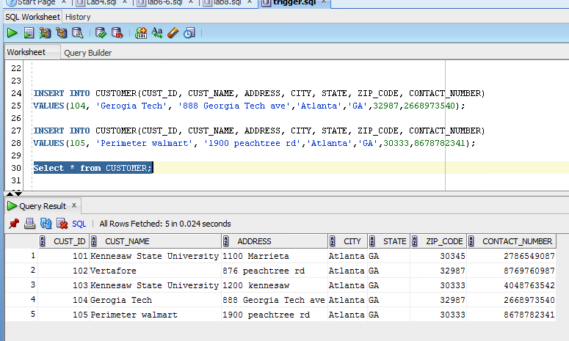

--b) Table Technician

**--drop Table Technician**

**Create Table Technician**

**(**

**T_ID INT primary key,**

**T_FirstName varchar(30),**

**T_LastName varchar(30),**

**T_Contact INT**

**);**

**INSERT INTO Technician(T_ID, T_FirstName, T_LastName, T_Contact)**

**VALUES(10, 'Vishal', 'Kharjul',4449862325);**

**INSERT INTO Technician(T_ID, T_FirstName, T_LastName, T_Contact)**

**VALUES(11, 'Vibha', 'Desai',9876098321);**

**INSERT INTO Technician(T_ID, T_FirstName, T_LastName, T_Contact)**

**VALUES(12, 'Kapil', 'Joshi', 5674321890);**

**INSERT INTO Technician(T_ID, T_FirstName, T_LastName, T_Contact)**

**VALUES(13, 'Mayur', 'Phadol',2679876543);**

**INSERT INTO Technician(T_ID, T_FirstName, T_LastName, T_Contact)**

**VALUES(14, 'Shobha', 'Phadol',9076234986);**

**Select * from Technician;**

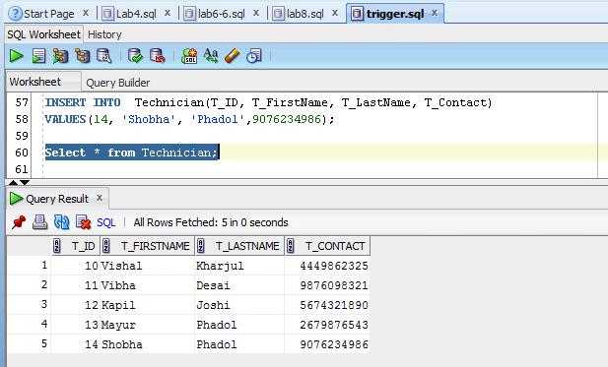

**--drop Table VendingMachine**

**create table VendingMachine**

**(**

**V_ID INT Primary key,**

**MachineLocation Varchar(50),**

**CUST_ID INT,**

**CONSTRAINT FK1_CUSTOMER FOREIGN KEY (CUST_ID) REFERENCES CUSTOMER(CUST_ID)**

**);**

**INSERT INTO VendingMachine(V_ID, MachineLocation, CUST_ID)**

**VALUES(501, '1100 Marrieta Atlanta GA 30345',103);**

**INSERT INTO VendingMachine(V_ID, MachineLocation, CUST_ID)**

**VALUES(502,'1032 Marsh trail cir Atlanta GA 30328', 105);**

**INSERT INTO VendingMachine(V_ID, MachineLocation, CUST_ID)**

**VALUES(503,'1902 Parkair Crossing NC 30876' , 101);**

**INSERT INTO VendingMachine(V_ID, MachineLocation, CUST_ID)**

**VALUES(504,'678 Morgans Fall Sandy springs GA 30332', 104);**

**INSERT INTO VendingMachine(V_ID, MachineLocation, CUST_ID)**

**VALUES(505,'234 Abernathy Sqaure Dunwoody GA 35467', 102);**

**select * from VendingMachine;**

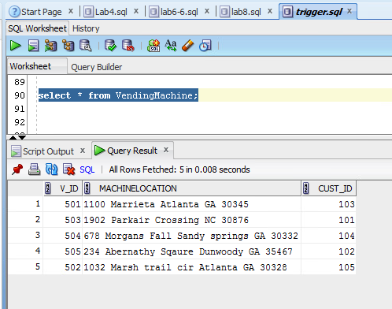

**--drop Table ItemInVendingmachine**

**Create table ItemInVendingmachine**

**(**

**Item_ID INT Primary key,**

**RefillDate date,**

**AvailableQuant INT,**

**T_ID INT,**

**V_ID INT,**

**CONSTRAINT FK1_Technician FOREIGN KEY (T_ID) REFERENCES Technician(T_ID),**

**CONSTRAINT FK_VendingMachine FOREIGN KEY (V_ID) REFERENCES VendingMachine(V_ID)**

**);**

**INSERT INTO ItemInVendingmachine(Item_ID, RefillDate, AvailableQuant, T_ID, V_ID)**

**VALUES(90001,'21-JUN-17', 100, 12, 501);**

**INSERT INTO ItemInVendingmachine(Item_ID, RefillDate, AvailableQuant, T_ID, V_ID)**

**VALUES(90002,'10-JUN-17', 90, 14, 503);**

**INSERT INTO ItemInVendingmachine(Item_ID, RefillDate, AvailableQuant, T_ID, V_ID)**

**VALUES(90003,'21-May-17', 50, 13, 505);**

**INSERT INTO ItemInVendingmachine(Item_ID, RefillDate, AvailableQuant, T_ID, V_ID)**

**VALUES(90004,'10-May-17', 100, 11, 504);**

**INSERT INTO ItemInVendingmachine(Item_ID, RefillDate, AvailableQuant, T_ID, V_ID)**

**VALUES(90005,'21-Apr-17', 110, 12, 501);**

**Select * from ItemInVendingmachine;**

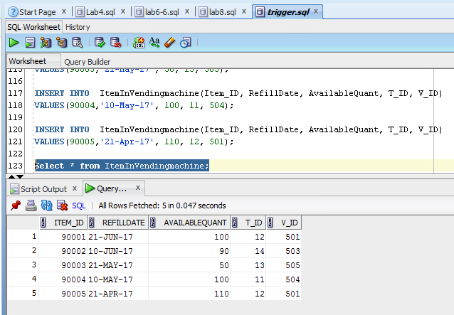

**--drop Table Orders**

**Create table Orders**

**(OrderID INT Primary key,**

**Orderdate date,**

**T_ID INT,**

**CUST_ID INT,**

**OrderStatus Varchar(50),**

**AMOUNT_PAID int,**

**CONSTRAINT FK_Technician FOREIGN KEY (T_ID) REFERENCES Technician(T_ID),**

**CONSTRAINT FK2_CUSTOMER FOREIGN KEY (CUST_ID) REFERENCES CUSTOMER(CUST_ID)**

**);**

**INSERT INTO Orders(OrderID, Orderdate, T_ID, CUST_ID,OrderStatus,amount_paid)**

**VALUES(401,'18-Jun-17', 12, 104,'Completed',1000);**

**INSERT INTO Orders(OrderID, Orderdate, T_ID, CUST_ID,OrderStatus,amount_paid)**

**VALUES(402,'9-Jun-17', 10, 101,'Completed',500);**

**INSERT INTO Orders(OrderID, Orderdate, T_ID, CUST_ID,OrderStatus,amount_paid)**

**VALUES(403,'19-May-17', 14, 105,'Completed',1000);**

**INSERT INTO Orders(OrderID, Orderdate, T_ID, CUST_ID,OrderStatus,amount_paid)**

**VALUES(404,'10-May-17', 13, 102,'Completed',500);**

**INSERT INTO Orders(OrderID, Orderdate, T_ID, CUST_ID,OrderStatus,amount_paid)**

**VALUES(405,'17-apr-17', 11, 104,'Completed',1000);**

**select * from Orders;**

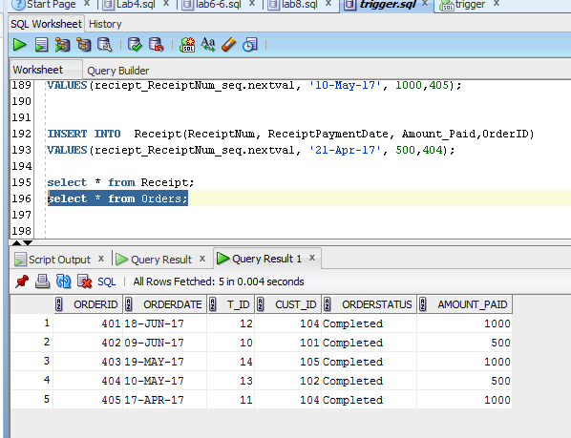

**Sequence for Receipt Table**

create sequence reciept_ReceiptNum_seq start with 10001

increment by 1;

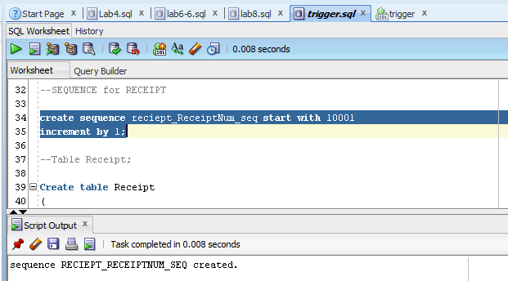

**Create table Receipt**

**(**

**ReceiptNum INT primary key,**

**ReceiptPaymentDate Date,**

**Amount_Paid INT,**

**OrderID INT,**

**CONSTRAINT FK2_Orders FOREIGN KEY (OrderID) REFERENCES Orders(OrderID)**

**);**

**INSERT INTO Receipt(ReceiptNum, ReceiptPaymentDate, Amount_Paid,OrderID)**

**VALUES(reciept_ReceiptNum_seq.nextval, '21-JUN-17', 1000,403);**

**INSERT INTO Receipt(ReceiptNum, ReceiptPaymentDate, Amount_Paid, OrderID)**

**VALUES(reciept_ReceiptNum_seq.nextval, '10-JUN-17', 1000,401);**

**INSERT INTO Receipt(ReceiptNum, ReceiptPaymentDate, Amount_Paid,OrderID)**

**VALUES(reciept_ReceiptNum_seq.nextval, '21-May-17', 500, 402);**

**INSERT INTO Receipt(ReceiptNum, ReceiptPaymentDate, Amount_Paid,OrderID)**

**VALUES(reciept_ReceiptNum_seq.nextval, '10-May-17', 1000,405);**

**INSERT INTO Receipt(ReceiptNum, ReceiptPaymentDate, Amount_Paid,OrderID)**

**VALUES(reciept_ReceiptNum_seq.nextval, '21-Apr-17', 500,404);**

**select * from Receipt;**

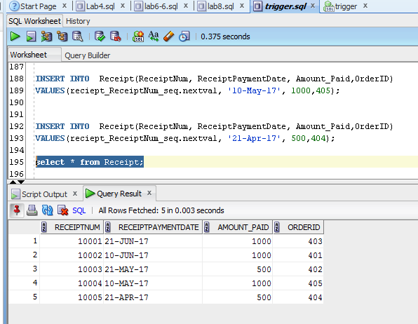

**--drop Table ItenInOrder**

**Create table ItenInOrder**

**(**

**Item_ID int primary key,**

**OrderID int,**

**Quantity Int,**

**CONSTRAINT FK_ORDERS FOREIGN KEY (orderID) REFERENCES ORDERS(OrderID),**

**CONSTRAINT FK_ItemInVendingmachine FOREIGN KEY (Item_ID) REFERENCES ItemInVendingmachine(Item_ID)**

**);**

**INSERT INTO ItenInOrder(Item_ID, OrderID, Quantity)**

**VALUES(90003,405,40);**

**INSERT INTO ItenInOrder(Item_ID, OrderID, Quantity)**

**VALUES(90001,402,50);**

**INSERT INTO ItenInOrder(Item_ID, OrderID, Quantity)**

**VALUES(90005,404,80);**

**INSERT INTO ItenInOrder(Item_ID, OrderID, Quantity)**

**VALUES(90002,403,70);**

**INSERT INTO ItenInOrder(Item_ID, OrderID, Quantity)**

**VALUES(90004,401,90);**

**select * from ItenInOrder;**

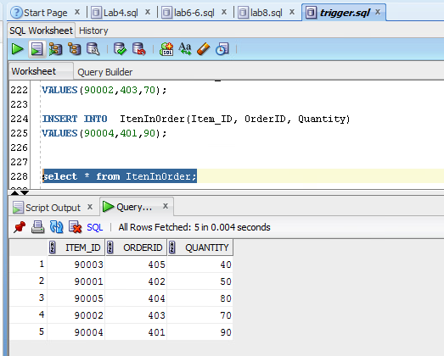

**Sequence for Receipt Table**

create sequence reciept_ReceiptNum_seq start with 10001

increment by 1;



**Before applying Trigger**

1. select * from Receipt;



1. select * from Orders;



**Section III**

**I applied trigger on orders, whenever orderstatus will be updated as “completed“ trigger will fire and in receipt table receipt will generate.**

**Trigger Query:**

create or replace trigger orders_after_update

AFTER UPDATE

ON ORDERS

FOR EACH ROW

BEGIN

IF :NEW.ORDERSTATUS = 'Completed' THEN

INSERT INTO RECEIPT VALUES(reciept_ReceiptNum_seq.nextval,SYSDATE,:OLD.AMOUNT_PAID,:OLD.ORDERID);

END IF;

END ;

/

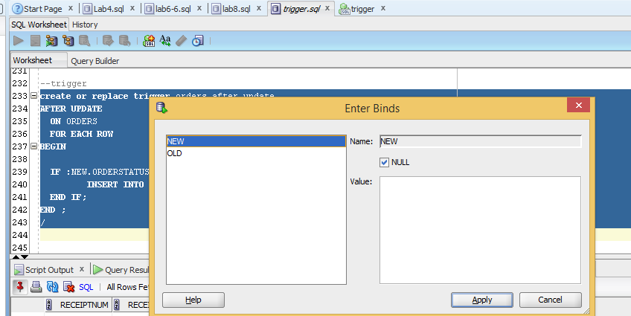

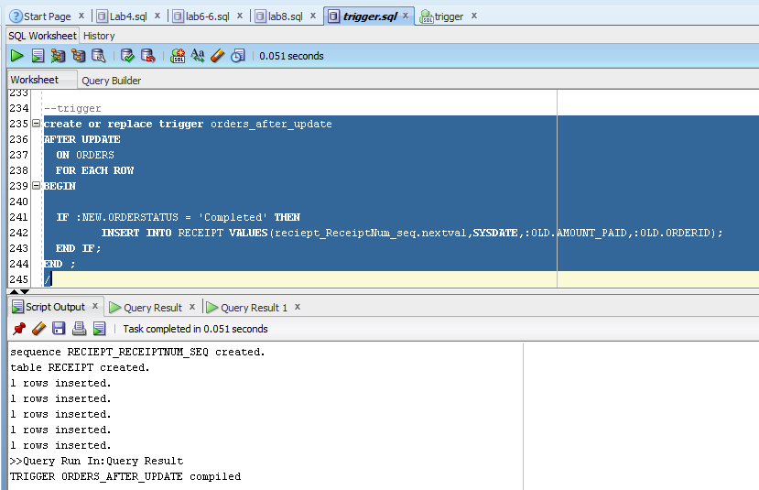

**--Inserting New row in order table**

INSERT INTO Orders(OrderID, Orderdate, T_ID, CUST_ID,OrderStatus,amount_paid)

VALUES(407,SYSDATE, 11, 104,'In Progress',20000);

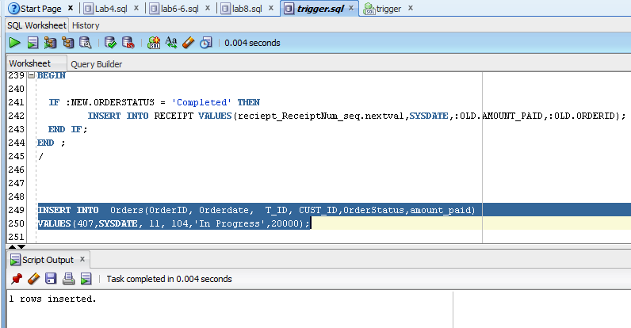

**After applying Trigger**

1. select * from orders ;

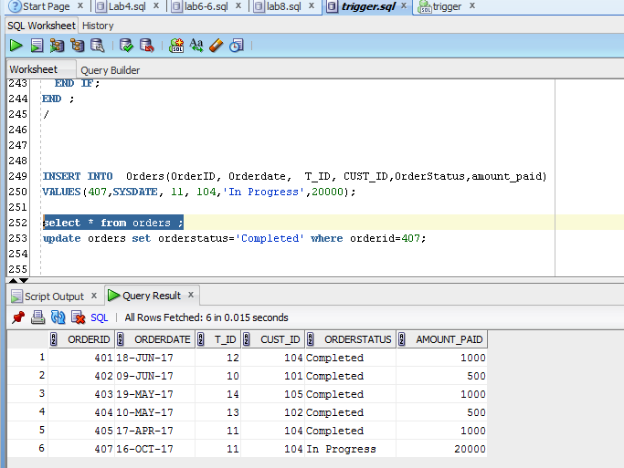

1. Select * from receipt;

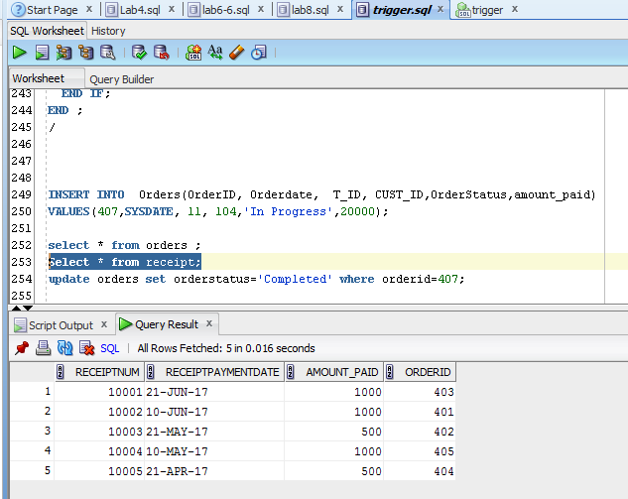

**Updated orderstatus to completed for OrderID=407 so that trigger will apply on receipt table**

1. update orders set orderstatus='Completed' where orderid=407;

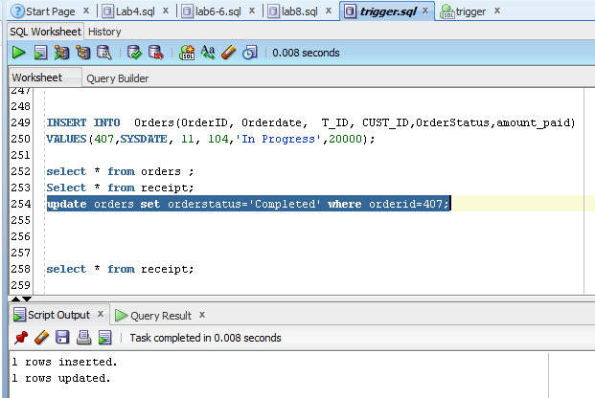

1. select * from orders ;

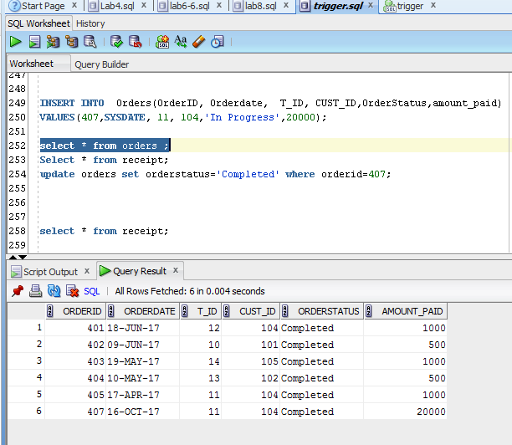

1. select * from receipt;

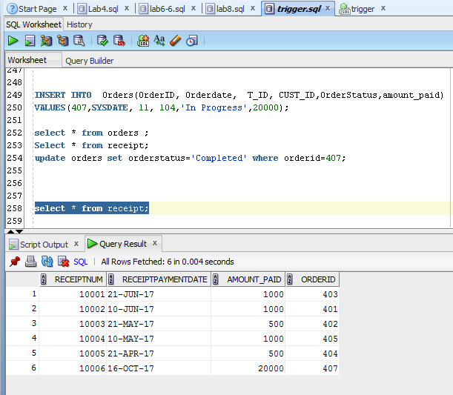

**Section IV**

* 1. **adding an item +5 points**

INSERT INTO ItemInVendingmachine(Item_ID, RefillDate, AvailableQuant, T_ID, V_ID)

VALUES(90006,'21-July-17', 500, 11, 505);

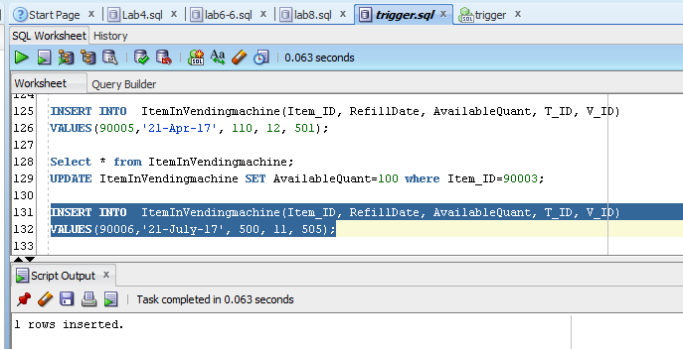

Select * from ItemInVendingmachine;

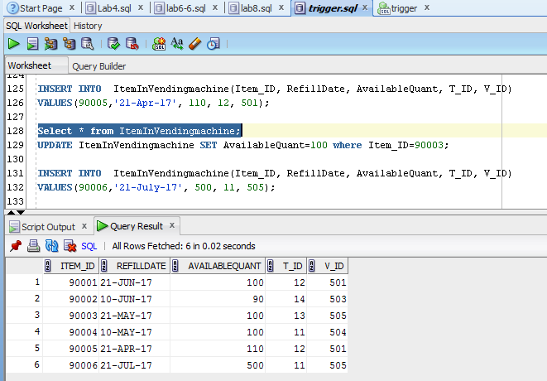

* 1. **adding a vending machine +5 points**

INSERT INTO  VendingMachine(V_ID, MachineLocation, CUST_ID)

VALUES(506,'1234 marsh trail Cir GA 35467', 105);

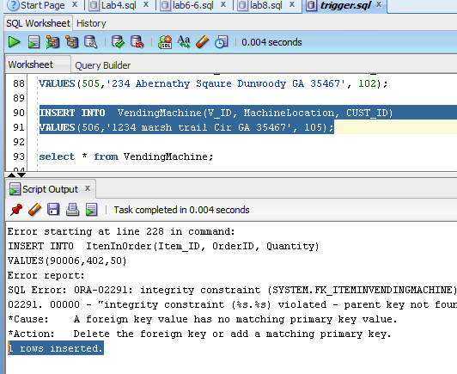

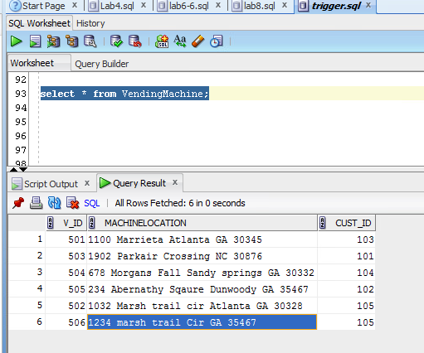

* 1. **updating inventory of the vending machine +5 points**

UPDATE ItemInVendingmachine SET AvailableQuant=100 where Item_ID=90003;

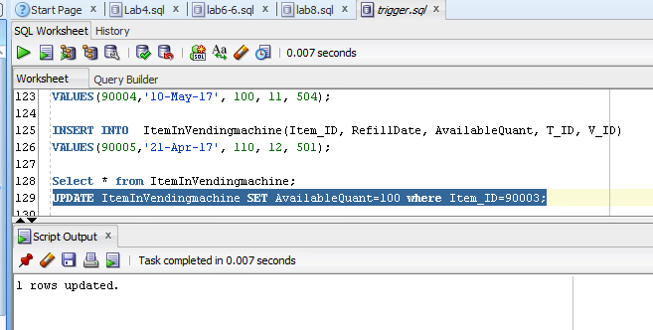

Select * from ItemInVendingmachine;

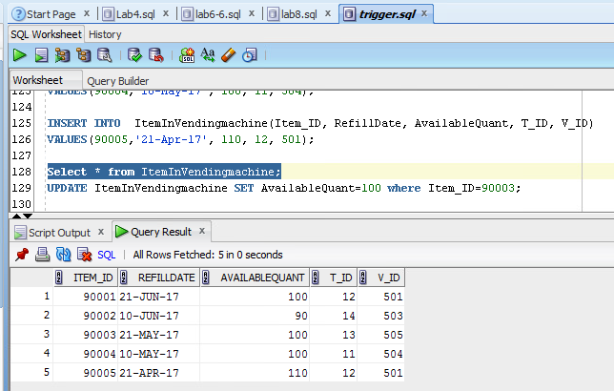

* 1. **updating the technician's information +5 points**

UPDATE Technician SET T_LastName= 'Vaidya' where T_ID=11;

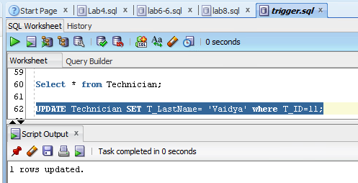

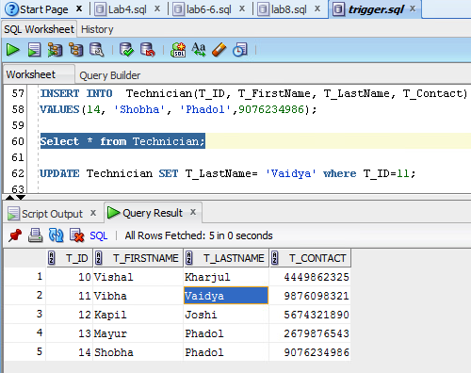

* 1. **deleting a vending machine +5 points**

select * from VendingMachine;

DELETE FROM VendingMachine WHERE V_ID=506;

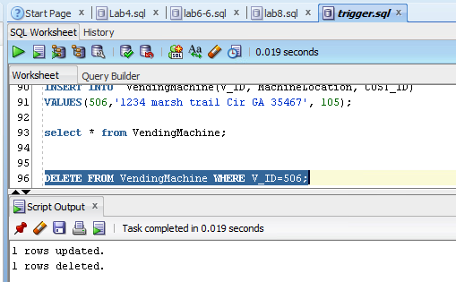

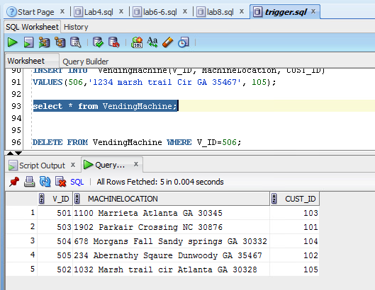

* 1. **deleting a technician +5 points**

Technician if FK for other tables so, first it was giving error then I dropped other tables to delete Technician.

DELETE FROM Technician WHERE T_ID=12;

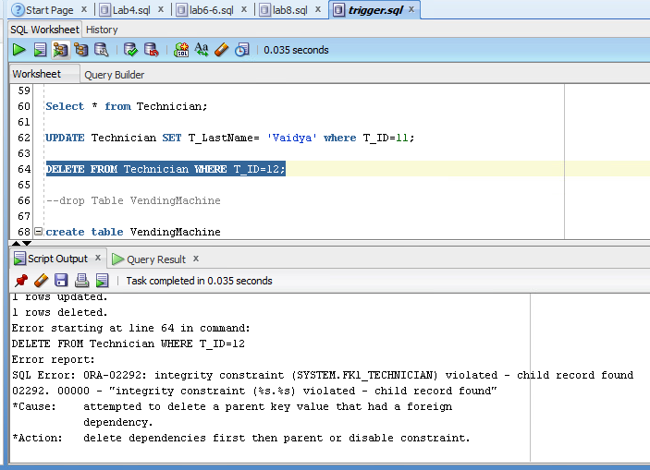

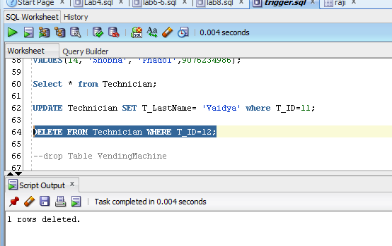

Select * from Technician;

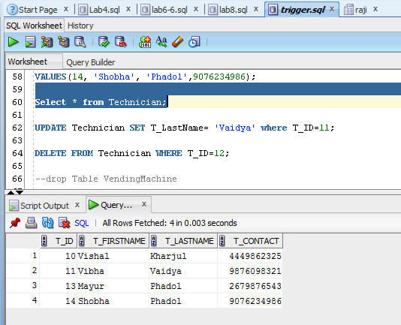

* 1. **demo user permissions for all three groups +15 points**

--user Administrator

**CREATE USER Raji**

**IDENTIFIED BY xyz123**

**DEFAULT TABLESPACE users**

**TEMPORARY TABLESPACE temp**

**QUOTA 10M ON users**

**PROFILE default;**

**GRANT connect to Raji;**

**GRANT create table to Raji;**

**GRANT insert,update, delete, select on**

**ItenInOrder to Raji;**

**GRANT insert,update, delete, select on**

**Orders to Raji;**

**GRANT insert,update, delete, select on**

**ItemInVendingmachine to Raji;**

**GRANT insert,update, delete, select on**

**Vendingmachine to Raji;**

**GRANT insert,update, delete, select on**

**Technician to Raji;**

**GRANT insert,update, delete, select on**

**Technician to Raji;**

**GRANT insert,update, delete, select on**

**Receipt to Raji;**

**GRANT insert,update, delete, select on**

**CUSTOMER to Raji;**

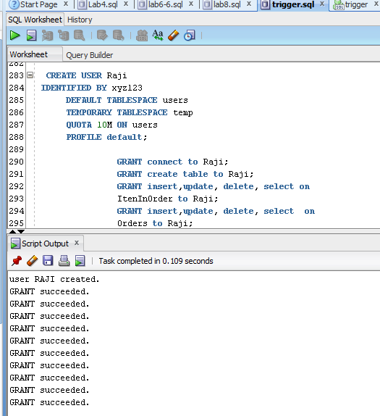

**Checking Grant: In SQL Plus**

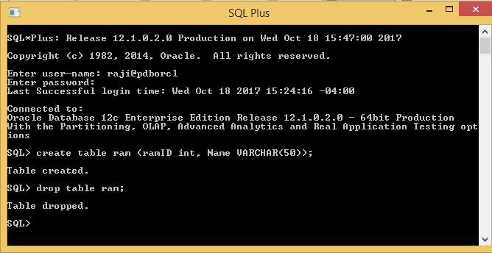

**--user Technician**

**CREATE USER Tech1**

**IDENTIFIED BY abc123**

**DEFAULT TABLESPACE users**

**QUOTA 10M ON users**

**TEMPORARY TABLESPACE temp**

**QUOTA 5M ON system**

**PROFILE default**

**PASSWORD EXPIRE;**

**GRANT connect to Tech1;**

**GRANT select,insert,update on Orders to Tech1;**

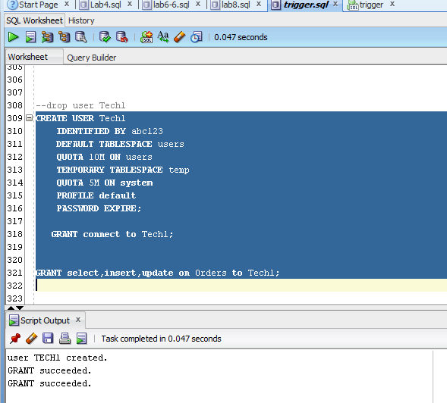

**SQL PLUS TESTING PERMISSIONS**

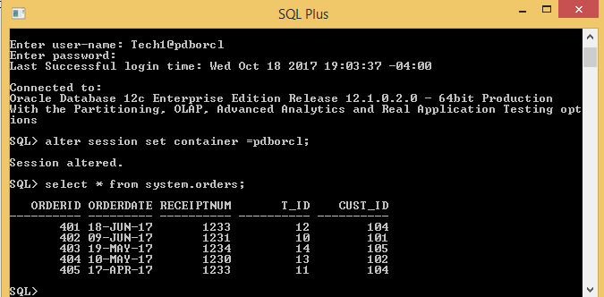

**--userReportingStaff**

**CREATE USER Vishu**

**IDENTIFIED BY abc123**

**DEFAULT TABLESPACE users**

**QUOTA 10M ON users**

**TEMPORARY TABLESPACE temp**

**QUOTA 5M ON system**

**PROFILE default**

**PASSWORD EXPIRE;**

**GRANT connect to Vishu;**

**Grant update on ItemInVendingMachine to Vishu;**

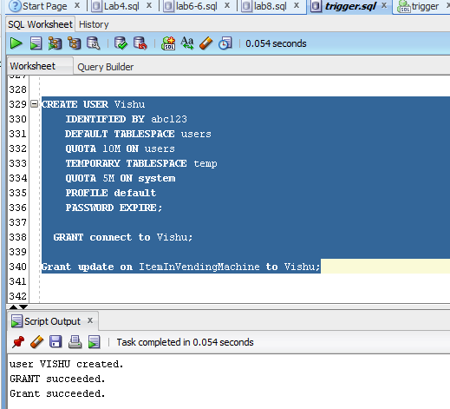

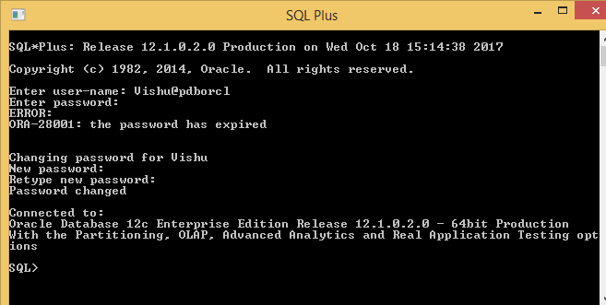

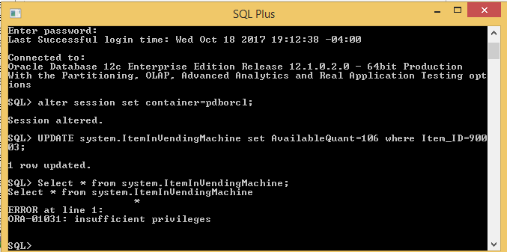

* 1. **weekly report generation +25 points**

**select * from orders where orderdate between SYSDATE-7 and SYSDATE and orderstatus='Completed' ;**

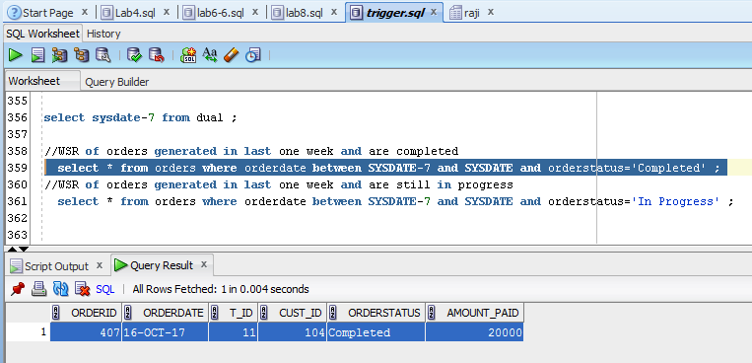

**After above query I created report and saved it.**

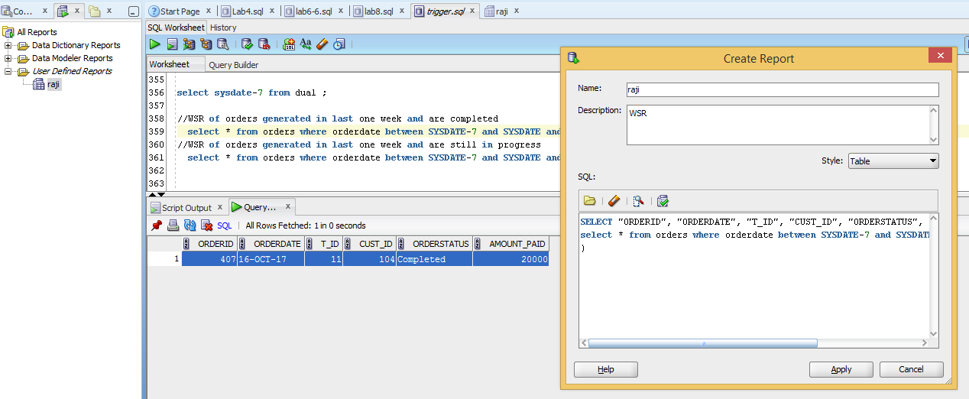

**Whenever you run the report you will get updated weekly report**

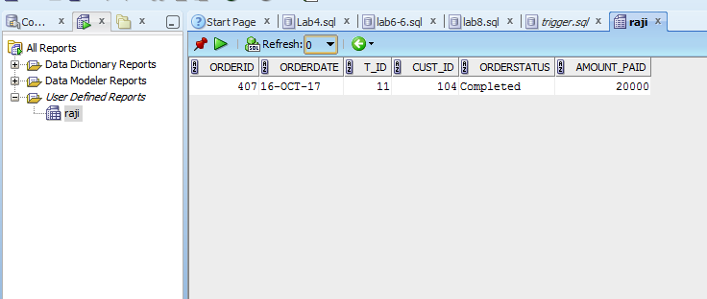

**select * from orders where orderdate between SYSDATE-7 and SYSDATE and orderstatus='In Progress' ;**