CSC/ITC 492 --- Senior Design / Research Project (F22)

Project Design and Analysis (Deadline: 10/23)

**********************************************************************************

Project Title: Predicting Exercise Progression in Fitness Application using Machine Learning

Student Name: Richard Pham

Student Major: Computer Science

**********************************************************************************

Project Design and Analysis Report Instructions:

- Report typically should be at least 3 pages long, single space, Times New Roman, 11 font size;

- Once again, the design and analysis stage is basically to formulate your project into formal math problems, build the math model and do some mathematical analysis. Please make your report as specific as possible. Diagrams, figures, tables, pictures, algorithm pseudocode, math equations, and/or math proofs are mandatory to show the details of the design and analysis.

1. Architecture/component diagrams of your project
Use Case Diagram:
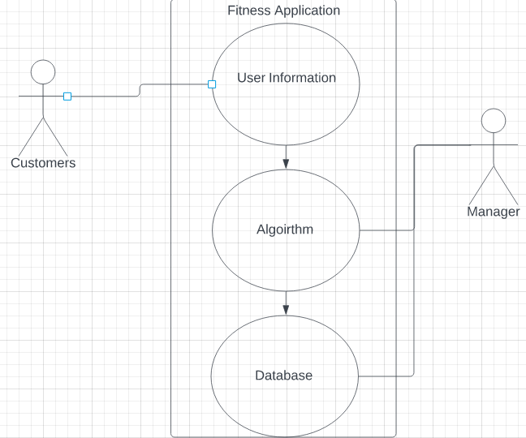\

Architecture Design:
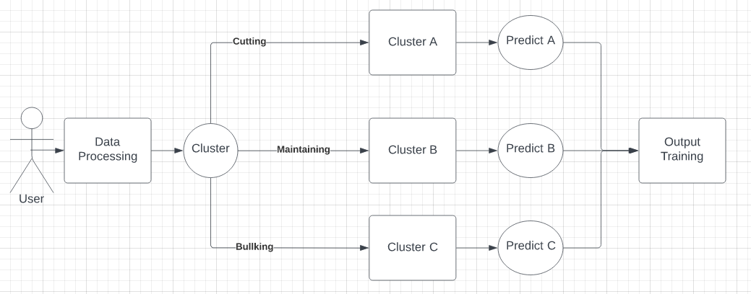

2. Detailed functions of components
Software used: IntelliJ, SQL
Coding Languages: Javascript (Front End Interface), Kotlin (Backend)

User Information:
Field | Type
Gender | Male or Female String
Height | Feet and inches converted to meters int to double
Weight | Pounds converted to kilograms Double
Age | Integer
Goal | Cut, Maintain, Bulk
Availability | Days as an Integer
Walking Time | Minutes
Heart Rate 1 Mile Walk | Integer
Experience | Months in Integer

Algorithm:
Birch Algorithm
Male or Female is deterministic on what workout layout due to body structures.
Height and Weight used to calculate BMI after height and weight converted.
Another Portion to figure out is stamina which is an important component on how long an individual can work out for.

Target the average case scenario for an average human being:
Male: 5’9 198lbs 18-24% body fat
Female: 5’4 170 lbs 25-31% body fat
US Standardized

Database:
Data stored would be the user information listed above as well as the workouts.
Workout exercises:
Body Part Targeted | Workout
Arms | Bicep Curl
 | Strict Curl
 | Hammer Curl
Shoulder | Overhead Press
 | Front Raises
 | Side Raises
 | Shoulder Shrugs
 | Lateral Raise
Chest | Bench Press
 | Incline Bench Press
 | Chest Fly
 | Dumbbell chest
Back | Barbell rows
 | Single Arm Dumbbell rows
Core | Sit-ups
 | Weighted Crunches
 | Leg Raises
 | Side Crunches
Legs | Squats
 | Leg extensions
 | Leg Curls
 | Calf Raises
Taken from the list of exercises we would be able to perform the algorithm to determine what workouts are needed for each day based off what the individual wants.

Architecture:
As the user inputs the data, the data will be processed as well as stored in the backend repository. The decision making will allow the individual data to put into a certain cluster that will arrange the individual to a similar training regime as the users with the same body type. With the clusters predicting the training workouts and then output the results.

Pseudocode:
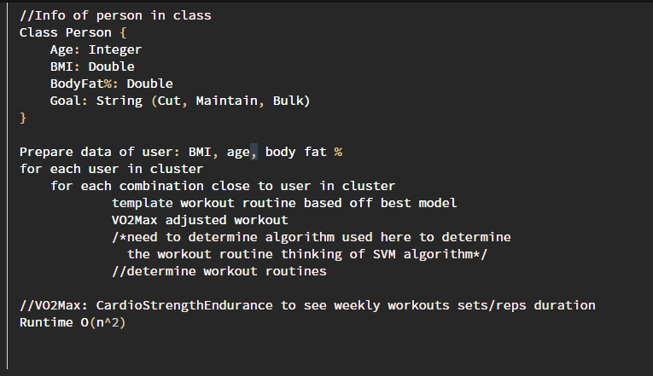

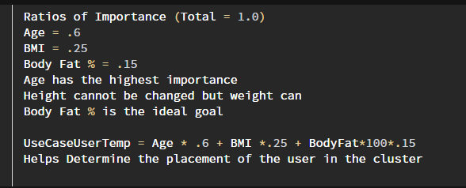
VO2 max = 132.853 - (0.0769 x your weight in pounds) - (0.3877 x your age) + (6.315 if you are male or 0 if you are female) - (3.2649 x your walking time) - (0.1565 x your heart rate at the end of the test)
VO2 max is the general equation for cardiovascular strength and endurance.

Since everyone is different in cardiovascular strength and endurance it would be hard to put it within the cluster as it would not be very accurate.

Determining Workout Routines Ideology:
CUTTING
- Calorie deficit
- Less Carbohydrates, More Proteins and Fats
- Workouts focused on endurance rather than strength
- More towards cardio and light workouts
MAINTAIN
- Working on a little of everything
- Evenly balanced diet
- Calorie count towards the average of the BMI
BULK
- Calorie surplus
- Carbohydrates and Proteins similar less Fats
- Progressive overlord

Control: Average Male and Female in the United States

Out of Scope:
- Advanced UI
- Backend for user log in (No username and id will be stored just information put in will result in a cluster)
- Predetermined data will already be in the cluster for the individuals as this is a work in progress for later implementation.

(Note that feel free to add other sections to your report if you think other sections will make your report better)

