Mechanical properties of simulated temporary cross-linked F-actin polymer networks
Rita Philavanh
SDSU Physics Undergraduate 2009
Advisor: Dr. Arlette R.C. Baljon, SDSU Department of Physics

The mechanical properties of the cell are predominantly determined by the properties of the polymeric F-actin network in the cytoplasm. These networks have been shown to exhibit interesting properties. An investigation into the dynamics of the network microstructures is crucial to understanding more about its behavior. This paper will begin by introducing some background of the F-actin network, along with mechanical properties of these networks that have been obtained from experimental studies. A model of a network will be described through simulation, and the methods and results gathered from this simulation will be discussed. Figures mentioned are shown at the end of the paper.

Introduction
F-actin is an important structural component in the cell and essential for its survival. Actin is a protein, and when arranged with other actin monomers into a consecutive chain, forms the F-actin polymer. In living cells, actin binding proteins (ABP) temporary cross-link different actin filaments together into a dynamic network where cross-links can be broken and reformed. This dynamic network makes up the cytoskeleton found in the cytoplasm of cells. Many mechanical properties of the cell are predominately determined by the properties of this F-actin network that makes up the structure of the cell.
In a paper from the Weitz lab^{[1]}, an in vitro experiment of cross-linked F-actin polymer networks was described. One of the properties measured was the strain of this network in response to an applied stress. The strain is the deformation of the network when stress is applied. From this, a stress-strain relationship is able to be determined. This can provide information about the stiffness and elasticity of a network, which is stress over strain. It was found that for low stress and strain, a linear relationship was observed until a critical stress. At large stress or strain, the mechanical response was highly nonlinear until the network eventually broke. This indicated that as more stress was applied, the network was able to resist tension and maintain its structure. Very high stress was also required to break the entire network.
The flexibility of the cross-linked F-actin polymer network making up the cytoskeleton is responsible for many important physiological roles. The findings of the Weits lab have shown that the network also exhibit interesting dynamics. In particular, the network's ability to resist tension, maintain structure and give the cell its viscoelastic properties are of interest. An explanation for this non-linear response observed is still laking and little is also known about how stress propagates through the cell. Being able to understand the dynamics of the network structure through simulation can help explain mechanical properties observed in actual cells.
Experimental
Structure is often related to function, and the F-actin network has similar properties of a general network structure ^{[2]}. Networks describes the system as nodes connected by links. In this particular F-actin network, the nodes that cross-link the chains together are nonpermanent. The Baljon lab has constructed code to model polymeric networks in which the cross-links are nonpermanent, just like in F-actin networks. This model is based on a well-tested Kremer and Grest bead-spring model ^{[3]}, which represents a polymer as a sequence of beads connected by nonlinear spring. There are 1000 chains in the simulation, each with 8 beads. The cross-links are represented as aggregates of end beads from different polymer chains that group together.
The beads are moves around in the simulation by molecular dynamics. All beads experience a truncated Lennard-Jones potential that models the interaction between them at different separation distances. At short distances there is a repulsive term, and at long distances there is an attractive term. The potential is defined by 2 independent parameters, σ on the length scale and ε on the energy scale, which define the reduced units used in this paper. The potential is used to obtain the force felt by each beads, which is then used in Newton's equation of motion to move the beads around in very small time increments. This gives the beads new position, which changes it's potential energy. The cycle is then repeated with a new force being calculated and the beads being moved up another small time step. In order for the cross-links to be nonpermanent, a Monte Carlo method is used to model the reaction between the linkers. These junctions are updated every 20 time steps, and the probability of breaking or forming junctions is based on the energy difference of new and old states.
Methods and Results
From the simulation, the network topology is completely characterized and its changes can be followed over time. There are many methods to use when analyzing how the overall network structure evolves. The mean square displacement can provide information into the diffusive properties of a network. To do so, the distance between each possible pair of beads in an aggregate are measured throughout time to see how far the beads move apart. This diffusive property has been studied in the Baljon lab for networks at various temperatures ^{[4]}. What is observed is that a lot of motion is exhibited in networks at higher temperatures. For very low temperatures, the network exhibits little diffusion over a long period. At the low temperature of .3 there is minimal diffusion, however motion is still present in the structure. Networks at a temperature of .3 will be further studied in order to understand more about structures within the network that may hold it together.
The network was first studied in its natural state with no oscillatory stress. One of the things investigated was the changes in cross-links over time. As was stated, cross-links are the aggregates. There are three ways that the aggregate size can change after each step: break apart, stay the same, or grow (where new end beads are being added to an existing aggregate). These three ways that an aggregate can change was followed over time and plotted as shown in Figure 1. All the aggregates were being compared to the initial timestep and incremented up in timesteps of 50. It is found that most aggregates break apart over time, and the ones remaining the same gradually decreases. However, the aggregates growing don't quickly decrease to zero. This means that there are still aggregates that remain the same over time, new beads are just being added to it. These aggregates that stayed the same will be looked into further to determine if they provide a percolating path through the network.
A network is said to be percolating if there is a connected path through the network from one surface to the other. If the aggregates that remained the same are also percolating, it is able to hold itself together despite clusters in the network changing shape. A plot of the aggregates from Figure 1 that stayed the same were compared for different sized time intervals to find the percent of these aggregates that exhibited percolation through the network. This is shown in Figure 2. For smaller time intervals, a high percentage of these aggregates are percolating through the network. However, there is a transition when comparing higher intervals that the percolation dies off. Although percolation of certain aggregates decreased over very long periods, percolation still exists for a set of aggregates over a smaller period, which can help give the network rigidity to maintain its structure.
Through percolation, the connectedness of aggregates that stayed the same in a network were able to be examined. The connectivity of the aggregates that break can also be examined. With Self-organized criticality ^{[5]} (SOC), we are investigating the distribution size of clusters that break. To give a brief example of a system with SOC, we have a forest fire model from Newman ^{[6]} represented as a cellular grid. A perturbation, such as fire, in one cell representing a tree can causes a forest fire if the trees provide a connected path for the fire to propagate through the system due to percolation. The number of cells that gets wiped out by this perturbation is the cluster size and shows how connected the system was.
In the F-actin network, a cluster is the set of aggregates that are connected to each other, with the size of a cluster being how many aggregates in contains. When an aggregate breaks, other aggregates that were connected and broke can be determined to find the cluster size that broke. A plot is shown in Figure 3 of the distribution of cluster sizes for aggregates that break. All the plots are at the same temperature of .3 and the dotted line represents an oscillation being applied to the system. The black and red represent different time intervals that were being compared for the aggregates that break. This time step is in the units of ε and σ that was mentioned earlier. What is observed in Figure 3 is that more small sized clusters break than larger ones. In the presence of an oscillation, the distribution of the cluster sizes change, and there is an increase in the number of larger cluster sizes that break.
Conclusion
The structure and dynamics of the actin cytoskeleton network was investigated through our simulation. The network has been shown to exhibit curious properties, such as very high stress needed to break the F-actin network, and an understanding of the connectedness of the network structure can help gain new insight. It is found that over time, beads in the same aggregate gradually diffuse apart, and some of these beads that cross-link together do remain in the same aggregate over time. For these aggregates, percolation is observed, but not for very long time intervals. For aggregates that break, the cluster size is mostly small, but some larger ones also break. In the presence of an oscillation, there is an increase in the number of larger cluster sizes that break. Thus, the network structure is changing over time, but the network is still able to hold itself together as long as there are a set of aggregates that is found to percolate at any given moment. In the future, networks at lower temperatures, such as at T=.275 where we don’t see much diffusion, will be looked into. A plot at the temperature of .275 for the changes in cross-links is shown in Figure 4. More data is needed to see if there are still aggregates that remain the same over a very long period of time, or if the number of aggregates that remain the same gradually decreases towards zero.

Figures
Figure 1
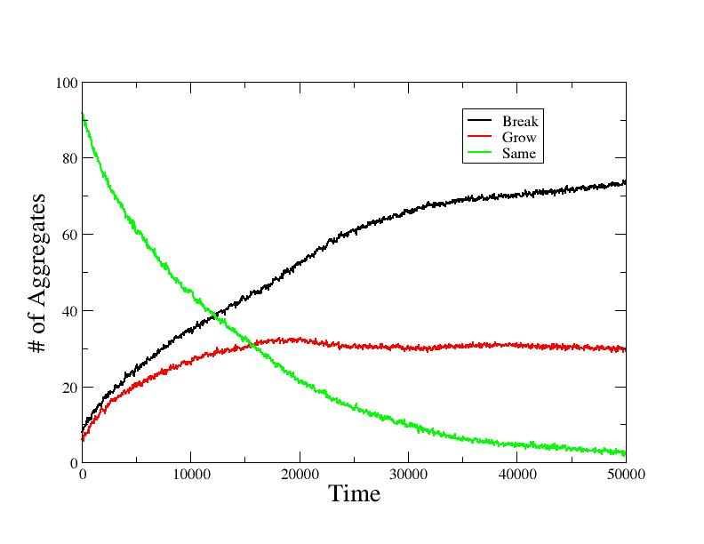

Figure 2
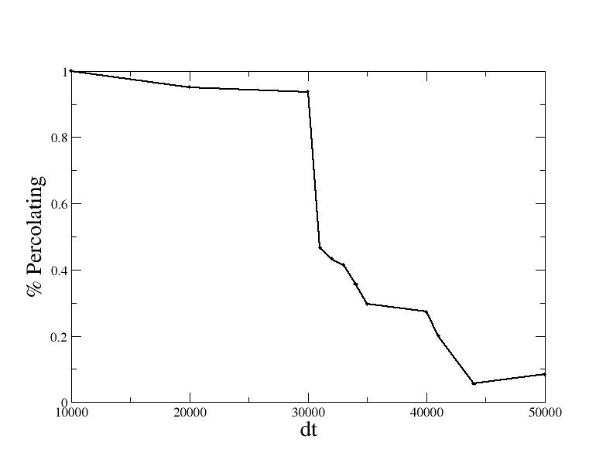

Figure 3

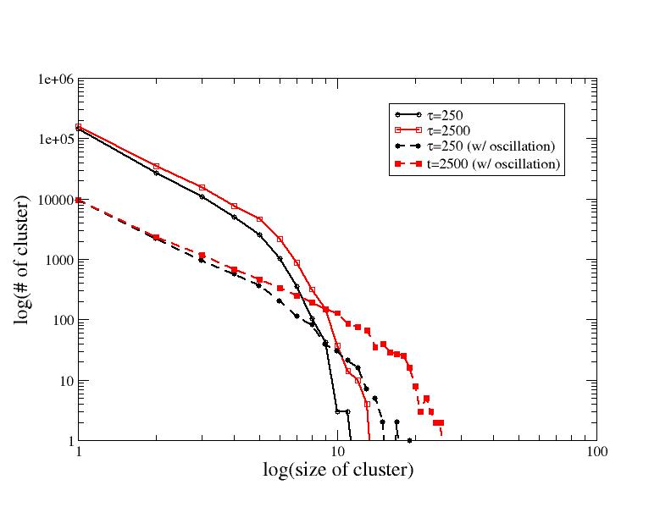

Figure 4

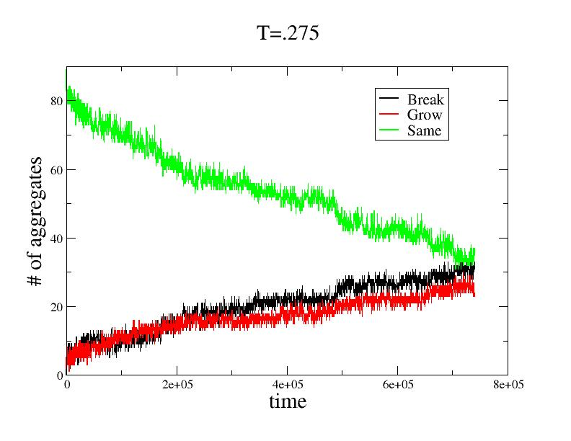

Bibliography
- Gardel, M. L., et al. 'Prestressed F-actin networks cross-linked by hinged filamins replicate mechanical properties of cells.' PNAS (Proceedings National Academy of the Sciences). February 7, 2006. Vol 103. p. 1762
- Strogatz, S. 'Exploring complex networks.' Nature. Vol 410. March 8, 2001. p. 268-276
- K. Kremer and G. S. Grest. Dynamics of entangled linear polymer melts: A molecular-dynamics simulation. Journal of Chemical Physics , 92:5057, 1990.
- A. Baljon, D. Flynn, and D. Krawzsenek. Numerical study of the gel transition in reversible associating polymers. The Journal of Chemical Physics, 126:044907, 2007.
- Bak, Tang, and Wiesefeld. 'Self-Organized Criticality: An Explanation of 1/f Noise.' Physical Review Letters. (1987).
- Newman, M.E.J. 'Power laws, Pareto distribution and Zipf's law.' arXiv:cond-mat/0412004v3 [cond-mat.stat-mech]. 29 May 2006.

