**Fall Detection and Reporting**

Talal Almutairi

Lane Department of Computer Science & Electrical Engineering

West Virginia University

Morgantown, WV 26506, USA

Ryan Hoke

Lane Department of Computer Science & Electrical Engineering

West Virginia University

Morgantown, WV 26506, USA

Kezia Butcher

Lane Department of Computer Science & Electrical Engineering

West Virginia University

Morgantown, WV 26506, USA

Boris Bagryanskiy

Lane Department of Computer Science & Electrical Engineering

West Virginia University

Morgantown, WV 26506, USA

***Abstract* — There is no substitute for having the companionship of another person that’s ready to help you when in need, but a second best would be to automate certain aspects of the lonesome life. In particular, a lot of harm comes from elderly not having the same strength, balance and grasp of their senses which could lead to falls. This would be even more harmful and potentially fatal if they become immobilized and cannot call for help. A good solution would start with helping these disadvantaged people to stay connected in case they ever find themselves in the need to overcome this life-threatening obstacle. Our group at West Virginia University consists of four students from Computer Science and Electrical Engineering backgrounds. We’ve set out to build a device that can accurately detect a fall. This device is intended to be cheaper than other options currently available on the market. On top of that, the overall system will make use of the user’s smartphone data to alert a caretaker when a fall occurs, thus mitigating the need for any subscription or extra fees.**

***Keywords – Fall detection, mobile application, caretaker.***

1. Introduction

As individuals age the increase of injury due to falling dramatically increases. Falls are the leading cause of injury and death for elderly people. The act of falling is not where the danger of falling stops. It’s only the first step in complications. After the initial fall many factors come into play. Can one be left alone, will one fall again, is one safe, will this financially burden the family? All are valid questions. The fear of leaving a loved one alone can impact one's life mentally and physically. Statistics say one in four elderly fall each year.[1] The fear of leaving a loved elderly alone is because one might fall and be injured. Every eleven seconds an elderly person is treated for fall injuries. There are 2.8 million injuries treated in the emergence room for elderly falling.[1] With the fall resulting in injuries it cost money. With the total cost of the fall injuries totaling to be $50 billion. [1] The fear that an elderly person has can interfere with their everyday life. A person that has a high risk of falling could limit their activity due to the fear of falling. They could stop doing the hobbies that they enjoy. This can result in side effects such as decrease of physical health and also in increase in depression. Falling is inedible in elderly people, however as technology advances throughout the years devices are being developed which can aid in falls not resulting in death. Our device cannot prevent falls but can detect when a fall occurs. The object of the device is to be able to detect the fall and alert a caretaker and/or the EMS. The device would be able to lower the rate of death due to a fall and being unable to call for help. The device is connected to the fall detection app via Bluetooth. Both the caretaker and the user have the app. The device should be worn at all times except at night. The device is worn on the belt of the elderly. When the device is worn and a fall occurs the fall detection device will report the fall to the user first, if no response is given, in a certain the amount of time, due to unconsciousness then the caretaker has the same option, if no response then a call will be simulated to EMS. The device can take the place of a caretaker needed to be present with the user. The user will be able to feel like they are able to do the activities they love without the fear of falling with no assistance available.

1. Background and Related Research

When trying to decide how to take of an elderly person that needs supervision or attention if they have fallen, many solutions exists. We will present some solutions that we have found on the market today. First, a device that we found that can be reasoned to be budget friendly was Assistive Technology Services – Medical Alert System [2]. Unlike most other services this one does not require you to pay a monthly fee. Instead, it has only a one-time fee of $299.99 [2]. This system relies on both a base station and a “pendant” that the user either wears on their neck or around their wrist [2]. This pendant comes with the initial offer price, but if an extra one is required then the cost of each additional pendant becomes $129.99 [2]. This system relies on the base station to communicate the SOS through a landline, but a mobile option is available if the user is willing to supply their own sim card [2]. There is a “walkie talkie” function that enables the user to communicate through the pendant to call to a previously entered SOS number during setup (maximum allowed is 3 SOS numbers) [2]. Some advantages of this system include: Having IP57 water resistance, communication through pendant, invoking communication through press of panic button, and system keeps calling until 1 of the 3 SOS numbers answers the call [2]. Some of the disadvantages includes: Limited settings customizability, only 3 SOS numbers can be used, startup cost is relatively high, does not offer GPS, and it needs a Bluetooth adapter for using base station with mobile device [2].

Fall Detection devices can also be expensive in the sense that monthly fees are required to use them. A few examples of this come from Medical Guardian, which has created two devices on the called Freedom Guardian and Active Guardian [3]. As of January 2018, these devices are high on the market and ranked number one in best medical alert systems [3]. Freedom Guardian is a wearable watch that has many features such as oversized icons, audible options, customizable, location tracking, reminders/alerts, weather forecast and connectivity [3]. Oversized icons will allow for the elderly to easily see what is shown on the screen and the audio option will read messages out loud [3]. Advanced location tracking feature will track the person using Wi-Fi positioning system [3]. Alerts will be sent to the watch for doctor appointments or medicine reminders [3]. There is also a companion mobile app [3]. The app allows for the Care Circle members to be in contact with the patient [3]. The price of the Freedom Guardian is $44.95/month and the watch are $99 [3]. The Active Guardian is a necklace that has many features such as being waterproof, call help button, two-way communication, GPS tracking, and add on features for additional cost [3]. An add on feature is fall detection [3].

1. The System

The system that we propose is meant to be a combination, more or less, of many of the features offered by other fall detection options mentioned previously. What separates ours, is that there will be no subscription fee. The only cost is the initial cost of the device, and the only other thing needed for everything to work is smartphone with a working connection. This could be Wi-fi or cellular data. The fall detection device will synch with the smart via a mobile application. This mobile app is what will register whenever the device detects a fall. Upon detecting a fall, the app will prompt the user to press and hold a button to signify that they are okay. If the button is not pressed and held within a limited time frame, then either a registered caretaker and/or the emergency medical services will be notified. A caretaker is another user who can also download the mobile app. They will be able to synch their account with the account of the user wearing the fall detection device. In the case of a fall, this person will also immediately be notified that the fall occurs.

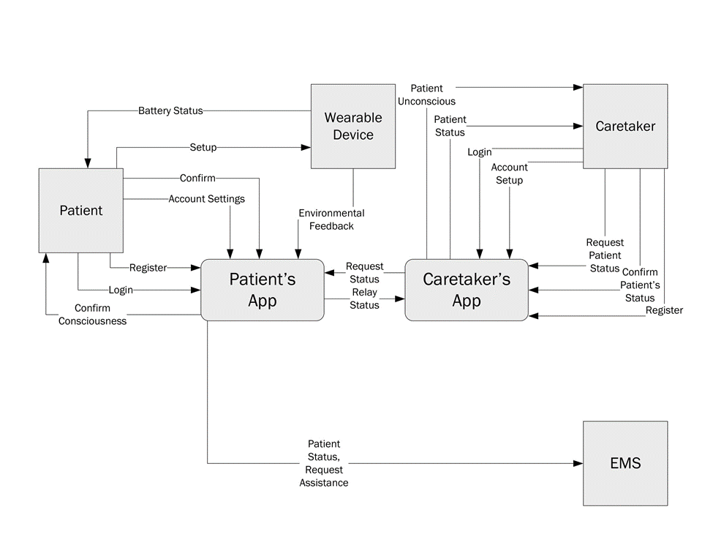

1. The Fall Detection Device

Our fall detection device relies on the gyroscope and accelerometer onboard the SparkFun MPU-6050. This board is connected to our microcontroller, the SparkFun’s nRF52832 Breakout. Providing power to the device is a SparkFun lithium-ion battery connected to an Adafruit 1000 Powerboost charger.

The device is programmed in the Arduino IDE, which uses C++ code. To connect and be able to read the raw gyroscope and accelerometer values, we relied on Jeff Rowberg’s open-source I2Cdev library [4]. His code enables the connection between the microcontroller and the MPU-6050. It then reads and prints the raw sensor data to the serial monitor. It was this raw data that we used to test a variety of falls to determine what is and what is not a fall. Jeff’s library offers the possible display of a variety of raw types of data available from the MPU-6050, such as the yaw, pitch, and roll values from the gyroscope or the x, y, and z accelerations from the accelerometer. It also provides more complex data, such as real-world acceleration adjusted for the world frame of reference (to achieve this, he takes into account data from both the gyroscope and accelerometer). After much experimentation, we settled for using only vertical acceleration data, adjusted for the world frame of reference.

After settling on vertical acceleration, we then tweaked the code to calculate the max and minimum vertical accelerations every 1/4th of a second (250 milliseconds). Using these two values we determined the maximum change in acceleration over the course of each instance of 250 milliseconds, and then printed each of these values to the serial monitor in succession. Now that the appropriate data we desired was being displayed, we proceeded to attach the device to one of our various fall testers to begin the challenge of determining what is and what is not a fall.

Throughout testing, multiple volunteers decided to willingly fall while wearing the device. They also performed other activities, such as jumping, running, sitting down, walking, and standing still. During each of these activities, the maximum change in vertical acceleration over the course of 250 milliseconds was printed to the serial monitor every 250 milliseconds. It was with this data that we looked for unique trends to determine what is an what is not a fall.

After hundreds of falls, a pattern was noticed. During a fall, change in vertical acceleration would spike to at the very least 5.98 meters per second squared. The actual sensor data was different. To get the actual acceleration it was necessary to plug in the sensor reading to (1).

*acceleration = (reading/16384) * 9.8 m/s^2*

(1)

Rather than showing 5.98 m/s^2, the sensor data actually read at least 10,000. This reading would only be displayed either once or twice in a row (as in it would only occur for either one or two 250 millisecond intervals). This data would immediately be followed by a change in acceleration of at the very least 2.39 m/s^2 (but less than 5.98 m/s^2) for only one interval. After that, the following subsequent interval readings would be much less.

The logic behind our determination assumes that after a fall, the person falling will be on the floor. Thus, change in acceleration would momentarily spike and then vastly slow down to a halt. This is what enables the differentiating between falling, running, and jumping. When jumping continuously or running, it is possible the accelerometer values would follow the same pattern as when falling. The only difference is that this pattern will repeat multiple times in a row. Thus, if the change in acceleration spikes for one or two intervals, then drops, and then spikes back up, we know it was not a fall. This has presented us with difficulty, though, of determining if a person was initially running or jumping when they had fallen. On the flip side, it was also difficult to differentiate a single jump from a fall, as they will have a very similar pattern as well. Because of these issues, it has been decided that this device is targeted for use by only the less mobile elderly. To be used by a young, physically activity person would potentially generate multiple false positives. If instead the device is used by an elderly person who does not regularly engage in intense physical activity, the device should work fine as intended. Throughout all of the tests, if a person is standing, walking, or if they sit down, the device will never register a change in acceleration greater than the previously mentioned 5.98 m/s^2.

This device of ours has built in Bluetooth Low Energy (BLE) technology on the microcontroller. Previously, all of our testing had been done whilst utilizing a very long microUSB cord connected to our device to transmit the serial data to a computer to display on a serial port. After determining the pattern of falling based on the data, simple if-else statements were encoded to determine what is and is not a fall. If a fall was detected, the plan was to transmit just the simple value of ‘1’ as a BLE characteristic to our mobile application. The mobile application would be listening for this BLE characteristic. Upon initiation of our device and system, this characteristic would have an initial value of ‘0’. It would change to ‘1’ once the device detected a fall. This change would be registered on the mobile application, thus triggering the fall alert. BLE characteristics can not only be read but also written. Thus, the mobile app should be able to reset the value back to ‘0’ after a fall alert so that multiple falls can be detected again and again. An issue that arose, however, is that once we began utilizing the device’s BLE, the sensor data from the MPU-6050 would sporadically spike. The explanation for this remains unknown to us. We were able to tweak our code to account for this possible spike, but it still would raise the likelihood of false fall alerts being detected. The moment we disabled BLE, the MPU-6050 sensor data would return to normal, with no spikes. If upon further research, one could figure out the reasoning behind this issue and prevent the spike, it would make the most sense to utilize the BLE technology. For now, we decided to ditch BLE and utilize classic Bluetooth. To do this, we purchased and connected to our device Atomic Market’s HC-06 Bluetooth Serial Pass.

5. The Companion Application

The purpose of our companion mobile application is to be able to use existing smartphone capabilities to alert either a caretaker and/or medical services in the case of a fall being detected. The mobile application was built with React Native Expo [5]. This is because it easily enables deployment and usability on both iOS and Android mobile devices. The main problem we encountered however, as that React Native Expo currently does not have a Bluetooth library. Although, one is currently being developed [6]. Until it is complete, we will not be able to finalize our idea using the tools we chose to work with. It is possible to create standalone apps for both iOS and Android with Bluetooth capabilities, but due to us being pressed for time, we did not. Also, the process is more complicated for each. If someone wanted to carry on our work and create these, then they can. Eventually, React Native Expo will have Bluetooth as well, which will make everyone’s lives easier (when it comes to create multi-platform apps). Because we could not get our app to utilize Bluetooth, for demonstration purposes we were able to synch the fall device up to a nearby computer using Bluetooth. The fall device would report a fall, which the computer would register. The computer would then update and alert the mobile app via internet connection.

6. Future Work and Conclusions

In this paper, we have discussed the fall detection device in detail. Our group has had the opportunity to work on this project for only a short amount of time. If given the opportunity to work on this project many aspects of the device could be modified and upgraded. The size of the device is a major disadvantage to the project. More research could be conducted on different hardware usage. For instance, different rechargeable batteries could be used to reduce space. Once the hardware is reduced in size then the device could be worn on the wrist. This has many advantages. The device would be more comfortable to wear. The user would not need to wear a belt every day. The device as a prototype, also has a potential of breaking under the pressure of a fall. Future work that would be beneficial to the project is eliminating the false positive results. The project has not yet been complete therefore there are still some aspects the group did not get working to its full potential. One aspect is once the caretaker has not responded to call the EMT. The app will prompt the user to call. Which means the number appears on the screen and asks the user if they want to call or cancel the call. An object for this app is to automatically call EMS without needing to be prompted. Another aspect of the project that can be improved is the Bluetooth factor. Since expo has not released a Bluetooth library, Bluetooth cannot be truly incorporated into the project. In the near future when the library is released the Bluetooth function can be implemented to its full potential. In conclusion we hope that our project is able to contribute to the assistance of building a better life for the elderly. We also hope that our project is able to encourage other around the world to continue our project and also create other projects to help the elderly live a normal life. We encourage everyone around the world to contribute to the Aging-in-Place Technologies Collaboratory (AipTec). We are truly thankful we were able to contribute to AipTec because one day we will need it as well. People interested in participating can contact our professor: Ramana Reddy (Ramana.Reddy “at” Mail.wvu.edu).

7. Acknowledgement

We are indebted to Processor Ready for presenting the RANIA to enable aging-in-place to the class as our capstone projects. We also would like to thank other facility at West Virginia: Brian Woerner, Powsiri Klinkhachorn, Gina Baugh, Amy summers, for assisting our professor in making the RANIA house possible. We would also like to thank other West Virginia faculty: Brian Woerner, Powsiri Klinkhachorn, AnGina Baugh, Amy summers for sponsoring projects. We would also like to acknowledge Jeff Rowberg’s for the open-source I2Cdev library. Which was used to connect chips together.

8. References

[1] Falls Prevention Facts: NCOA. (2019). *Falls Prevention Facts*. [online] Available at: https://www.ncoa.org/news/resources-for-reporters/get-the-facts/falls-prevention-facts/ [Accessed 29 Apr. 2019].

[2] Assistivetechnologyservices.com. (2019). [online] Available at: http://www.assistivetechnologyservices.com/documents/atsfd1%20-%20Fall%20Detction%20Med%20Alert%20wOrder%20Form.pdf.

[3] Guardian, M. (2019). Medical Alert Systems & Monitoring Devices | Medical Guardian. [online] Medical Guardian. Available at: https://www.medicalguardian.com/ [Accessed 1 May 2019].

[4] GitHub. (2019). jrowberg/i2cdevlib. [online] Available at: https://github.com/jrowberg/i2cdevlib [Accessed 1 May 2019].

[5] Expo. (2019). Expo. [online] Available at: https://expo.io/ [Accessed 1 May 2019].

[6] Expo.canny.io. (2019). Bluetooth API | Feature Requests | Expo. [online] Available at: https://expo.canny.io/feature-requests/p/bluetooth-api [Accessed 1 May 2019].