MPS IDE & ANSI Display Lab Exercise

Using the IDE and ANSI Display Commands
Student's name & ID (1): ___________________________________________________
Partner's name & ID (2): ___________________________________________________
Your Section number & TA's name __________________________________________
Notes:
You must work on this assignment with your partner.
Hand in a printer copy of your software listings for the team.
Hand in a neat copy of your circuit schematics for the team.
These will be returned to you so that they may be used for reference.
------------------------------- do not write below this line -----------------------------

 | POINTS  (1) (2) |  | TA init.
Grade for performance verification (30% max.)
Grade for answers to TA's questions (20% max.)
Grade for documentation and appearance (50% max.)
 |  |  | TOTAL

Grader's signature: ___________________________________________
Date: ______________________________________________________
Using the IDE and Programming an ANSI Display
GOAL
By doing this lab assignment, you will learn:
- About the STM32 Hardware Abstraction Layer (HAL) and built-in hardware.
- To use the VT100 Terminal Interface (with PuTTY, ProComm Plus, or your favorite serial terminal like GNU screen or picocom) on the STM32.
- To program an ANSI terminal display through a C program using the GNU ARM C Compiler (also known as GCC ARM Embedded, or just GCC ARM).
- Perform basic I/O with the STM32F769NI.
PREPARATION
• Introduce the STM32 hardware features.
• Review the C language stdio utilities.
• References: Mastering STM32
Ch. 1 (Intro), Ch. 6 (GPIO)
769 Discovery Kit User Manual
It’s a good idea to go through the whole thing. It’s pretty short, and has lots of good tables/schematics/etc.
(Note for section 6.1.5: Virtual COM is actually on USART1, not USART3, and the USB connector is CN16, not CN1.)
769 Datasheet (Alternate Functions etc).pdf
Ch. 1, 2 (skim only)
769 Description of HAL Drivers.pdf
Ch. 2 (only up to and including Table 3 in 2.1.2)
769 Errata (Device Limitations).pdf
This is a list of known hardware bugs and workarounds
VT100/ANSI ESCAPE SEQUENCES and Hello.c sample program
These are provided at the end of this document.
769 Reference Manual (Register Map).pdf
Ch. 6 (GPIO; up to 6.4, use 6.4 as a register reference.)

• Take a deep breath, and get ready for awesome.
IDE SETUP
- Connecting the Board
Plug the USB A end of a Micro-USB cable into your computer. Plug the Micro-B end of the same Micro-USB cable into CN16, the trapezoid-shaped USB port on the Discovery board (it’s also marked “ST-LINK”). Be careful not to confuse the two Micro-USB ports on the board; the rectangular shaped one (CN15) is for the board to connect to other USB devices (it’s a Micro-USB A plug compliant with the USB-OTG standard, for those interested in learning more about what you can do with it).
Congratulations, you’ve just taken the first step into working with a modern microcontroller development board! Unfortunately, working with modern microcontrollers isn’t always that easy—this thing alone has over 2000 functions—but microcontroller development has come a long way since the 8051 was introduced many decades ago. At the very least, you won’t be getting “Evelyn the modified dog” errors anymore when you use ‘=’ instead of ‘==’ (the compiler will just tell you exactly what and where your issue is), and if you forget a semicolon in your C code then GCC, the GNU C compiler, will throw an error showing you exactly where you missed it. But enough about that—let’s get that dev environment up and running.
- Using The IDE
Linux, Mac, and Windows users who want to use their own editor like Atom or Sublime: Download the relevant pack for your system, and start with “Before you start.txt” (Warning: Packs are 300MB. Blame ARM.).
http://www.rpi.edu/dept/ecse/mps/mps_handouts.html

Windows: MPS_Windows.zip
Mac: MPS_Mac.zip
Linux: MPS_Linux.tar.gz
All other Linux, Mac and Windows users, and those who want a full STM32 IDE that includes a step-by-step debugger that can step through your C code, use the “STM32 Workbench Install and Usage Guide” also found at the same link:
http://www.rpi.edu/dept/ecse/mps/mps_handouts.html
Note: If you want to get the best of both worlds (your own IDE + the debugger), you can, but you’ll have to figure out how to do that yourself.
ANSI PROGRAMMING TASKS FOR THE STM32
- Introduction to The User Interface
Input from the terminal keyboard and output to the terminal display can be done using the getchar(a) and putchar(a) functions. Write a simple C program to run on the STM32F769NI (or 769, for short) that outputs "The keyboard character is *." whenever you type a printable character, where * stands for that character. Since you will be waiting for an indefinite number of characters to be typed, use <ESC> (or ^[ key combination, where ^ = <Control>) to end the program. Display this information at the top of the screen when the program starts.
- VT100/ANSI Terminal Control Escape Sequences
ProComm Plus and HyperTerminal use VT100/ANSI terminal emulation by default. More modern programs like PuTTY, picocom, and GNU screen generally don’t differentiate between old terminal types without explicit instruction to and can emulate anything. In any case, by sending special codes to the terminal, it is possible to clear the screen, position the cursor, set terminal colors, and perform many other operations. These codes are called escape sequences because the first character is the <ESC> character, or $1B in ASCII (033 octal). A table is included at the end of this lab document that contains some useful escape codes.
Modify the C program of Part 1 to:
- Display yellow characters on a blue background.
- Center the program’s termination information on line 2.
- Display the keyboard response text on line 6.
- Change the color of the keyed-in character to white, leaving the rest of the characters in yellow. If you are using a terminal window where yellow and white look very similar, then make the keyed-in character black text on a white background.
- For nonprintable characters, have the program blink the output "The keyboard character $XX is 'not printable'." and beep, where XX are the hexadecimal digits of the nonprintable character (include the underline on the terminal). This line should appear at the line in the center of the screen (e.g. line 12 if 24 lines are being displayed in the terminal window).
Also, although the top message may overwrite the previous message each time a new key is hit, the ‘not printable’ message should be written on the line beneath the previous line.
When it writes on the last line of the screen, the terminal should scroll just the lines on the lower half of the screen. See the figure below of a terminal screen shot. Note that scrolling only occurs when you output a ‘\n’ while on the bottom line of the display. Moving the cursor to the bottom line and writing will only overwrite any text already there.
There are escape sequences that simplify these operations, which you are expected to use as much as possible.
Unfortunately, the PCs and PC cards in the Sun workstations do not have external speakers so headphones are needed to hear the beep and ProComm must be used instead of HyperTerminal. The version of HyperTerminal used on the PCs does not seem to support the beep sound (^G = Ctrl-G or ASCII 'BEL'). PuTTY on Windows is fine, as should GNU screen and picocom on Mac and Linux machines.
NOTE: If the terminal doesn’t respond properly to escape sequences, it may no longer be in an ANSI compatible mode. Make sure the leftmost bottom parameter button in the HyperTerminal window is set to either VT100 or ANSI BBS and likewise for ProComm Plus. If you’re using PuTTY, you may have accidentally typed a different escape sequence that disabled expected behavior. Closing and reopening the serial session should reset the correct behavior.
NOTE 2: “Escape sequence” does NOT necessarily mean you need to use <ESC> to enable it. For example, “\n” is the escape sequence for inserting a newline into a printf() statement.
Good programmer's tip: Design the program top-down. Then write the routines bottom-up. Write them one at a time and thoroughly test each one before integrating them. This way you will have isolated any errors to the routine that you are currently writing. Good programmers follow this method.
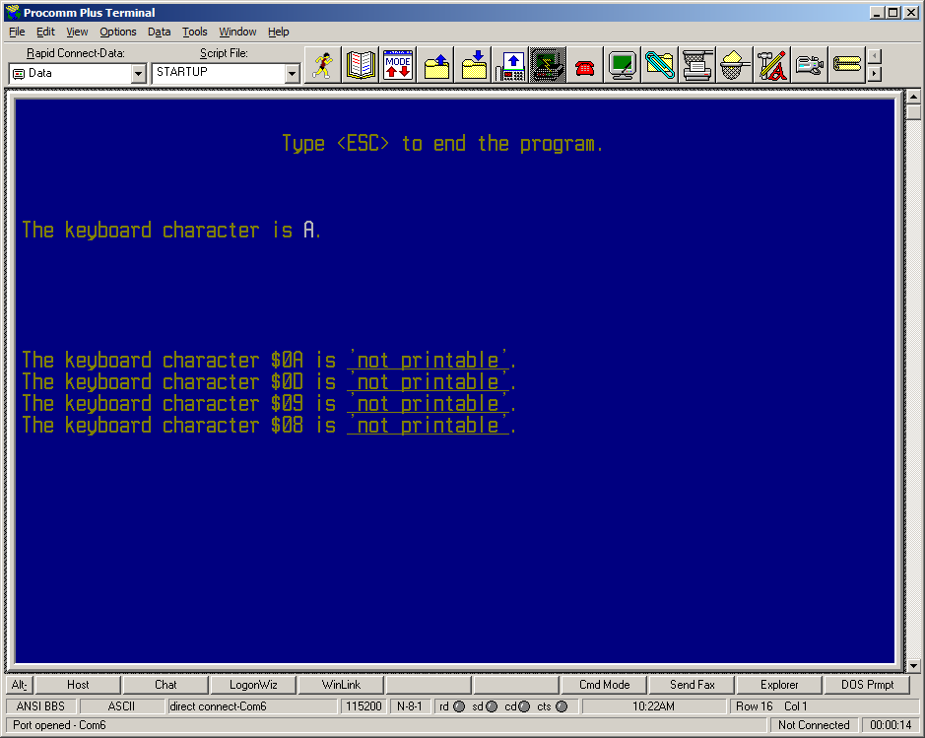
Program termination information line 2

Overwritten printable character line 6

Scroll area for nonprintable characters
(blinking text)
- Port Input/Output
Configure the 769 to properly execute the following tasks:
- Set each on-board LED port pin to output (use Figure 3 to see what 769 port pins to use for each LED, LD1 through LD4). You will first need to set the corresponding bits in each GPIO port’s data direction register (GPIOJ->MODER for LD1 and LD2, for example) to a 1 for output and use the bit set/reset register (GPIOx->BSRR, x is the port letter J, A, or D) to write the bits for output.
- Set Arduino pins D0 through D3 to be inputs with pull-up resistors (use Figure 4, the Arduino pin map, later in this document to see what 769 port pins to use). Use 0 V (ground) for logic low and +5 V through a 1kΩ resistor for logic high. You will need to set registers (GPIOx->MODER for direction and GPIOx->PUPDR for pull-up/pull-down modes) for input. Then, read from the input data register (GPIOx->IDR).
- Continuously read in a value on from an input pin and output the value to the corresponding output, which has been connected to an LED. In other words, a state change in D0 should cause a state change on LD1, while a state change in D1 should cause a state change in LD2. Bear in mind that, since the input pins will be in pull-up mode, connecting an input pin to ground will produce a state change from high to low.
The minimum steps necessary to read in a voltage on GPIO port C pin 7 (Arduino D0) and output a change on GPIO port J pin 13 (LED1) are as follows:
- Enable GPIO C and J peripheral clocks with the function __HAL_RCC_GPIOx_CLK_ENABLE(). Note: GPIOx = GPIOA, GPIOB, etc., and you need to enable a clock for each port you want to use otherwise nothing will work on those ports.
- Enable output mode on GPIO J pin 13.
- Enable input mode on GPIO C pin 7. (While true that the STM chip defaults to input mode for all pins on GPIO C through K, we still want to see that you know how to do this.)
- Set GPIO C pin 7 to pull-up mode.
- Read the 32-bit numerical value from GPIO C’s input data register into a local variable.
- Turn on the LED on GPIO J pin 13 when GPIO C reads low.
If a potentiometer (use the pot modules assigned to lab groups by the TA), whose end terminals are between ground and +5V with its wiper connected to an input, is used to give various voltage readings, you should be able to confirm that voltages near 0V yield a numerical value of 0, and near +5V yield 1. Explain why this makes sense, and determine if the input uses a Schmitt trigger (hysteresis) on voltage levels.
ADDITIONAL NOTES:
- Be sure the +5V supply is NOT connected to the +3.3V supply on the microcontroller.
- LED4 uses inverted output logic.

VT100/ANSI ESCAPE SEQUENCES
Name | Escape Code | Hexadecimal |  | Description
Reset Device | <ESC>c | $1B $63 |  | Resets all terminal settings to default.
Enable Line Wrap | <ESC>[7h | $1B $5B $37 $68 |  | Enables wrapping text to the next line if text is longer than the display area.
Disable Line Wrap | <ESC>[7l | $1B $5B $37 $6C |  | Disables wrapping text; text will be clipped if longer than display area.
Cursor Home | <ESC>[H | $1B $5B $48 |  | Moves the cursor to the home position (upper left hand corner).
Cursor Position | <ESC>[{ROW};  {COL}H | $1B $5B ${ROW} $3B ${COL} $48 |  | Sets the position of the cursor at ({ROW}, {COL}).
Cursor Up | <ESC>[{NUM}A | $1B $5B ${NUM} $41 |  | Moves the cursor up {NUM} rows;  {NUM} defaults to 1 if omitted.
Cursor Down | <ESC>[{NUM}B | $1B $5B ${NUM} $42 |  | Moves the cursor down {NUM} rows;  {NUM} defaults to 1 if omitted.
Cursor Left | <ESC>[{NUM}D | $1B $5B ${NUM} $44 |  | Moves the cursor left {NUM} columns;  {NUM} defaults to 1 if omitted.
Cursor Right | <ESC>[{NUM}C | $1B $5B ${NUM} $43 |  | Moves the cursor right {NUM} columns;  {NUM} defaults to 1 if omitted.
Save Cursor | <ESC>[s | $1B $5B $73 |  | Saves the current cursor position.
Restore Cursor | <ESC>[u | $1B $5B $75 |  | Restores the previously stored cursor position.
Erase End of Line | <ESC>[K | $1B $5B $4B |  | Erases from the current cursor position to the end of the current row.
Erase Start of Line | <ESC>[1K | $1B $5B $31 $4B |  | Erases from the start of the current row to the current cursor position.
Erase Line | <ESC>[2K | $1B $5B $32 $4B |  | Erases the entire current row.
Erase Down | <ESC>[J | $1B $5B $4A |  | Erases from the current row down to the bottom of the screen.
Erase Up | <ESC>[1J | $1B $5B $31 $4A |  | Erases from the current row to the top of the screen.
Erase Screen | <ESC>[2J | $1B $5B $32 $4A |  | Erases the entire screen and moves the cursor to the home position.
Scroll All | <ESC>[r | $1B $5B $72 |  | Enables scrolling for the entire display.
Scroll Section | <ESC>[{SRT};  {END}r | $1B $5B ${SRT} $3B ${END} $72 |  | Enables scrolling only for rows {SRT} to {END}.
Scroll Down | <ESC>D | $1B $44 |  | Scrolls the display down one line.
Scroll Up | <ESC>M | $1B $4D |  | Scrolls the display up one line.
Attribute Mode set | <ESC>[{ATR1};  ...;{ATRn}m | $1B $5B ${ATR1} $3B ... $3B ${ATRn} $6D |  | Sets multiple display attribute settings; any number can be set. ATRn may be any of the following values:
Standard Values for Attribute Mode Set | 0 Reset Attributes  1 Bright  2 Dim  4 Underscore  5 Blink  7 Reverse  8 Hidden |  | Foreground Colors  30 Black  31 Red  32 Green  33 Yellow  34 Blue  35 Magenta  36 Cyan  37 White |  | Background Colors  40 Black  41 Red  42 Green  43 Yellow  44 Blue  45 Magenta  46 Cyan  47 White
Do not include the ‘{‘ or ‘}’ characters in the print statement.
Ex.) <ESC>[{ROW 10};{COL 20}H would be “\033[10;20H”.
For SFRs, see the file stm32lib/Drivers/CMSIS/Device/ST/STM32F7xx/Include/stm32f769xx.h
[This might be in a folder called “Backend” if you’re using the build scripts system.]

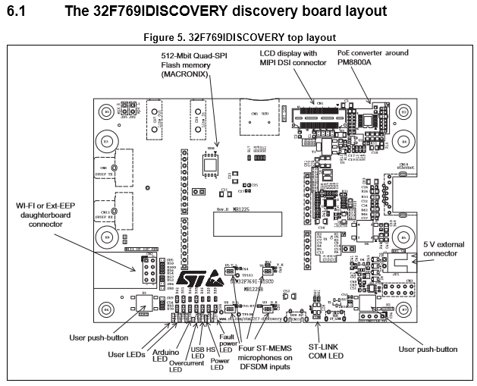
Figure 1: Page 10, 769 Discovery Kit User’s Manual.pdf
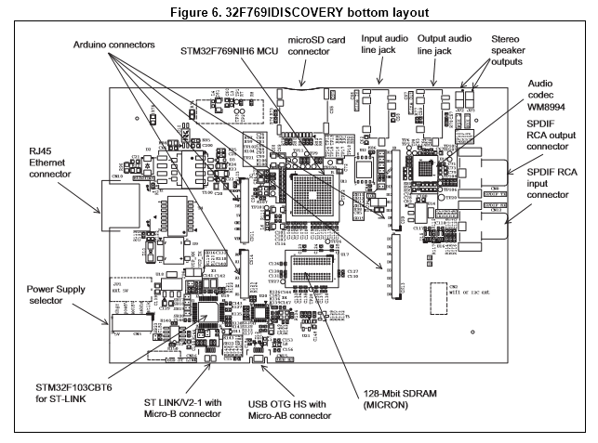
Figure 2: Page 11, 769 Discovery Kit User’s Manual.pdf
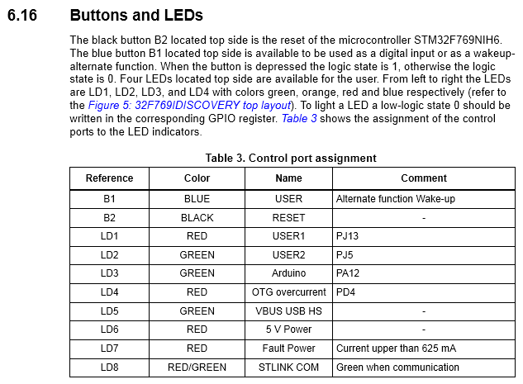
Figure 3: From page 20, 769 Discovery Kit User’s Manual.pdf
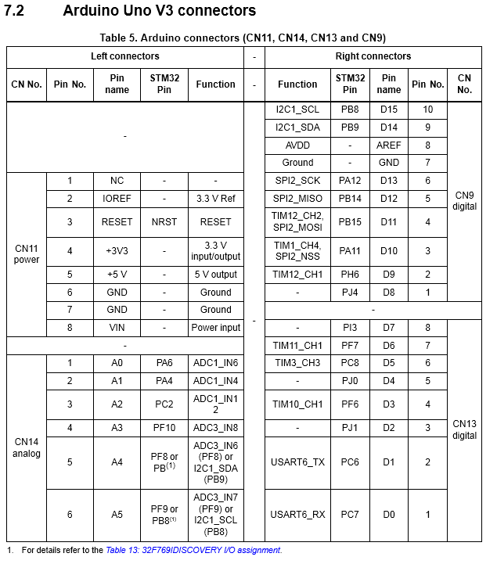
Figure 4: Page 25, 769 Discovery Kit User’s Manual.pdf

//------------------------------------------------------------------------------------
// Hello.c
//------------------------------------------------------------------------------------
//
// Test program to demonstrate serial port I/O. This program writes a message on
// the console using the printf() function, and reads characters using the getchar()
// function. An ANSI escape sequence is used to clear the screen if a '2' is typed.
// A '1' repeats the message and the program responds to other input characters with
// an appropriate message.
//
// Any valid keystroke turns on the green LED on the board; invalid entries turn it off
//

//------------------------------------------------------------------------------------
// Includes
//------------------------------------------------------------------------------------
#include "hello.h"

//------------------------------------------------------------------------------------
// MAIN Routine
//------------------------------------------------------------------------------------
int main(void)
{
Sys_Init(); // This always goes at the top of main (defined in init.c)

char choice;
char in[3];
int size = 3;

printf("\033[2J\033[;H"); // Erase screen & move cursor to home position
fflush(stdout); // Need to flush stdout after using printf that doesn't end in \n
printf("Test of the printf() function.\n\n");

// __HAL_RCC_GPIOJ_CLK_ENABLE(); // Need to enable clock for peripheral bus on GPIO Port J

volatile uint32_t * RCC_AHB1_CLOCK_ENABLE = (uint32_t*) 0x40023830U; // Enable clock for peripheral bus on GPIO Port J
*RCC_AHB1_CLOCK_ENABLE |= 512U; // Bitmask for RCC AHB1 initialization: 0x00000200U or 512U in decimal

// A cool trick to have printf give you the address of a pointer:
//
// printf("GPIOJ_BASE_ADDR: %p\n", (void*)GPIOJ);
// printf("BSRR: %p\r\n", (void*)&(GPIOJ->BSRR));
// printf("ODR: %p\r\n", (void*)&(GPIOJ->ODR));

// GPIOJ->MODER |= 1024U; //Bitmask for GPIO J Pin 5 initialization (set it to Output mode): 0x00000400U or 1024U in decimal
// GPIOJ->BSRR = (uint16_t)GPIO_PIN_5; // Turn on Green LED (LED2)
// GPIOJ->BSRR = (uint32_t)GPIO_PIN_5 << 16; // Turn off Green LED (LED2)
// GPIOJ->ODR ^= (uint16_t)GPIO_PIN_5; // Toggle LED2

// It doesn't get lower level than this!
volatile uint32_t * GREENLEDMODER = (uint32_t*) 0x40022400U; // Init GPIO J Pin 5 (LED2 with no Alt. func.) to Output
*GREENLEDMODER |= 1024U; // Bitmask for GPIO J Pin 5 initialization: 0x00000400U or 1024U in decimal

volatile uint32_t * GREENLEDBSRR = (uint32_t*) 0x40022418U; // Address of GPIO J Bit Set/Reset Register
*GREENLEDBSRR = (uint16_t)0x0020U; // Turn on Green LED (LED2)

HAL_Delay(1000); // Pause for a second

volatile uint32_t * GREENLEDODR = (uint32_t*) 0x40022414U; // Address of GPIO J Output Data Register
*GREENLEDODR ^= (uint16_t)0x0020U; // Toggle Green LED (LED2)

while(1)
{

printf("Hello World!\r\n\n");
printf("( greetings from Russell P. Kraft )\r\n\n\n");
printf("1=repeat, 2=clear, 0=quit.\r\n\n"); // Menu of choices
// Don't forget to end printf with newline or run fflush(stdout) after it!

// choice = uart_getchar(&USB_UART, 1);
choice = getchar();
putchar(choice);

// Messing around with stuff:
// putchar('9'); // Putchar is weird, man.
// choice = uart_getchar(&USB_UART, 0);
// uart_putchar(&USB_UART, &choice);
// puts("stuff\r\n");

// select which option to run
// HAL_GPIO_WritePin(GPIOJ, GPIO_PIN_5, GPIO_PIN_SET); // Turn green LED on (GPIO_PIN_SET == 1)
*GREENLEDBSRR = (uint16_t)0x0020U; // Turn on Green LED (LED2)
if (choice == '0')
return 1;
else if(choice == '1')
printf("\r\n\nHere we go again.\r\n\n");
else if(choice == '2') // clear the screen with <ESC>[2J
{
printf("\033[2J\033[;H");
fflush(stdout);
}
else
{
// inform the user how bright he is
*GREENLEDBSRR = (uint32_t)0x0020U << 16; // Turn off Green LED (LED2)
printf("\r\nA \"");
putchar(choice);
// uart_print(&USB_UART, choice);
printf("\" is not a valid choice.\r\n\n");
}

// Messing around with more stuff
printf("Enter an alphanumeric sequence (press <enter> if you want to send less than %d characters): \r\n", size + 1);
int a = uart_getline(&USB_UART, in, size);
printf("\r\nuart_getline result: %d\r\n", a);
}
}

//------------------------------------------------------------------------------------
//Extra thing to consider...
//------------------------------------------------------------------------------------
void serial_print_things(void) {
//Input Buffer
char input[2];
input[0]=0;
input[1]=0;

//Initialize the system
Sys_Init();
initUart(&Second_UART, 9600, USART6); // Allow printing over USART6 (Arduino pins D0 - Rx and D1 - TX)
uart_print(&USB_UART, "\033[2J\033[;H");
uart_print(&Second_UART, "\033[2J\033[;H");
uart_print(&USB_UART, "Hello World: This is the USB Serial Connection\r\n");
uart_print(&Second_UART, "Hello World: This is the other UART Connection\r\n");
uart_print(&USB_UART, "In order to send newlines to this terminal,\r\n");
uart_print(&USB_UART, "Press <ESC> and type \"[20h\" (without quotes)\r\n");
uart_print(&USB_UART, "To get out of newline mode and back to line feed mode,\r\n");
uart_print(&USB_UART, "Press <ESC> and type \"[20l\" (without quotes)\r\n");
uart_print(&USB_UART, "\"Thanks for Playing!\" --Super Monkey Ball Announcer Guy\r\n");

printf("OMG THIS SENTENCE USES PRINTF!!!\r\n");
// Don't forget to end printf with newline or run fflush(stdout) after it!

while(1) {
input[0]=uart_getchar(&USB_UART, 0);
uart_print(&USB_UART, input);
uart_print(&Second_UART, input);
}

while(1);// HALT AND CATCH FIRE
}
//------------------------------------------------------------------------------------
// Hello.h
//------------------------------------------------------------------------------------
//
// Author:
// Karl Nasrallah
//
// Function prototype definitions and related for hello.c
//

#ifndef __HELLO_H
#define __HELLO_H

//------------------------------------------------------------------------------------
// Includes
//------------------------------------------------------------------------------------
#include "init.h" // Always need init.h, otherwise nothing will work.

//------------------------------------------------------------------------------------
// Function Prototypes
//------------------------------------------------------------------------------------
void serial_print_things(void);

//------------------------------------------------------------------------------------
// Global Variables
//------------------------------------------------------------------------------------
UART_HandleTypeDef Second_UART;

#endif /* __MAIN_H */

Picocom is highly recommended for Linux users (and Mac users with MacPorts/homebrew/Fink). It’s a well-featured, lightweight serial terminal with a really, really good man page.
Also known as the Disco board (STM32769I-Discovery). This should not be confused with the Analog Discovery USB oscilloscope/function generator/million other things device. Though both can do everything, they each do different kinds of everything. Although, you could probably make a 769 do what an Analog Discovery board does if you really wanted to…
Note: GPIO port A pins 9 and 10, PA9 and PA10, respectively, are in use for the USB serial terminal (PA9 = TX, PA10 = RX). If ever that suddenly stops working, make sure you haven’t overwritten those pins!

