Robert Pierucci
CMPS 3390
Final Project

Final Project – Dining Philosopher Simulation

For my final project, I recreated the Dining Philosopher simulation we had created in Lab 7 for Android devices. This application simulates the Dining Philosopher problem and displays a table to the screen once opened. The table has 5 philosophers sitting around it and displays the status of each philosopher in text. The status’ change from “Waiting”, “Eating”, and “Resting”. When a philosopher is eating, forks appear in front of the philosopher on the table as well as food on their plate.
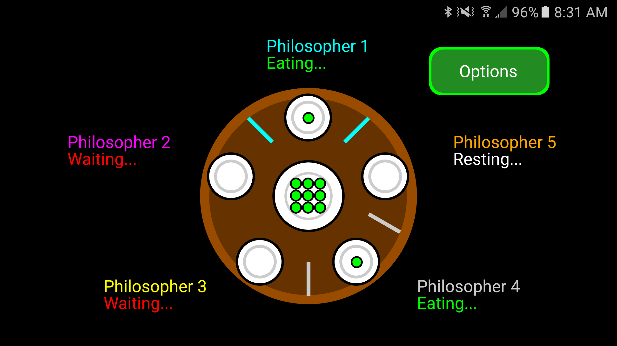
This program uses a monitor to check each philosophers status and once a philosopher is able to pick up both forks, it does so. This limits the philosophers sitting directly left and right of them to have to wait. The status “Resting” is a cool-down period after a philosopher has wait which signifies they are not currently seeking food.
The Android version has an added “Options” menu that I have created. When a user touches this button, a menu comes up allowing the user to change the food drawn to the philosopher’s plates. Additionally, information about myself and the product version is listed on this window.
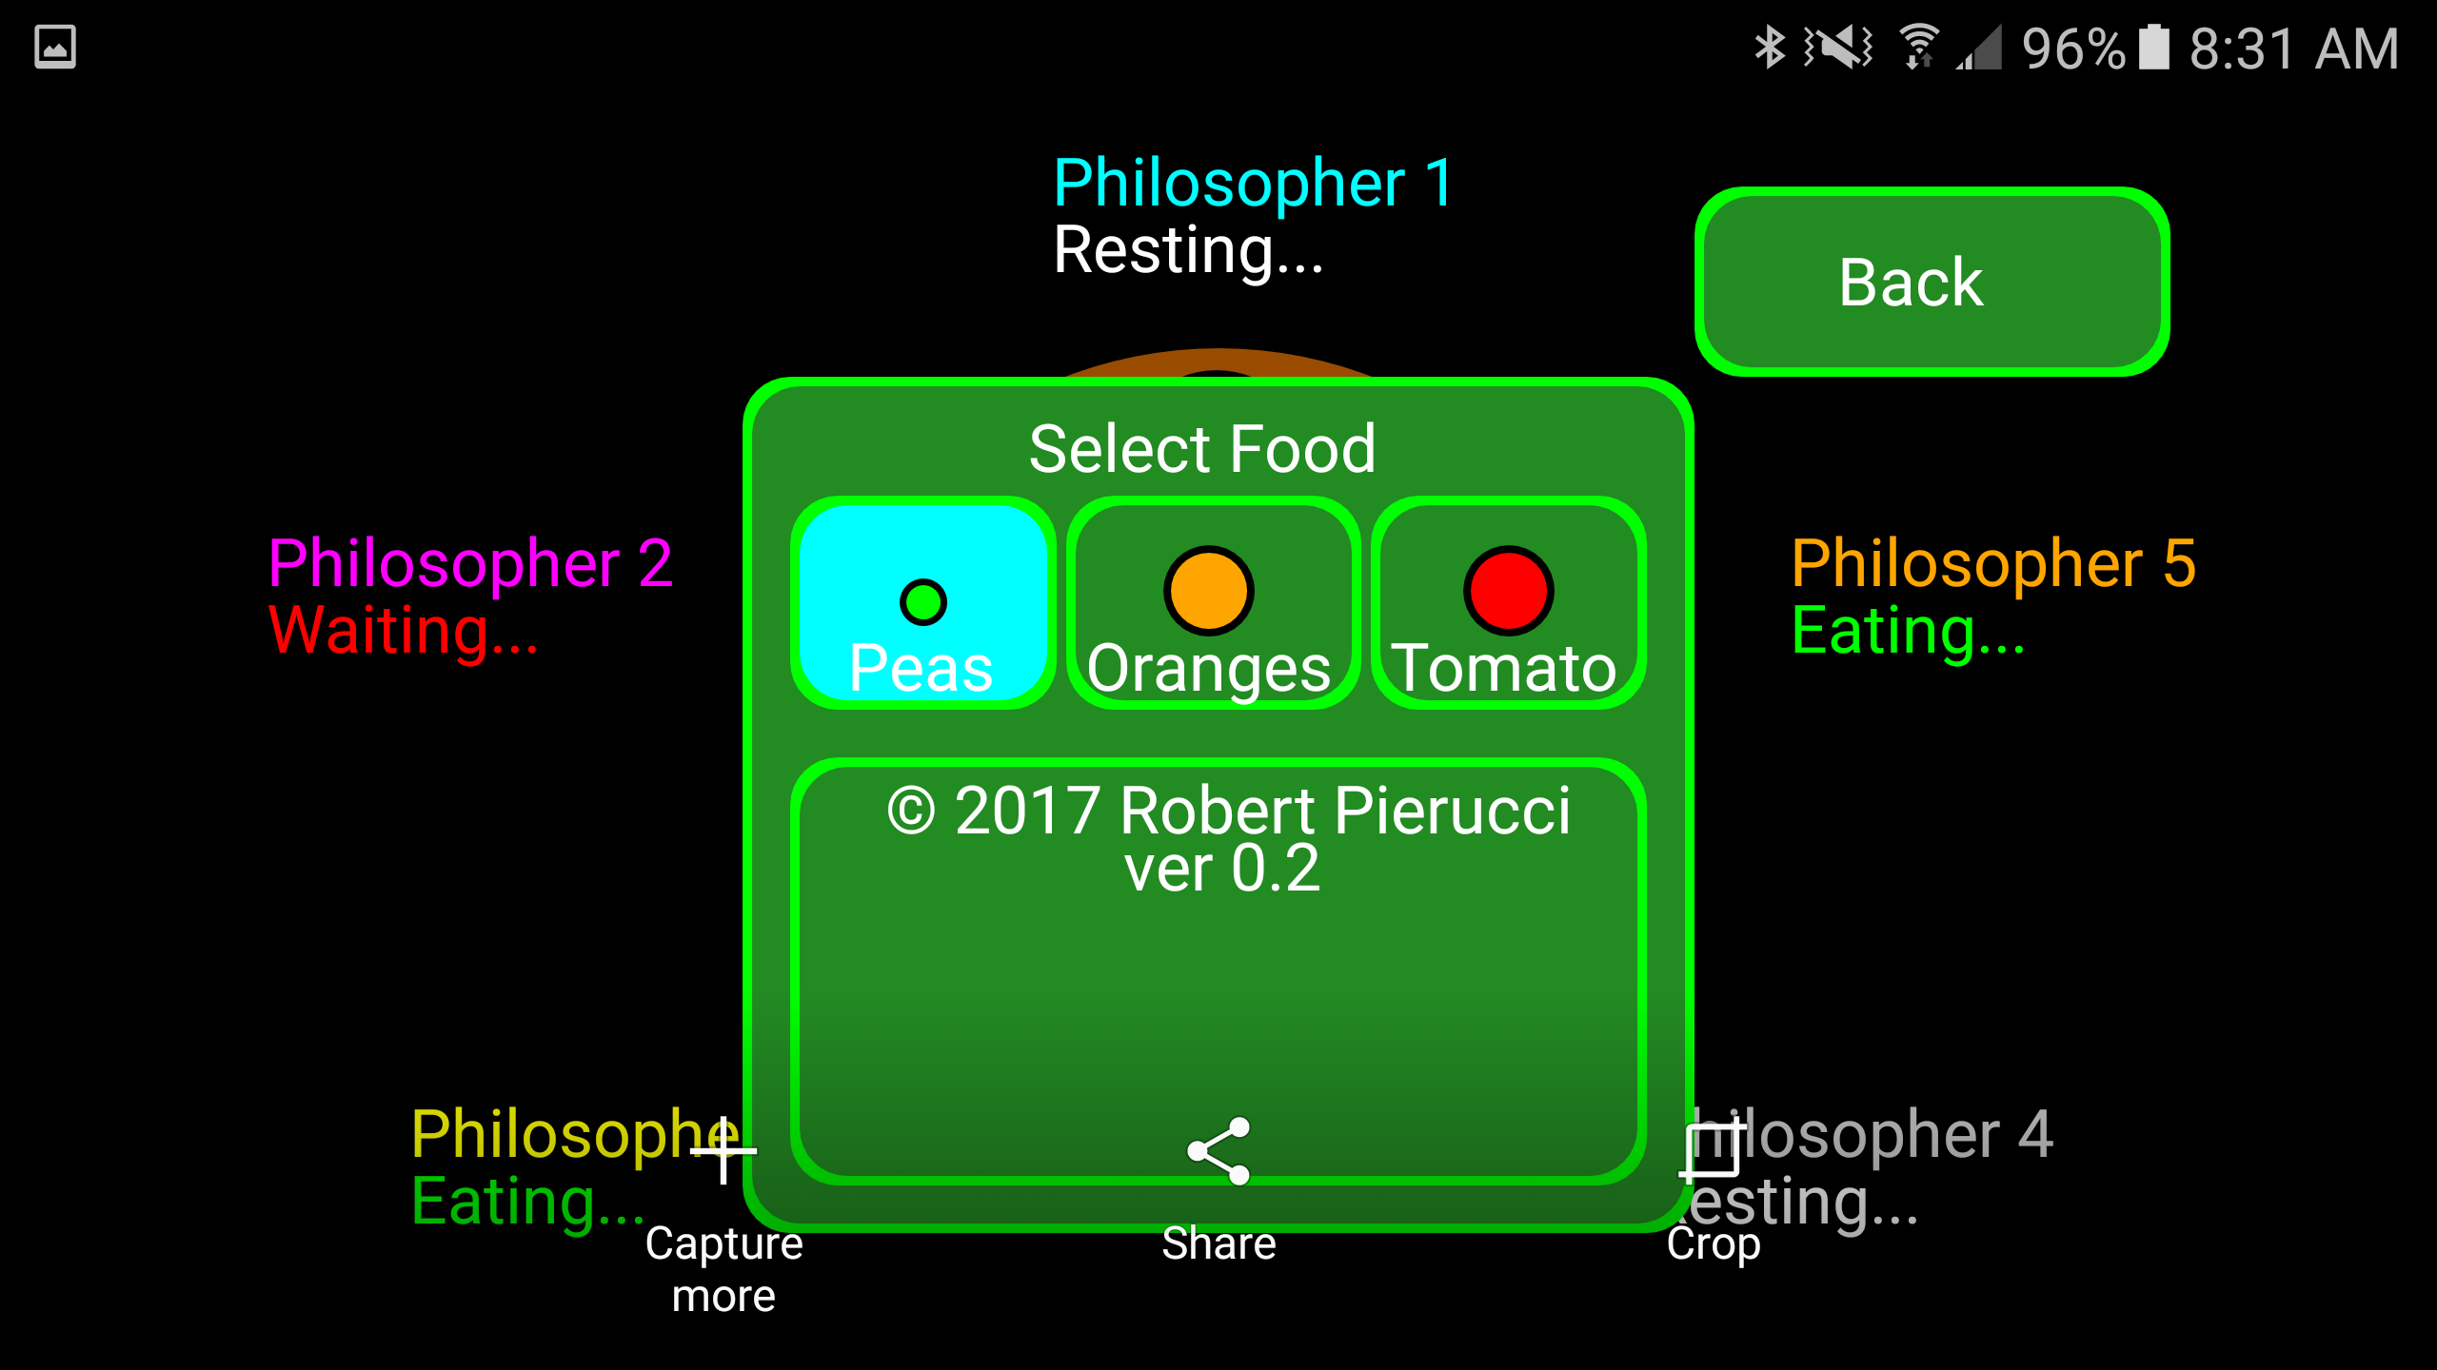
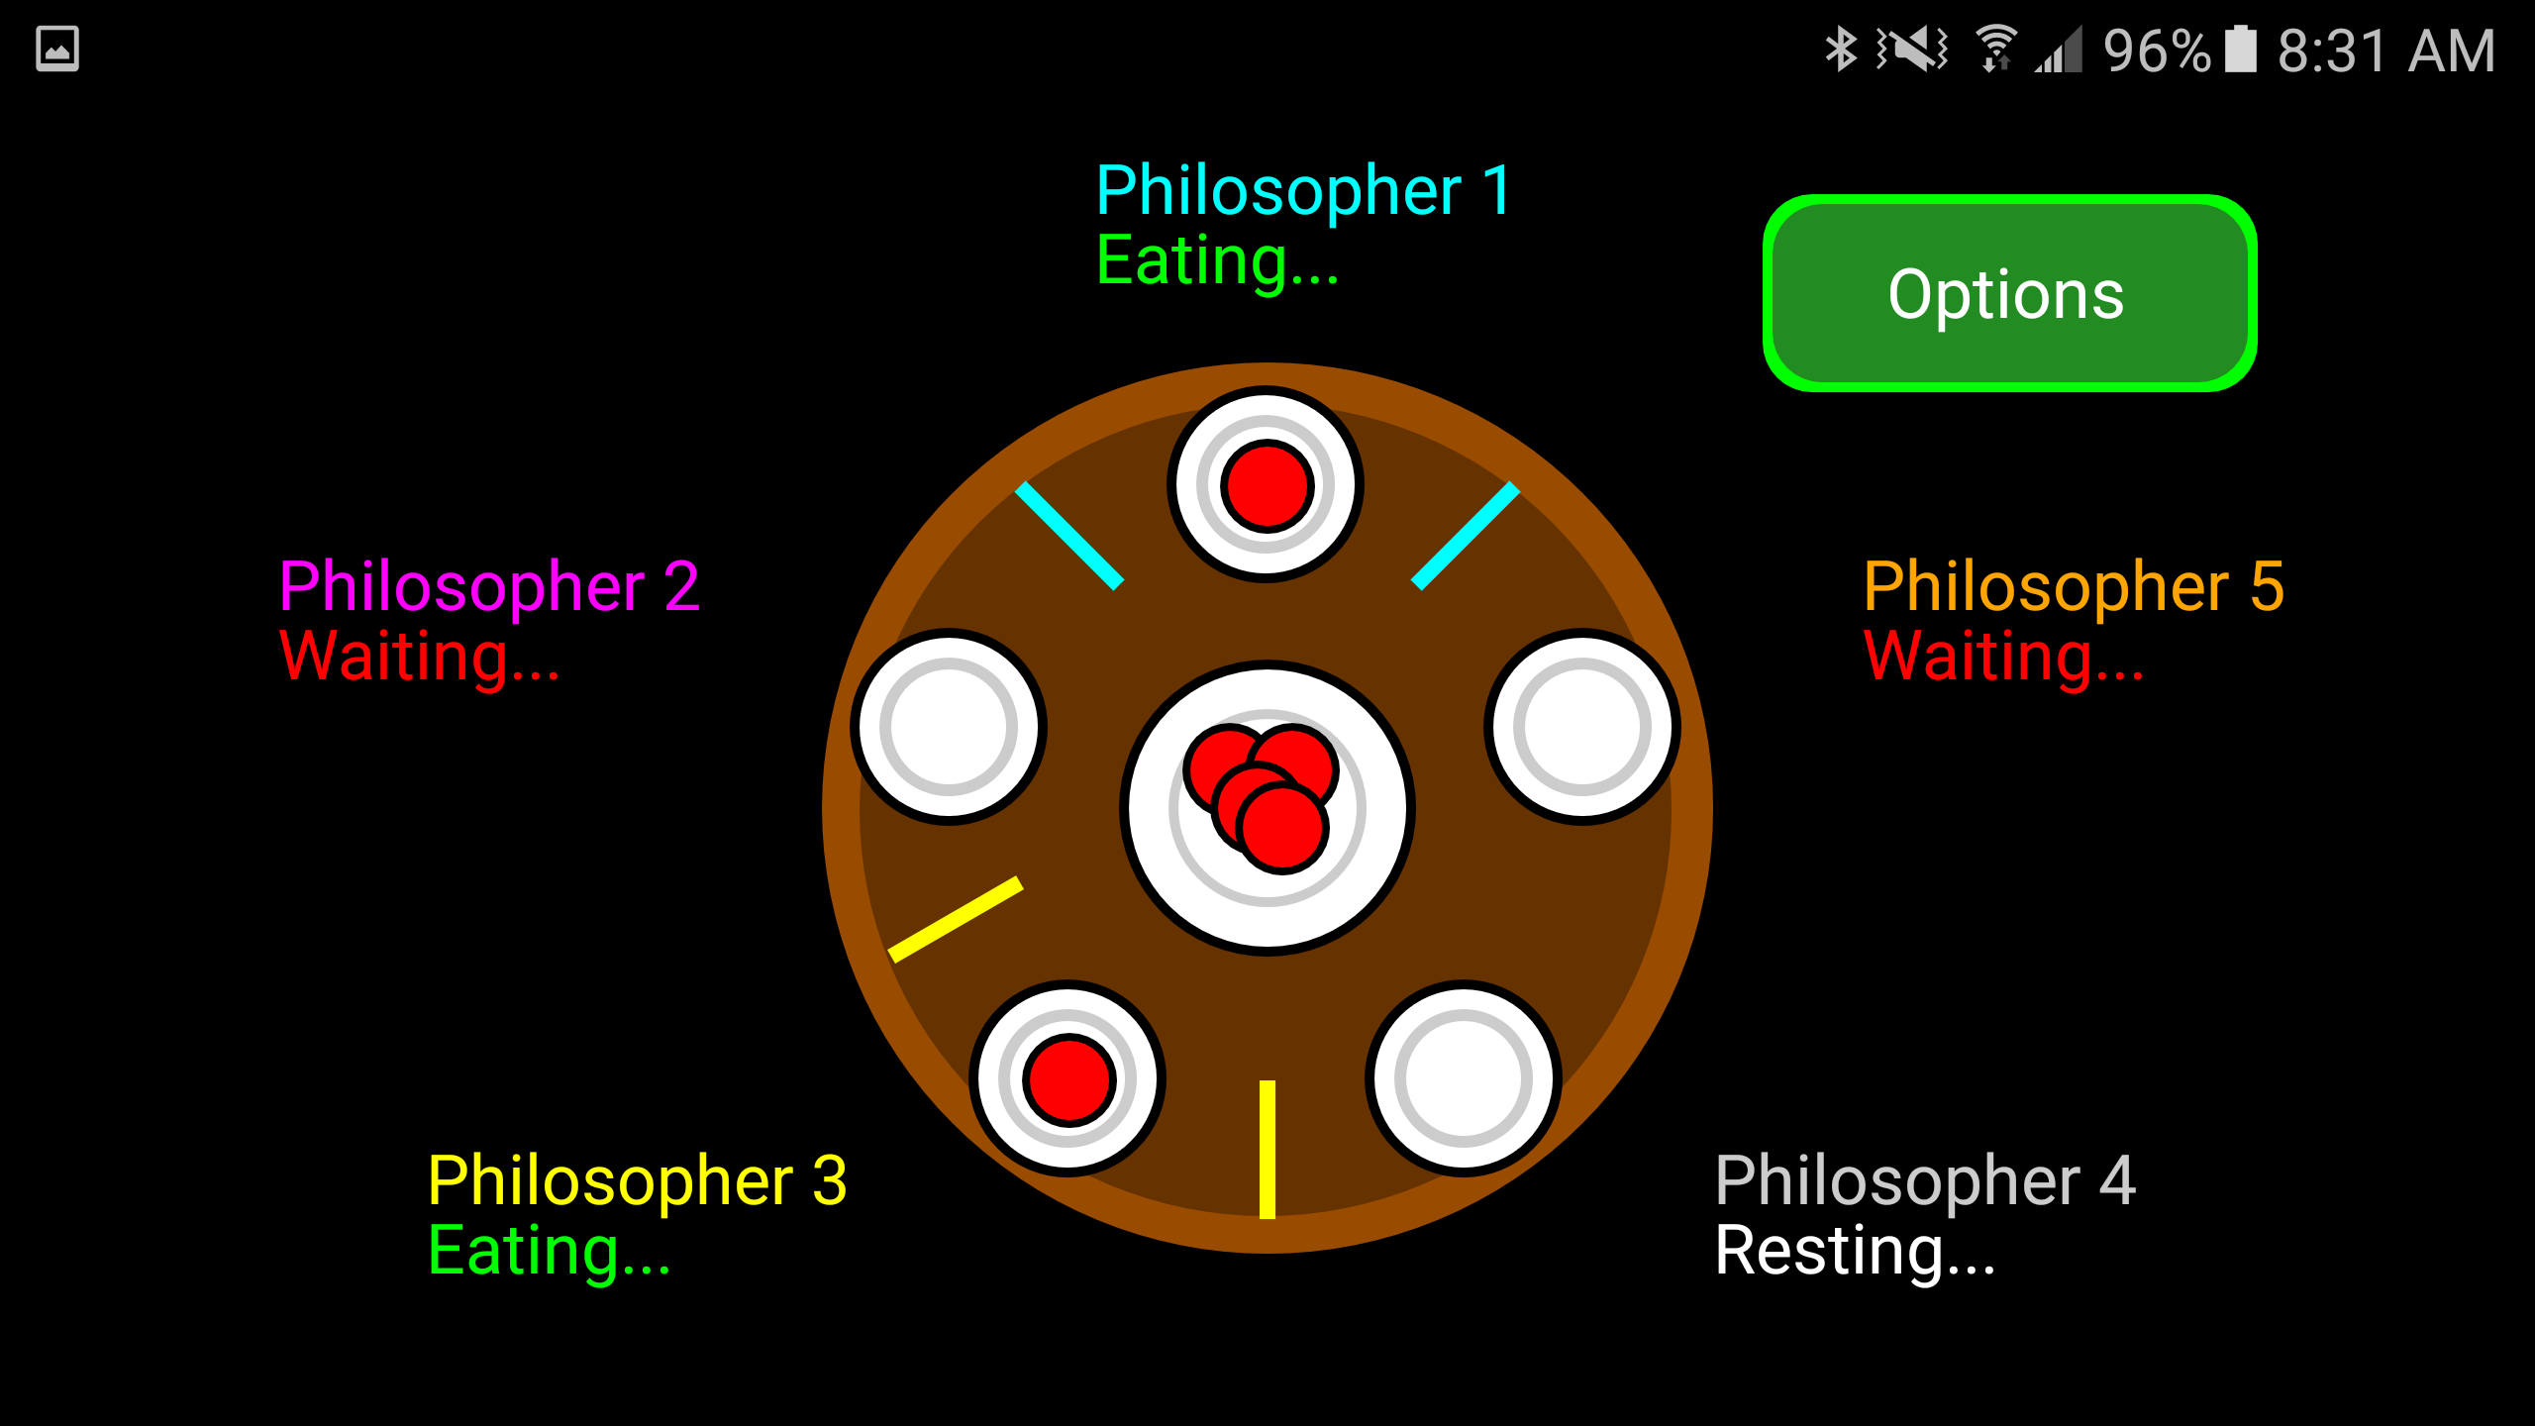
Additionally, there are confirmation sounds when the options button is pressed as well as colors that change when you click on each food to select. There is also “music” that is in fact the sound of a busy restaurant in the background to simulate the philosophers eating.
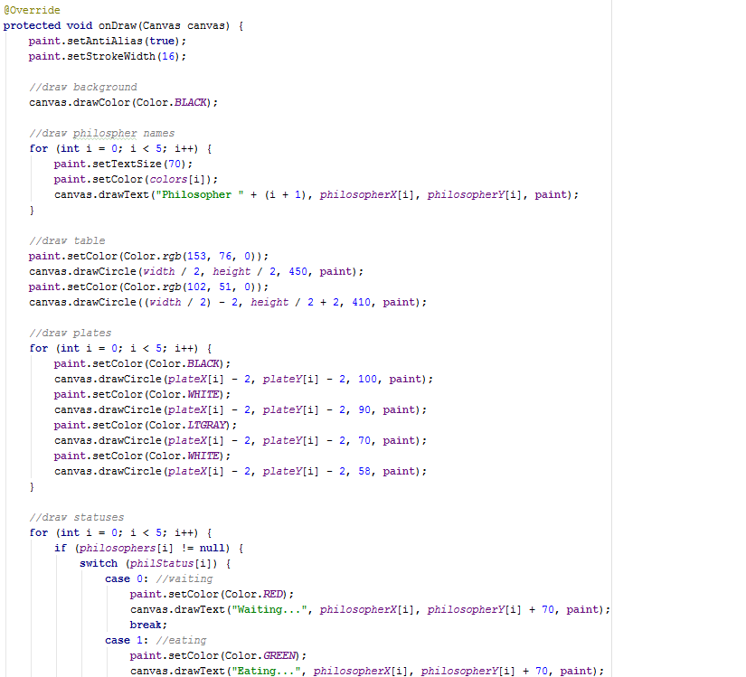
For porting this program to Android, the philosopher and monitor classes are virtually the same. The class “CustomView” that I created to draw the GUI is vastly different. While on the desktop version I used Java swing’s PaintComponent function and overloaded it to create my animation, I used an overloaded function onDraw on Android. All of my coordinates for the different shapes I was drawing were changed. I worked to implement a way to draw the image based on the user’s device size using DisplayMetrics in my main activity and grabbing the user device’s width and height.

For sound, I used an object called MediaPlayer to create sounds for both the button and the song. I created the objects in my mainActivity and passed them to a constructor in customView to allow the songs to play each time you click on the screen or the program starts.
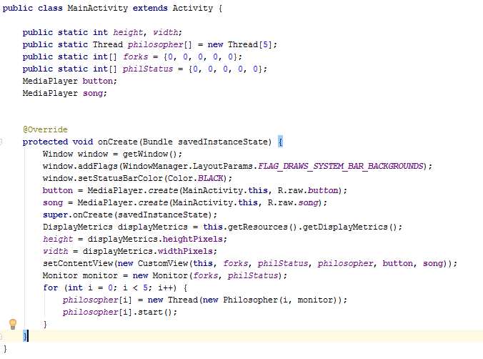
Overall, I found this project to be highly enjoyable as working with animations and GUI’s is something I really like to do. I would like to continue working on this project outside of this class to further improve it and hone my skills as well as put it on the Google Play store to see how that works. If you would like to see the source code for this, I have uploaded the zip to my public Sleipnir at the following address:
http://cs.csubak.edu/~rpierucci/cs3390/DiningPhilosopher.zip
Robert Pierucci

