Name: Rocco Pietrangelo

Course: BTR820

Date: April 14, 2017

Professor: Howard Steinberg

VIRTUAL REALITY IN MEDICAL EDUCATION

2017

# Abstract

The research and study on how the current medical school curriculum works and if virtual reality can be used to improve or advance the current system. The current traditional system for medical school will be explained in brief detail and a brief understanding of virtual reality will be given before seeing how it is used today in medical scenarios. With the explanation of medical school and virtual reality, different ways will be discussed on how virtual reality can be used to teach students in medical school with the current technology. Different scenarios like virtual reality streaming (Weller) and virtual reality human models ("Surgical Theater Unveils”) were developed and are being used by medical experts in the medical field. There are many benefits to using virtual reality in medical education, but there are also draw backs. With the advancing of technology older generation doctors do not like using newer technology and feel uneasy about it (Boeldt, L. Debra, et al. 215) and students cannot be solely trained on virtual simulations alone (David Geffen School of Medicine). Real surgery is a complete different experience than operating on a fake body. The research concludes that virtual reality is a key tool that can be used in medical schools, but still has mush more development before it can be fully utilized within the medical school environment.

# Key Words

Virtual, Reality, Surgery, Medical, School, Education, Doctors, Surgeons, Technology,

Operating, Models, Multimedia.

Table of Contents

Introduction 4

Virtual Reality 5

What is virtual Reality? 5

Virtual reality concepts 5

Where virtual reality is today 6

Medical Education 8

Current Medical Education Curriculum 8

Current Technologies Used in Medical Education 8

Success Rate of Students in Medical School 9

Acceptance Rate of Medical School 9

Virtual Reality in the Medical Environment 11

How Virtual Reality is Being Used by Medical School Graduates and students 11

Overview 11

Using Virtual reality to alter the impossible with neuroscience 11

Trauma Decision-Making Simulator 12

Studying 3-D models with virtual reality 13

The Benefits of Using Virtual Reality in Medical School 14

Overview 14

Multimedia Increases Students Learning Rate 14

Virtual reality as a type of multimedia in the Medical Education Environment 15

Live Virtual Streaming of Surgery 15

Being Educated by Virtual Models 16

World Wide Availability for Medical Students 17

Why Virtual Reality Cannot be Implemented Instantly 18

Virtual reality surgery compared to real surgery 18

The current modern medical technologies for virtual reality is just the beginning 19

Older Generation Doctors Don’t Like the Newer Technology 20

Conclusion 21

Work Cited 22

# Introduction

When thinking of virtual reality many people think of entertainment. Virtual reality has the potential to be so much more than a piece of entertainment used with video games or movies. With virtual reality many things can be made possible which didn’t seem possible a few years ago. Virtual reality can be used in schools to teach students with this technology. Using this technology students in medical school could learn and advance in knowledge to a degree that the traditional system cannot. Imagine playing a video game. No matter how many times your character dies it is always possible to try again. There is limitless lives on your characters life in a game, sadly in reality this is not the case. If a human dies in real life they are dead no try again. Imagine a scenario where doctors can perform the same surgery on a patient until it is perfected to the point of little to no error. With virtual reality a surgeon can practice difficult surgeries with little success rate as many times as they like with no life on the line. A student can learn about complicated surgeries that have been performed by professionals and practice them while in school. This is just the beginning of what can be possible in the foreseeable future using virtual reality.

# Virtual Reality

## What is virtual Reality?

“Virtual reality is an artificial environment that is created with software and presented to the user in such a way that the user suspends belief and accepts it as a real environment. On a computer, virtual reality is primarily experienced through two of the five senses: sight and sound.”(Rouse)

The user of virtual reality experiences these senses through the help of sensors placed on the body. The sensors are usually located on a headset that the user wears to access the virtual environment. While the headset is on the user will experience the environment as if they were actually there and move around it as if it were real.

## Virtual reality concepts

Virtual reality aims to remove the standard mouse and keyboard interaction that users have to use when working with technology. Virtual reality can also be used as a problem solving device where objects or environments can be explored much farther than technologies that can only be seen on a screen. (“Virtual Reality Society”)

This allows people to make alteration to designs of products being created with less time and money because it is being created in virtual space. Similar to creating models on the computer or prototypes the structure can be altered in anyway until the proper requirements are met and the user is satisfied.

## Where virtual reality is today

When virtual reality was still being developed it was costly to set up a virtual environment. The cost of the headset as well as a computer that was strong enough to run the environment would have costed a lot of money to set up. Today a virtual environment can be set up with a cheap headset and a smartphone. With everyone having the ability to access virtual reality for an affordable cost it is capable of being used in many new areas.

Today a lot of money is being invested in the use of virtual reality in many different fields. Virtual reality has split off from an entertainment only technology to a technology being used to aid other businesses. Even though Video games still has the most money invested into virtual reality, Healthcare is second on the list.

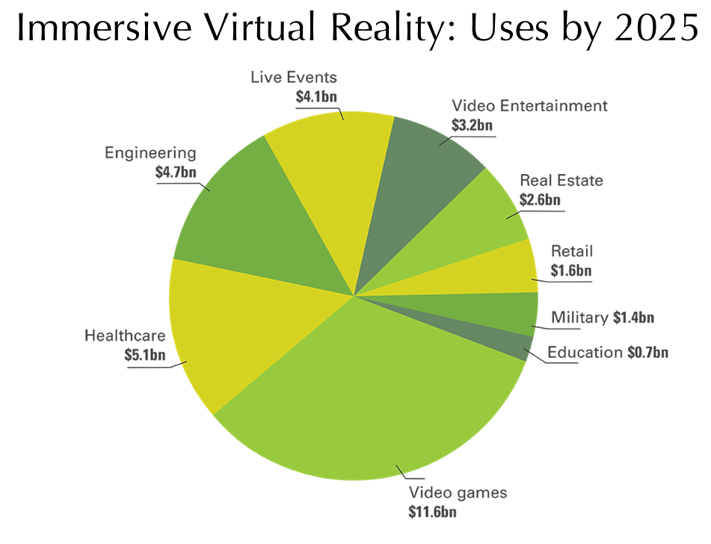

Fig. 1. Money being invested in the different areas that use virtual reality. Appleton Creative “How Video is Changing the Way We View the World in 2016”, 2016, http://appletoncreative.com/2016/04/12/how-video-is-changing-the-way-we-view-the-world-in-2016/ Accessed 12 April 2017.

# Medical Education

## Current Medical Education Curriculum

Medical school consists of a four year program to train students to become medical doctors. The first half of the curriculum is to teach students about the essentials. The first half can consist of teaching methods such as traditional lectures, problem-based learning, laboratory sessions, simulated patient sessions, and some clinical experience. The second half of the curriculum is based on an internship where students work at clinics while supervised and working with patients. The students work under licensed physicians and learn through them. (Wikipedia)

## Current Technologies Used in Medical Education

The generation today is all about online. Everything in business and even schools are shifting to put as much things possible available on the web. Medical schools are also switching to a more online standards of teaching. Schools such as Yale are giving out iPads to all first year students so they have access to online materials that the course will offer. Many schools are starting to record lectures to put them online for students to stream at any time. Some have even shifted to a more open environment where all resources online are available to anyone even non students. (Colbert and Chokshi 1584) Medical schools are willing to change to keep up with the technology available today if it is able to help with the advancing of education.

## Success Rate of Students in Medical School

With the current medical school curriculum majority of the students who enter medical school end up graduating and fulfilling their goals of becoming doctors. There is only about an average of 6 percent of doctors who do not make it past medical school once they are accepted. The 6 percent dropout rate has a few reasons of why students leave after being accepted. On a less harmful way some of the students feel they chose the wrong path and feel like this is not truly what they want to do. A more drastic case is the stress from the schooling has caused them to develop a stress or eating disorder to try and keep up with studies. (Franco) A small percent of students are accepted out of the many that apply to medical school and it would be great if the success rate was closer to 100 percent.

## Acceptance Rate of Medical School

The acceptance rate at medical school is fairly low. Refer to Fig.2 the acceptance rate is less than 50 percent of total applicants. Out of the 43,919 students that applied to medical school in 2011, only 20,176 made it through. The 20,176 that made it through almost all graduated with only 946 not being successful. This doesn’t look like a lot but when put beside the original number of applicants, it is quite a small percent that are fully successful.

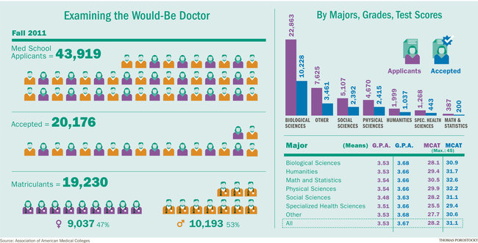

Fig. 2. Application and success rate of medical school. Roth, Al “Medical school admissions statistics” Market Design, 2012, http://marketdesigner.blogspot.ca/2012/06/medical-school-admissions-statistics.html. Accessed 12 April 2017.

# Virtual Reality in the Medical Environment

## How Virtual Reality is Being Used by Medical School Graduates and students

### Overview

As technology advances people find ways to incorporate the technologies into what they do to make it easier or to help them. As the technology leans towards virtual reality medical professionals will seize this opportunity to try to make it better for all the people in their field. Virtual reality is being used in many ways to help medical professionals accomplish things that seemed near impossible in the past.

### Using Virtual reality to alter the impossible with neuroscience

Neuroscience is the study of the nervous system or the brain. When working with nerves and the brain it can be a very dangerous and delicate process that takes a lot of time to understand. There is so much functionality involved that there is still so much to discover. With virtual reality it allows the combination of experimental control with natural behaviours. With the help of virtual reality it has increased the understanding of the neural process for not only humans but insects and animals as well. The benefits of using virtual reality is that the experimenter has the ability to alter the nerves to get results that would be unobtainable in the real world. These results can be from nerves that cannot act on their own and being able to isolate them in virtual reality can increase the knowledge of how the nerve works or how to fix it in certain scenarios. With the help of virtual reality this allows experiments to take place where they can fully examine specific nerves in the body without the interference of other nerves. This allows an increase of knowledge for each specific part of the nervous system. This shows that without virtual reality a lot of the knowledge within neuroscience would still be not achievable. (Minderer, Matthias, et al)

### 

### Trauma Decision-Making Simulator

A Trauma decision making Simulator was developed and is the first of its kind. It was made to see if the virtual reality technology can be a steady base to create a whole new platform for medical technology. The simulator used scenarios to create environments where medical experts will have to determine the problem with the patient in a timely manner. These scenarios involved the experts who were volunteers, consisting of instructors and novice medical technology associates, which went through a series of scenarios to try and save all the patients in the virtual reality game. The Simulator was a great success and was made to determine feasibility and proof-of-concept. The simulator confirmed its ability to distinguish decision making skills because the instructors scored higher than the novice users. Thee feedback was positive and they felt that this simulation was a cost effective learning tool for medical technology. (Harrington M. Cuan, et al)

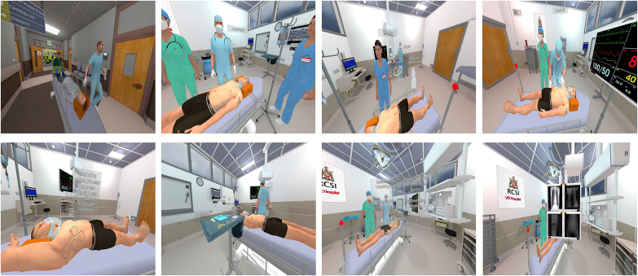

Fig. 3. The simulation game created in virtual reality. Harrington M. Cuan, et al. “Development and evaluation of a trauma decision-making simulatorin Oculus virtual reality” The American Journal of Surgery, (volume number and pages still to beadded states the article)(2017) ScienceDirect

### Studying 3-D models with virtual reality

With the virtual reality constantly advancing the potential things that can be done with it are increasing rapidly. Medical students have the ability to view three dimensional anatomy structures in a virtual environment without the need of animal models and high costs. Virtual reality allows the user to explore the three dimensional environment from anywhere. The user can access the three dimensional model and navigate through it as well as manipulate the model to increase the knowledge gained. The manipulation can also be done to gain knowledge on how stress or weather conditions can change the virtual body. (Jang, Susan, et al) The ability to navigate through a virtual body gives a lot of potential to allow students to learn without killing or working on animals. This is great because for each experiment they would need a new model, while using virtual reality they are able to use the same model and start again at any time.

## 

## The Benefits of Using Virtual Reality in Medical School

### Overview

Virtual reality is a great tool that can be used as a resource for learning. As the technology increases more and more things are possible that were not before. Medical school can start to develop a curriculum around virtual reality to increase the students learning potential.

### Multimedia Increases Students Learning Rate

Multimedia is where more than one way of communicating is used. In a school environment a multimedia example would be the professor is talking to the class while pictures are being shown at the same time. A study have been done to see how multimedia effects the learning outcome of students. The study that was conducted involved two separate groups of students being taught a subject on shock. The first group was taught using a lecture and traditionally designed slides. The other group was taught using a midwifed version of the information that followed the multimedia designs. The results showed that the group taught using multimedia got greater success in results than the group that was taught in the traditional lecture style. (Issa, Nabil, et al)

### Virtual reality as a type of multimedia in the Medical Education Environment

Virtual reality can be used as a type of multimedia to teach in classes. With multimedia being so successful in teaching students and allowing them to retain more knowledge, it would make sense to use this great tool to allow even more advances in medical school. A study was done using virtual reality where students were split into two separate groups. Both groups were going to be taught the same thing except one group was going to be taught with virtual reality and the other group was going to be taught using recordings and pictures received from the virtual reality. This study was done because there was belief that an optimal view of a scene can sometimes teach more than what a virtual environment can. The students were looking into an inner ear and those who used the virtual reality were able to draw out the diagram more accurately than those who got the recordings and pictures. It also proved that students who had less spatial ability benefited much more than students with higher special ability while using virtual reality. (Jang, Susan, et al)

### Live Virtual Streaming of Surgery

Streaming today is a huge part of how this generation spend their time. Streaming can be used as an entertainment tool like video games or movies, or it can be used for educational reasons. Streaming gives the user the ability to live broadcast something in real time so others can view it while it is happening. Think like watching a live hockey game on television except this is streamed from the computer live. With this technology a doctor merged both streaming and virtual reality to create the world’s first virtual stream of a live surgery. The surgery was completed by a doctor named Shafi Ahmed and performed surgery on a fake patient. The surgery was set up with 360 degree cameras and a lot of lenses around the operating room to allow the virtual simulation of the live stream. Viewers of the stream were able to hook up their virtual reality headsets and watch live as if they were in the room with the doctor as he performed surgery on the patient. The viewers had the ability to move around the room and view the body from any angle they wanted to gain the knowledge of what a surgeon does in an operating room. (Weller) With this kind of technology this opens up a whole new era of how students can be taught medical educations. Student will be able to watch live surgery or any other live streams of professional medical experts performing tasks that the student s will need to do after graduation. The student can put on the virtual helmet and become part of the atmosphere and gain valuable knowledge that cannot be easily obtained by simply learning with pictures diagrams and theories. This is such a valuable tool that can be used within medical school that can farther advance how students are taught and be incorporated in the teaching methods used in the first 2 years of medical school.

### Being Educated by Virtual Models

It is common practice for medical students to be instructed using fake human models to become educated on the human body. Now imagine being able to use a virtual body that can be manipulated and surgery performed on it without effecting a person’s life. This is possible with the newly developed medical reality visualization. This technology uses state of the art jet simulators and NVidia graphics to upload a patients MRI scan and create a virtual model of them. When a patient goes to a hospital and requires an MRI scan the doctor does this to see deeper within the person to have a better understanding of what the problem can be. Instead of seeing an image of the patient imagine being able to upload that image into a full virtual clone of the scanned person. This clone will have the same interior as the scanned person which can allow farther investigation of possible problems. This can allow the doctor to get better angles instead of a flat image to try and find possible problems. Not only can a doctor go more in-depth with the virtual model, but the doctor can then perform surgery on the virtual patient as well. If the patient has a rare or difficult condition that has a high fatality rate the doctor can practice on the virtual patient and reset as many times as needed until they feel comfortable or ready to work on the patient themselves. ("Surgical Theater Unveils”) This technology allows for student within their first 2 years of medical school to perform surgery and analyze the body of a patient without the use of test subjects. Medical experts who used certain scans of a rare or unknown disease that was found on a person can now be replicated virtually for students in medical school to explore and learn from to make sure that the disease can be addressed if it comes up again. This kind of technology can allow medical schools to share a huge database of virtual patients with different conditions that can be used to teach students different scenarios and how to solve them. Students can also use them to view the internal areas of a human model from any angle which can allow more freedom and control in the learning environment for students.

### World Wide Availability for Medical Students

When it comes to worldwide shared knowledge for medical education there is not much that offers that. Some countries will not have the money or resources required to have as advanced a school as they want. With virtual reality becoming less expensive it is possible to develop a virtual reality system within schools to benefit students internationally. The cost to set up a virtual environment with today’s technology can cost as low as 5 dollars plus a smart phone. (Robertson, Adi). With this cheap set up price students from around the world will have access to all this virtual reality content to help expand the amount of knowledge that they have access to whether it be live virtual stream surgery performed by professional medical experts or using virtual models to learn from.

The availability of this information is also an issue for medical students from around the world. Some countries have strict constraints on what is allowed to be accessed on the web and what’s not. Certain countries have the government filter out what people are looking up. This can be a great issue for medical students wanting to share knowledge worldwide. IFMSA is an organization that ensures medical students worldwide contribute to the development of medical education. This organization makes sure that all medical students are trained properly no matter what country. (IFMSA) With an organization like this trying to keep medical schools up to date all around the world, this would be a great way to distribute the virtual reality resources that can be available for medical students. If this company were to host a database with all these resources and have it available to all medical students internationally it will greatly increase the learning material available to all medical students.

## Why Virtual Reality Cannot be Implemented Instantly

### Virtual reality surgery compared to real surgery

Although virtual reality is a great tool to help medical students learn and develop a feel for surgery it can only go so far. Virtual surgery is great for giving students an idea about how to do surgery or a visual on what it would look like. How far can it actually prepare a student to work on a living human. When working on a virtual model of a human even with resistance from the jet simulators, students still have no worries or stress of physically harming a patient. When working with a virtual model students can forget they are operating on a human and feel it’s more like a game with as many resets as they need until they get it just right. Where working with a human it can be scary and cause major anxiety knowing someone’s life is in your hands. “She describes the surgery as an incredible experience. “From the first incision to the final suture, I learned an incredible amount and gained an unbelievable amount of experience.” (David Geffen School of Medicine) A student operating on a real living human can learn a lot more and gain valuable knowledge on coping with the stress and anxiety surgery has to offer than working with a tool such as virtual reality. Virtual reality should be a tool used to help students learn but cannot be used to fully replace actually surgery under the supervision of medical experts.

### The current modern medical technologies for virtual reality is just the beginning

As the technology continues to advance more and more virtual technology is being created for the medical field. Although there is all this useful technology available to explore and educate medical students, it still needs to be refined to a point that it will be useful as a teaching tool. With the help of virtual models and the ability to create them from MRI scans ("Surgical Theater Unveils”) and the ability to create live virtual surgery (Weller) as stated above, students will have access to a vast amount of knowledge. The problem is it is just a start of what possible potential it can have. There is not enough available to be used in developing a curriculum based on virtual reality in its current state. With continuing advancements of technology and ability to develop more virtual reality medical experiments a base can be developed to begin virtual reality in the curriculum.

The use of virtual reality is trying to be used to educate nurses in school using simulation training. It is difficult for nurses to be able to learn under supervision of experts because the lack of experts available. With virtual simulation it is possible to allow some training to have all nurses be able to experience the environment. The problem with this is that it is just a starting area to use virtual simulation to train nurses but with the current state there needs to be more researched and developed before it can be fully used. (Kilmon, Carol A., et al 314)

### Older Generation Doctors Don’t Like the Newer Technology

The newer generation of students were raised and born into technology. With this new advancements and being able to use almost all technologies quickly is second nature to them. The problem is the older generation and how they react to newer technologies. They were raised and educated through the tradition medical school education and find the technology to be irrelevant or something they really don’t see as necessary. A survey was done to see what medical providers thought of using newer technology in the medical field. A total of 1406 medical providers were asked on their thought of newer technology that was going to be used in the medical field and only 13.80 percent preferred the changes in the medical field while the rest didn’t. It is important to farther research the newer technologies to help advance the medical field but it is also important to see what the medical experts feel with this change and how it effects them. (Boeldt, L. Debra, et al. 215)

# Conclusion

The result of this research paper shows that virtual reality is a key tool to the advancement and success of medical school. Although traditional medical school is effective and almost has 100 percent success rate of all applicants, it would offer more knowledge to the students to be able to work in an environment where they have a virtual patient. This will help students from easing into the work place rather than going from lecture and theory straight to operation under supervision. This can be a huge jump and will guide them to make it so they will have a little virtual simulation practice before fully going into supervised surgery or dealing with patients. With this kind of technology being added to medical school it would farther advance and prepare students to handle more medical related cases. Unfortunately the virtual reality is still being researched and developed and won’t be fully active in the medical curriculum anytime soon. With the pace it is going and how much advancements being made virtual reality can become a solid tool that all medical schools will begin using.

# Work Cited

Boeldt, L. Debra, et al. “How Consumers and Physicians View New Medical Technology: Comparative Survey” JMIR Vol. 17, No. 9, 2015, pp. 215 PMC, doi: 10.2196%2Fjmir.4456

Colbert, James A., and Dave A. Chokshi. “Technology in Medical Education—Osler Meets Watson.” Journal of General Internal Medicine vol. 29, no. 12, 2014, pp. 1584–1585. PMC.

David Geffen School of Medicine, “What was it like to perform your first surgery?” 2015, http://medschool.ucla.edu/body.cfm?id=1158&action=detail&ref=20 Accessed 13 April 2017.

Franco, Kathleen. “Understand Common Reasons Students Leave Medical School” U.S.News 2013, https://www.usnews.com/education/blogs/medical-school-admissions-doctor/2013/10/22/understand-common-reasons-students-leave-medical-school. Accessed 11 April 2017.

Harrington M. Cuan, et al. “Development and evaluation of a trauma decision-making simulatorin Oculus virtual reality” The American Journal of Surgery, (volume number and pages still to beadded states the article) 2017 ScienceDirect

IFMSA, “Medical Education”, 2017, https://ifmsa.org/medical-education/ Accessed 13 April 2017.

Issa, Nabil, et al. “Applying multimedia design principles enhances learning in medical education” ASME Vol. 45, No. 8, 2011, pp. 818-826. Wiley Online Library, doi: 10.1111/j.1365-2923.2011.03988.x

Jang, Susan, et al. “Direct manipulation is better than passive viewing for learning anatomy in athree-dimensional virtual reality environment” Vol. 106, 2016, pp. 150-165. Science Direct.

Kilmon, Carol A., et al. "Immersive Virtual Reality Simulations in Nursing Education." NursingEducation Perspectives vol. 31, No.5 (2010), pp. 314-7. ProQuest.

Minderer, Matthias, et al. “Neuroscience: Virtual reality explored” Vol. 533, (2016), pp. 324-325. Nature, doi:10.1038/nature17899

Robertson, Adi, “THE ULTIMATE VR HEADSET BUYER’S GUIDE”, http://www.theverge.com/a/best-vr-headset-oculus-rift-samsung-gear-htc-vive-virtual-reality Accessed 13 April 2017.

Rouse, Margaret. “*Virtual Reality”*, TechTarget 2015, http://whatis.techtarget.com/definition/virtual-reality. Accessed 11 April 2017. Virtual Reality

Society. “Virtual Reality Concepts”, 2017, https://www.vrs.org.uk/virtual-reality/concepts.html. Accessed 11 April 2017.

"Surgical Theater Unveils Medical Virtual Reality Visualization at NVIDIA GPU Technology Conference."Medical Devices & Surgical Technology Week, 24 Apr. 2016, pp. 692. Gale Academic OneFile.

Weller, Chris. “Doctors just live-streamed a surgery in virtual reality for the first time”, 14 Apr.2016,http://www.businessinsider.com/virtual-reality-surgery-2016-4.Accessed 29 Jan 2017.

Wikipedia “Medical school in Canada”, 2016, https://en.wikipedia.org/wiki/Medical_school_in_Canada. Accessed 11 April 2017.