***Intern Name: RUDRA PRATAP JHA  
Internship duration: 02 Jun 2025 – 08 Aug 2035 (2 months)***

***PROJECT: Digital twin of the Collaborative Robot (Robotic Arm).***

**Digital Twin & Robotics Workflow Report**

This report provides a comprehensive overview of the workflow followed during the internship/project focused on digital twin simulations, robotic arms, AMRs, and ROS integration. It details the steps taken to familiarize with digital twin technology, Emulate3D 2025, robot markup, and real-time data communication protocols. This document serves as a guide for future developers to continue the project, outlining the key processes and considerations for successful integration and automation.

**1. Overview**

This report documents the workflow followed during the internship/project for working with digital twin simulations, robotic arms, AMRs, and ROS integration. It serves as a guide for future developers to continue the project.

**2. Workflow Steps**

**2.1 Studied Digital Twin Technology**

Read Twin-Control (Chapters 1–2) → gained an overview of Digital Twin concepts, applications in robotics, simulation, and system integration. This provided a foundational understanding of the theoretical aspects of digital twins and their relevance to the project.

**2.2 Familiarized with Emulate3D 2025**

Opened Emulate3D 2025 and went through documentation and tutorial videos to understand the interface, simulation workflow, and basic tools. This step was crucial for gaining hands-on experience with the simulation software that would be used throughout the project.

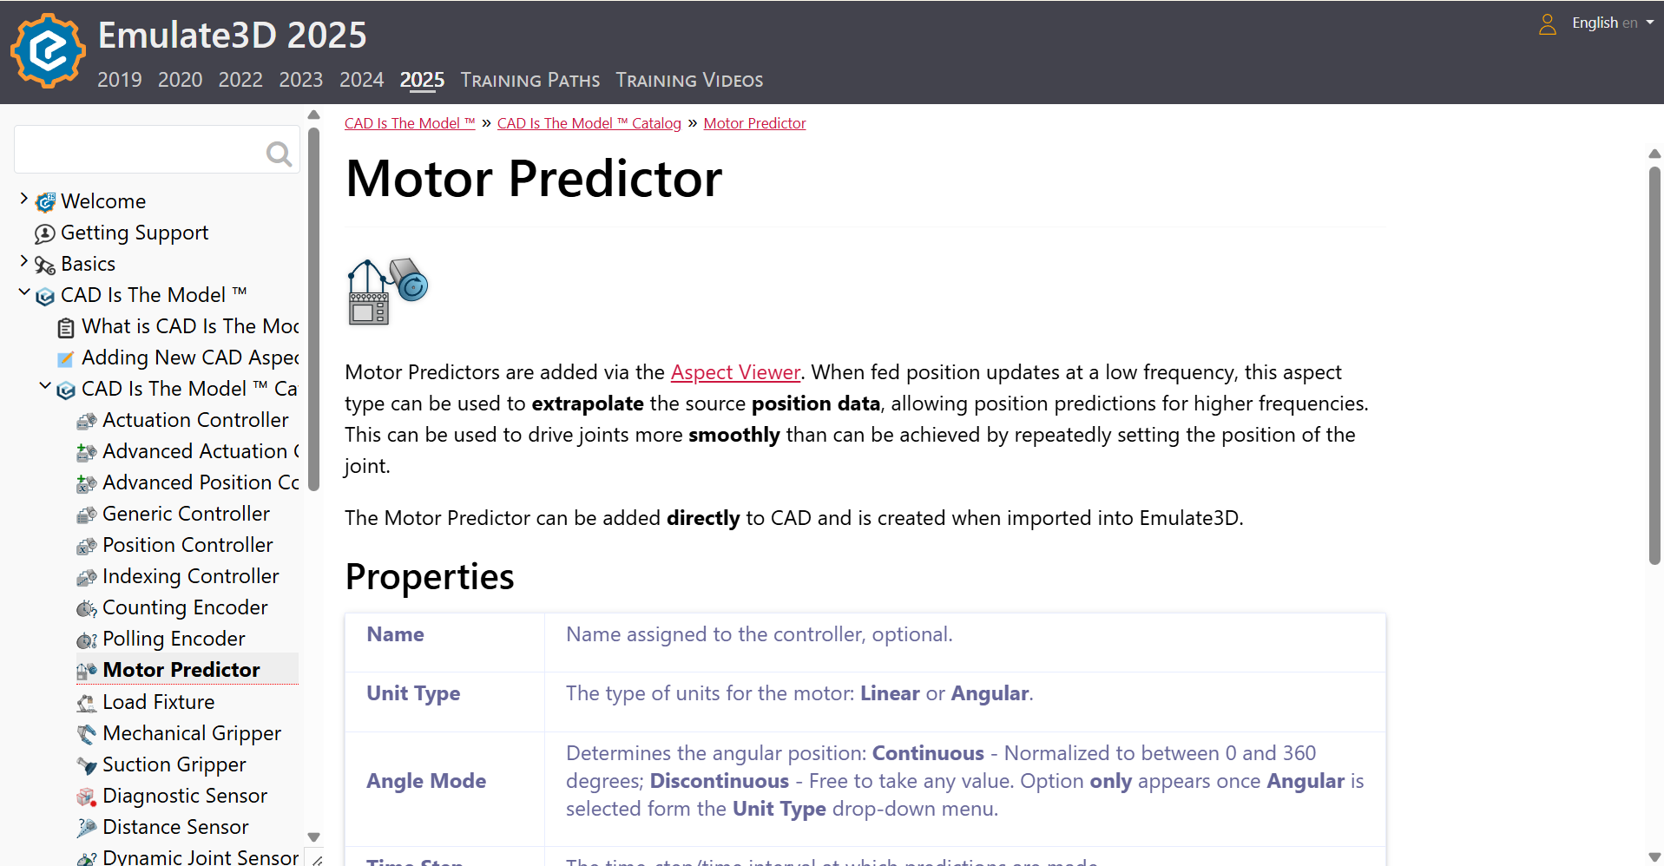

**2.3 Practice with Demo Factory Assemblies**

Built demo factory line assemblies in Emulate3D → practiced workflows to gain fluency with simulation tools and robot handling. This practical exercise helped in understanding the intricacies of building and simulating factory environments within Emulate3D.

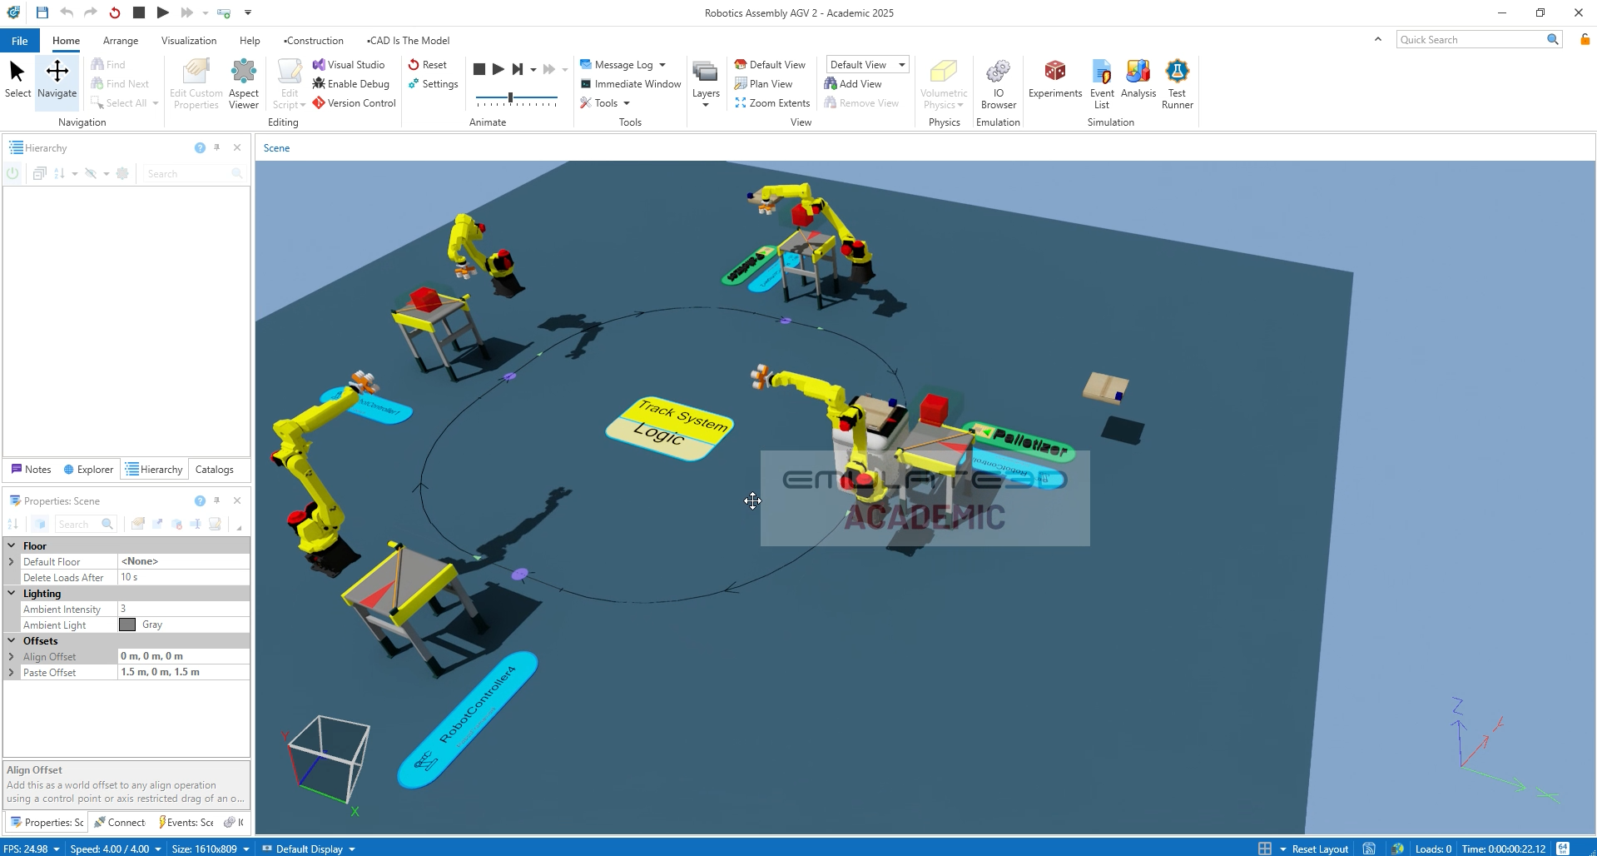

**2.4 Learned Demo Robot Markup & Libraries**

Explored demo markup of robots in Emulate3D. This involved examining how robots are defined and configured within the simulation environment, including their properties, behaviours, and interactions with other elements.

Used the software library to download relevant packages and catalogues for robots and equipment. This ensured access to a wide range of pre-built components and models, streamlining the simulation setup process.

**2.5 Downloaded TM5-700 Cobot CAD**

Retrieved TM5-700 cobot CAD model from the official website for simulation and integration into the digital twin setup. The TM5-700 cobot was chosen as the primary robotic arm for the project, and obtaining its CAD model was essential for accurate simulation.

**2.6 Imported TM5-700 CAD into Emulate3D**

Imported the cobot CAD into Emulate3D to begin simulation setup. This step involved bringing the CAD model into the simulation environment and preparing it for further configuration.

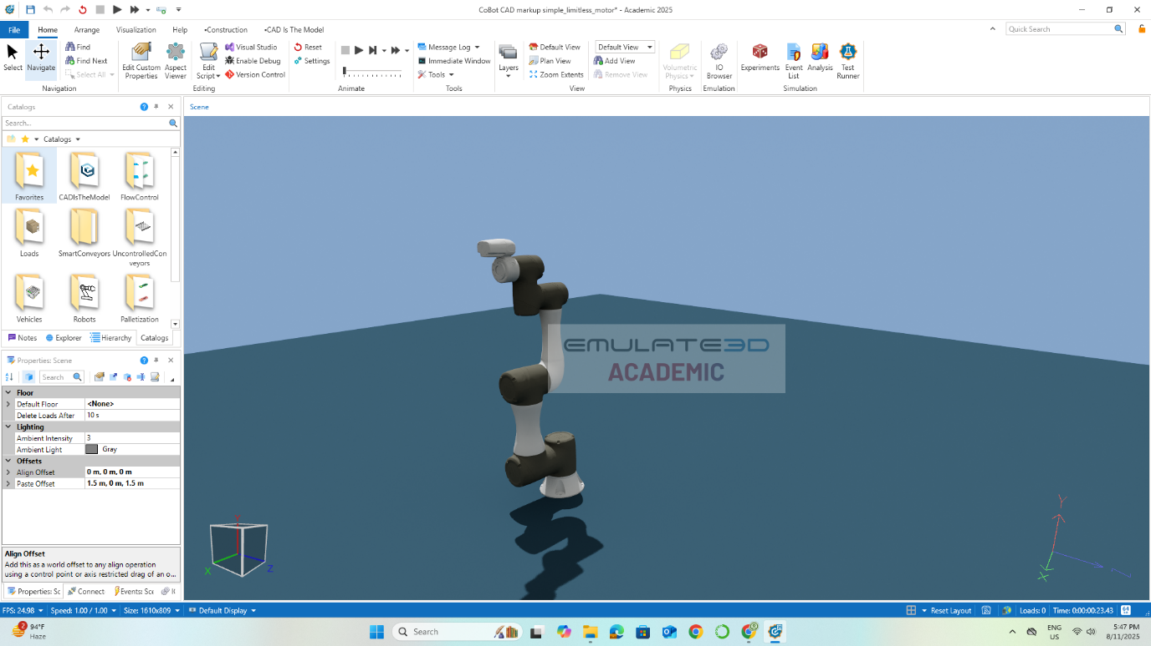

**2.7 Robot Markup with Motors and Joints**

Added motors and joints to the CAD model → enabled kinematic behaviour for robot simulation. This process involved defining the movable parts of the robot and assigning motor properties to them, allowing the robot to move and perform tasks within the simulation.

**2.8 Kinematics Testing**

Tested the robot in forward and inverse kinematics modes → verified motion planning, joint coordination, and kinematic responses. This step was crucial for ensuring that the robot's movements were accurate and predictable, and that it could perform the desired tasks within the simulation.

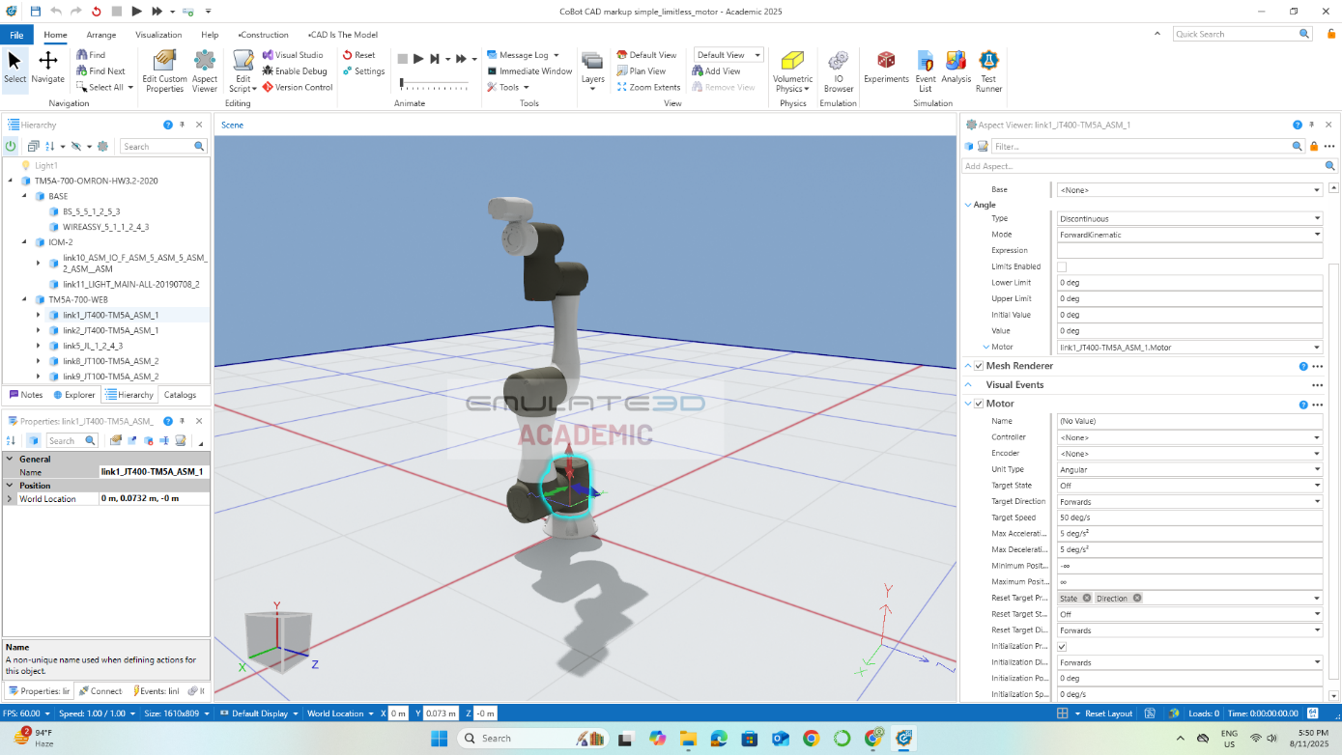

**2.9 Physical Robot Data Access Options**

Identified two methods to acquire real-time data from the physical robot:

* ROS 2 interface
* TMflow software

This step was essential for establishing a connection between the physical robot and its digital twin, allowing for real-time data exchange and synchronization.

**Investigation of Real-Time Data Communication Protocols**

Explored multiple protocols for real-time robot data integration:

**a. Industrial Protocols:**

* OPC UA (Open Platform Communications Unified Architecture): Secure, platform-independent data exchange.
* Modbus (TCP/RTU): Simple, widely supported industrial communication.
* PROFINET / PROFIBUS: Siemens-centric automation protocols.
* EtherCAT / EtherNet/IP: Real-time industrial Ethernet protocols for precise control.

**b. Robot Middleware:**

* ROS / ROS2: Topics, services, and actions for structured robot data exchange.

**c. Web / IIoT Protocols:**

* HTTP/HTTPS & REST APIs: Standard web-based communication.
* WebSockets: Real-time bidirectional communication for dashboards and live monitoring.
* MQTT (Message Queuing Telemetry Transport): Lightweight publish/subscribe messaging, widely used in IIoT.

Conducted practical tests using Postman for WebSocket communication. This involved sending and receiving data using WebSockets to verify its suitability for real-time communication.

Consulted FSM networking team → possible use of IIT server for data streaming, pending permissions. This step explored the possibility of using existing infrastructure for data streaming, which could simplify the integration process.

This step lays the foundation for connecting the digital twin environment with real-time robot operations and represents a major milestone in the project workflow.  
  
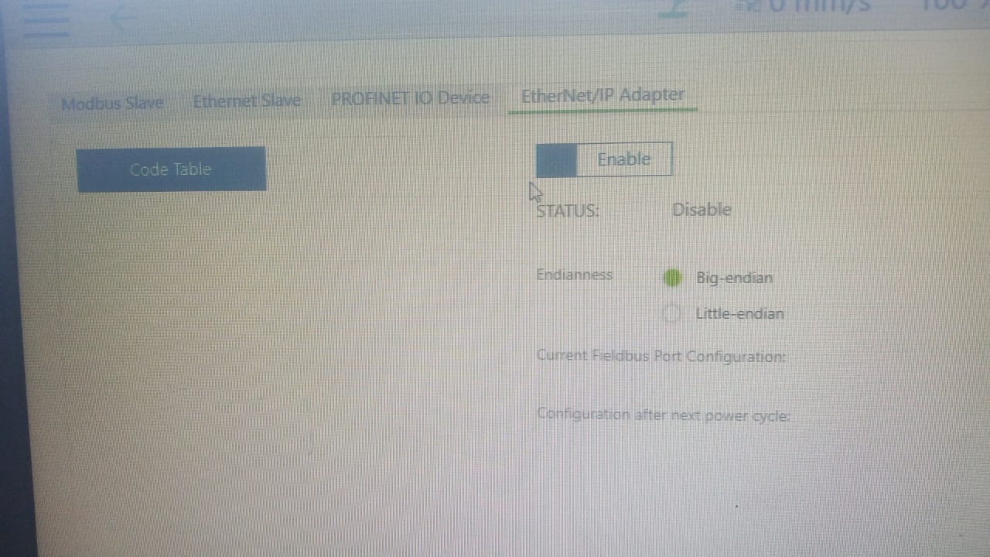   
communication protocols on TMflow  
  
  
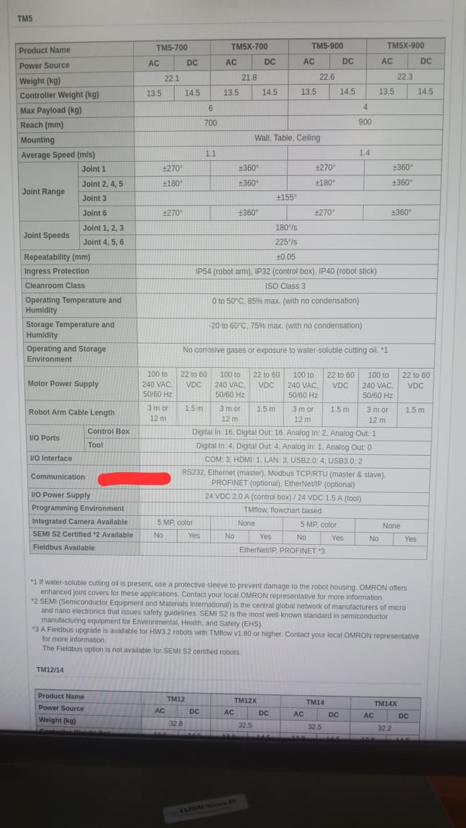  
communication protocols as mentioned by CoBot TM5-700 specifications   
  
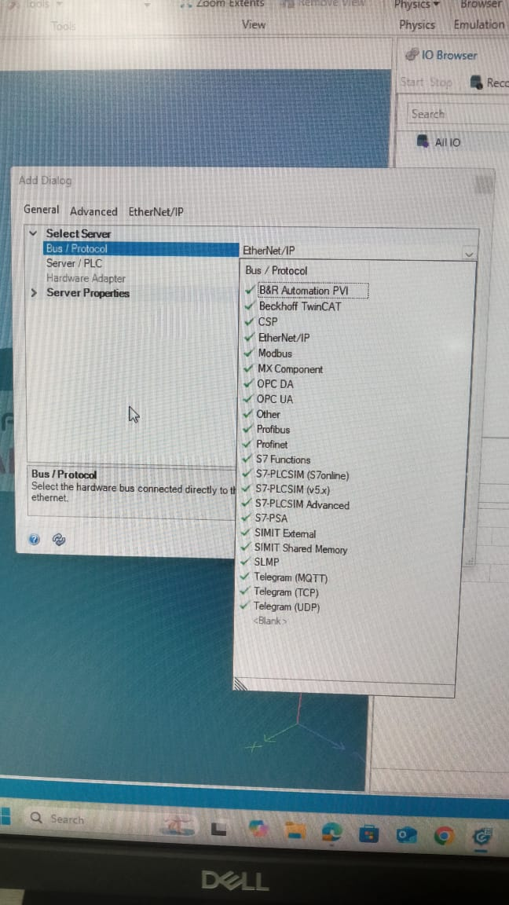  
communication protocols on Emulate3D

**3. Notes for Continuation**

The next steps include setting up ROS 2 data streaming, linking the physical robot to the digital twin, and implementing real-time dashboards. These steps will involve configuring the ROS 2 interface, establishing a communication channel between the physical robot and the digital twin, and creating visual representations of the data being exchanged.  
Infrastructure permissions and protocol selection (ROS2 vs TMflow, WebSockets, MQTT, etc.) are crucial for continued development. The choice of communication protocol will depend on factors such as security, performance, and compatibility with existing infrastructure.  
The project is ready for further integration, testing, and automation based on the documented steps above. The foundation has been laid for building a fully functional digital twin system that can be used for a variety of applications, such as robot control, simulation, and optimization.

**4. More Resources**

**GitHub Repository**  
🔗 <https://github.com/rpj33/digital_twin_cobot_rpj>  
Includes:  
AMR (and CoBot) Operation Guide  
Screen recording of factory AGV assembly robot on Emulate3D  
Repository for ROS and ROS2 code base  
*Twin-Control* book

**Additional Resources**

* Overview of Digital Twin by Prof. Sunil Jha  
  🔗 [YouTube Lecture](https://www.youtube.com/watch?v=PpXT2tXDpkc&t=27s)
* TMflow Operation (OMRON Playlist)  
  🔗 [YouTube Playlist](https://www.youtube.com/playlist?list=PLgLwd1hs9waS5UoiV-7m_TG8pq1innTwl)
* TM Robot Official Documentation  
  🔗 [Documentation](https://www.tm-robot.com/en/docs-category/tm-robot/)
* TM ROS Driver  
  🔗 [Driver Documentation](https://www.tm-robot.com/en/tm-ros-driver/)
* Emulate3D Official Documentation (training videos and guides)  
  🔗 [Emulate3D Docs](https://store.sim3d.com/demo3d_2025/welcome)