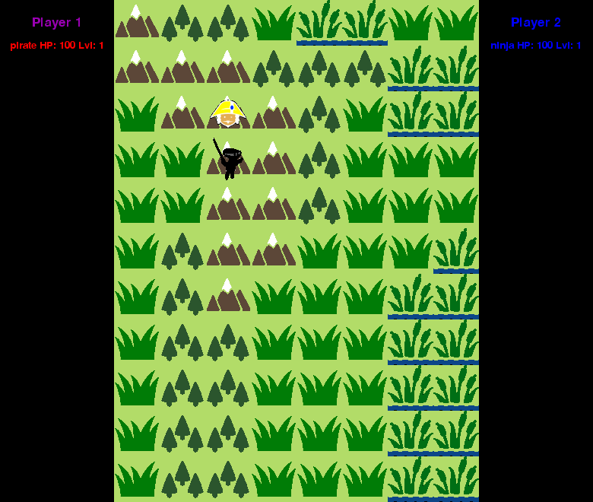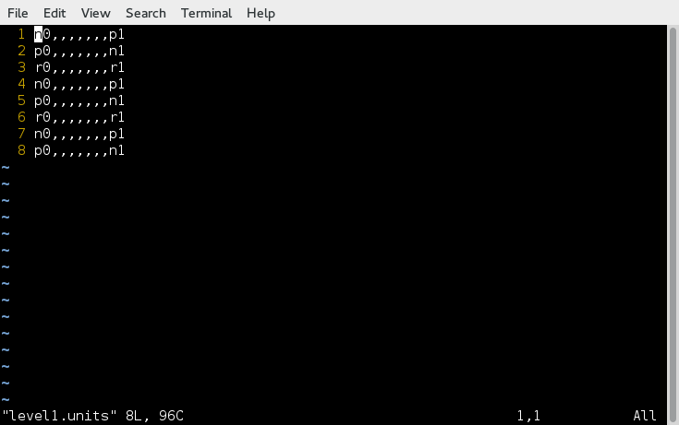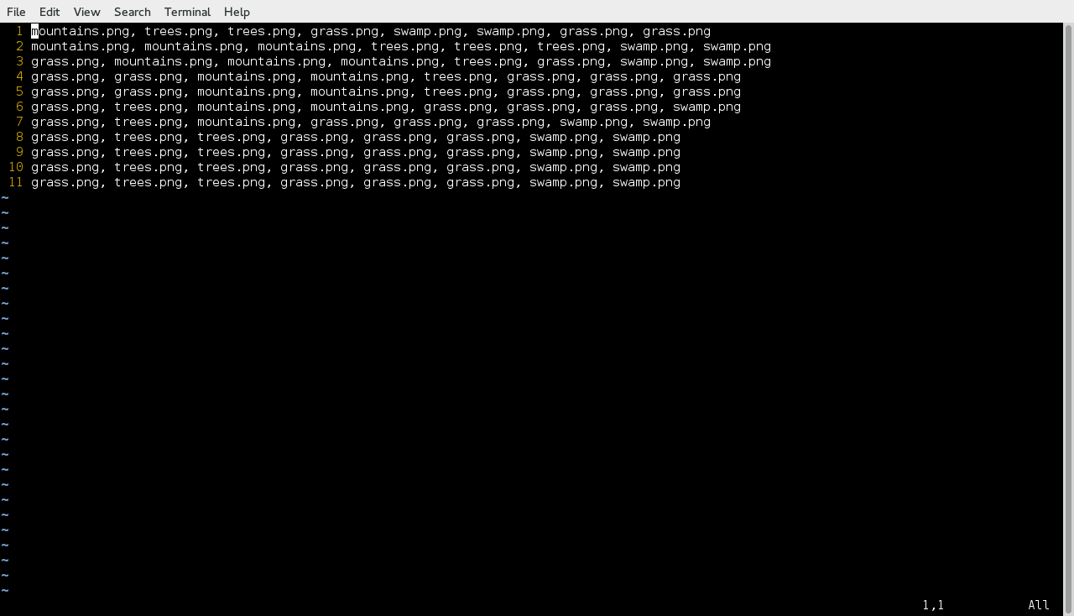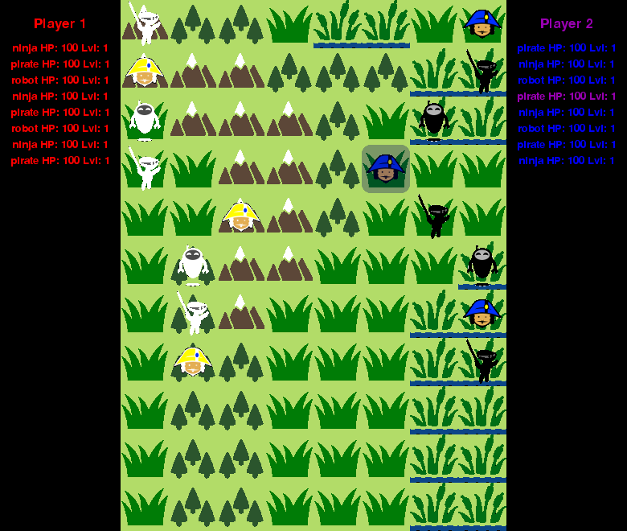**Ninjas Vs Pirates Vs Robots**

Richard Kelly

Ninjas Vs Pirates Vs Robots is a turn based multiplayer strategy game, that puts each player in command of an army of pirates, ninjas, and robots. The goal of the game is nothing short of the total destruction of your opponents army.

White units belong to Player 1, and black units are Player 2’s. You play by click on a unit, and then using the arrow keys, or the “W”, “A”, “S”, or “D” keys to move the unit one space in the corresponding direction. If you try and move into a space occupied by an enemy unit, you attack.

In general, ninjas beat pirates who beat robots who beat ninjas. But the relative health of each unit is taken into account, as well as a random factor. A very injured ninja will stand little chance against a pirate at full health. Units gain experience to level up and deal more damage. They are also healed when they level up.

The game is inspired by games such as Fire Emblem, Final Fantasy Tactics, Advanced Wars, and Civilization, as well as a lifelong love of traditional board games such as chess, Risk, and Axis and Allies.

The game is fully customizable via two CSV files, level1.map and level1.units. These files define the tiles of the map, and the location and types of units respectively. This allows players to create their own stories and make the game be what they want it to be.