LAMTEST ­ DEMO & TEST UTILITY FOR THE EXTERNAL COMPUTER CONTROL OF SUTTER INSTRUMENT’S LAMBDA SERIES OF OPTICAL WAVELENGTH SWITCHING AND SHUTTERING PRODUCTS

# Communications

The first step when running Lamtest.exe is to establishing communication with the Lambda series controller. There are two standard options for communications: USB port and serial (RS-232) port. All Lambda-series products operate with a default USB data rate of 128,000 bps (Bits per Second or “baud”), and a default serial port data rate of 9600 bps. The USB data rate applies to both the primary direct USB device driver implementation as well as the secondary virtual com port (VCP) device driver. If you wish to run either the USB port or the virtual com port at an alternate data rate (such as 9600 bps) then it is necessary to match the selected data rate on the Lambda-series controller as well (applies only to the Lambda XL and newer versions of the Lambda 10-3 and 10-B).

## Changing the Data Rate in the Lambda Series Controller for USB/VCP Communications

1. Lambda 10-3: To change the data rate on the Lambda 10-3, first go to local mode (press <LOCAL>) and then press the <MODE> key twice. This will bring up a special menu where the USB data rate may be selected from a list.
2. Lambda 10-B: To access this menu on the Lambda 10-B (LB10-B/IQ), press <F1> then <F2> (after going into Local mode) to bring up this list.
3. Lambda SC: This option is not available on the Lambda-SC. There is, however, a firmware solution available for production serial numbers LBSC-2150 and above. This new firmware implements an auto baud detection scheme. Auto baud detection is only valid for 9600 and 128k baud. If you are communicating via 9600 baud it will be necessary to send the open com command (128 (decimal) or EE (hexadecimal)) twice to establish communications.

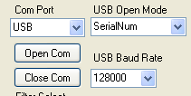

Once the appropriate device driver is installed on your computer, communications via the USB port can be opened by pressing the ‘Open Com’ button in the Lamtest program. This should open the USB port at the specified data rate. To open communications via the serial port, specify the port and press the ‘Open Com’ button. If you are unsure of which port is associated with the device, press the ‘Get Com Ports’ button which will return a list of available COM ports. Your device should be associated with COM1, COM2, COM3, or even COM20. To select COM20 enter ‘”COM20” into the ‘Com Port’ combo box. Remember that the USB data rate in the device must match the USB data rate in the ‘USB baud rate’ combo box; otherwise you will not be able to establish communications. Once communication has been established, the dialog box below should say “USB: Is Open” followed by the configuration string from the device. In the example below, that would be a “10-B” for the controller, the wheel”W–“is a”25”mm filter wheel, and the shutter”S–“is a SmartShutter (“IQ”).

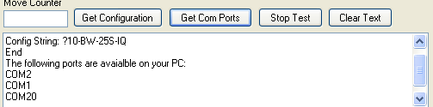  
The above dialog box is very useful for tracking the progress of various commands as they are issued. These commands have been translated into a more user-friendly format. If you wish to see the actual communications, the Com String dialog box is useful.

**Neither the Lambda 10-2 nor the Lambda DG-4 / DG-5 (including DG-4Plus & DG-5Plus) support the ‘Get Status’ command, nor do they echo a response after the ‘Go Online’ command. As a consequence, if the program fails to get a response it will default to the presence of the LB10-2. If you see the dialog box indicating that the device is a LB10-2, when you know the device is actually a LB10-3 or LB10-B, then open the COM port again to establish communications. If you still get the response ‘LB10-2’ then serial communications has not been established.

## Parallel Port Communications

The parallel port is primarily useful for the Lambda 10-2 and DG-4/5 series. The parallel port is, however, available for optional use in later versions of the Lambda 10-3. Support for the parallel port exists in the Lamtest program primarily for diagnosing parallel port issues. To use the Lamtest program with the parallel port, the device driver ‘INPOUT32’ must first be installed. To install this driver, copy the file ‘INPOUT32.DLL’ into the Win32 System directory. This file can be found in the ‘Release’ folder. Simply copy and paste it to Win32 System directory so that Windows can find it. Information on how to use INPOUT can be found at the following web address:

http://www.codeproject.com/Articles/15020/Reading-from-Parallel-Port-using-Inpout32-dll

# Tracking Your Communications

All data being transmitted to, and received from, the connected Lambda-series device is logged and displayed in the scroll panel shown below.

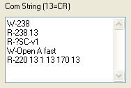

Lines beginning with “W” indicate data that was written out or transmitted to the device. All return data (received from the connected device) are on lines that begin with an “R”. All commands are echoed back. In the above example the ‘Open Shutter A in Fast Mode’ routine was called. This routine consisted of the following commands:

220 =Set Fast Mode <CR>1= Shutter 1 (A) <CR> 170= Open Shutter <CR>. This tracking panel can be very useful for being informed as to what is being transmitted and what is being received, diagnosing problems, and even for developing your own command routines to control the Lambda-series device...

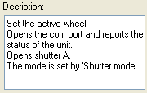

Another useful dialog box is the “Description” dialog box. Many of the text boxes and buttons will display their function when the cursor “hovers” over them. This can be very useful for a quick reference to the various functions.

# Front Panel

Once communications have been established you can send commands to the connected Lambda-series controller. Connected to the controller will be one or more peripherals, such one or more filter wheels, one or more shutters, etc. Each type of peripheral has control region on the Front Panel with controls that are designed specifically for that type of peripheral

## Filter Wheel Control

The most straight forward way to test the movement of a filter wheel is to simply click one of the “Filter Select” radio buttons.

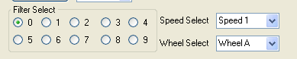

The home position of the Lambda filter wheel is Filter 0. So by default this radio button is selected. The filter wheel will not move unless you select another filter position. The combo boxes above will dictate the speed of the filter move as well as the selected wheel (A, B, or C).

## Shutter Controls Tab

To open one of the shutters simply click on the appropriate open / close radio buttons. The Shutter Mode applies to SmartShutter’s only. The mode can be Fast, Soft, or Neutral Density, with fast being the default. Neutral Density Mode has a neutral density setting that ranges from 0 to 144 micro-steps. It should be noted that there is a safety margin of approximately 20 micro-steps on either end of travel so you can expect values of 20 through120 to produce results with the greatest change in light output.

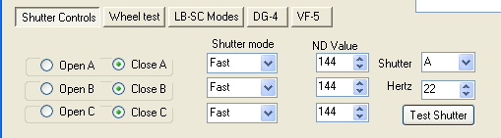

You will also notice a special “Test Button” to the right. This button is useful for testing the stability of the shutter running a certain number of cycles per second (Hertz). At approximately 20 Hz, there will be constructive and destructive harmonics which could hinder the proper operation of the shutter. For instance, the top frequency of the 25mm shutter is 42 Hz. It can run very reliably at this rate. If, however, you move a little slower (e.g., at 38 Hz) the shutter will behave very poorly and erratically.

## Wheel Test Tab

The next tab, “Wheel Test”, has many useful test routines related to filter wheel testing. The first of the tests is “Test Wheel”, which is the production test. This test will run through the speeds defined by “Top Speed” and “Last Speed”. The default top speed of the filter wheel is Speed 1. Speed should not be used without a lightened wheel, such as the 4 position wheel or a wheel loaded with Semrock’s thin filters. There are two factors to produce error-free filter moves. One is the speed of the filter wheel; the other is the delay between the filter moves. As with the shutter, there are constructive and destructive harmonics in the movement. These harmonics are dependent upon the load of the filter wheel which changes with the number of filters installed. This delay may be increased by a “Delay Multiplier” for the speeds marked in the check box, for instance in the example below the delay at speed 1 would be 120msec. At Speed 2, the delay multiplier would kick in and the new delay would be 120msec X 5= 600msec. This can be useful for determining a good speed to move your filter wheel.

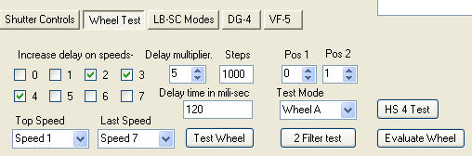

The production test employs a random position algorithm. If you are primarily interested in 2-filter moves, such as between positions 1 and 2, then the “2 Filter Test” is the recommended one to use. The “HS 4 Test” is a special version of the 2-position test that names two specific filters on which to perform this test. There is also the “Evaluate Wheel” test that performs a random position test at increasing delays and at increasing speeds. The random test can be useful in determining what speeds will work for you. The “Test Mode” combo box allows you to choose the wheel on which to run the tests. When testing in “Batch Mode” (Lambda 10-2 and 10-3 only), follow-up testing is automatically performed if a wheel movement error occurs so that the wheel causing the error can be determined.

## LB-SC Modes Tab

The LB SC Modes tab contains controls for testing the special features that are unique to the Lambda SC.

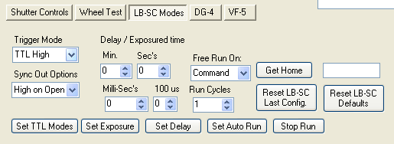

**Trigger Mode (TTL IN):** The trigger mode corresponds to the TTL IN signal. The default setting is “TTL High”, which causes the shutter to open once the signal on TTL IN is high. The Trigger Mode can also be set to “TTL Low” (open shutter when TTL signal is low (grounded)). In addition to TTL High and TTL Low, high and low transitions are also supported. By opening on a transition, the TTL can cause the shutter to open and close in toggle mode. For instance if you change the shutter state only on a high transition, the shutter will open on the low-to-high transition and close on the next transition.

**Synch Out Options (TTL OUT):** The options for the sync out pulse are high on shutter open, low on shutter open, or disabled.

For both Trigger Mode and Synch Out Options, press the “Set TTL Modes” button to save the changes to the controller as the power-on defaults.

**Free Run Mode:** The second set of important features to be found on this tab involves the “Free Run Mode”. In the “Free Run Mode” there are three parameters that can be set, Exposure, Delay, and repeat cycles. If you want to set the shutter to open for 20ms after a delay of 60ms, you would first enter 20ms into the timer counters and then press “Set Exposure”. Next, you would enter 60ms into the timer counters and then press “Set Delay”. The order of these two steps is irrelevant. When either the Set Delay or Set Exposure button is pressed, the Free Run Mode, the number of Run Cycles is set to 1 (single cycle). Repeated cycles can be set by increasing the number of Run Cycles. Note that any number of cycles above 65,000 places the Free Run mode into continuous mode (infinite cycles).

NOTE: **Once the Lambda SC is set in Free Run mode, it will not respond to any commands until either the “Stop Run” button or the “Reset LB-SC Defaults” is pressed (or the equivalent commands are sent from another application).** Merely stopping the auto run without subsequently pressing “Set Auto Run” causes the controller to revert to the original auto run mode when it is next powered on.

Realigning a Shutter: The last button “Get Home” is primarily of use when the shutter has become misaligned and needs realignment. There are some subtleties to correctly setting up the shutter so if you need to perform this procedure call Sutter and speak to a Technician.

## DG-4 Tab

The functions specific to the DG-4 / DG-5 (and DG-4 Plus/DG-5 Plus) can be found on the DG-4 tab panel. In a DG-series system, the shutter is closed on power on. Since the shuttering is controlled by the internal mirrors, a movement to any position effectively opens the shutter.

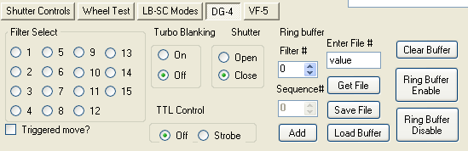

The first set of controls on the left simply move the DG series system to the programmed filter position. The factory defaults for the DG-series are: Filter values 1-4 are filters 1-4 at 100% intensity, values 5-8 are filters 1-4 at 66% intensity, and lastly values 9-12 are filters 1-4 at 33% intensity. The values programmed into the DG-5 follow a similar pattern where values 1-5 are at 100% intensity, 6-10 are at 66%, and 11-15 are at 33% intensity. By default these moves are performed once a radio button is selected. You can also opt to have a trigger initiate the movement.

By default, the turbo blanking mode is off. What this means is that both internal switching mirrors will switch simultaneously for the fastest switching time. This may produce a brief pulse of unfiltered light. To avoid this occurrence turbo blanking can be switched on, and one mirror will shutter the other during movement producing a ‘clean’ filter switch.

The next series of buttons deal with the ring buffer. To achieve the absolute fastest filter switching, the filter values are preloaded into a buffer. This buffer sequence can then be triggered using the strobe input. Each strobe pulse will increment through the ring buffer sequentially. The ring buffer can be programmed into the DG-series using this utility. In addition, the ring buffer sequence can be saved or retrieved from a file. Lastly, the ring buffer can be enabled, disabled, and cleared from this tab panel.

## VF-5 Tab

The last tab, “VF-5”, is for the new Versachrome filter wheel. In many respects, the VF-5 is similar to a monochromator. The VF-5 employs 5 variable filters covering from 60 to 100 nanometers in wavelength. The initial or base value of the filter is at zero degrees of tilt. The rage of each filter is variable and based upon the base value, the shorter the wavelength the narrower the spectrum of the variable filter.

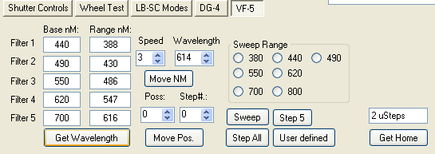

### Filter

To determine which filters are in place, it is first necessary to store the value into the VF-5. In most cases, the VF-5 will come preprogrammed with the correct values at the factory. To get the setup using this utility, press the Get Wavelength button. This will populate the filter fields with the base value of the filter. The range is calculated based upon the specifications of the filter. There is some overlap in the range. The VF-5 will resolve these discrepancies internally and move to the optimal filter and angle for the wavelength. To move to the desired wavelength, enter the wavelength (in nanometers) and the Tilt Speed and press the “Move NM” button. Zero is the fastest speed, and can cause considerable vibration on long moves. To achieve a smooth transition when moving the filter wheel, the default speed value is therefore set to “3”. You can also opt to move to a specific position and angle using the “Move Pos.” button. The Lambda VF-5 has a look-up table stored within it that indicates the expected wavelength based upon the filter base value and angular tilt. Lastly, there are some built in routines that sweep through a filter in single wavelength increments, or you may opt to step through all 5 filters one wavelength at a time. These routines are primarily used for testing as is the Get Home button.